ENTERPRISE REAL ESTATE SALES PLATFORM & CLOUD TELEPHONY INTELLIGENCE
Comprehensive Real Estate CRM Feature Guide & Operational Workflow Specification
A business-focused, functional blueprint explaining how the CRM works from start to end: browser-native cloud calling, AI speech intelligence, interactive 2D layout plot booking, chauffeur fleet dispatching, closed-loop marketing analytics, and fraud protection.
Platform Dimension | Operational Scope & Coverage
System Name | Real Estate Enterprise CRM & Omnichannel Telephony Suite
Document Purpose | Executive Feature Manual, User Workflow Blueprint & Operational Guide
Target Audience | Executive Management, Sales Directors, Team Leaders & Operations Teams
Telephony Engine | Browser-Native WebRTC Softphone (Tata Smartflo PBX Integration)
AI Intelligence | Google Gemini 2.x Conversational Diarization, Sentiment & Intent Scoring
Release: Version 2.0 (High-Level Functional Edition) | October 2026

1. Executive Summary: What the CRM Is & Why It Exists
1.1 The Business Challenge in Real Estate Sales
Real estate transactions are high-value, multi-touch decisions that demand immediate responsiveness and flawless operational coordination. Prospective buyers inquire through diverse advertising channels: Meta campaigns, Google search ads, property listing portals (99acres, MagicBricks), and outdoor billboards. In conventional setups, marketing leads are dumped into disconnected spreadsheets, calls are taken on personal mobile phones or separate desk hardware, customer requirements are jotted down on paper, and site visit logistics are handled through uncoordinated phone calls. The result is severe lead leakage: delayed callbacks, unanswered inquiries, lost customer requirements, lack of accountability for telecallers, and an inability to tell which marketing campaign actually resulted in signed sale deeds.
1.2 The Unified Solution Architecture
This CRM platform solves these critical bottlenecks by unifying telephony, customer relationship management, property inventory mapping, logistics fleet dispatching, and artificial intelligence into a single browser-based cockpit. No physical desk phones or third-party softphone installations are required. Agents open the CRM in their browser, put on their headset, and immediately manage inbound inquiries, outbound sales campaigns, customer profile qualification, site visit coordination, and plot reservations.
- Browser-Native Calling: Agents take and make calls directly inside the CRM tab with zero dial latency and crystal-clear audio.
- AI Conversational Intelligence: Every conversation is transcribed, summarized into key bullet points, and scored for buying intent by Google Gemini AI.
- Interactive 2D Plot Management: Replaces static unit spreadsheets with a visual, color-coded 2D layout map showing real-time plot availability, pricing, and buyer reservations.
- Site Visit Logistics Dispatch: Coordinates company cars (Ertiga, Innova) and verified drivers to transport buyers to project sites, with automated sales executive assignment.
- Closed-Loop Marketing Attribution: Connects every advertising dollar spent on Meta or Google directly to phone calls, site inspections, and plot bookings.
- Telecom Security & Blacklist: Blocks spam bots, fraudulent callers, and abusive numbers either account-wide or on specific marketing campaign numbers.
2. End-to-End Operational Lifecycle: The Customer Journey
To understand how the CRM operates, follow the end-to-end journey of a prospective buyer and sales agent across ten distinct operational stages:
Stage 1: Lead Capture & Marketing Attribution
A prospective homebuyer sees a digital advertisement (e.g., a Meta Ad for 'Vibhava Meadows') and dials the phone number displayed. That number is a dedicated Virtual DID (Direct Inward Dialing number) assigned exclusively to that specific campaign. Alternatively, the buyer submits an inquiry on Facebook or a property portal. The CRM instantly captures the inquiry, creates a lead profile, and permanently tags it with the marketing source and campaign.
Stage 2: Automatic Queue Routing & Softphone Alert
The telecom PBX identifies available, ready telecallers assigned to the 'Vibhava Campaign'. Within milliseconds, the selected agent's browser rings, and the Live Call Workspace pops onto the screen, showing the caller's phone number, geographic location, and the marketing ad they called from. The agent clicks 'Answer' (or auto-answer takes over) and begins speaking through their browser headset.
Stage 3: Live In-Call Qualification & Profile Capture
While conversing, the agent has full access to in-call controls: Mute, Hold, and Blind Transfer (to escalate to a senior manager or another department). On the same screen, the agent records the customer's full name, email, alternate phone number, budget range (e.g., 40-50 Lakhs), preferred property type (open plot, villa, apartment), and purchase timeline. If the customer called previously, their past conversation history and agent notes appear in an instant drawer.
Stage 4: Call Wrap-Up & Mandatory Dispositioning
When the call concludes, the CRM enforces a mandatory wrap-up phase. The agent cannot take new calls or go on break until they select a structured outcome disposition: 'Site Visit Scheduled', 'Callback Scheduled', 'Requirement Captured', 'Loan Assistance Required', 'Not Interested', or 'Invalid Number'. This rule guarantees 100% data capture.
Stage 5: Follow-Up Nurturing & Missed Call Recovery
If the customer requested a callback, the system automatically schedules it into the agent's Callbacks queue, showing a visual countdown timer (Due in 2 hours, Due Now, Overdue). If a customer called during off-hours or hung up while waiting in queue, the call automatically drops into the Missed Calls recovery console, where agents can redial the lead with a single click to ensure strict Service Level Agreement (SLA) compliance.
Stage 6: Site Visit Booking & Chauffeur Fleet Dispatch
When the buyer agrees to visit the project, the agent schedules a Site Visit ticket. If the buyer requires transportation, the logistics coordinator assigns a company vehicle (e.g., Maruti Ertiga or Toyota Innova) and a dedicated driver, specifying pickup address and scheduled arrival time. An on-ground sales executive is assigned via automated round-robin to meet the customer at the site gate.
Stage 7: On-Site Inspection & Interactive 2D Plot Selection
Upon arriving at the property site, the sales executive opens the Plot Management Workspace on a tablet or laptop. The customer is presented with an interactive, color-coded 2D layout map of the development. Clicking on any plot instantly displays dimensions, facing direction (East, West, North, South), base price per sq.yd, developmental charges, and gross total cost.
Stage 8: Plot Reservation & Advance Token Locking
When the buyer selects their preferred plot, the executive updates its status from 'Available' (Green) to 'Reserved' (Blue) and links it directly to the customer's CRM profile. The plot is now locked across all company branches, preventing double bookings. Once the token advance payment is verified, management transitions the status to 'Sold' (Slate).
Stage 9: Post-Call AI Speech Audit & Quality Assurance
Meanwhile, behind the scenes, Google Gemini AI analyzes the call recording. It generates a 2-3 sentence executive brief, scores the customer's buying intent from 0 to 5, evaluates emotional sentiment (Positive, Hesitant, Negative), and extracts concrete follow-up commitments (e.g., 'WhatsApp brochure sent', 'Check home loan CIBIL score'). Team leaders review these summaries in seconds without having to listen to 20-minute audio recordings.
Stage 10: Closed-Loop Marketing Attribution & Scaling
Executive management reviews the Digital Marketing Analytics dashboard. By tracing the signed sale deed back to the original Meta campaign and virtual DID, leadership knows the exact Return on Investment (ROI) of each marketing channel, enabling data-backed decisions on where to allocate the next month's advertising budget.
3. Deep-Dive Feature Specifications & Visual Operational Guide
This section delivers an exhaustive functional breakdown of every core feature and capability in the CRM platform. Each module is detailed from a user experience and business operations perspective, explaining what the screen is, why it is essential for driving real estate sales, and how teams interact with it step-by-step.
3.1 Real-Time Agent Floor Wallboard (Live Supervisor Monitoring)
The Live Agents Status wallboard is the operational radar for contact center supervisors, team leaders, and sales managers. In a busy real estate sales floor, supervisors must know at a glance who is available to speak with incoming buyers, who is currently engaged on a call, who is lingering excessively in post-call wrap-up, and who is on break.
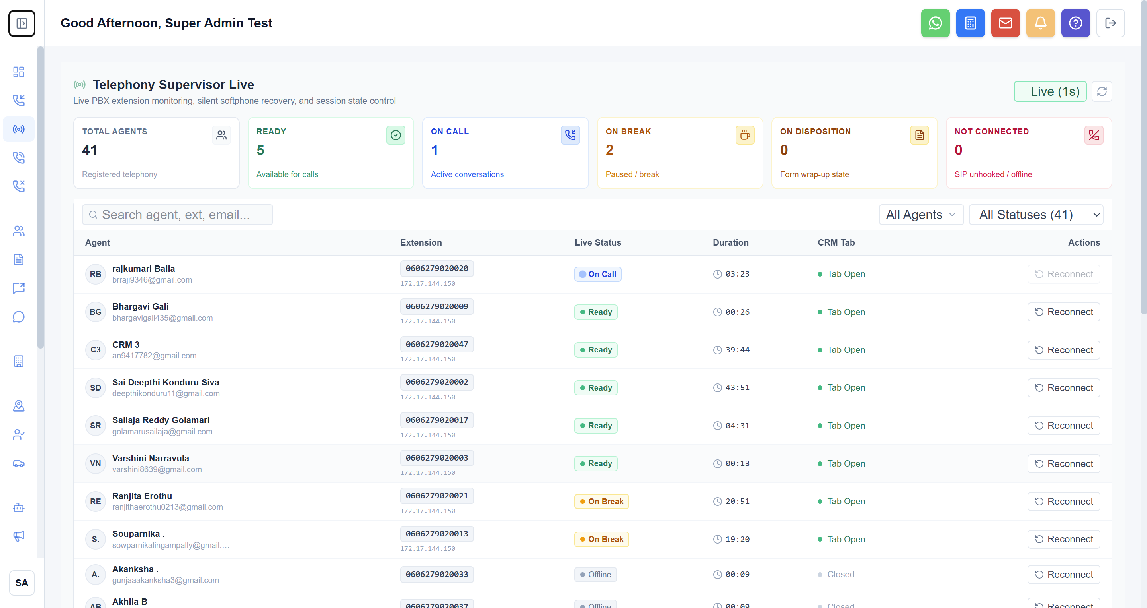
Figure 1: Real-time supervisor wallboard showing live telecaller states, digital status timers, and quick supervisor actions.
How the Feature Works in Daily Operations
- Live Telephony Status Badges: Every telecaller is displayed with a real-time status pill: Ready (Green / available to receive calls), On Call (Blue / speaking with a client), In Wrap-Up (Purple / submitting customer requirement form), On Break (Amber / pause code active), or Offline (Gray / logged out).
- Real-Time State Duration Timers: An active digital stopwatch tracks the exact elapsed time in the agent's current state. If an agent remains in wrap-up or on break for longer than allowed floor thresholds, supervisors receive immediate visual alerts to prevent floor bottlenecks.
- CRM Tab Connection Indicator: Verifies whether the agent actually has their CRM browser tab open and focused, preventing telecallers from appearing 'ready' while browsing external websites.
- Remote Reconnection Tool: If an agent experiences local network instability or microphone glitches, the supervisor can click 'Reconnect Audio Socket' to silently reset their WebRTC connection without forcing a full system reboot.
- Supervisor Force Logout: Allows supervisors to gracefully disconnect stuck sessions if an agent leaves their workstation without logging out.
3.2 Live Active Calls Monitor & Telephony Console
The Live Calls Monitor provides complete enterprise visibility into all telephone conversations currently occurring across the organization. It allows floor managers to monitor active call volume, detect queue build-ups during peak marketing hours, and verify carrier network health.
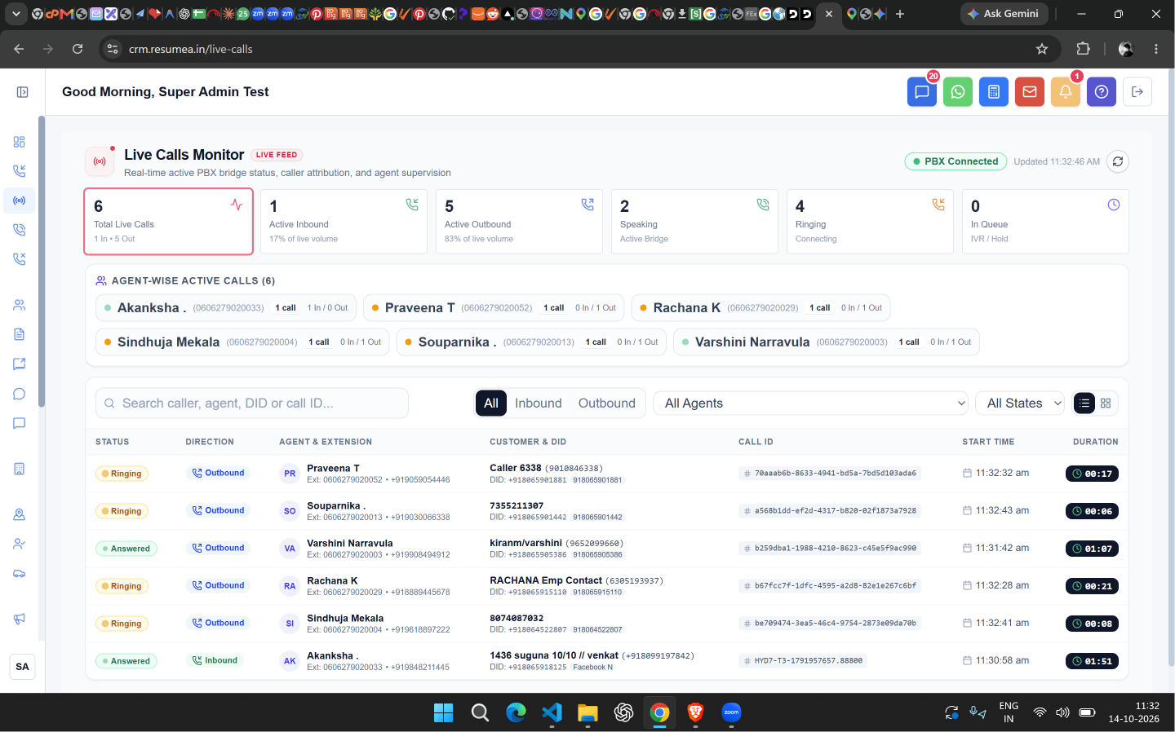
Figure 2: Live active calls radar showing in-progress conversations, call speaking durations, and telecom link status.
How the Feature Works in Daily Operations
- Speaking Calls Console: Displays active two-way audio conversations with live duration timers, showing the caller's phone number, assigned telecaller, and dialed campaign DID.
- Ringing State Visibility: Highlights customer calls currently ringing on agent softphones with an amber pulsing indicator, allowing managers to intervene if ringing times exceed SLA thresholds.
- Queue Congestion Alert: Monitors incoming callers waiting in queue for the next available agent, providing early warnings when marketing traffic surges overwhelm available floor capacity.
- Call Direction Segmentation: A toggle bar enables managers to filter live traffic by Inbound (marketing inquiries), Outbound (prospecting dials), or All active calls.
- Carrier Media Health Indicator: Continuously measures latency and round-trip ping to the Tata Smartflo telecom servers, alerting IT administrators to any carrier voice degradation.
3.3 Agent Active Call Cockpit & Dynamic Dispositions
The Agent Live Call Workspace is the central cockpit for sales telecallers. Activated automatically the moment an incoming or outbound call connects, it replaces multiple disjointed windows with an all-in-one calling interface where agents manage audio controls, capture buyer requirements, review customer history, and submit structured call outcomes.
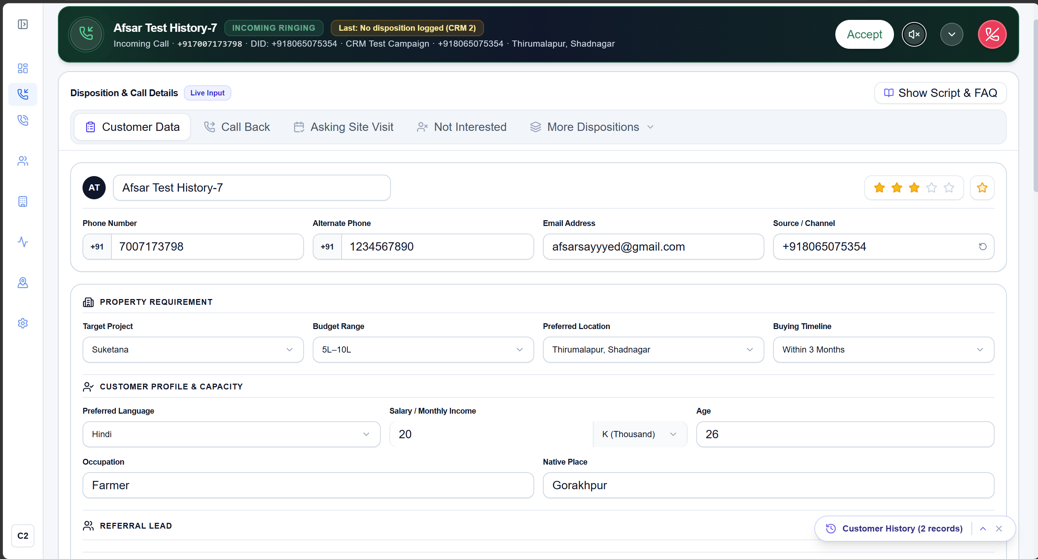
Figure 3: Agent Calling Cockpit featuring hardware audio controls, customer profile inputs, disposition choices, and interaction history.
How the Feature Works in Daily Operations
- In-Call Audio Controls: Allows the agent to Mute their microphone, put the caller on Hold with hold music, or Hang Up directly from the browser window.
- Blind Call Transfer: Enables the agent to transfer an active customer call to another internal sales executive's extension or an external senior manager's phone with a single click.
- Live Customer Profile Form: Editable input fields for Customer Name, Alternate Mobile, Email Address, Current City, and Primary Lead Source, saving updates in real-time.
- Instant Interaction History Drawer: An expandable side drawer that displays past phone calls from this customer, previous telecallers who spoke with them, and recorded conversation notes.
- Dynamic Disposition Selector: When the call concludes, the agent selects from structured outcomes: 'Site Visit Scheduled', 'Callback Scheduled', 'Requirement Captured', 'Loan Assistance Needed', 'Not Interested', 'Wrong Number', or 'Duplicate'.
OPERATIONAL DIRECTIVE: MANDATORY DISPOSITION ENFORCEMENT
To ensure zero lead leakage and 100% data integrity, the system locks the agent in a post-call wrap-up state until a disposition form is submitted. The agent cannot receive new calls, dial out, or initiate lunch/tea breaks until the customer's details and next follow-up action are formally recorded.

3.4 Outbound Softphone Dialer & Campaign Execution
The Outbound Dialer empowers telecalling teams to conduct high-velocity sales prospecting directly from their web browser. Agents eliminate manual number typing on physical handsets, connecting calls through their computer headsets with a single click.
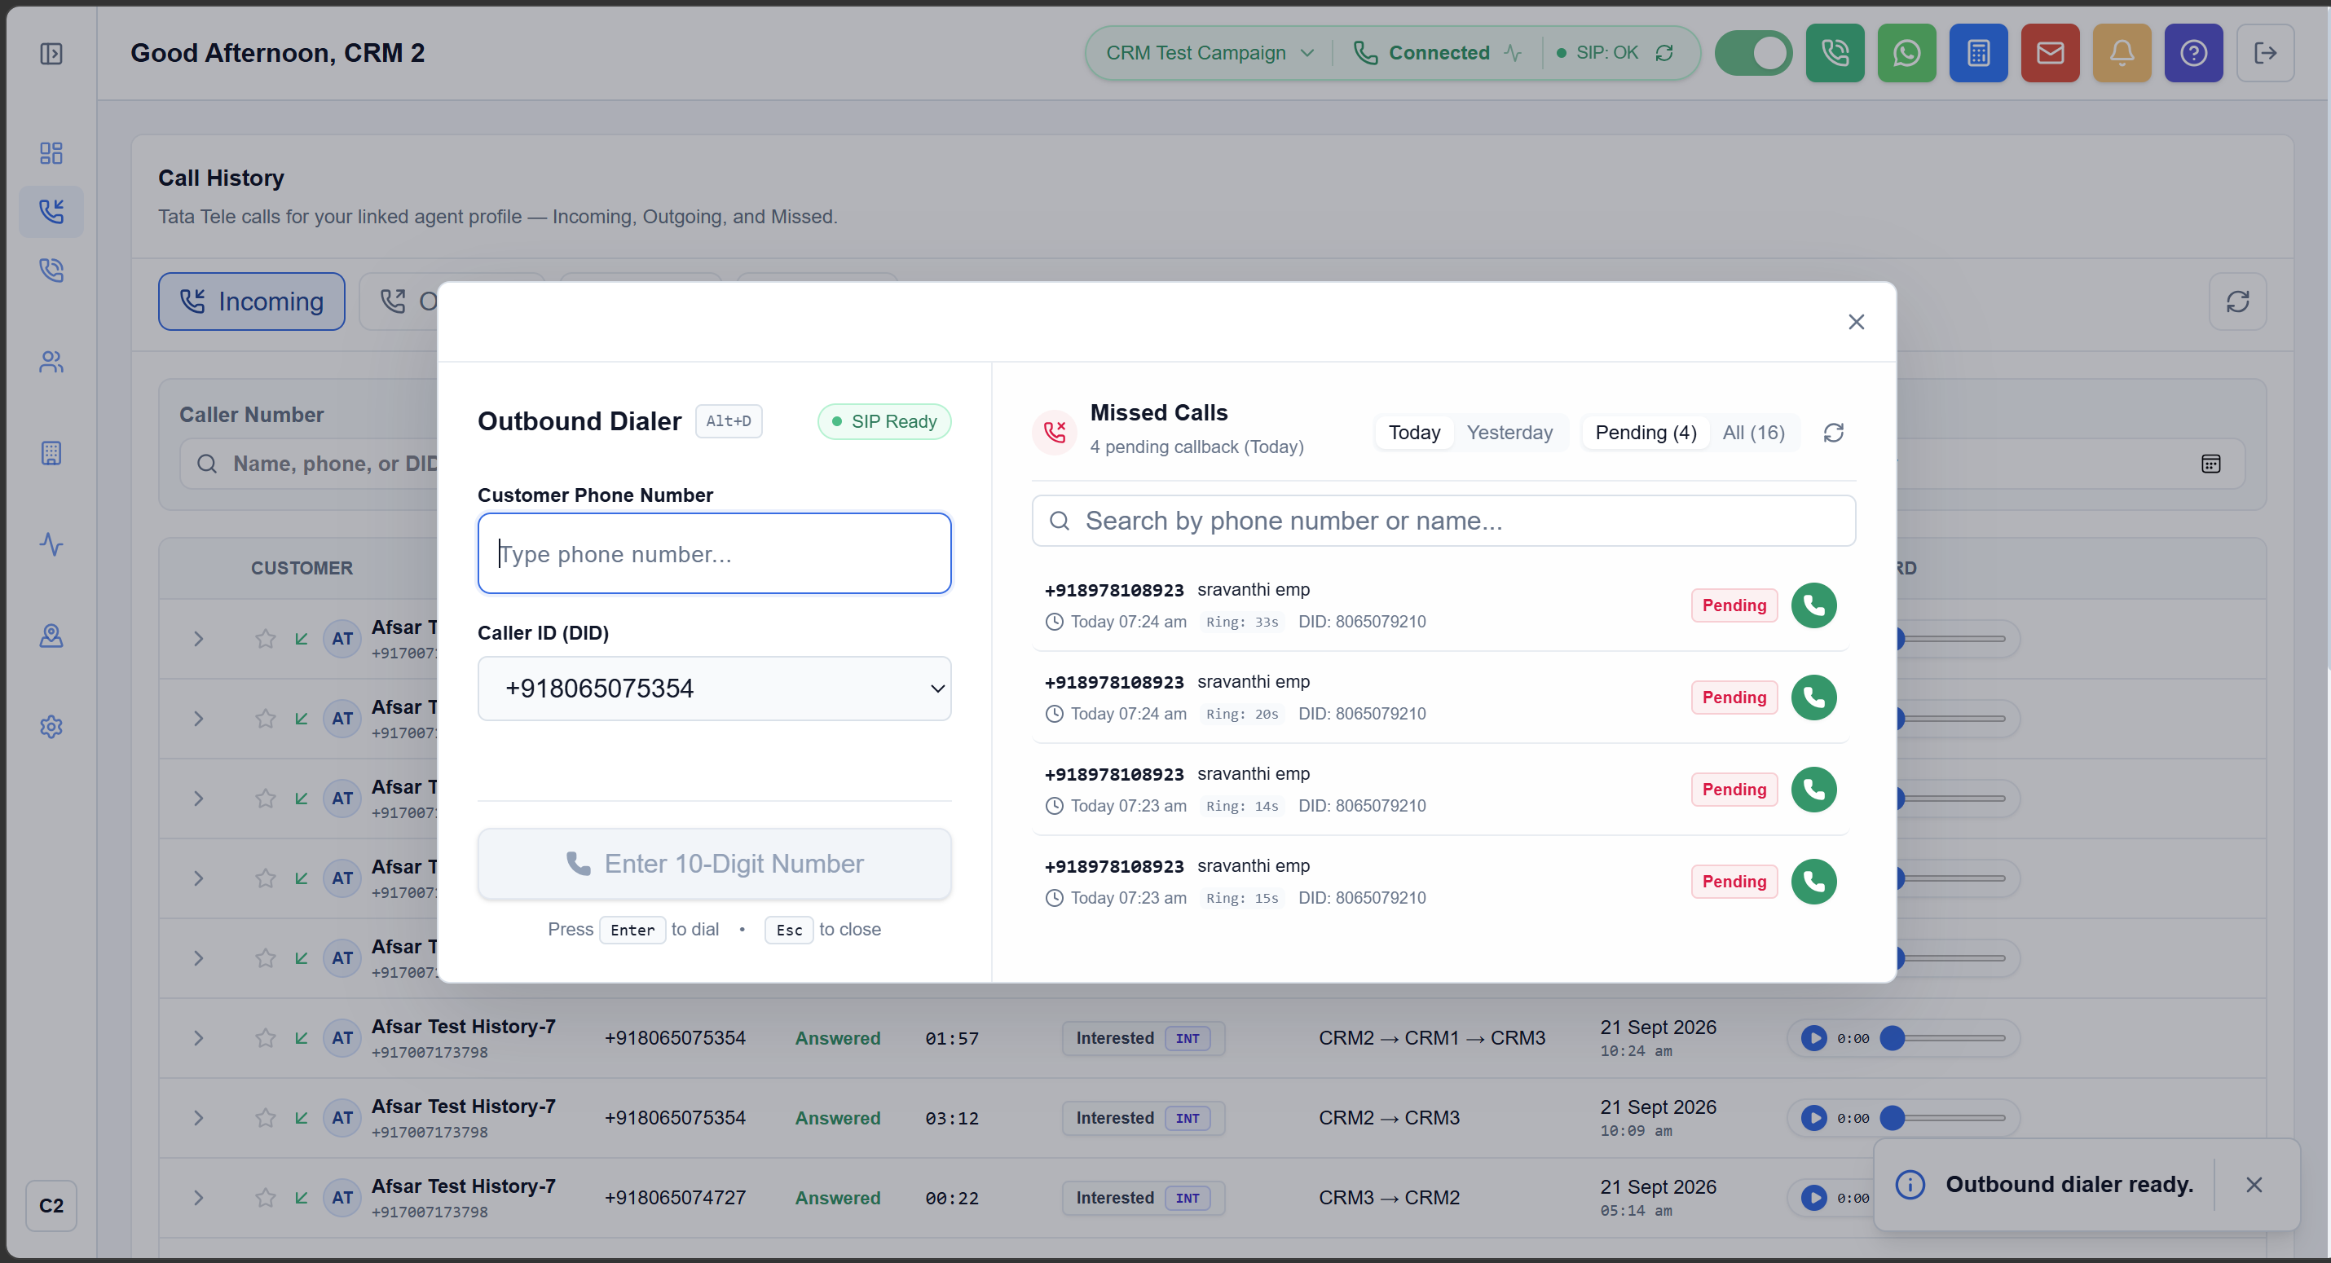
Figure 4: Web-native outbound dialer showing campaign selection, manual dial pad, and active lead dialing controls.
How the Feature Works in Daily Operations
- Campaign Selector: Agents select from designated sales campaigns (e.g., 'Vibhava Phase 2 Prospecting', 'Past Site Visit Follow-ups'), ensuring calls are properly categorized.
- Progressive & Manual Dialing Modes: Supports both single-click manual dialing for individual high-priority leads and progressive dialing where the system automatically dials the next lead on the agent's assigned contact list upon call wrap-up.
- Instant Headset Connection: Calls connect through a pre-established audio pipe in the browser, eliminating the 5-10 second connection lag common in legacy mobile call bridging systems.
- Verified Outbound Caller ID: The customer's mobile phone displays the company's verified, branded outbound DID number, ensuring professional presentation and high answer rates.
3.5 Scheduled Callbacks & Lead Follow-up Management
In real estate, over 70% of property sales occur during subsequent follow-up discussions rather than the initial call. The Callbacks module provides an automated, organized follow-up queue ensuring that promised customer callbacks are executed punctually.
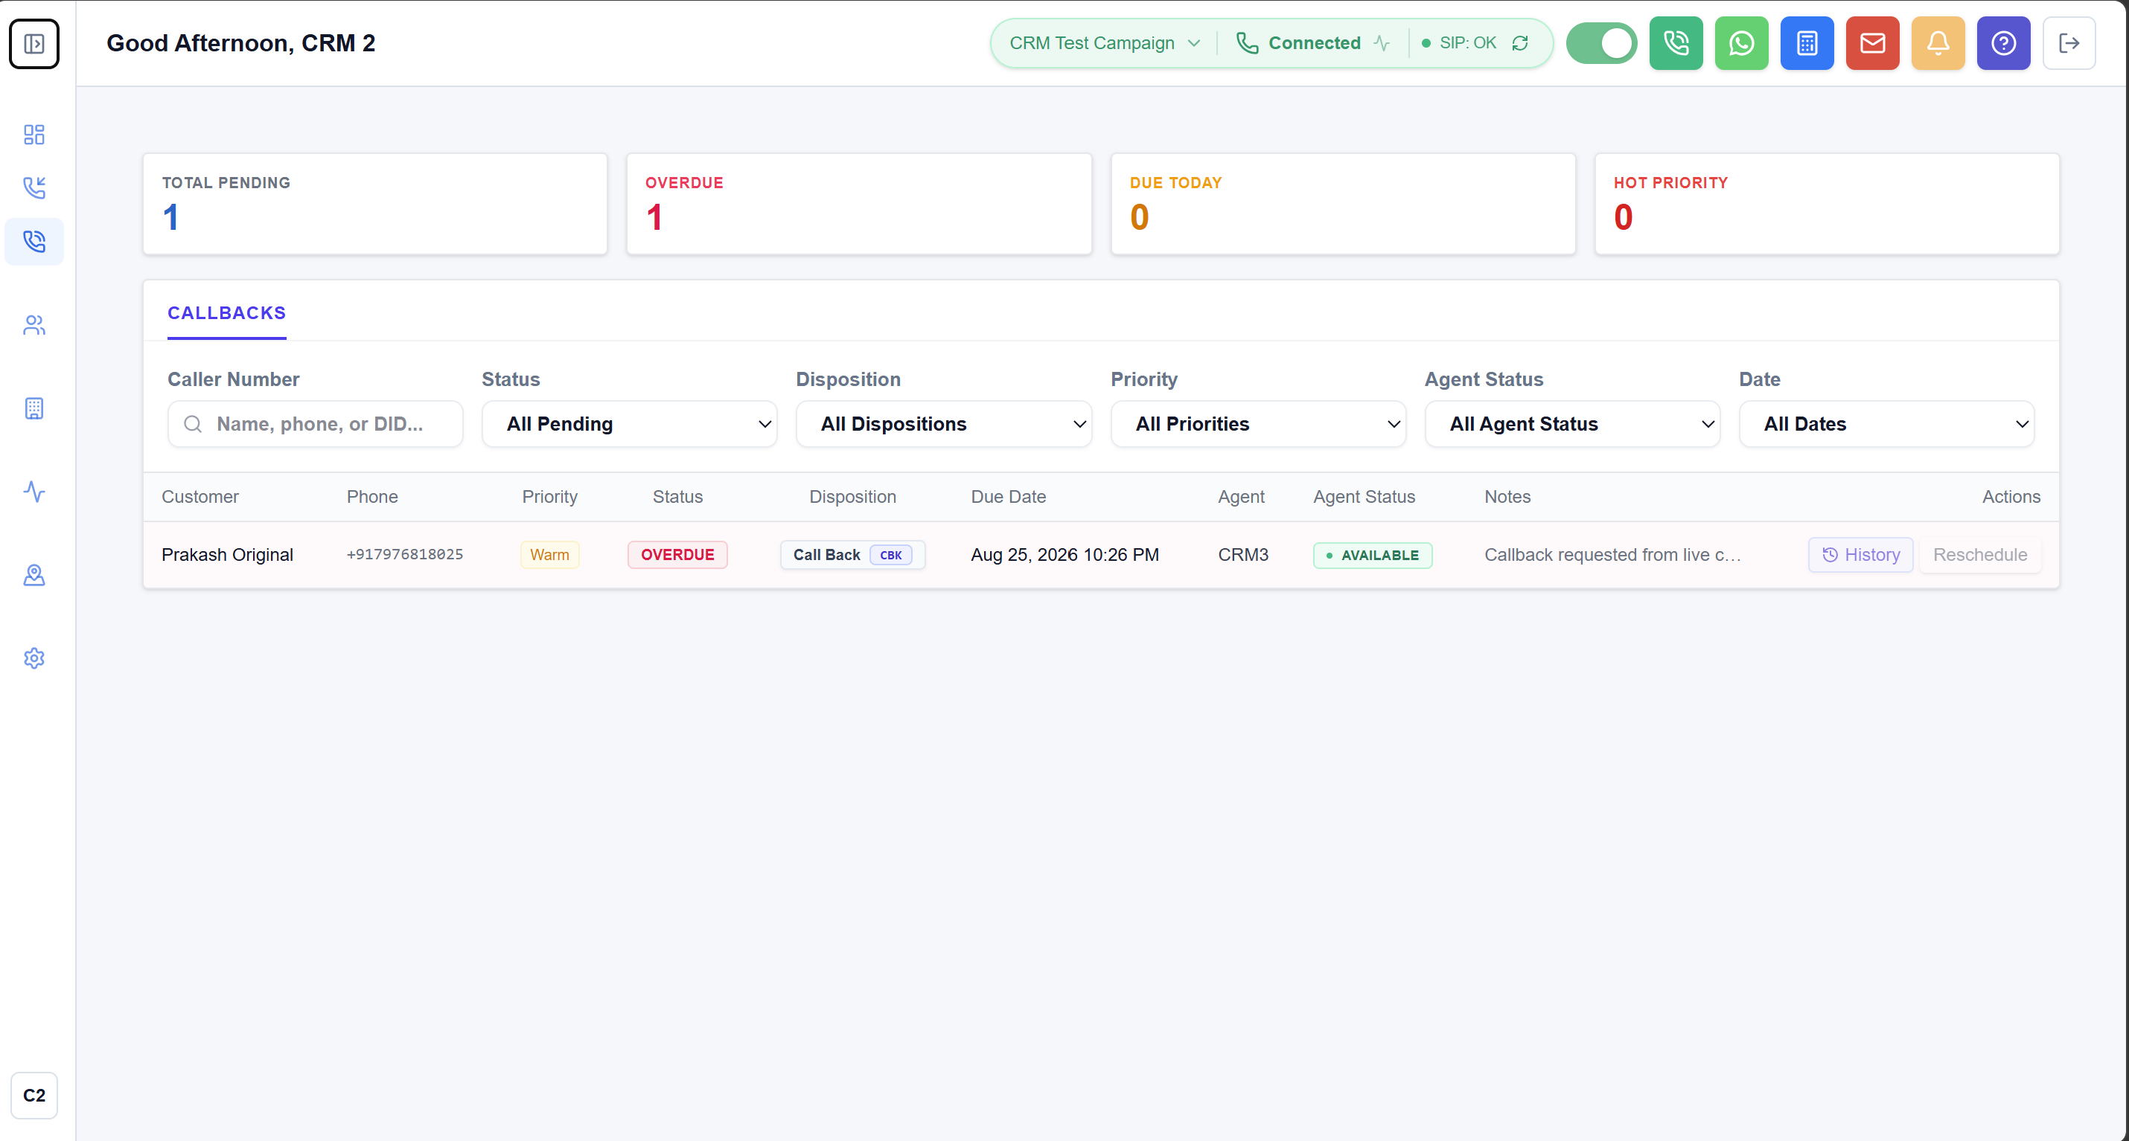
Figure 5: Scheduled Callbacks Queue showing pending, completed, and overdue follow-ups with instant softphone dialing triggers.
How the Feature Works in Daily Operations
- Smart Countdown Badges: Callbacks are automatically organized by scheduled date and time. Clear badges highlight whether a callback is Upcoming, Due Now, or Overdue.
- One-Click Softphone Dialing: Telecallers click the call icon directly in the callback row to immediately dial the prospective buyer through their browser headset without having to copy-paste numbers.
- Callback Reassignment Modal: If an agent is on leave, absent, or overwhelmed with site visits, team leaders can select pending callbacks and reassign them to available floor telecallers with full context.
- Contextual Follow-up Notes: Hovering over or clicking a callback immediately reveals the customer's budget, preferred unit size, and notes from prior calls, allowing the agent to open the conversation with complete context.
3.6 Inbound Missed Call Recovery & SLA Enforcement
Every missed inbound call represents a high-intent buyer who saw a property advertisement and took the initiative to call. If left uncontacted, these leads quickly contact competing developers. The Missed Calls Recovery console acts as a safety net, capturing all dropped or unhandled calls and enforcing strict recovery workflows.
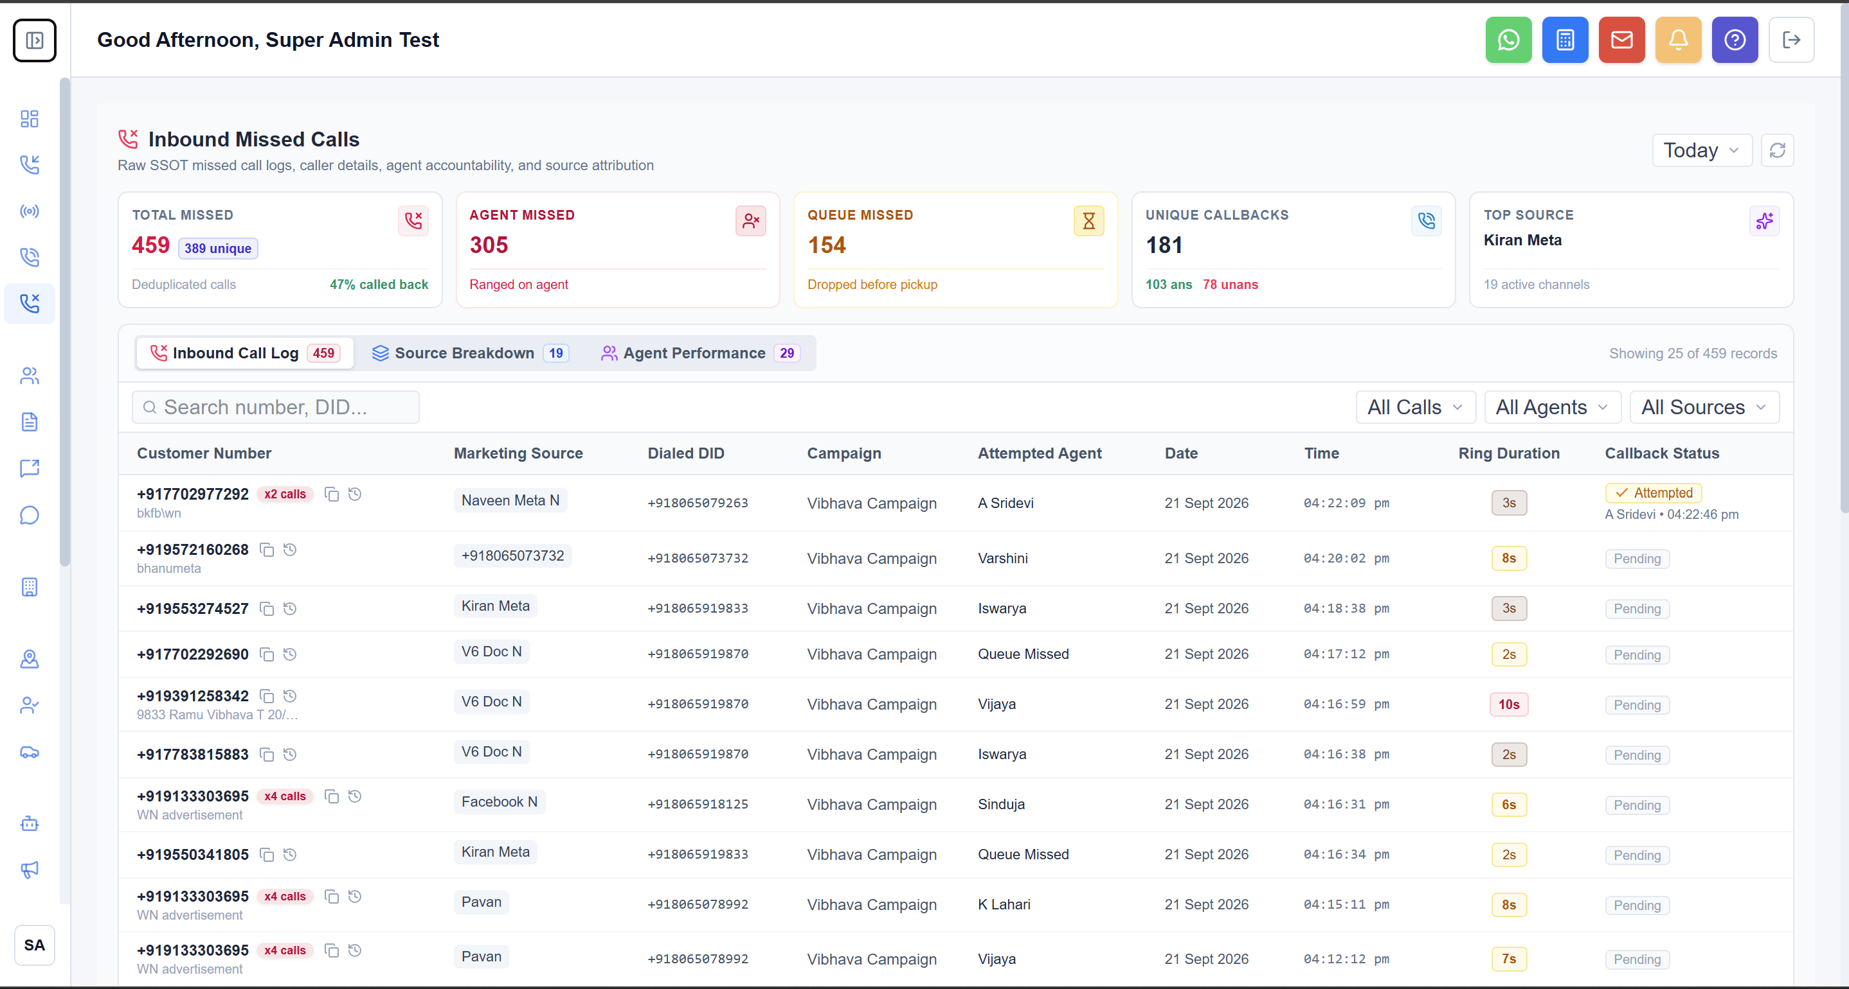
Figure 6: Missed Calls Recovery Console tracking dropped calls, campaign origins, delay timers, and redial status.
How the Feature Works in Daily Operations
- Instant Missed Ingestion: Logs the caller's phone number, the exact marketing DID dialed, and the precise timestamp the call dropped.
- SLA Delay Tracking: Displays a live timer showing how much time has passed since the call was missed (e.g., 'Missed 12 minutes ago'), prioritizing the oldest uncontacted prospects.
- One-Click Recovery Action: Telecallers click 'Redial' to initiate an immediate callback through the softphone. Once connected, the record automatically updates to 'Recovered'.
- Recovery Performance Analytics: Supervisors track the overall Missed Recovery Rate (e.g., '56% called back today'), ensuring marketing dollars are not squandered on unaddressed callers.
3.7 Interactive 2D Plot Inventory & Layout Plan Workspace
The Plot Management Workspace revolutionizes real estate inventory administration by replacing error-prone spreadsheets with an interactive, visual 2D layout map. Sales executives and management can inspect plot dimensions, check real-time availability, calculate pricing, and lock reservations instantly.
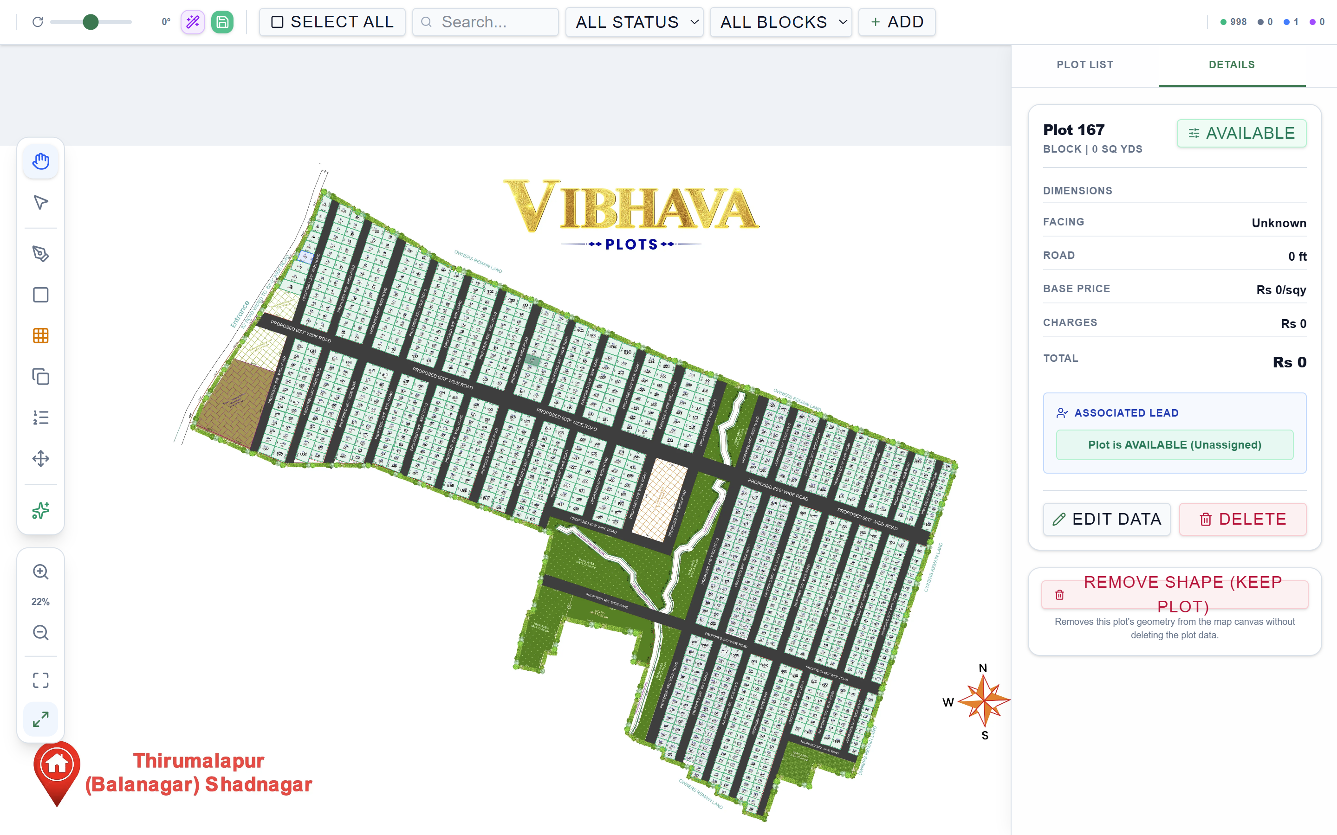
Figure 7: Interactive 2D Plot Inventory Layout Workspace displaying real-time unit statuses, pricing calculator, and buyer lead assignment.
How the Feature Works in Daily Operations
- Visual Status Grid & Map: Every plot on the project layout is color-coded by its live status: Green (Available), Blue (Reserved for a client), Slate (Sold), Purple (Bank Mortgage), and Amber (Blocked).
- Dynamic Financial Calculator: Selecting any plot displays its exact dimensions (e.g., 30x40, 40x60), facing direction (East, West, North, South), base price per sq.yd, and developmental charges, automatically calculating the gross total investment.
- Direct Customer Lead Linking: Executives link a reserved plot directly to an active CRM customer lead profile, displaying the buyer's name, phone number, budget, and assigned sales executive in the side panel.
- Multi-Select Bulk Operations: Supervisors can select multiple plots at once to execute bulk status updates (e.g., releasing a block of plots from Mortgage to Available).
- Full-Screen Blueprint Mode: A single click opens the high-resolution architectural layout plan in a full-screen presentation mode, ideal for showcasing the property to clients in person or over video walkthroughs.
- Strict Role-Based Security: To prevent accidental cancellations or inventory tampering, only authorized Super Administrators can edit plot dimensions, modify base pricing, or delete plots.
3.8 Site Visit Logistics & Driver/Vehicle Dispatch Console
In physical real estate, an on-ground site inspection is the most critical milestone preceding a purchase. The Site Visit Logistics module coordinates the physical movement of prospective buyers, company vehicles, professional drivers, and on-site sales executives.
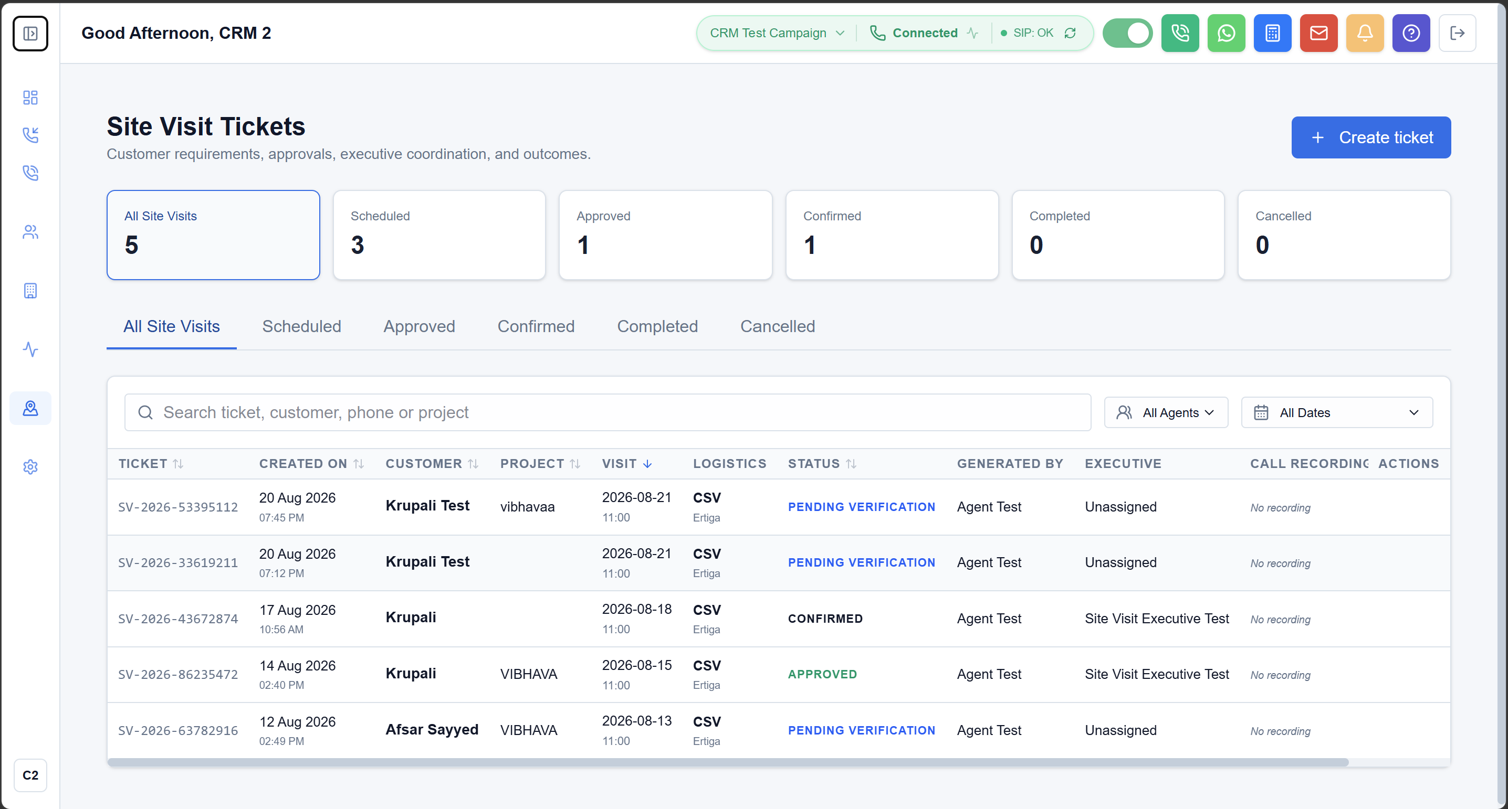
Figure 8: Site Visit Dispatch Dashboard tracking scheduled client inspections, vehicle/cab allocations, and assigned sales executives.
How the Feature Works in Daily Operations
- Travel Arrangement Classification: Captures whether the buyer is traveling independently ('Self Visit') or requires company transportation ('Company Transport / Pickup Required').
- Chauffeur Fleet Dispatching: For company transport, dispatchers assign vehicles from the corporate fleet (e.g., Maruti Ertiga, Toyota Innova) and verified company drivers, logging driver phone numbers and scheduled pickup locations.
- Sales Executive Allocation: The system automatically assigns an on-ground sales executive via round-robin to meet the buyer at the project gate, ensure a guided site tour, and answer technical property queries.
- Visit Lifecycle Progression: The ticket progresses through clear operational milestones: Scheduled -> Driver Dispatched -> Customer Picked Up -> Arrived on Site -> Inspection Completed -> Feedback & Booking Outcome Recorded.
3.9 Dual-Channel Call Recording Playback & Dialogue Timeline
The Call Evaluation console provides complete transparency into customer dialogues. Quality assurance (QA) evaluators, team leaders, and managers can listen to high-fidelity audio recordings streamed securely from cloud storage while following a synchronized, speaker-separated text transcript.
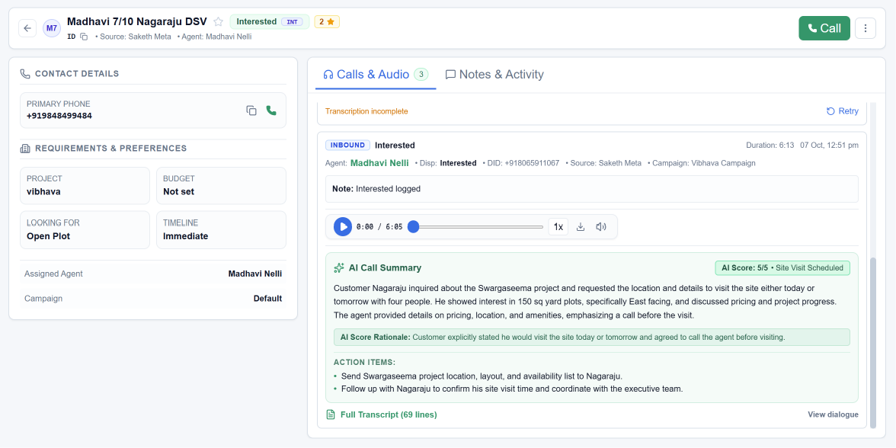
Figure 9: Dual-channel call audio playback with seekable waveform and synchronized speaker-separated dialogue timeline.
How the Feature Works in Daily Operations
- Interactive Audio Player: A unified web audio player featuring visual waveform seekbars, 10-second skip forward/backward buttons, variable playback speeds (1x, 1.25x, 1.5x, 2x), and volume controls.
- Speaker-Separated Transcript: The conversation is diarized into distinct speaking turns, clearly labeling 'Agent' dialogue versus 'Customer' dialogue with exact minute-and-second timestamps.
- Keyword Dialogue Search: Evaluators can type keywords (e.g., 'price', 'discount', 'loan', 'location') to instantly jump to the exact moment in the dialogue where the topic was discussed.
- Call Telephony Metadata: Displays the complete operational metadata of the call: calling agent name, customer mobile number, dialed marketing campaign, virtual DID, and call duration.
3.10 Gemini AI Conversational Intelligence & Buying Intent Scoring
Reviewing dozens of 15-minute phone calls manually is impossible for busy sales managers. The platform leverages Google Gemini AI to automatically analyze completed conversations and extract high-level sales intelligence in seconds.
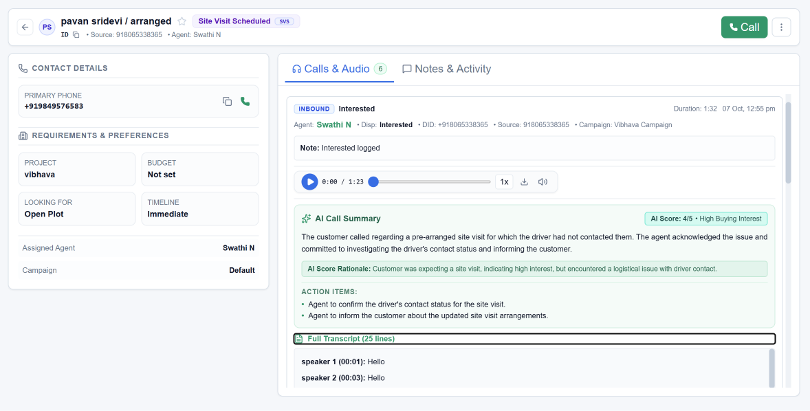
Figure 10: AI Conversational Intelligence Card displaying executive summary, 0-5 buying intent score, sentiment, and action items.
How the Feature Works in Daily Operations
- AI Executive Brief: Generates a clear 2-3 sentence narrative summarizing the client's interests, preferred unit size, budget, and agreed next steps.
- Buying Intent Score (0 to 5): Assigns an objective buying intent score from 0 to 5 (5=Site visit confirmed / Ready to book, 4=High interest in pricing, 3=Qualified conversation, 2=Casual inquiry, 1=Low interest, 0=Not interested / Wrong number).
- AI Score Justification: Provides a 1-sentence justification explaining the assigned score based on the buyer's explicit statements (e.g., 'Customer confirmed site visit for Sunday morning').
- Sentiment Classification: Evaluates the customer's emotional disposition: Positive, Neutral, Hesitant, or Negative, allowing managers to identify prospects requiring senior executive reassurance.
- Automated Action Items Checklist: Automatically detects commitments made during the call and outputs an actionable checklist for the telecaller (e.g., 'Send project brochure on WhatsApp', 'Verify bank loan eligibility').
3.11 Agent Performance Overview & Operational Floor Diagnostics
The Agent Performance Overview is the premier operational command dashboard for contact center leadership. It unifies daily call traffic, floor availability, telecaller productivity, and queue drop diagnostics into an all-in-one executive view.
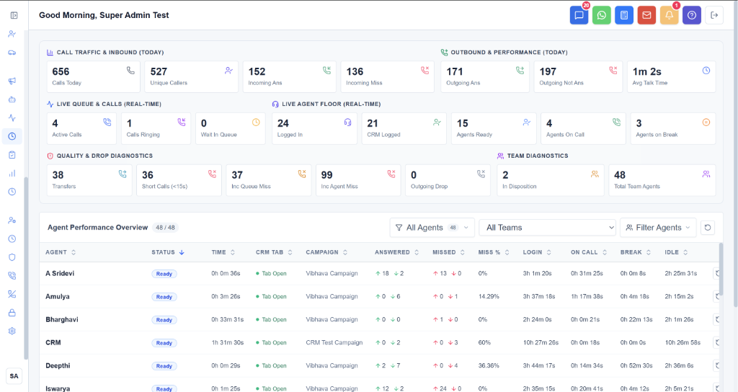
Figure 11: Agent Performance Overview displaying comprehensive KPI diagnostic strips and granular agent-by-agent activity metrics.
How the Feature Works in Daily Operations
- Executive Diagnostic Ribbon: The top diagnostic ribbon provides six specialized KPI strips: Call Traffic & Inbound (Calls Today, Unique Callers, Incoming Answered/Missed), Outbound & Performance (Outgoing Answered/Unanswered, Average Talk Time), Live Queue (Active Calls, Ringing Calls, Queue Waiting), Live Agent Floor (Logged In, CRM Logged, Ready, On Call, Break), Quality Diagnostics (Transfers, Short Calls <15s, Inbound Queue/Agent Misses), and Team Diagnostics (Agents in Disposition, Total Team Size).
- Granular Agent Activity Table: The comprehensive table lists every telecaller on the floor with their live status, time in status, CRM tab activity, assigned campaign, answered inbound/outbound calls, missed calls, miss percentage, total login hours, total talk time, break duration, and idle time.
- Dynamic Team & Agent Filtering: Leadership can filter the entire floor by specific Teams or individual Agents, allowing team leaders to evaluate their exact squad while general managers monitor company-wide operations.
- Productivity Benchmarking: By comparing 'On Call' talk time against 'Idle Time' and 'Break Time', managers can objectively identify top performers and address underutilized capacity.
3.12 Digital Marketing Analytics & Inbound Marketing Conversion Pipeline
The Digital Marketing Analytics console provides a bird's-eye view of closed-loop telephony response, tracing marketing inquiries from raw advertising clicks all the way to on-ground site visits and final plot closures.
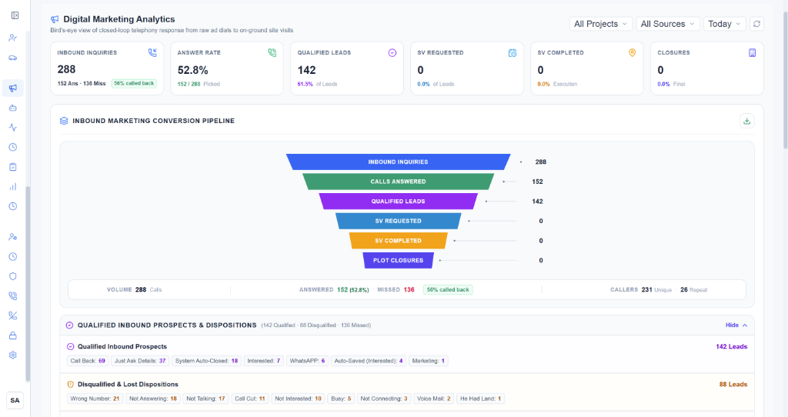
Figure 12: Digital Marketing Analytics dashboard featuring executive KPI cards, 6-stage conversion pipeline, and disposition breakdown.
How the Feature Works in Daily Operations
- Top-Level Marketing KPIs: Prominently displays Inbound Inquiries (with answered/missed split and callback percentage), Answer Rate (percentage of calls picked up by agents), Qualified Leads count and qualification rate, Site Visits Requested, Site Visits Completed, and Final Plot Closures.
- Inbound Marketing Conversion Pipeline: A multi-stage visual funnel mapping lead drop-off: Inbound Inquiries (288) -> Calls Answered (152 / 52.8%) -> Qualified Leads (142 / 61.5%) -> Site Visits Requested -> Site Visits Completed -> Plot Closures. Call volume and unique vs repeat caller counts are reported at each step.
- Qualified Inbound Prospects Breakdown: Categorizes all qualified leads into specific engagement buckets: Call Back, Just Ask Details, Interested, WhatsApp, Auto-Saved (Interested), and Marketing.
- Disqualified & Lost Dispositions Analysis: Provides complete transparency into why leads dropped off: Wrong Number, Not Answering, Not Talking, Call Cut, Not Interested, Busy, Not Connecting, Voice Mail, or Customer Already Owned Land.
3.13 Marketing Source & Virtual DID Attribution Performance
To maximize marketing ROI, marketing directors need to know exactly which creative campaigns produce actual property buyers. The Marketing Source & DID Performance table connects every advertising channel to its dedicated virtual telephone number, tracking closed-loop sales performance.
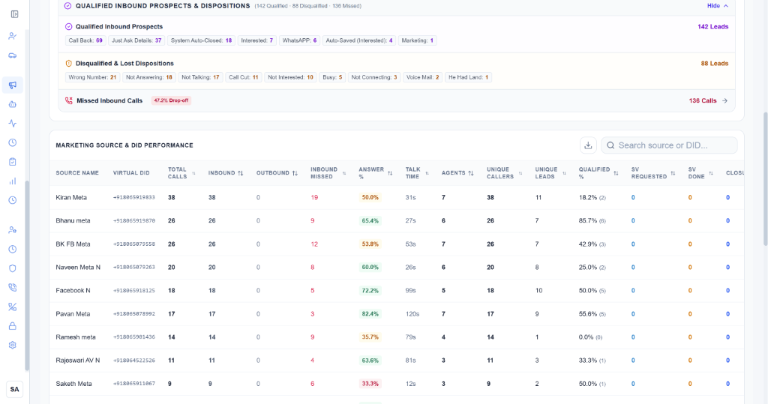
Figure 13: Granular marketing attribution table tracking call volume, answer rates, talk time, and site visits by campaign DID.
How the Feature Works in Daily Operations
- Campaign-to-DID Mapping: Each digital ad campaign (e.g., Kiran Meta, Bhanu meta, BK FB Meta, Naveen Meta N, Facebook N, Pavan Meta, Ramesh meta) is mapped to its dedicated Virtual DID phone number (e.g., +918065919833).
- Telephony Volume & Connection Metrics: Tracks total calls, inbound calls, outbound prospecting dials, missed calls, answer rate percentage, and average talk time per campaign.
- Lead Quality & Uniqueness: Reports the number of unique callers, unique CRM leads generated, and the percentage of callers who met qualification criteria.
- Closed-Loop Sales Attainment: Traces campaign leads through on-ground outcomes: Site Visits Requested, Site Visits Done, and Final Plot Closures.
- Search & Multi-Sheet Excel Export: Marketing executives can search by source name or phone number and export the complete attribution dataset to Excel for executive board presentations.
3.14 Blocked Numbers & Blacklist Security Management
High-volume advertising campaigns frequently attract nuisance callers, spam robocalls, fraudulent telemarketers, and abusive individuals. If left unchecked, these callers tie up valuable agent lines, distort marketing conversion analytics, and frustrate sales teams. The Blocked Numbers module provides enterprise telecom security and caller blacklisting.
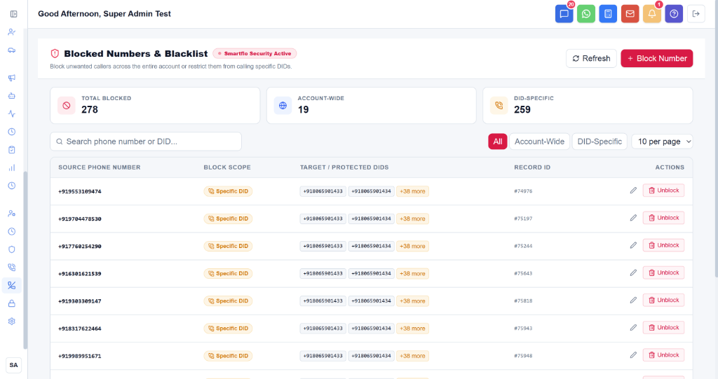
Figure 14: Blocked Numbers and Blacklist security dashboard managing account-wide and DID-specific caller restrictions.
How the Feature Works in Daily Operations
- Blacklist KPI Overview: The top security strip reports Total Blocked Numbers (e.g., 278), Account-Wide Blocks (19), and DID-Specific Blocks (259).
- Dual-Scope Blocking Policy: Administrators choose between two blocking scopes: 'Account-Wide' (completely blocks the caller from reaching any virtual number in the entire enterprise) or 'Specific DID' (restricts the caller from dialing specific marketing campaign numbers while preserving access to other lines).
- One-Click Block Creation: Clicking '+ Block Number' opens a secure modal where administrators enter the target phone number, select the blocking scope, assign protected DIDs, and record a mandatory justification note.
- Search & Immediate Unblock Control: Provides real-time search across phone numbers, DIDs, and record IDs, with an instant 'Unblock' action to safely restore legitimate callers if a number was flagged in error.
3.15 Agent Hourly Call Traffic & Productivity Heatmap
Customer calling patterns vary dramatically throughout the business day. The Hourly Source Report acts as a productivity heatmap, breaking down call volume, answer rates, and site visits across each hour from 9:00 AM to 8:00 PM.
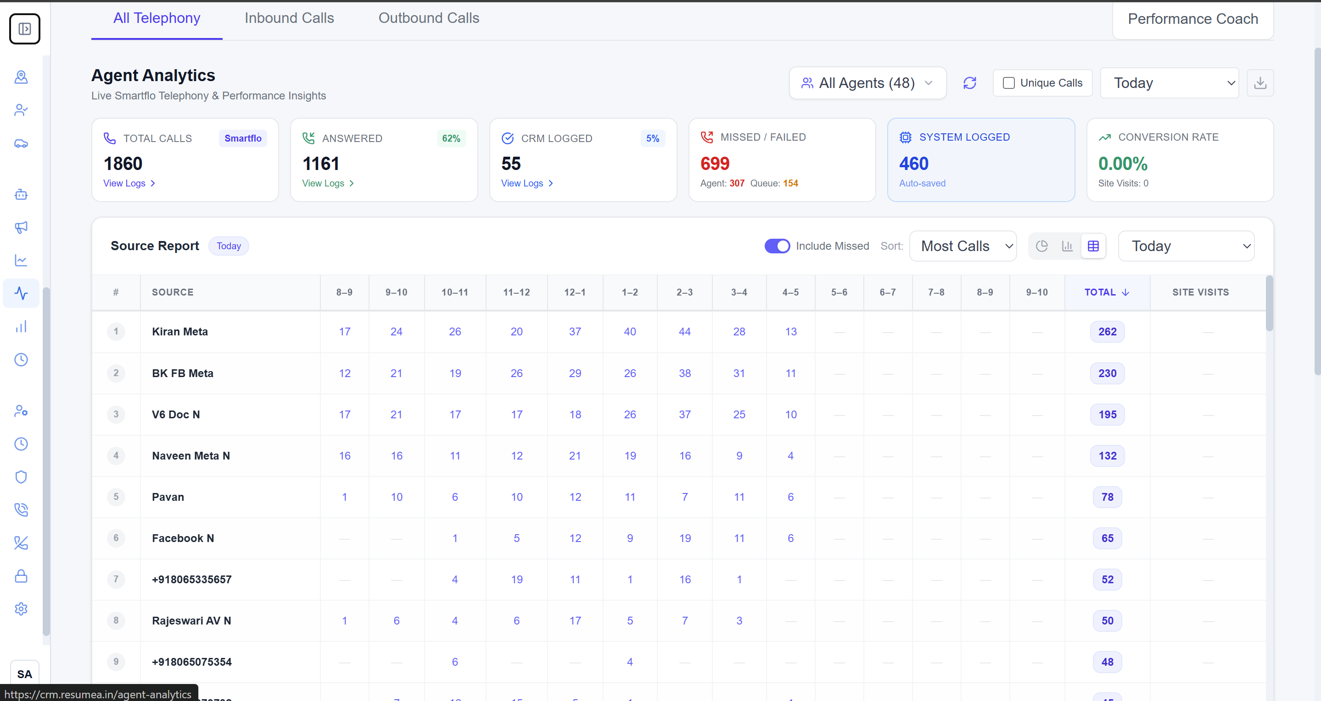
Figure 15: Hourly Source Report displaying call distribution, answered ratios, and site visits across the operational day.
How the Feature Works in Daily Operations
- Traffic Heatmap Visualization: Organizes call volume into hourly columns, showing peak inquiry windows (e.g., 11:00 AM - 1:00 PM and 5:00 PM - 7:00 PM) where marketing interest is highest.
- Staffing Optimization: Pinpoints specific hours where missed calls spike, guiding supervisors to stagger lunch breaks and avoid understaffed queues during prime customer calling periods.
- Conversion Timing Intelligence: Reveals which hours of the day generate the highest site visit conversion rates, allowing teams to schedule outbound follow-up calls during peak receptivity windows.
4. User Roles & Operational Responsibility Matrix
Enterprise real estate brokerages rely on distinct specialized teams. The CRM enforces role-based access to ensure that employees see the exact tools and data necessary for their daily responsibilities while safeguarding sensitive financial and customer records.
User Role | Primary System Workspace | Operational Responsibilities & Daily Functions
Super Administrator | System Administration & Settings | Full system configuration, user provisioning, plot pricing overrides, blacklist management, and executive audit logging.
General Manager & Director | Digital Marketing & Global Analytics | High-level KPI oversight, marketing ROI evaluation, sales pipeline velocity tracking, and budget re-allocation.
Team Leader & Floor Manager | Agent Performance & Live Calls | Real-time floor supervision, live call monitoring, callback reassignment, QA transcription evaluation, and coaching.
Sales Executive / Telecaller | Live Call Workspace & Callbacks | Inbound call answering, outbound prospecting, customer requirement qualification, callback execution, and site visit booking.
Site Visit Executive | Site Visits & Plot Management | Meeting prospective buyers at the project site, conducting physical property walkthroughs, and assisting with plot selection.
Transport Coordinator & Driver | Site Visit Dispatch & Fleet | Chauffeur vehicle assignment (Ertiga/Innova), customer pickup/drop coordination, and transit status updates.
5. Operational Best Practices & Contact Center Playbook
To achieve maximum sales efficiency and lead conversion, sales and telecalling teams must adhere to the following operational guidelines:
5.1 Inbound Call Answering Discipline
- 3-Ring Standard: Every telecaller in 'Ready' status must maintain their browser tab active and headset connected. Incoming calls must be answered within 3 rings (< 10 seconds).
- Post-Call Wrap-up SLA: When a call concludes, the agent must submit the customer profile and disposition within 60 seconds, ensuring prompt return to the ready queue.
- In-Call Disconnection Prohibition: Agents must never initiate breaks or disconnect sessions while a call is ringing or active.
5.2 Follow-Up Call & Missed Recovery Cadence
- 15-Minute Missed Recovery SLA: Missed inbound calls must be redialed within 15 minutes of dropping. Prompt redials increase connection rates by over 400% compared to delayed attempts.
- Punctual Callbacks: Promised customer callbacks must be executed within 10 minutes of the scheduled time. Overdue callbacks trigger alerts to team leaders.
5.3 Site Visit Coordination & Transport Standards
- Advance Fleet Booking: Company transportation must be booked at least 4 hours in advance. Chauffeur vehicles must arrive at the customer pickup location 10 minutes prior to the scheduled time.
- Pre-Arrival Preparation: Site visit executives must contact the buyer while in transit to confirm gate arrival and prepare relevant project brochures and plot layout maps.
5.4 Plot Reservation Integrity
- Mandatory Lead Linkage: Plots can only be marked as 'Reserved' when an active buyer lead is explicitly linked. Generic or speculative reservations without customer names are prohibited.
- 48-Hour Token Window: Reserved plots remain locked for a maximum of 48 hours. If the advance booking token is not verified within this window, the plot must be released back to 'Available' status.

