Web Design Preferences of Germany and German-Speaking Switzerland

|  |
| --- |
| **Maria Dahman**  DePaul University  1 E. Jackson Blvd., Chicago, IL 60604  maria.dahman@gmail.com |

# ABSTRACT

Web design preferences of Germans and Swiss Germans are notably different, despite a common language and similar scores on Hofstede’s five cultural dimensions [12]. In this paper, the web design preferences are highlighted by examining three types of comparable websites in Germany and Switzerland: Airlines, Government and Professional Design Organizations. The nine-point difference between Germany and German-speaking Switzerland in Power Distance manifests in the display of experts on the German sites. The nine-point difference in Uncertainty Avoidance manifests as more traditional interactions on German sites, as well as help-text that is more explicit. The effects of the 20th Century Design movement of the Bauhaus in Germany are evident in the use of color on German web sites and the utilitarian, craft-like feel of the designs, and the effects of the International Typographic Style in Switzerland are evident in the modular, grid layout and the abandonment of the “page-as-frame” concept on the Swiss websites.

Keywords: Languages, Design, Web Design.

# INTRODUCTION

German and Swiss German culture is both similar and strikingly different. The regions are geographically close [see Figure 1], and share the same written language. Most notably, German-speaking Switzerland’s scores in Hofstede’s five cultural dimensions are closer to Germany’s scores than to French-speaking Switzerland’s scores [See Figure 2]. [1] Yet the web design preferences of the two nations are notably different.

While their cultural dimension scores are similar, there is a nine-point difference between Germany and German-speaking Switzerland in Power Distance and Uncertainty Avoidance. I will note how Power Distance and Uncertainty Avoidance manifest in web design preferences by comparing three categories of websites from Germany and Switzerland: (1) the nations’ two major airlines, Air Berlin and SWISS (formerly Swissair), (2) government websites, and (3) the professional design organizations of the German Design Council and the Swiss Design Association.

To further examine the aesthetic differences, I will review the 20th century design movements of Germany and Switzerland, namely the Staatliche Bauhaus Movement and the International Typographic Style.

Finally, to summarize the preferences, I have created wireframes for two fictional user experience professionals, one from Germany and one from Switzerland. These wireframes, as well as notes on the wireframes, appear in Appendix C.

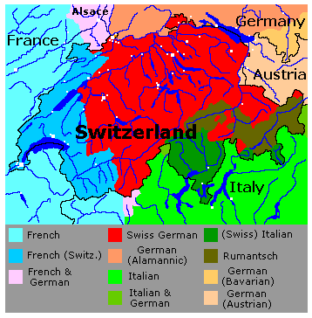

**Figure 1. Swiss German (in red) is the largest population in Switzerland.**

## CULTURAL DIMENSIONS

20% of Switzerland is composed of immigrants [19]. According to polling done in the 1990s, Germans are the least-liked European immigrant group in Switzerland [10, 11].

Differences in communication styles, as well as a nine-point difference in Power Distance and Uncertainty Avoidance, reflect subtle but powerful differences between Germany and Switzerland.

**Figure 2. Cultural Dimension Scores for Germany, German-speaking Switzerland and French-speaking Switzerland.**



While such a large percent of immigrants would seem to indicate a general tolerance or acceptance of foreigners, the fact that German immigrants are highly educated and are taking management, banking and university positions in Switzerland makes them less popular with the Swiss [9, 11]. By contrast, consider that most immigrant groups enter into a population doing low-skill work.

As an ad for an “integration course” starts: “Germans often wonder why they are considered arrogant in Switzerland, when they say all they want to do is to express themselves clearly” [10].

The direct communication style of the Germans, particularly of German managers and professors, makes them seem arrogant, abrupt and too direct to the Swiss [10]. This is typical of a “low context” culture, where being explicit makes it unnecessary to make inferences [13]. This attribute is also related to Germany’s high Uncertainty Avoidance score: being as explicit and direct as possible is a mechanism for avoiding ambiguity.

The Swiss, having a very low Power Distance Index score, are accustomed to listening and being heard. In Germany, there is a strong reliance on expertise [12], and “experts” feel they should not have to listen to other people’s opinions. If the German manager knows what the problem is, he will tell his subordinate what he did wrong and how to fix it. This is not the approach of the Swiss; rather, people’s opinions are heard, regardless of their position [10].

Finally, with recent language reforms, phrases such as “could you,” and “may I please ask you” were outdated in Germany, but these more indirect phrases are still common in Switzerland [10]. The more direct “you must” is common in German, and is a mark of a Power Distance that is higher than Switzerland.

## 20th CENTURY DESIGN MOVEMENTS OF GERMANY AND SWITZERLAND

The International Typographic Style (also called simply “Swiss Style”) was developed in the 1950s in Switzerland, and emphasizes cleanliness, readability and objectivity [14]. As Ellen Lupton put it, “rejecting the artistic clichés of self-expression and raw intuition, the artists of this style aspired to…a cool and fascinating beauty.” [15]. By introducing the grid, the Swiss Style got rid of the idea of the “page as a frame.” A traditionally designed page would have important information at the top and large, and the visual hierarchy would proceed from there. But with a page broken up into a grid, there were any number of areas that could be the most important; also, with the grid there is a suggestion that the “page” goes on to a wider area. In Swiss Style, shapes can be cropped to fit the grid, and can be of unusual proportion [15].

Instead of a focus on clarity and objectivity, the Staatliche Bauhaus (also called simply “Bauhaus”) movement from 1919-1933 in Germany, sought to unify art, craft and technology [2]. Artists were “a guild of craftsmen” [3].This reflects a pragmatic approach to integrating theory and practice, and the school of design upon which the Bauhaus movement was founded, was unique in requiring a solid understanding of design principles and elements, as well as color theory. Color experimentation is a theme among the painters associated with the Bauhaus, notably Wassily Kandinsky and Paul Klee [3].

## WEB DESIGN MANIFESTATIONS OF GERMAN AND SWISS CULTURAL DIMENSIONS AND DESIGN MOVEMENTS

**Overview**

In Appendix A, Figures 3, 4 and 5 show a German airline [Figure 3], a German government site [Figure 4], and a German design professional organization [Figure 5]. The next set of figures, in Appendix B, show a Swiss airline [Figure 6], a Swiss government site [Figure 7] and a Swiss design professional organization [Figure 8].

Generally, the Swiss sites might be described as “simpler,” or more open. There are fewer elements, no tabs, and the sites are much shorter, i.e., do not use vertical scrolling. The Swiss sites also have a much more strategic use of color, allowing large portions of the sites to be grayscale. By contrast, the German sites are very colorful.

The absence of people is noticeable on the Swiss sites. The single person that is on any of the Swiss sites is a little girl on the airline site who is presumably to be a passenger [Figure 6]. This strongly contrasts with the German sites, which have many images of people, most of whom seem to have authority or inside knowledge, such as design professionals who are in the midst of a lecture [Figure 5], or a flight attendant [Figure 3]. Many of the people in the German government site are in business suits [Figure 4].

Finally, the German sites can be described as more traditional webpages. All of the German sites read from top to bottom only, using a vertical scroll, while two of the three Swiss sites employ horizontal scroll (the third, the Swiss airline site, does not use any scrolling). The German sites use tabs and traditional interaction designs, such as accordions and navigation bars.

*Cultural Dimensions: Power Distance*

As mentioned previously, Germany scores nine points higher on Power Distance than Switzerland. A Power Distance manifestation seen on the German sites that is absent from the Swiss sites is an appeal to authority through the use of images of knowing-looking people and videos of experts. On the German Design Council site [Figures 5], many of the images on the large slider are of designers giving lectures. As the reader scrolls down the page further, there are more videos of lectures and talks. The viewer is given ample opportunity to watch videos of knowing people speaking about their field.

The German government site uses images of people in business suits, another indication of Power Distance.

By contrast, a personified presence of authority is absent from the Swiss sites. The image of the young girl on the airline site [Figure 6] is meant to relay the idea of the reliability and the safety of the airline. No one on any of the Swiss sites is a person that one would look to for guidance or information.

*Cultural Dimensions: Uncertainty Avoidance*

On the German sites, traditional interactions, such as downward scrolling, tabs and dropdown menus are all indicative of a higher Uncertainty Avoidance score.

By looking at the German sites, one gets the impression that Germans are very measured with their mouse-clicks, and want to see all of the information in front of them before they make a decision. This is also a manifestation of a higher Uncertainty Avoidance.

Finally, and related to measured-mouse-clicks, the German sites will offer reassurances such as “clicking this will open the video in a new window.” Again, this is associated with a desire to reduce ambiguity as much as possible, characteristic of high Uncertainty Avoidance.

By contrast, the Swiss sites use innovative interactions, such as a horizontal scroll, and the arrow of the scroll changes shape as you hover. The images and pages themselves are also less traditional. For example, the government site uses cartoon representations of people and blurred edges on the elements to the right of the page to indicate that the user can continue scrolling to the right [Figure 7].

*Design Movements*

The German sites’ use of colors is an obvious relationship to the Bauhaus movement. However, a more subtle relationship might be found in the fact that these sites also display a very solid craftsmanship. The merging of art and craft was the major theme of the Bauhaus, and these sites certainly follow a craft-like formula.

The strong modules and grids and unusual cropping and sizing of the Swiss websites relate them directly to the International Typographic Style.

# Conclusion

While the cultural dimension scores for Germany and German-speaking Switzerland are similar, the aesthetic preferences indicate the influence of different art movements and attitudes. Germany’s web design preferences draw from the Bauhaus movement, particularly in the use of color, and Switzerland sites draw on the International Typographic Style and its use of grids and ignoring the page as the “frame.” The nine-point differences in Power Distance and Uncertainty Avoidance also create different web design preferences. Germany’s higher Uncertainty Avoidance score can be seen in its reliance on more traditional web interactions, and its higher Power Distance score can be seen in the number of personified “experts” visible on its webpages.

The culmination of these findings is presented in wireframes for two fictional user experience professionals, one from Switzerland and one from Germany. These wireframes are in Appendix C.

# REFERENCES

1. Airberlin. <http://www.airberlin.com>.
2. Bauhaus. <http://en.wikipedia.org/wiki/Bauhaus>.
3. Bauhaus: 90 Years of Inspiration. <http://www.smashingmagazine.com/2009/08/02/bauhaus-ninety-years-of-inspiration/>.
4. Ch.ch. https://www.ch.ch.
5. Deutschland.de. https://deutschland.de.
6. Four Differences Between German and American Design Methods. <http://www.gnizak.com/blog/4-differences-between-german-and-american-design-methods/>.
7. Georgi, W. *Italian Design is Coming Home to Switzerland.* Polyedra AG, 2011.
8. German Design Council. http://www.german-design-council.de.
9. Germans Experience a Tide of Xenophobia. <http://www.swissinfo.ch/eng/swiss_news/Germans_experience_tide_of_xenophobia.html?cid=8292198>.
10. Germans Struggle to Tune into the Swiss Wavelength. <http://www.swissinfo.ch/eng/swiss_news/Germans_struggle_to_tune_into_Swiss_wavelength.html?cid=31302372>.
11. Helbling, M. Why Swiss Germans dislike Germans: Opposition to culturally similar and highly skilled immigrants. *European Societies* *13*, 1 (2011), 5-27.
12. The Hofstede Center. <http://geert-hofstede.com/germany.html>.
13. Hofstede, G., Hofstede, G.J., and Minkov, M. *Cultures and Organizations: Software of the Mind, 3rd ed.* McGraw-Hill, New York, 2010.
14. International Typographic Style. <http://en.wikipedia.org/wiki/International_Typographic_Style>.
15. Lupton, E. *Thinking with Type, Second, Revised and Expanded Edition.* Princeton Architectural Press, 2010.
16. Schumacher, R. *The Handbook of Global User Research.* Elsevier Inc., 2010.
17. SWISS. <http://www.swiss.com>.
18. Swiss Design Association. <http://www.swiss-design-association.ch>.
19. Swiss People, Mentality and Demography. <http://official-swiss-national-languages.all-about-switzerland.info/swiss-people-mentality.html>.

**APPENDIX A: GERMAN WEB PAGES**

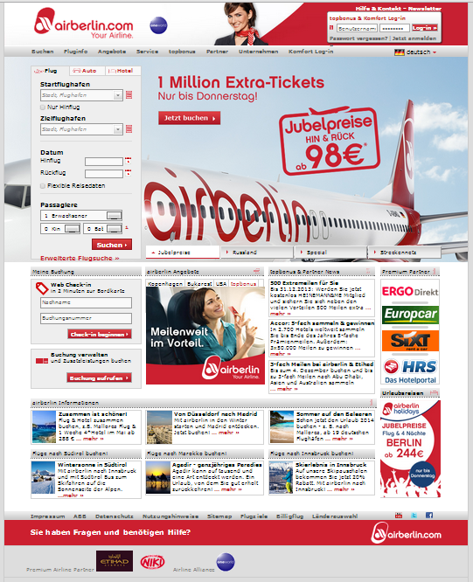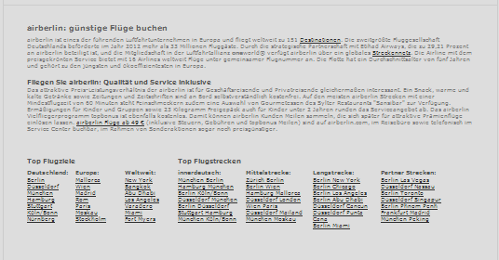

**Figure 3. airberlin.com (German airline example).**

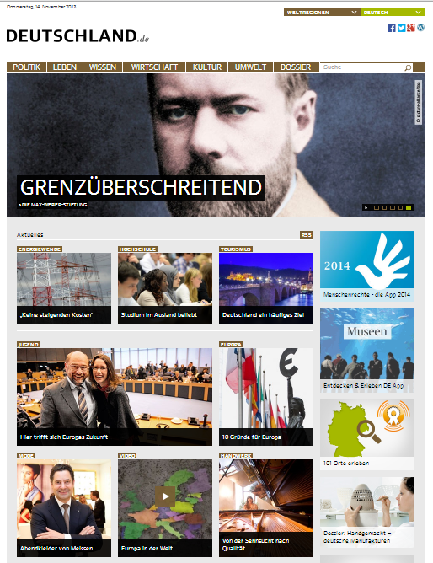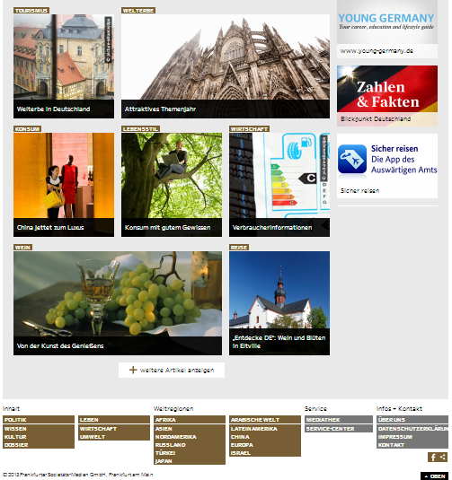

**Figure 4. deutscheland.de (German government example).**

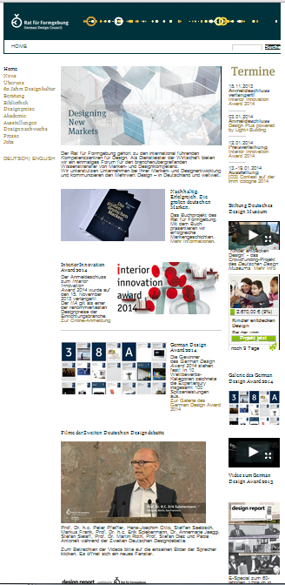

**Figure 5. german-design-council.de (German design professional organization example).**

**APPENDIX B: SWISS WEB PAGES**

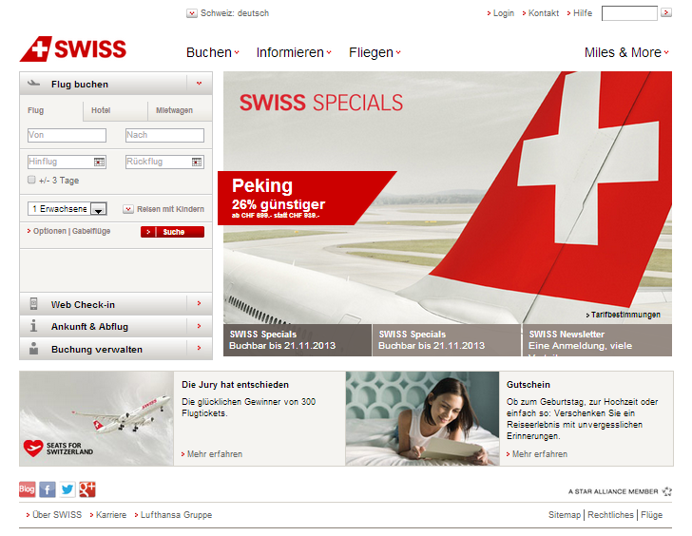

**Figure 6. SWISS.com (Swiss airline example).**

## 

**Figure 7. ch.ch (Swiss government example).**

## 

**Figure 8. swiss-design-association.ch (Swiss design professional organization example).**

**APPENDIX C: WIREFRAMES AND NOTES**

Maria Dahman

UX Professional, CH

Maria Dahman

User Experience Professional, Germany

Portfolio | Bio | Contact | References | 2013

Portfolio | Bio | Contact | References

**NOTES ON WIREFRAMES**

**German user experience professional wireframe**

Since German websites tend to be very traditional, this site uses standard links in the upper right and at the footer. The name and information about the site is in the upper left hand corner. The page would have photos both of the designer and her work to give a confidence in the person (ethos) and the impression of expertise (logos).

**Swiss user experience professional wireframe**

The site for the Swiss user experience professional can be a little more playful and out of the ordinary. I have used the grid system and modules to create a simple, open site. Each module would display an image on-hover. The name on the left in a different orientation also follows the Swiss Style.

1. The Long Term Orientation scores for Germany and Switzerland are 31 and 40 respectively, but since the score for Switzerland has not been separated by French-speaking Switzerland and German-speaking Switzerland as the other scores have, I excluded it from this discussion.