**Preliminary User Research:**

**Habits of Local Theatre Attendees**

***Project 1: HCI 445 (Inquiry Methods and Use Analysis)***

***DePaul University***

Maria Dahman

Khary Menelik

Jennifer Tanaka

Rosalind Wills

**Table of Contents**

I. Executive Summary ……………………………………………………………………………… 3

II. Objectives …………………………………………………………………………………………… 4

III. Methods and Procedures …………………………………………………………………… 4

*Participant Recruitment*

*Interview Process*

*Participant Demographics*

IV. Findings ……………………………………………………………………………………………… 8

*Theme #1: Decision-making*

*Theme #2: The Social Nature of Theatre*

*Theme #3: Discounts*

*Analysis of Themes*

V. Results ………………………………………………………………………………………………… 10

*Persona*

*Scenario*

VI. Conclusions ……………………………………………………………………………………….. 12

Appendix A: Interview Questions ……………………………………………………………. 13

Appendix B: Informed Consent Form ……………………………………………………… 14

Appendix C: Raw Interview Data …….………………………………………………………. 15

Appendix D: Roles and Responsibilities …………………………………………………… 15

Appendix E: Spectrum Analysis and Participant Clustering ……………………… 16

**I. Executive Summary**

Our team conducted exploratory interviews with adult theatregoers who live in big cities. The goal of this research was to determine how best to help people who want to buy discounted tickets for live theatre performances in their area, with an eye toward designing a tool for that purpose. We interviewed 14 people in seven cities, coded the interviews for key words and phrases, derived themes from our participants’ answers, and summarized our findings in a primary persona with a scenario.

In brief, we found that participants:

* Relied on a variety of sources to decide which shows to see, but some wished for a way to consolidate these streams of information;
* Would like to be notified when shows they might want to see, based on their taste or past attendance, are playing near them;
* Expressed a desire to use social media tools in conjunction with theatre-going, either to tell friends and family about shows they recommend or as a way to coordinate a date to see a show;
* Said they want discounted tickets and craved an easier way to find them.

This report documents the team’s objectives, methodology, findings, results, and conclusions of our research.

**II. Objectives**

The team’s objective is to create a technology tool—a web-based service or smartphone application, or perhaps a combination of the two—to give theatregoers easy access to discounted tickets for shows playing where they live. We conducted exploratory interviews with 14 adults in seven cities to help answer these foundational research questions:

* Who is the target audience and what are its needs?
* Does this audience already use a tool similar to the one we’d like to develop?
* Are these theatregoers interested in discounted tickets?
* How do theatregoers currently decide on which shows to see?
* How comfortable is the target audience with computing technology? Social media?

**III. Methods and Procedures**

***Participant Recruitment***

Each team member recruited three to five people for short individual interviews about theatre attendance and behavior. These participants were all friends or acquaintances of the team members, and self-identified as adult patrons of local theatre who lived in or near a major metropolitan area in the United States. We recruited participants from different cities, hoping to gain insight into the habits of the average city theatregoer.

***Interview Process***

Before conducting interviews, we created a standard list of question for the sake of consistency across participants (see “Appendix A: Interview Questions”).

All team members offered their interviewees the opportunity to give informed consent before taking part in the study (see “Appendix B: Informed Consent Form”). Interviewees were told about the intended outcomes of the study and the level of participation needed; the researchers emphasized that no personally identifiable information would be retained over the course of our investigation. Participants were invited to ask questions at any point during the interview. For remote participants, this process was done verbally or via a copy of the consent form, which was delivered, signed, and returned using e-mail; Chicago participants who were interviewed in person signed and returned the form to the researcher.

After receiving the informed consent form or verbal agreement from the interviewee, we performed a short interview that lasted about 20 to 30 minutes each; interviews were conducted in person, over the phone, or via Skype, the web-based teleconferencing service. The interviewer took notes on the participant’s responses, which were then aggregated with other answers for analysis.

***Participant Demographics***

A total of 14 interviewees participated in the study; all participants were adults located in or near major U.S. metropolitan areas. The geographic distribution broke down as follows:

|  |  |
| --- | --- |
| Chicago, IL | 4 |
| Atlanta, GA | 3 |
| Boston, MA | 2 |
| Baltimore, MD | 2 |
| San Diego, CA | 1 |
| Denver, CO | 1 |
| Washington, D.C. | 1 |

Of the 14 participants, about 1 in 4 were male. The majority of the participants—more than three quarters—were female.

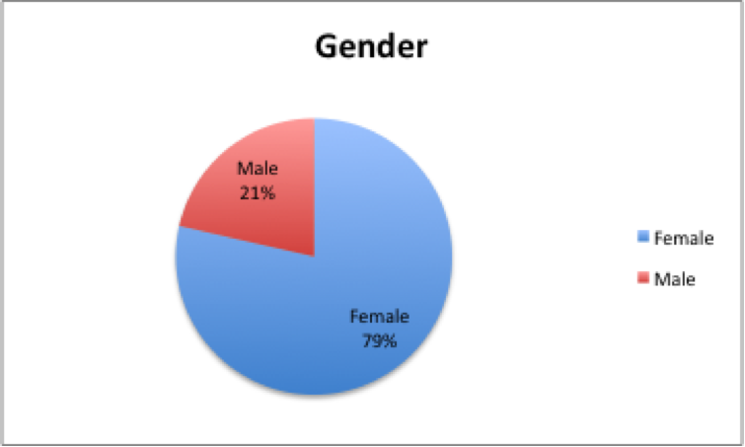

The participants ranged in age from their mid-20s to 70. The average participant was in his or her 40s:

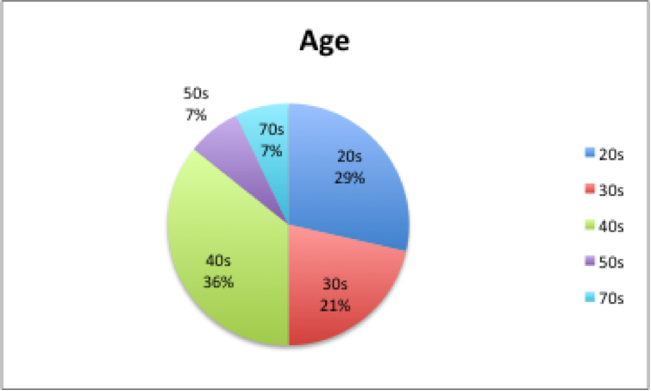

Approximately half of the study participants characterized themselves as highly proficient with communications technology. Less than a third (in general, the older participants) said they had limited or no facility with such technology.

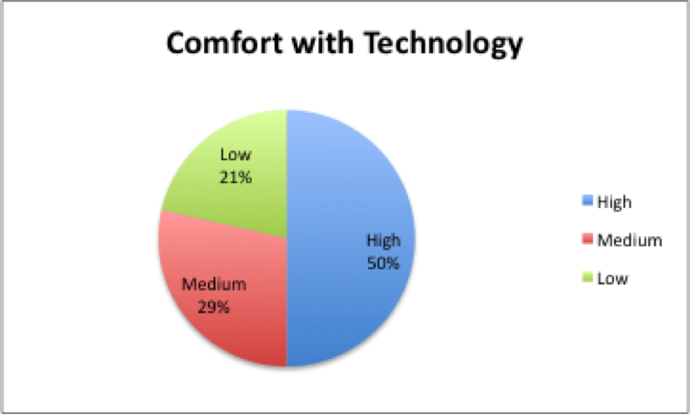

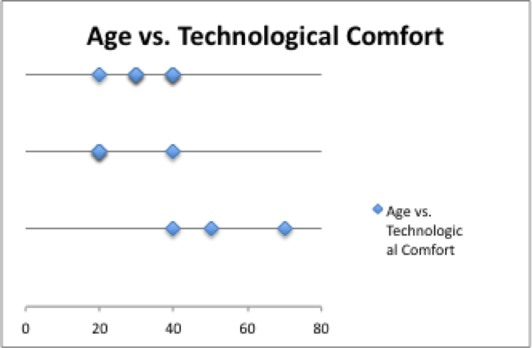

**IV. Findings**

From our collected interview transcripts (see “Appendix C: Raw Interview Data”), we coded the participants’ answers for recurring keywords and phrases and drew three themes from these clusters of information:

***Theme #1: Decision-making***

Keywords/phrases: Local-theatre-Facebook group, Facebook groups, Facebook app, [meetup.com](http://meetup.com/) group, [meetup.com](http://meetup.com/) app, websites of local papers, local papers like the *Chicago Reader,* friends in the industry, professional reviews, recommendations from friends and family, WBEZ (Chicago’s public radio station), 848 (a show on WBEZ), a play I’ve always heard of, Twitter, special occasion, an actor I’ve always liked, what my spouse wants to see, flyers from the theatre companies, mailing lists, e-mail mailing lists, billboards for traveling national shows, playwright, director, interview on Charlie Rose (TV show), Android Places app, GPS locator, theatre’s website, Google.

***Theme #2: The social nature of theatre***

Keywords/phrases: Group of friends, host an event in my home (she has an opera company and does in-home performances), setting Facebook attendance, [meetup.com](http://meetup.com/) group members, [meetup.com](http://meetup.com/) “checking in” feature, posted outings in a Facebook group, Twitter, I will tell people, groundswell, someone telling me in person.

***Theme #3: Discounts***

Keywords/phrases: HotTix (Chicago), rush tickets, ushering, industry comps (complimentary tickets), group discounts, updates on social media, industry nights, WBEZ membership, 2-for-1 offers from companies, TKTS Booth (New York), season tickets, student discounts, multiple tabs online to check for competitive ticket prices.

***Analysis of themes***

1. ***Decision-making***   
   Most interviewees had trusted sources of information that they used to make decisions about which shows to see. Several participants wished for a consolidated source of information to see what’s playing in the area, rather than receiving mailings from a variety of companies. They also expressed a desire for a tool that would flag shows of particular interest—for example, by genre, title/author, director, or good reviews from critics—and notify them with timely event information, such as venue, address, and ticket availability and price. One participant wanted a website or application where non-professional reviewers could comment on and rate shows, in the style of Yelp.
2. ***The Social Nature of Theatre***  
   Only one interviewee regularly sees theatre alone. Most of the participants make an effort to see theatre in groups; some told us that they notify friends about their plans to see theatre through computer-enabled social networks. Among the participants, about half reported they find social media relevant to theatre-going (see “Appendix E: Spectrum Analysis and Participant Clustering”) and the rest, even those who do not use social media at all, at least said they tell friends and family about seeing a show. The social-media users said they like to “check in”—either with a feature through sites such as [meetup.com](http://meetup.com/), which allow a member to send an alert that they have arrived at an event, or by RSVPing “yes” to an event that shows up in their Facebook profile, based on groups to which they subscribe.
3. ***Discounts***Our participants like discounts. Only one of the 14 interviewees always pays full price for tickets. Several interviewees mentioned that an easy, consolidated way to browse for discounts would be desirable.

**V. Results**

***Persona***

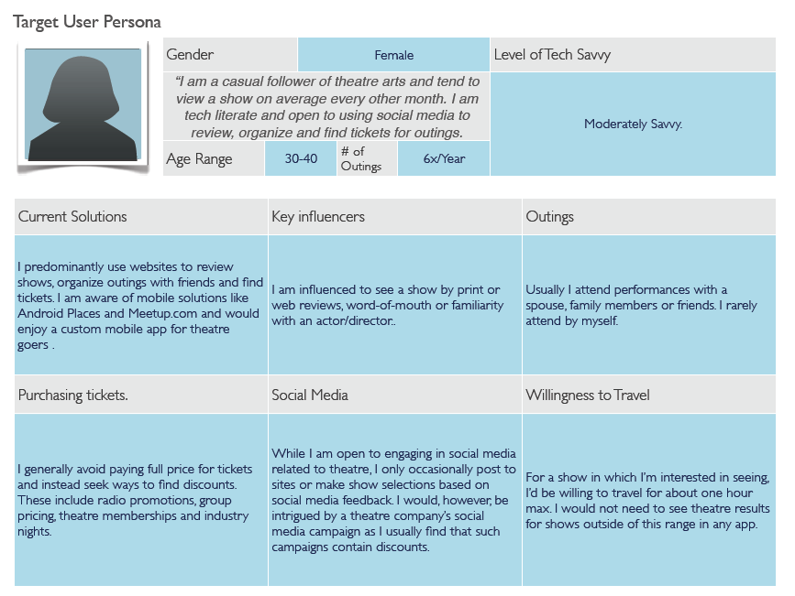

***Scenario***

Our scenario involves a user of our app who decides to research nearby theatre shows. Upon install, the app asks for permission to use the user’s location. After launching the app, the user enters a date range for the returning of theatre events in their area. Results are then shown to the user. The user can drill into an event to read details such as reviews, story lines, casting, show times and places to buy tickets. From this screen a user man add their own comments, view other app users who have selected to ‘Add’ themselves to the event and the user may ‘Add’ herself. This will add the selected theatre showing to the user’s calendar and acts as a social tool for organizing theatre parties. Upon arriving at an event, the user may pull up her app details and ‘Check In’. This will show up in other app user’s event details.

**VI. Conclusions**

Based on this preliminary research, we think we’ve identified a real need in the marketplace: a one-stop comprehensive service for theatregoers that aggregates information about shows and displays real-time discount ticket availability. Our participants’ feedback confirmed one of the team’s most basic initial assumptions: theatre-going is a social event that is constrained by location.

Some of the surprising findings were the extent to which some users relied on social media for organizing group dates to see shows, how much effort some participants expended on cobbling together information in order to make a decision about seeing a play, and that everyone interviewed seemed willing in theory to pursue a discounted ticket offer.

These interviews also laid the groundwork for a detailed follow-up survey, in which we will delve deeper into the real features of a new application. In our next phase of research, survey questions will likely include:

* What conditions make it difficult today to find, buy, and pick up discounted tickets?
* Which features of a new tool or application would be most useful?
* Does the target audience crave more information about shows and, if so, what kind of information?
* How willing are they to learn or adopt new applications?
* Would buyers feel comfortable purchasing discounted tickets from a third-party service?
* What trade-offs—limited availability of prime-time seats, for example, or same-day ticketing—would the target audience be willing to accept?

**Appendix A: Interview Questions**

1. How do you decide which show to see?
2. Which tools do you currently use when deciding which show to see? (Some examples: newspaper reviews, web-based tools, mobile apps) Which do you consider the most reliable?
3. With whom do you most often see theatrical performances?
4. How far do you usually like to travel to see a theatrical performance? What is the farthest you have ever traveled?
5. How important, if at all, is sharing your intention to see theatre in groups such as Facebook? Do you make decisions to see shows based on information from groups?
6. Do you follow a particular actor, playwright, theatre company, or style of theatre? How important is the genre of theatre that you see?
7. How often do you pay full price for a ticket?
8. What, if any, are your favorite ways to look for discounted tickets?
9. How often do you see live theatre shows?
10. Do you currently use any electronic apps to research local theatre? If so, which and what features in them do you find useful?

**Appendix B: Informed Consent Form**

***Informed Consent Form***

***DePaul HCI 445 User Research Project***

Please read the following carefully.

Thank you for your participation in this user research interview. I am _______________, a graduate student at DePaul University. This interview is to obtain information for my *Inquiry Methods and Use Analysis* class, for which I am researching user needs regarding tools for regular live theatre attendees.

If you have any questions regarding the nature of this study or this consent form, please ask me at any time.

This interview should last approximately 30 minutes, depending on how detailed your answers are. No personally identifiable information will be published as part of this study.

Please note that, as a participant in this study:

1. Your participation is completely voluntary.
2. You have the right to withdraw from the session at any time for any reason.
3. There are no foreseen risks from participating in this study and no direct benefits.
4. I will take notes on your responses and all information you provide is confidential.
5. At the conclusion of your session, you may see your data or request to withhold any information if you so desire. If you decide to withdraw your data, please notify me immediately.

Your participation is greatly appreciated. Remember that you are not being evaluated, and that the purpose of the interview is to gather information. Please keep this form for your records.

If you have any questions, please don’t hesitate to ask me.

Participant Signature:

________________________________________________________

Date: _____________________

**Appendix C: Raw Interview Data**

Please see attached Excel file.

**Appendix D: Roles and Responsibilities**

|  |  |
| --- | --- |
| **Name** | **Tasks** |
| All | * Developed interview questions * Conducted interviews * Interview transcription * Analysis * Writing and editing |
| Maria Dahman | * Data coding * Spectrum analysis * Participant clustering * Themes |
| Khary Kwabena Menelik | * Persona * Scenario |
| Jennifer Tanaka | * Executive Summary * Objectives * Conclusions |
| Rosalind Wills | * Project Manager * Methods * Procedures |

**Appendix E:   
Spectrum Analysis and Participant Clustering**

