Lab 1: Performance Monitoring

NET311 - Computer Networks Management

Instructor: Dr. Mostafa Dahshan

Objectives

1. Get introduced to network management functions.
2. Use operating system’s built-in monitoring tools.

References

1. 70-411 Administering Windows Server 2012 R2 Lab Manual, Lab 3, Microsoft Official Academic Course.
2. Administering Windows Server 2012 R2 Training Guide, Lesson 10, Orin Thomas.

Instructions

1. Read the lab instructions.
2. Provide question answers and screenshots in the supplied answer sheet.
3. After finishing the lab, upload your saved answer sheet to LMS.

# Part 1: Using Event Viewer

1. Login to Windows Server.

2. Run **Server Manager**.

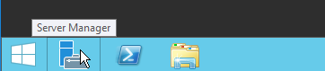

3. Using Server Manager, click **Tools** > **Event Viewer**.

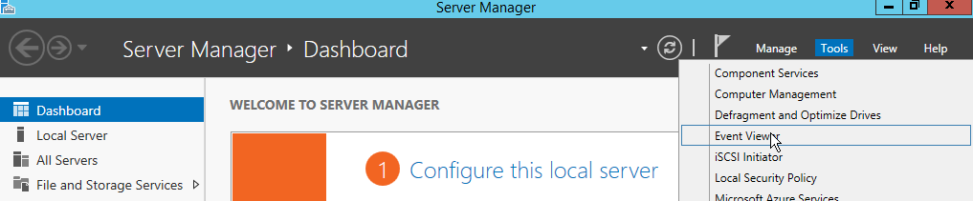

4. Expand **Windows Logs** folder and click on **System log**.

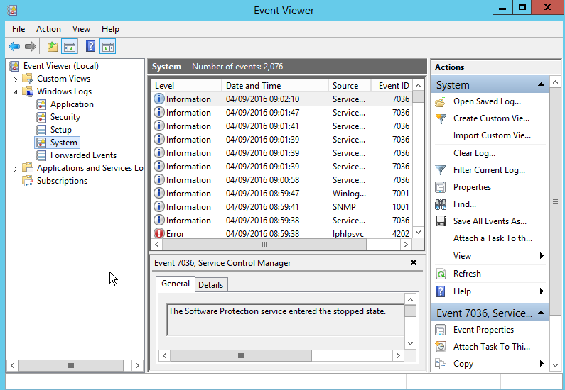

## Lab sheet 1.1: provide a screenshot showing the System log.

5. Click on **Filter Current Log**.

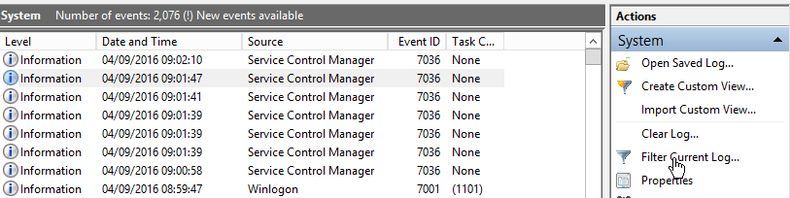

6. Select the following filter options: Logged: **Last 7 days**. Event level: **Critical, Error, Warning**.

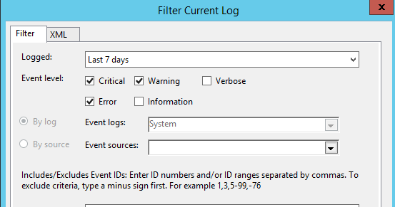

## Lab sheet 1.2: provide a screenshot showing the filtered System log.

# Part 2: Using Resource Monitor

1. Click Start, type **resource monitor**, then click Enter.

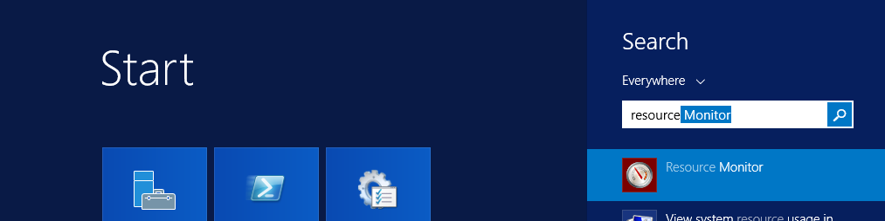

2. Open the **CPU** tab.

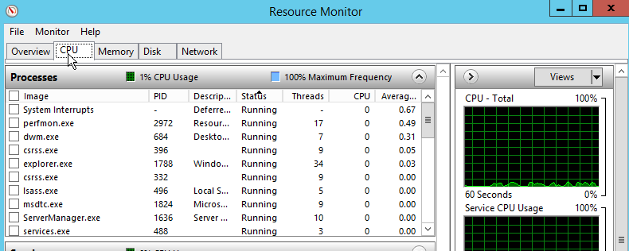

## Lab sheet 2.1: provide a screenshot showing the CPU tab in the Resource Monitor.

3. Sort the processes based on the Average CPU usage by clicking on the **Average CPU** column.

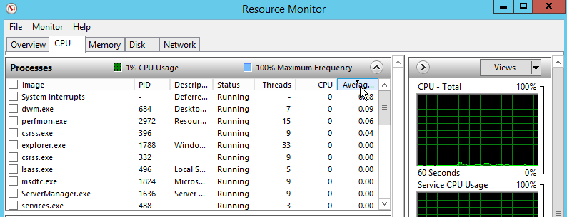

## Lab sheet 2.2: type the name of the Image that has the highest Average CPU.

4. Open the **Network** tab.

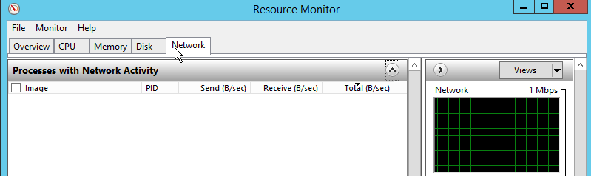

5. Expand the **Listening Ports** section.

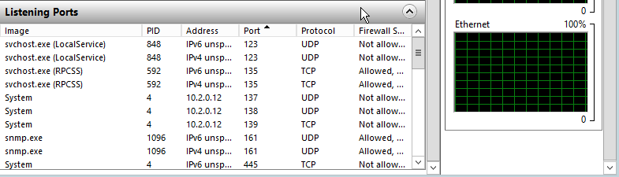

## Lab sheet 2.3: provide a screenshot showing the Listening Ports section under the Network tab.

# Part 3: Using Performance Monitor

1. Run **Server Manager**.



2. Using Server Manager, click **Tools** > **Performance Monitor**.

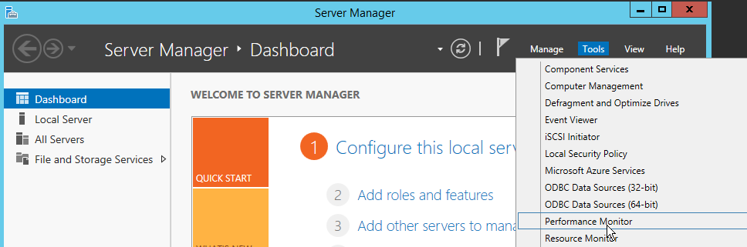

3. Under **Monitoring Tools**, click **Performance Monitor**.

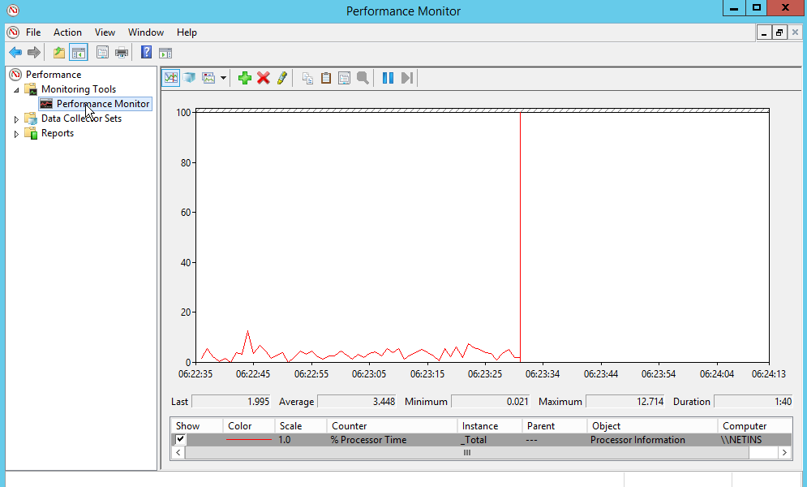

## Lab sheet 3.1: provide a screenshot showing Performance Monitor.

4. While selecting the **%Processor Time** counter, click the **Delete** button on the toolbar.

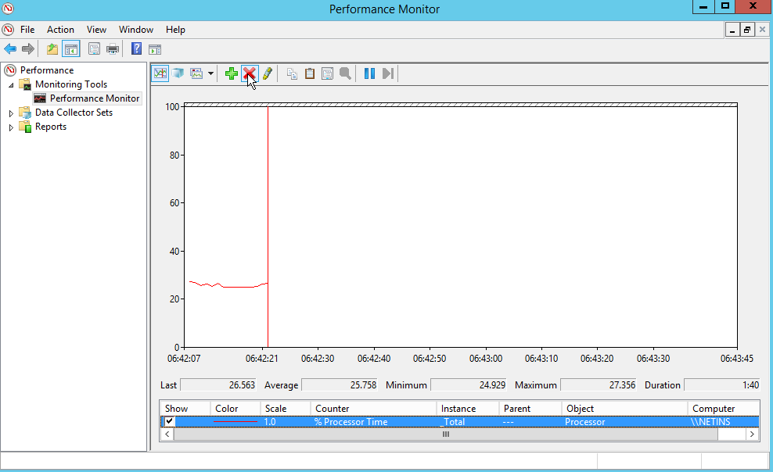

5. On the toolbar, click the Add button.

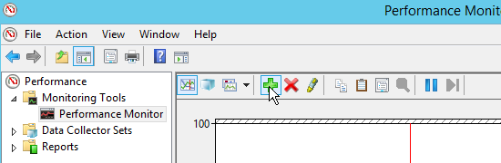

6. Under **Network Interface**, select **Bytes Received/sec** and **Bytes Sent/sec** and click **Add**.

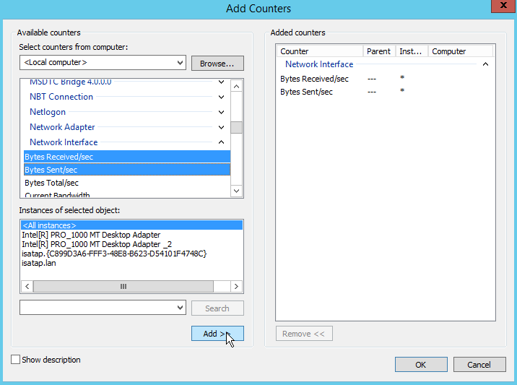

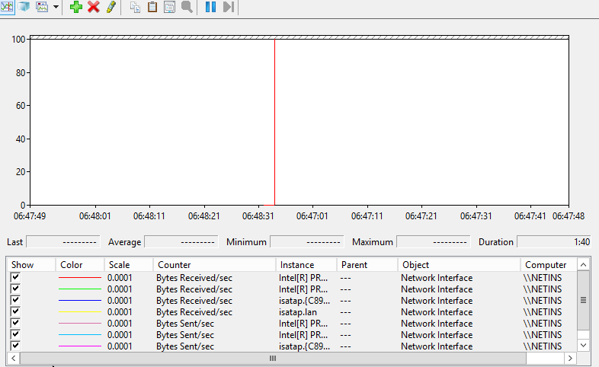

## Lab sheet 3.2: provide a screenshot showing the added counters.

7. Open Firefox web browser and browse to a web site of your choice.





8. Check the Bytes Received/sec and Bytes sent/sec counters.

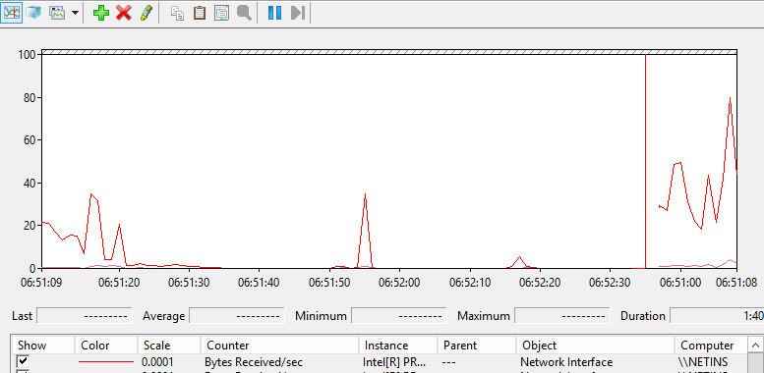

## Lab sheet 3.3: provide a screenshot of the Network Interface counters after opening the page.