Lab 2: Network Troubleshooting

NET311 - Computer Networks Management

Instructor: Dr. Mostafa Dahshan

## Objectives

1. Use protocol analyzers, such as Wireshark, to inspect the packet contents.
2. Use basic network troubleshooting tools, such as ping and traceroute utilities.

## References

1. Computer Networks 5/E, Lab Exercise, Protocol Layers, David Wetherall.
2. Computer Networks 5/E, Lab Exercise, ICMP, David Wetherall.

## Instructions

1. Read the lab instructions.
2. Provide question answers and screenshots in the supplied answer sheet.
3. After finishing the lab, upload your saved answer sheet to LMS.

# Part 1: Protocol Analyzers

1. Run the **Wireshark** application as an **Administrator**.

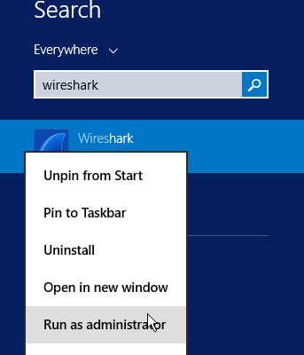

2. In Wireshark, select the **Ethernet** interface, and start a capture using the following **filter**:

tcp port 80

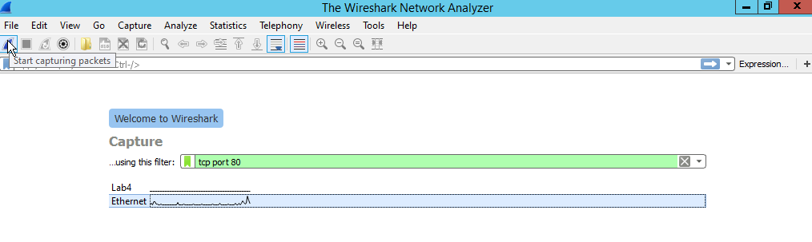

3. Open **Windows PowerShell** and type the following command:

Invoke-WebRequest http://www.ksu.edu.sa

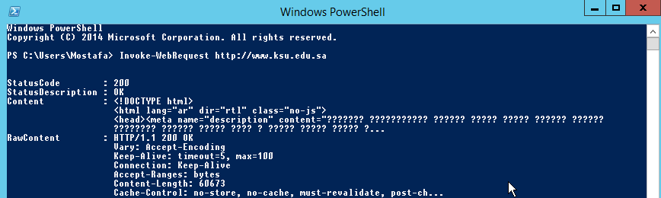

4. After the command is finished, return to Wireshark and **stop** the capture.

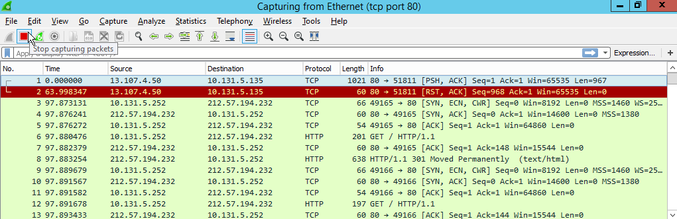

## Lab sheet 1.1: provide a screenshot of Wireshark screen showing the captured packets.

5. Locate the packet **HTTP GET** packet and double click on it to inspect it.



6. Expand the details of **Internet Protocol Version 4**.

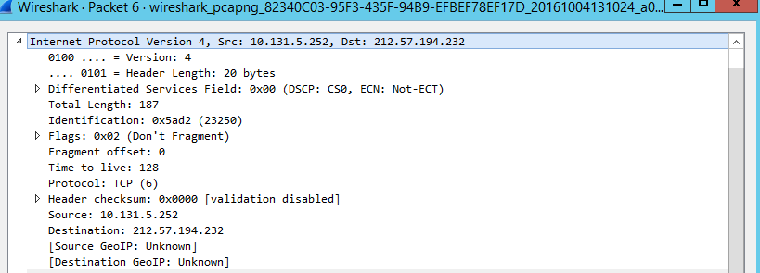

## Lab sheet 1.2: Fill the following details of the Internet Protocol Version 4 protocol.

|  |  |  |  |  |
| --- | --- | --- | --- | --- |
| Total Length | Time to Live | Protocol | Source | Destination |

7. Expand the details of **Hypertext Transfer Protocol**.

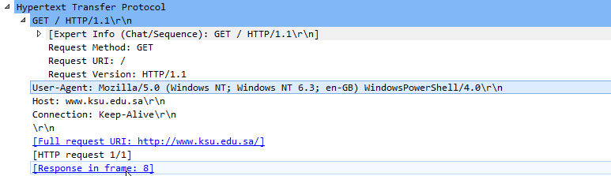

## Lab sheet 1.3: Fill the following details of the Hypertext Transfer Protocol.

Hint: You can use Control-C to copy from the Wireshark window.

|  |  |  |  |
| --- | --- | --- | --- |
| Request Method | Request URI | User-Agent | Host |

# Part 2: Network Troubleshooting Tools

1. Run the **Wireshark** application as an **Administrator**.



2. In Wireshark, select the **Ethernet** interface, and start a capture using the following **filter**:

icmp

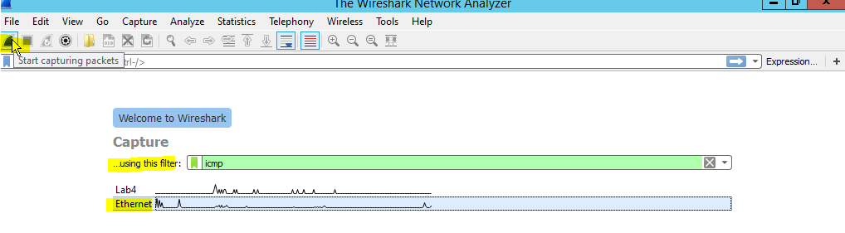

3. Open **Windows PowerShell** and type the following command:

ping www.google.com.sa

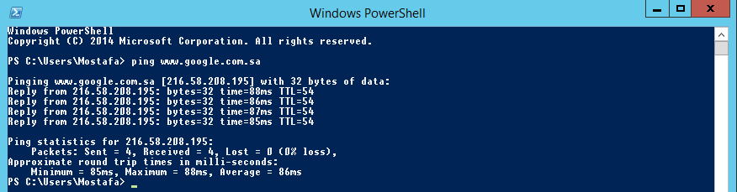

4. After the command is finished, return to Wireshark and **stop** the capture.

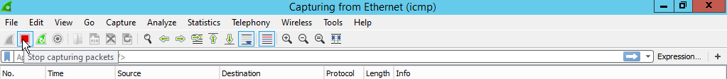

5. Inspect the ICMP packets by expanding the **Internet Control Message Protocol** fields, then answer the following questions.

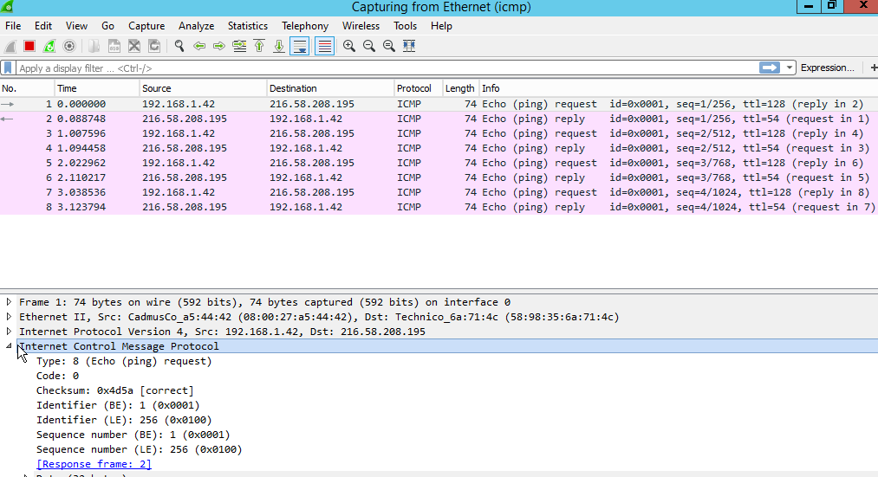

## Lab sheet 2.1: Answer the following questions.

|  |  |
| --- | --- |
| What is the Type/Code value of the first ICMP request? |  |
| What is Type/Code value of the first ICMP reply? |  |
| What is Sequence number of the second ICMP request? |  |
| What is Sequence number of the second ICMP reply? |  |
| What is Data of the third ICMP request? |  |
| What is Data of the third ICMP reply? |  |
| What is Time of the fourth ICMP request? |  |
| What is Time of the fourth ICMP reply? |  |

6. Close the Wireshark capture.

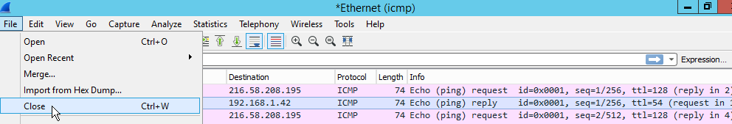

7. In Wireshark, select the **Ethernet** interface, and start a capture using the following **filter**:

icmp



8. Open **Windows PowerShell** and type the following command:

tracert -d www.yahoo.com

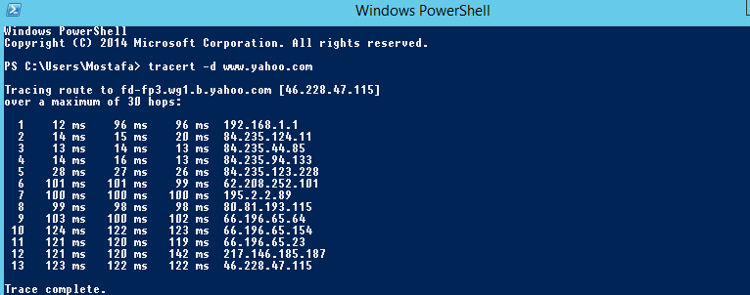

## Lab sheet 2.2: Provide a screenshot showing the output of the tracert command.

9. After the command is finished, return to Wireshark and **stop** the capture.



10. Inspect the ICMP packets by expanding the **Internet Control Message Protocol** fields, then answer the following questions.

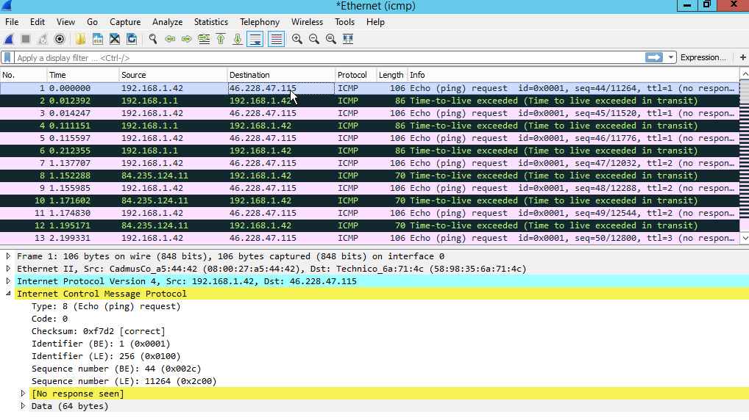

## Lab sheet 2.3: Answer the following questions.

|  |  |
| --- | --- |
| What is the TTL (Time to live) value in the first ICMP request? |  |
| What is the Type/Code value of the first ICMP request? |  |
| What is the Type/Code value of the first ICMP TTCL Exceeded response? |  |
| How many ICMP packets with TTL = 1? |  |
| What is the source IP address of the second ICMP TTL Exceeded response? |  |
| What is the source IP address of the third ICMP TTL Exceeded response? |  |
| What is the largest TTL value in ICMP requests after the last TTL Exceeded response? |  |

11. Expand the **Internet Protocol Version 4** section of the first ICMP request.

## Lab sheet 2.4: Provide a screenshot showing the details of the Internet Protocol Version 4 section of the first ICMP request.

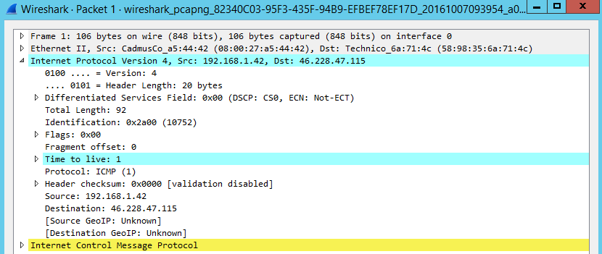

12. Expand the **Internet Control Message Protocol** -> **Internet Protocol Version 4** subsection of the first ICMP Time Exceeded response.

## Lab sheet 2.5: Provide a screenshot showing the details of the first ICMP Time Exceeded response.

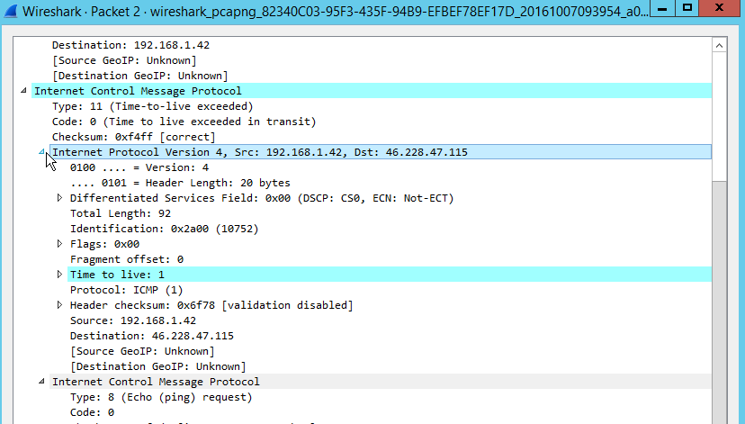

13. Compare the payload of the ICMP response with the ICMP request.