Lab 3: SNMP in Windows

NET311 – Computer Networks Management

Instructor: Dr. Mostafa Dahshan

## Objectives

1. Install and configure SNMP service in Windows Server.
2. Use a MIB browser software to interact with Windows SNMP agent.

## References

1. [How to Install SNMP and Configure the Community String](https://support.managed.com/kb/a764/how-to-install-snmp-and-configure-the-community-string.aspx), Managed.com.
2. [SnmpB download](https://sourceforge.net/projects/snmpb), SourceForge.net.

## Instructions

1. Read the lab instructions.
2. Provide question answers and screenshots in the supplied answer sheet.
3. After finishing the lab, upload your saved answer sheet to LMS.

# Part 1: Install and Configure SNMP Service in Windows Server

1. Log in to Windows Server.

2. Click on **Windows Key > Administrative Tools > Server Manager**.

3. Click **Manage >** **Add Roles and Features**.

4. Click **Next > Next > Next > Next**. Follow steps to install SNMP Service.

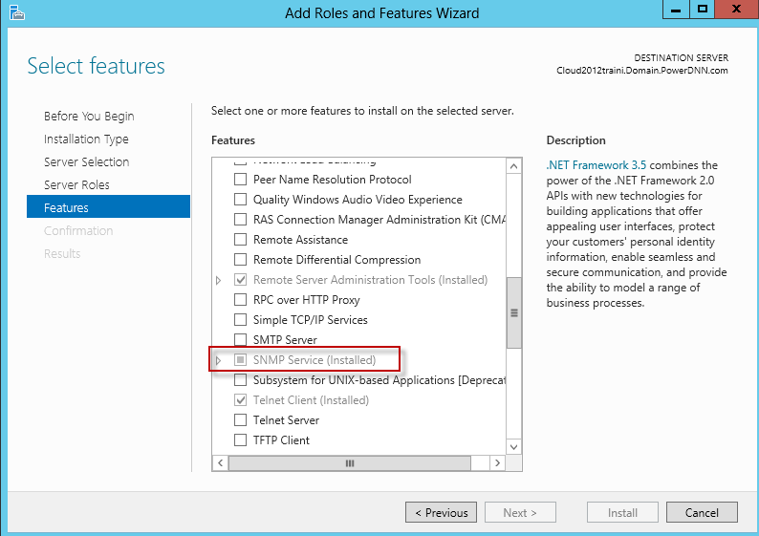

### Lab sheet 1.1: provide a screenshot of the Add Roles and Features screen.

5. Run **PowerShell** as **Administrator**.

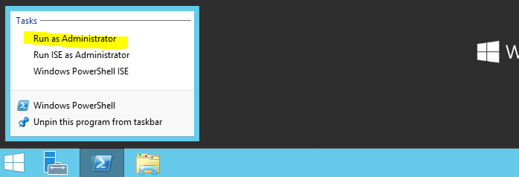

6. Run the following command:

install-windowsfeature RSAT-SNMP



7. Click on **Windows Key > Administrative Tools > Services**.

8. Right click on **SNMP Service**and click on **Properties**.

9. Click on the **Security**tab.

10. Type your Community Name. Make sure it is **READ ONLY**.

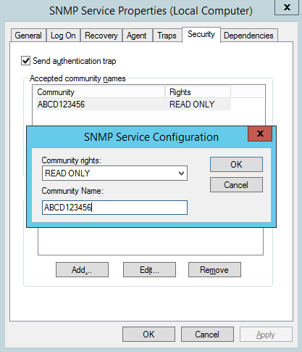

### Lab sheet 1.2: type the value of the Community Name.

### Lab sheet 1.3: provide a screenshot of your Security configuration screen.

11. Click on the Agent tab and enter your **Contact** and **Location** information.

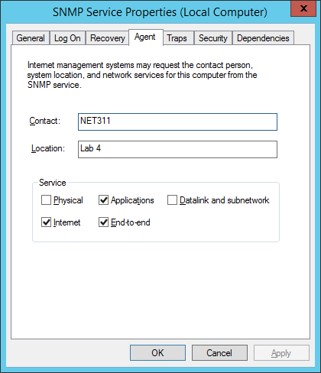

### Lab sheet 1.4: type the contact information you entered.

### Lab sheet 1.5: provide a screenshot of your Agent configuration screen.

# Part 2: Use a MIB browser to interact with Windows SNMP agent

1. Install the SnmpB software from the **Downloads** folder.

2. Run the SnmpB software.

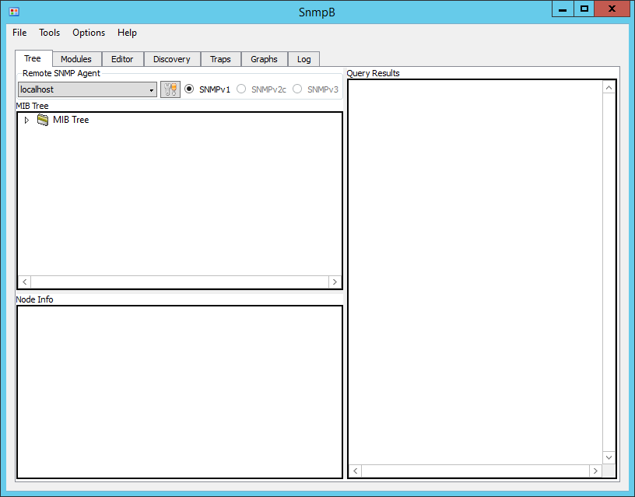

3. Click Options > Manage Agent Profiles.

4. Expand the **localhost** profile.

5. Under Snmpv1/v2c, enter the Read Community value configured in Part 1.

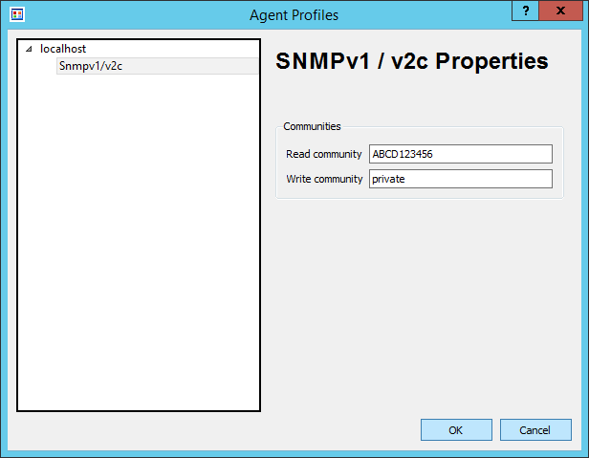

6. Click OK.

### Lab sheet 2.1: provide a screenshot of the running SnmpB screen.

7. Expand the MIB Tree > iso > org > dod > internet > mgmt > mib-2 > system

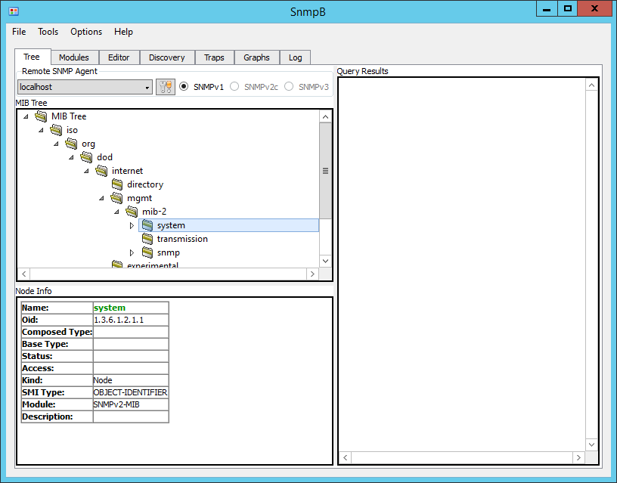

### Lab sheet 2.2: type the value of the OID you selected.

8. Right-click on **system**, then click on **Walk**.

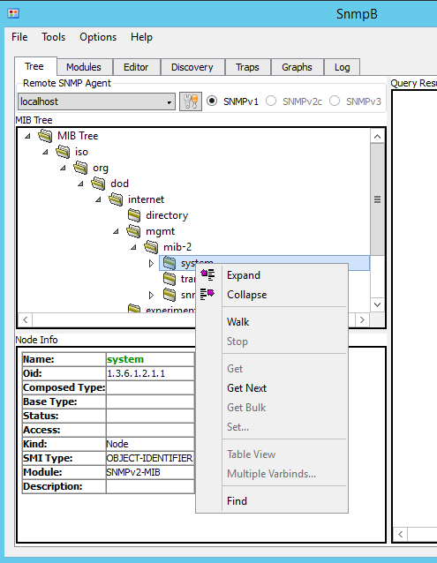



### Lab sheet 2.3: provide the Query Result contents (copy/paste).

# Extra Tasks

Load more modules in SnmpB that can help finding more OIDs. For example, use IF-MIB to find the ifDescr.

Use alternative SNMP browser tool, such as snmputilg.