Lab 8: RMON

NET311 - Computer Networks Management

Instructor: Dr. Mostafa Dahshan

Objectives

1. Understand RMON.
2. Configure remote monitoring on Cisco devices.
3. Generate network traffic to test RMON probes.
4. Access RMON probes using an SNMP manager.

References

1. [RMON | Bits and Beans](https://bitsandbeans.wordpress.com/2012/01/18/rmon/).
2. [Configuring RMON Support - Cisco](http://www.cisco.com/c/en/us/td/docs/ios/12_2/configfun/configuration/guide/ffun_c/fcf016.html).
3. [CCIE - RMON - Remote MONitoring](http://lostintransit.se/2011/05/27/rmon-remote-monitoring/).
4. [VPCs Tutorial | RedNectar's Blog](https://rednectar.net/archives/vpcs-tutorial/).
5. [SNMP Counters: Frequently Asked Questions - Cisco](http://www.cisco.com/c/en/us/support/docs/ip/simple-network-management-protocol-snmp/26007-faq-snmpcounter.html).
6. [RMON Commands - Cisco](http://www.cisco.com/c/en/us/td/docs/ios/12_2/configfun/command/reference/ffun_r/frf016.html).

Instructions

1. Read the lab instructions.
2. Provide question answers and screenshots in the supplied answer sheet.
3. After finishing the lab, upload your saved answer sheet to LMS.

# Part 1: Lab Setup

The lab setup required is the same as the lab setup for Lab 05. If you have not performed Lab 05, you must perform Part 1 in Lab 05 before completing this lab.

# Part 2: Starting the Network

1. Run **GNS3** as an **administrator**.

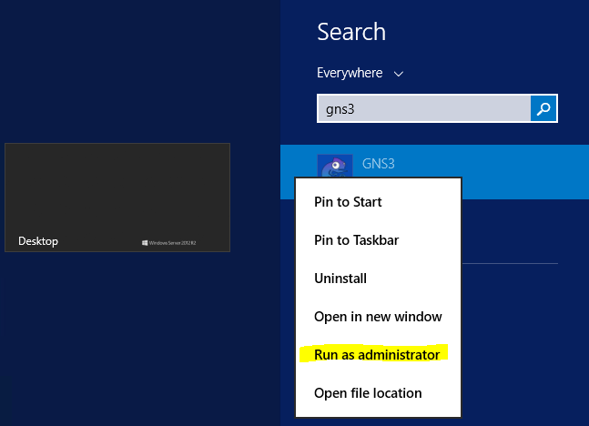

2. Open the GNS3 project **NET311-Lab-08.gns3.**

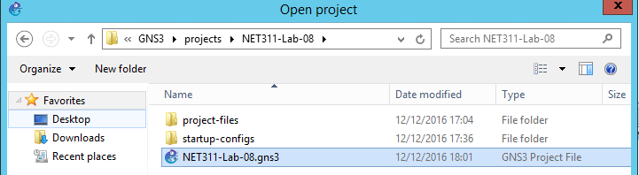

1. Start all devices

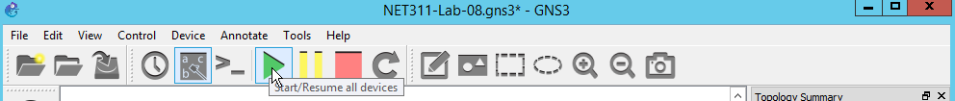

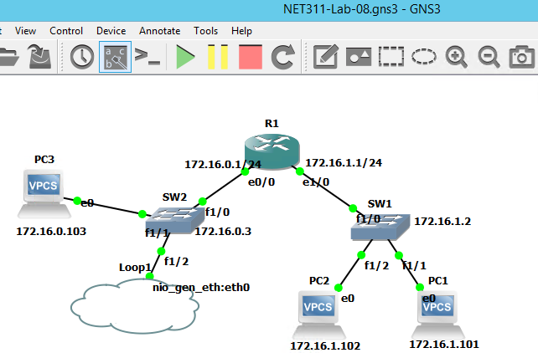

## Lab sheet 2.1: provide a screenshot of the running network.

# Part 3: Configure RMON on a Cisco Router

1. Double-click on R1 to open its console.

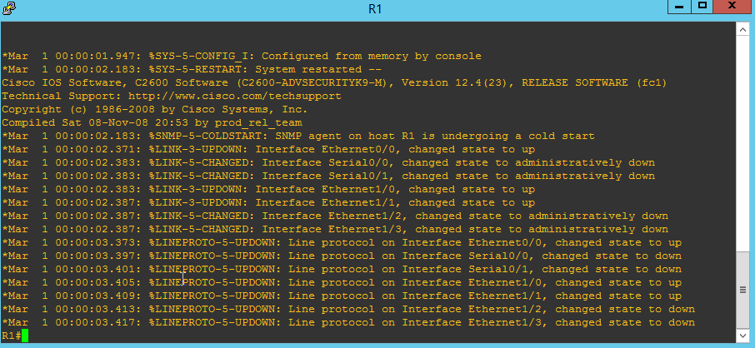

We want to configure an RMON alarm to monitor the total number of octets received on the interface **e1/0**, defined by the OID **ifInOctets** (1.3.6.1.2.1.2.2.1.10). The alarm will sample every **10** seconds. If the increase amount (delta) is **2000** octets or larger, it will trigger event **1**. If the decrease amount is **1000** or lower, it will trigger event **2**.

2. Configure the two RMON events.

config t

rmon event 1 log description HighInput owner NET311

rmon event 2 log description LowInput owner NET311

Before configuring the RMON alarm, we need to find out the ifIndex that corresponds to the interface **e1/0**.

3. Find the interface index of e1/0 (Ethernet1/0)

end

show snmp mib ifmib ifindex

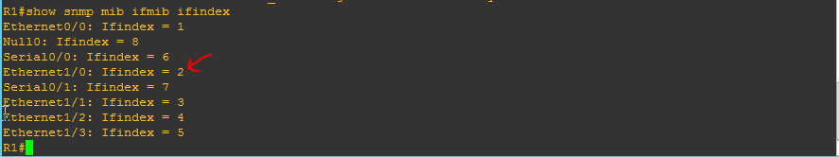

4. Configure the RMON alarm.

config t

rmon alarm 1 ifInOctets.2 10 delta rising-threshold 2000 1 falling-threshold 1000 2 owner NET311

Note that, after 10 second, the falling trap is generated because no packets have been received on the interface.



5. Verify the RMON alarm and events you have created:

end

show rmon alarms

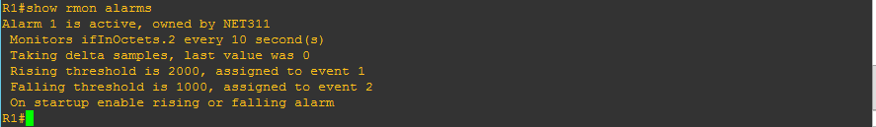

## Lab sheet 3.1: provide a screenshot showing the RMON alarms.

show rmon events

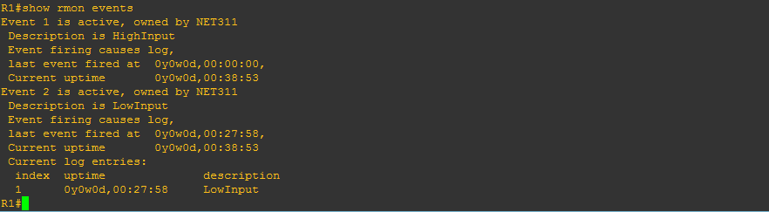

## Lab sheet 3.2: provide a screenshot showing the RMON events.

# Part 4: Generate Traffic

To test the raising trap, we need to generate some traffic on the interface e1/0 of R1. We do that by using the **ping** command **from PC1** that needs to be routed **to PC3** through the interface **e1/0** of R1.

1. Double-click on **PC1** to open its console.

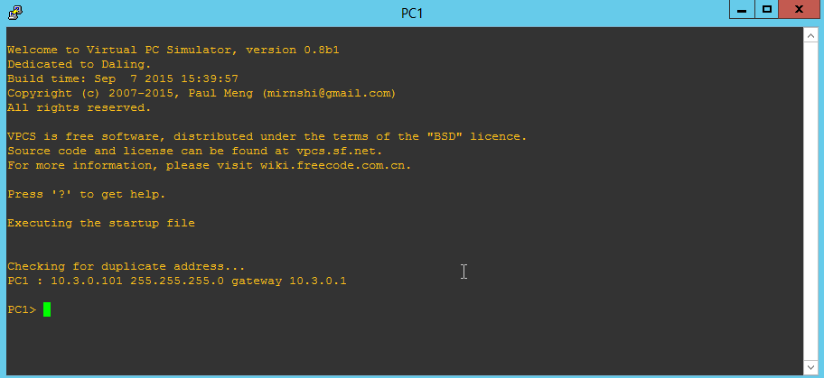

2. Send **1000** ICMP packets to PC3 with **10 ms** delay between them.

ping 172.16.0.103 -c 1000 -i 10

3. Check the console window of R1. It should show that rising trap is generated.



## Lab sheet 4.1: provide a screenshot of R1's console showing the Rising trap.

4. After another 10 seconds with no activity, check the console window of R1. The falling trap is again generated.



## Lab sheet 4.2: provide a screenshot of R1's console showing the falling trap.

# Part 5: Access RMON Probe using an SNMP Manager

As a network manager, you may want to periodically check RMON probes located at different parts of your enterprise's network.

1. On your Windows computer, run the **SnmpB** application and configure the **agent profile** to access **R1**.

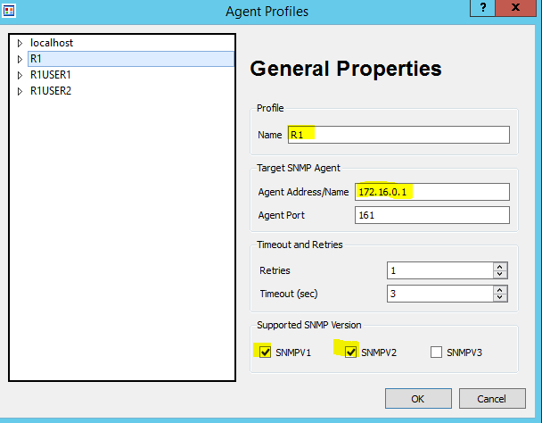

2. From the SnmpB **Modules** tab, load the two modules **RMON-MIB** and **RMON2-MIB**.

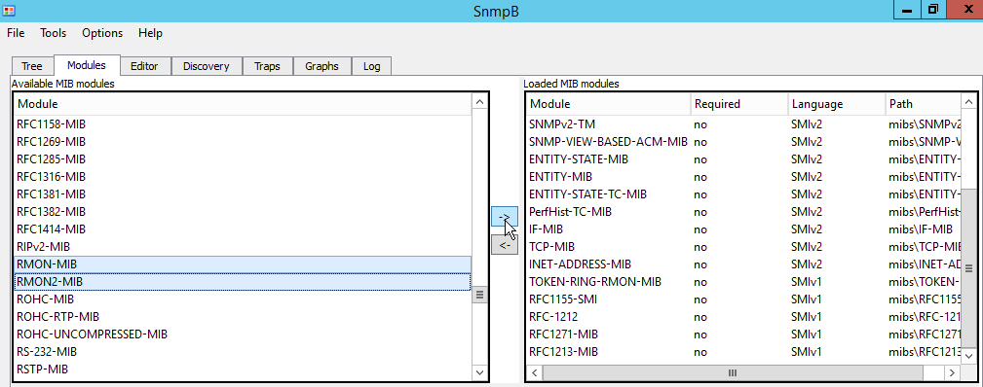

3. Using the R1 agent profile, and SNMP **v2c**, query the **mib-2.rmon.alarm.alarmTable** OID using the **Table View** option.

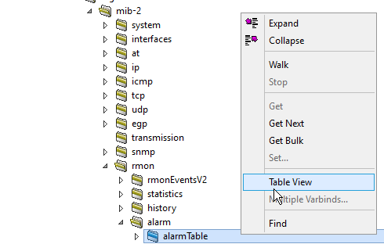

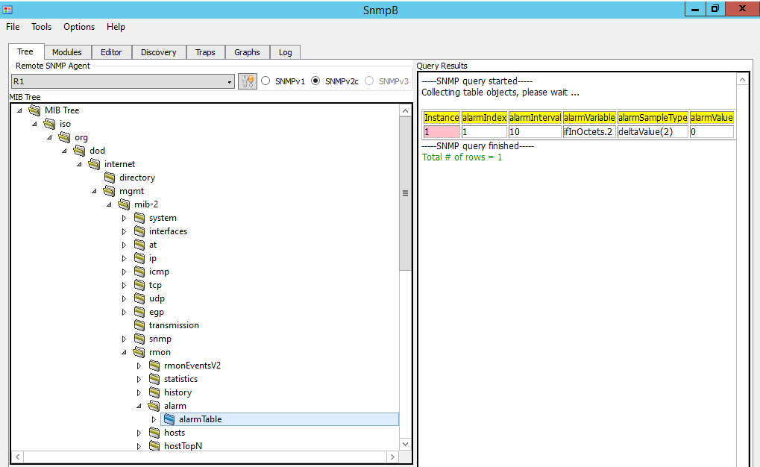

## Lab sheet 5.1: provide a screenshot of the Table View of the alarmTable of R1.

4. Using the R1 agent profile, and SNMP v2c, query the **mib-2.rmon.event.eventTable** OID using the Table view option.

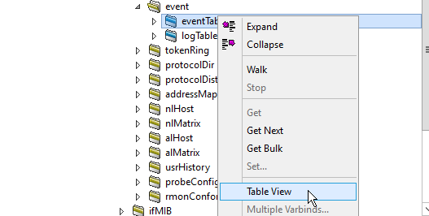

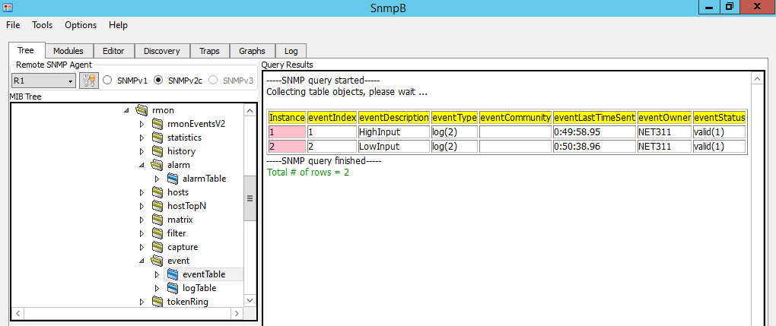

## Lab sheet 5.2: provide a screenshot of the Table View of the eventTable of R1.