Lab 10: HP Networks Node Manager

NET311 - Computer Network Management

Instructor: Dr. Mostafa Dahshan

Objectives

1. Deploy Network Management System Software.
2. Install and configure HP NNMi.
3. Troubleshoot network problems.

References

1. [HP NNM](https://www.youtube.com/playlist?list=PLDE8F6DD26352DEC6)i.
2. [Configuring Communication Protocol](http://helpfiles.intactcloud.com/NNMi/9.22/nnmDocs_en/htmlHelp/nmHelp/Subsystems/nmAdminHelp/nmAdminHelp_Left.html#CSHID=nmAdminHelp%2FnmAdmConfComm0110DefCommStrTab.htm|StartTopic=Content%2FnmAdminHelp%2FnmAdmConfComm0110DefCommStrTab.htm|SkinName=_HP_WebHelpSkin_no_Index).

Instructions

1. Read the lab instructions.
2. Provide question answers and screenshots in the supplied answer sheet.
3. After finishing the lab, upload your saved answer sheet to LMS.

# Part 1: Lab Setup

The lab setup required is the same as the lab setup for Lab 5. If you have not performed Lab 5, you must perform Part 1 in Lab 5 before completing this lab.

1. Run **PowerShell** as **Administrator**.

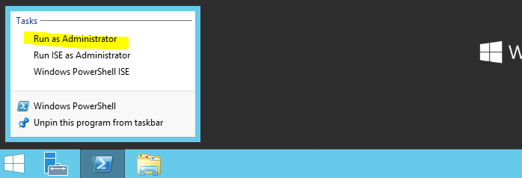

2. Type the following commands to stop the PostgreSQL service. This is important because this service conflicts with the PostgreSQL database used in HP NNMi.

$s = Get-Service -Name "postgresql-x64-9.5"

Set-Service -InputObject $s -StartupType disabled

Stop-Service -InputObject $s

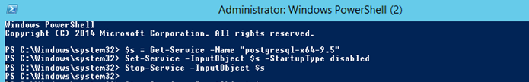

## Lab sheet 1.1: provide a screenshot of the PowerShell screen.

3. Save your lab sheet, then restart the computer.

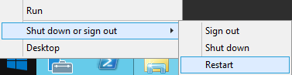

4. Run **PowerShell** as **Administrator**.



5. Type the following command to configure the route to the lab network:

Route add 172.16.0.0 mask 255.240.0.0 172.16.0.2 metric 1

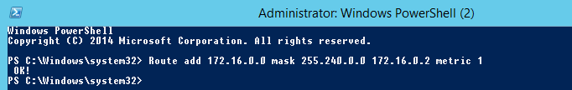

# Part 2: Starting the Network

1. Run **GNS3** as an **administrator**.

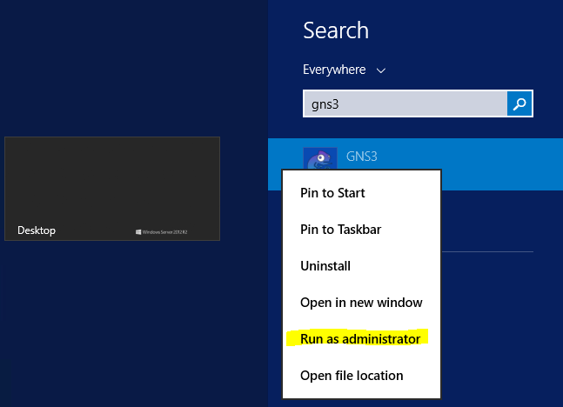

2. Open the GNS3 project **NET311-Lab-10-.gns3.**

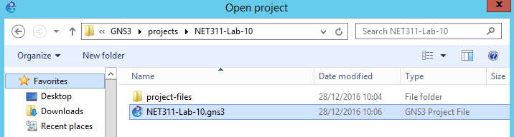

3. Start all devices

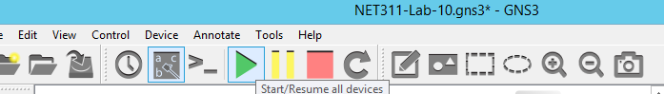

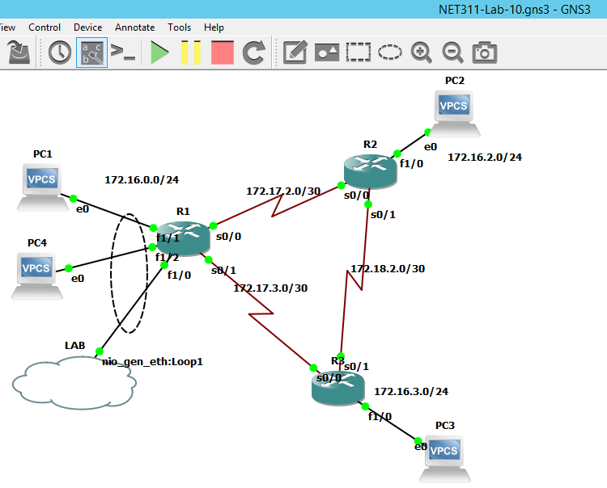

## Lab sheet 2.1: provide a screenshot of the running network.

# Part 3: Install HP Network Node Manager

1. Locate the Disc image **Software_HP_NNMi_Community_Edition_Windows_TB765-15700.iso** under **Downloads**.

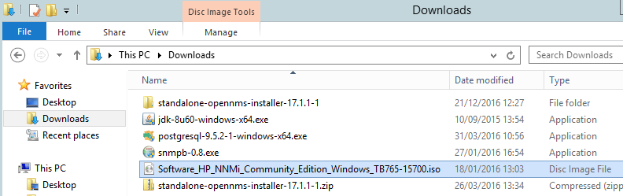

2. Double click on the image to mount it.



3. Locate and open the mounted DVD drive on your computer.

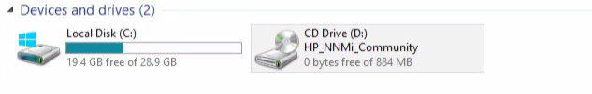

4. Start the **setup** program.

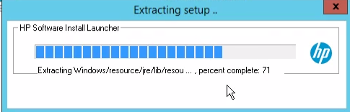

5. Follow the steps of the setup program. **Keep the default settings** unless otherwise specified.

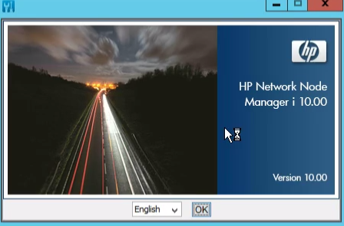

6. In the System Account Password field, type **net311**.

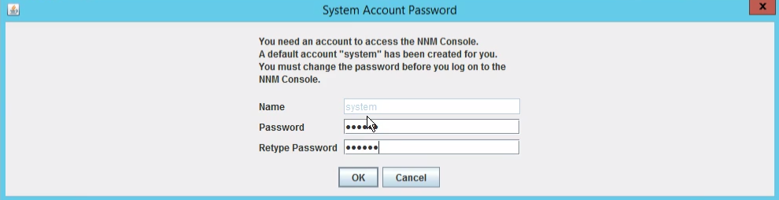

7. Keep the default ports 80 and 443.

|  |  |
| --- | --- |
|  |  |

8. In the Offical FQDN field, type **localhost**.

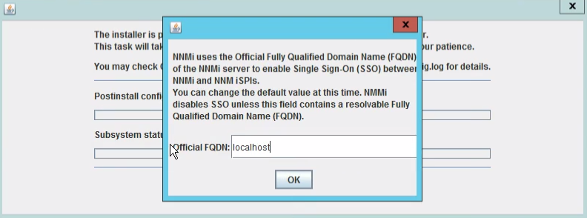

9. Click on **Skip Patching**.

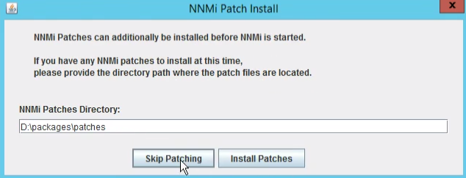

10. Click on **Finish**.

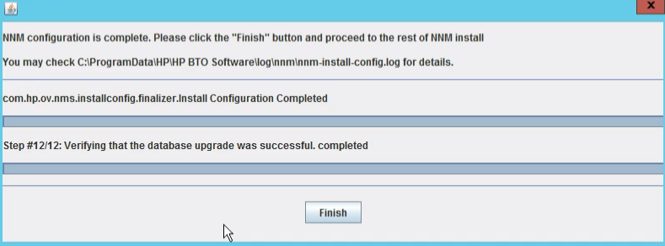

## Lab sheet 3.1: provide a screenshot showing the Finish screen of NNM setup.

11. Click **No** to skip the Quick Start Configuration Wizard.

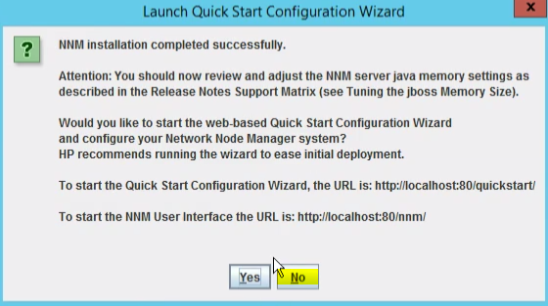

# Part 4: Configure HP NNM Communication and Discovery

1. Run the Firefox web browser.

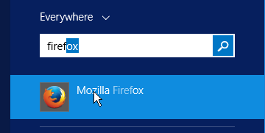

2. From the top right corner, open **Options**. In the **General** tab click on **Make Default**.

|  |  |
| --- | --- |
|  |  |

3. Check the **Select All**, then click **Save**.

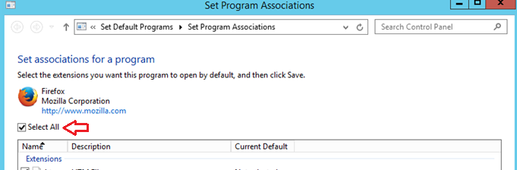

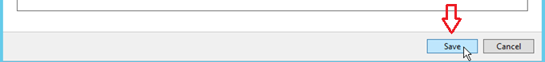

4. In the **Content** tab, uncheck the “**Block pop-pup windows**” option.

|  |  |
| --- | --- |
|  |  |

5. Locate and run the **NNM Console**.

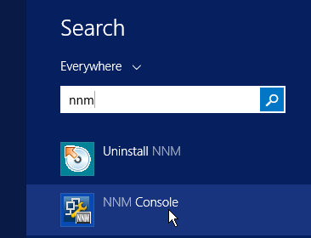

6. Sign in with user name **system** and password **net311**.

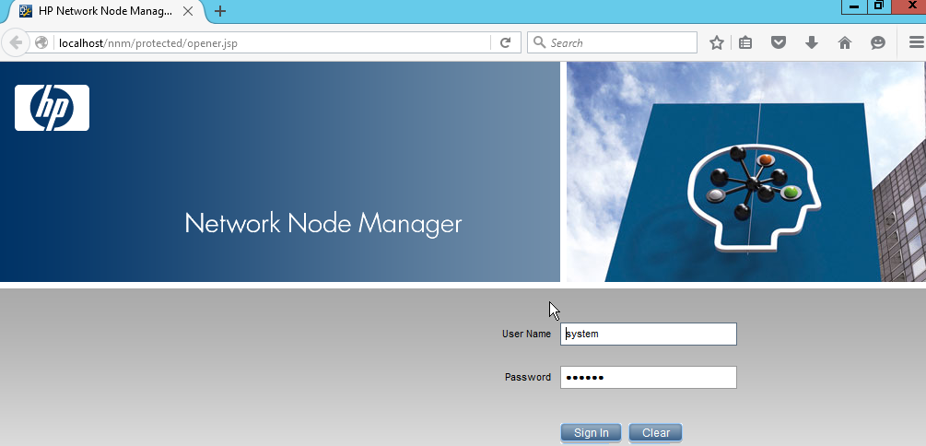

7. In the Network Node Manager window click on **Configuration** tab, then click on **Communication Configuration**.

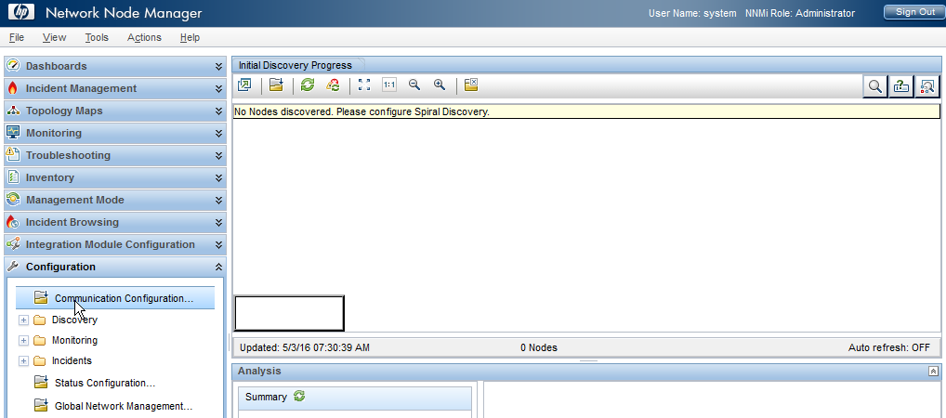

8. Check Enable **SNMP Address Rediscovery**. Set the **SNMP Timeout** to **20** and **SNMP Retries count** to **10**.

9. Click the **New** button under Default SNMPv1/v2 Community Strings.

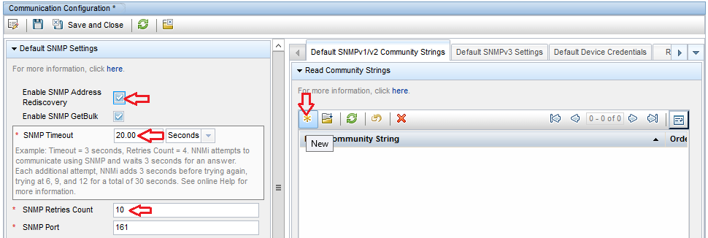

10. Add the Read Community String **public** and Ordering **1**. Click on **Save and Close**.

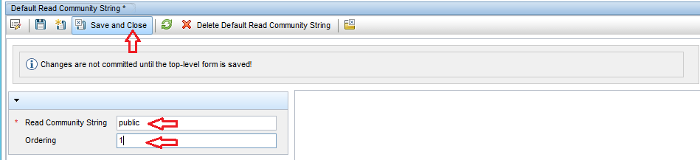

11. In **Write Community String**, type **private** and **private**.

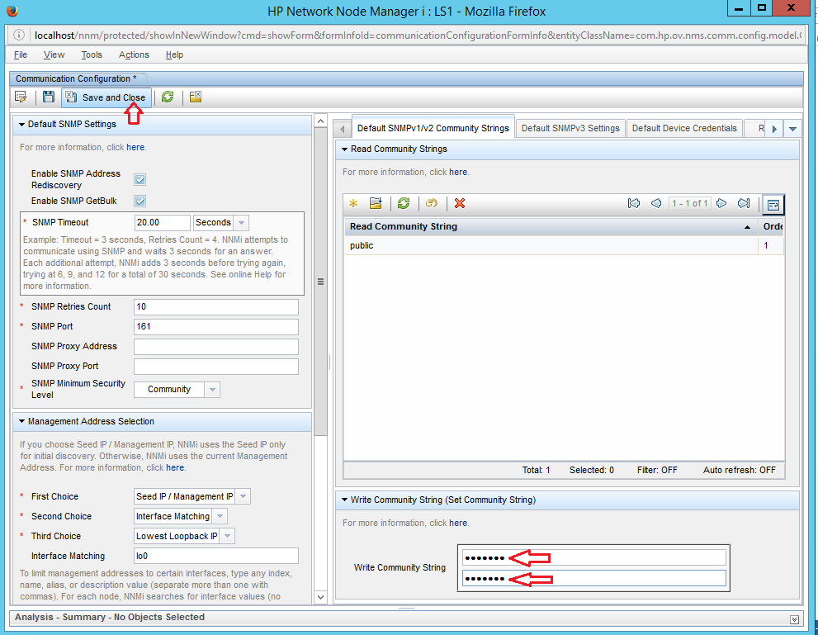

12. Scroll down then change the **ICMP Timeout** to **20** and **ICMP Retries Count** to **10**.

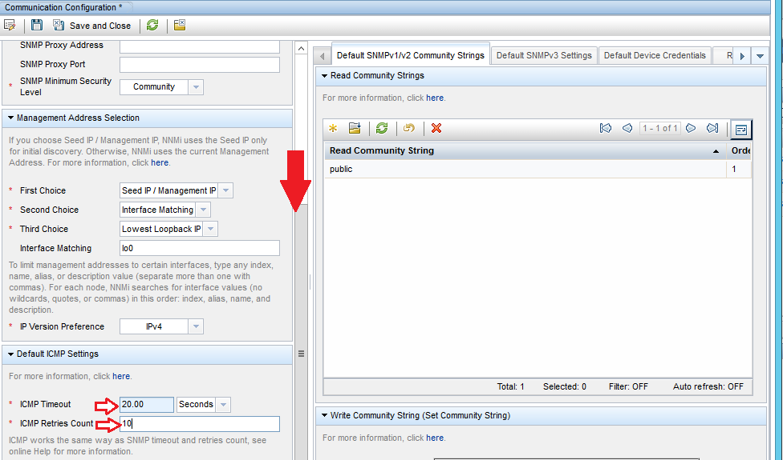

## Lab sheet 4.1: provide a screenshot showing the Communication Configuration screen.

13. Click on **Save and Close**.

14. Click on **Discovery** then click on **Discovery Configuration**.

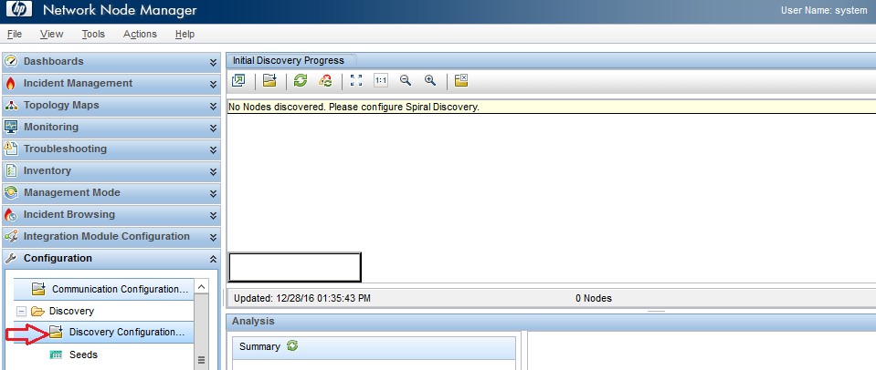

15. Open the **Auto-Discovery Rules** tab, then click on **New**.

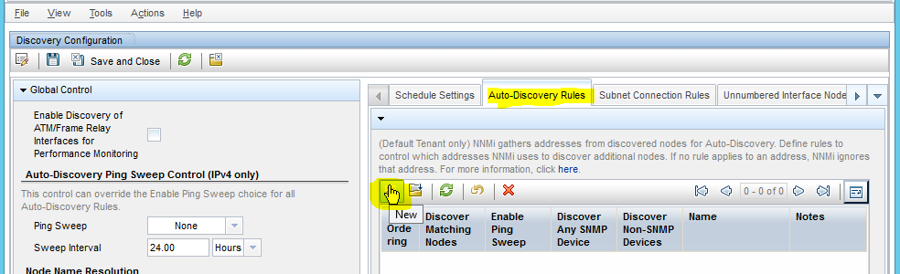

16. Add the Name **Lab-10**, Ordering **1**. Check the options **Discover Any SNMP Device**, **Discover Non-SNMP Devices** and **Enable Ping Sweep**. Then click **New**.

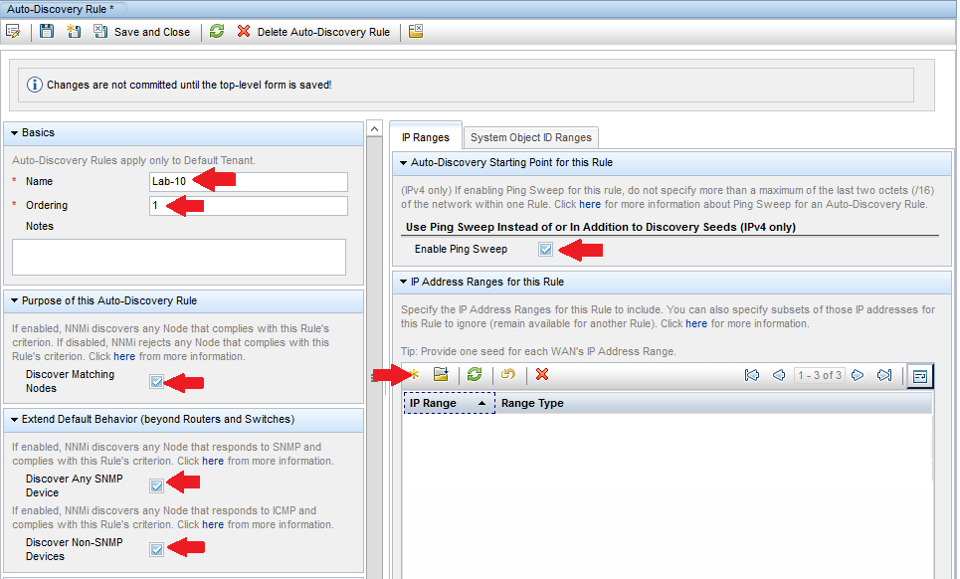

17. Add the IP Ranges **172.16.0.0/24**, **172.16.2.0/24**, **172.16.3.0/24**. Click **Save and Close**.

|  |  |  |
| --- | --- | --- |
|  |  |  |

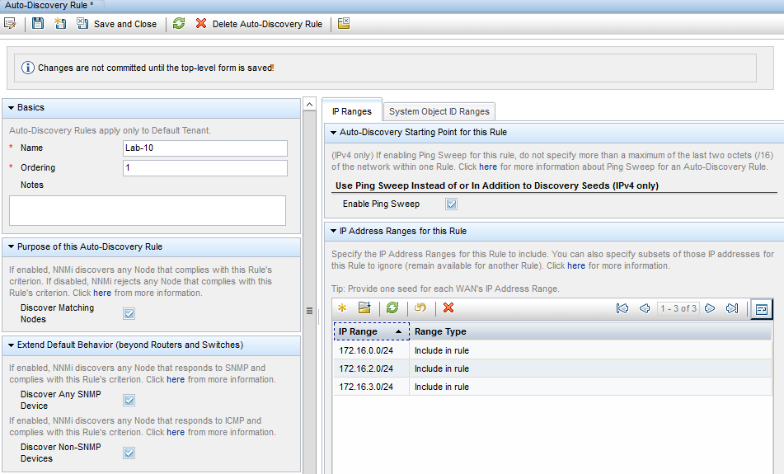

## Lab sheet 4.2: provide a screenshot showing the Auto-Discovery Rule screen.

18. In the Auto-Discovery Rule window, click **Save and Close**.



19. In the Discovery Configuration window, click **Save and Close**.



20. Click on **Discovery** then click on **Seeds**. Then click on **New**.

|  |  |
| --- | --- |
|  |  |

21. Enter Hostname/IP values: **172.16.0.1**, **172.16.2.1** and **172.16.3.1**. Click **Save and Close**.

|  |  |  |
| --- | --- | --- |
|  |  |  |

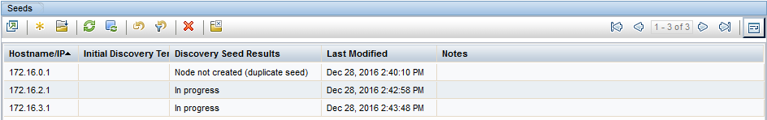

## Lab sheet 4.3: provide a screenshot showing the Seeds screen.

# Part 5: Inspect Network Devices using HP NNM

1. Click on **Inventory**, then click on **Nodes**.

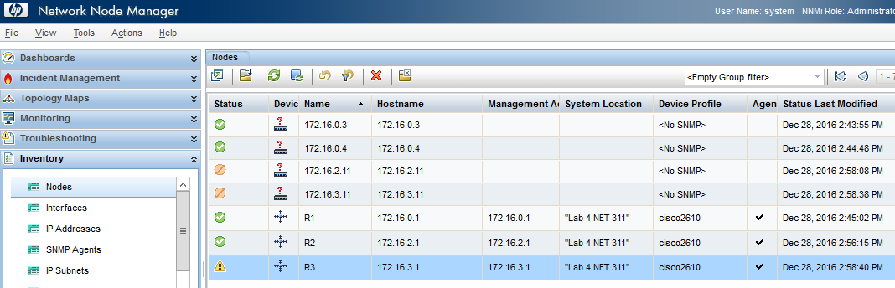

## Lab sheet 5.1: provide a screenshot showing the Nodes screen.

2. Double click on **R1** and view its information. You can view in a separate window by clicking on .

3. Browse the different tabs on R1.

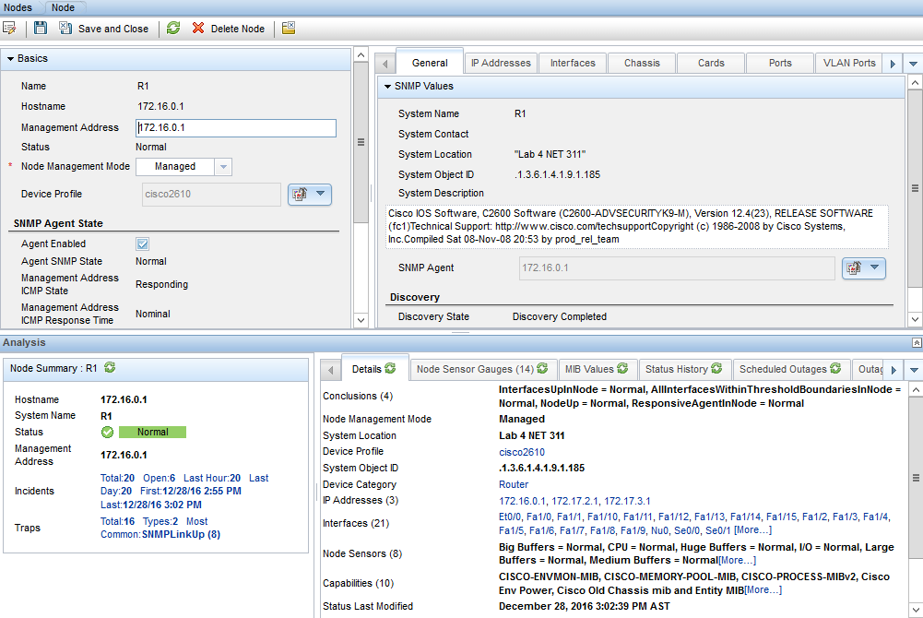

4. Click on the **Interfaces** tab of R1. You can view it in a separate window by clicking on .

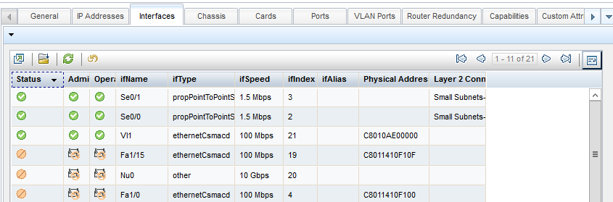

## Lab sheet 5.2: provide a screenshot showing the Interfaces of ESW1.

5. Close the Interfaces window by clicking on .



6. Under **Topology Maps,** click on **Network Overview**.

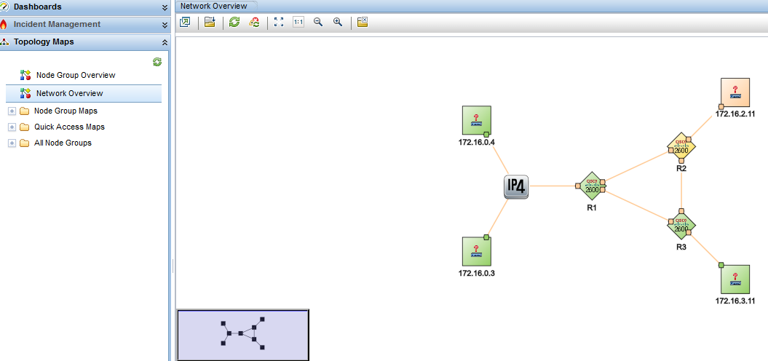

## Lab sheet 5.3: provide a screenshot showing the Network Overview screen.

# Part 6: Network Troubleshooting using HP NNM

1. **Stop** one of the nodes in the network, for example **PC1**.

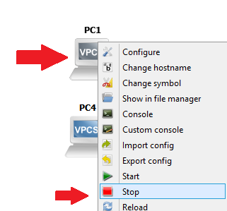

2. Under **Incidents,** click on **All incidents** and locate the **Node Down** incident for the IP of PC1.

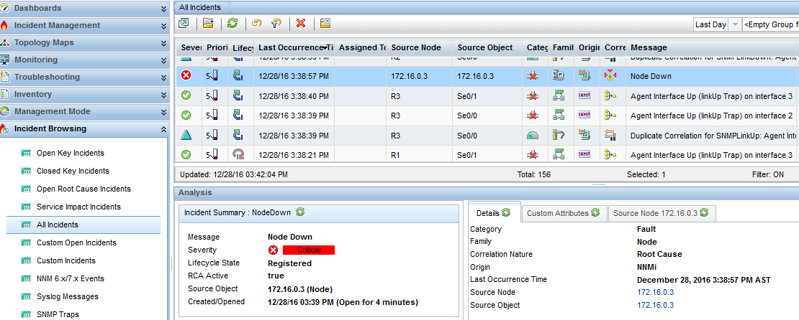

## Lab sheet 6.1: provide a screenshot showing the Incidents screen.

3. In the **Topology** > **Network Overview** screen, right-click on **R2** then click on **Node Access > Ping (from server)**.

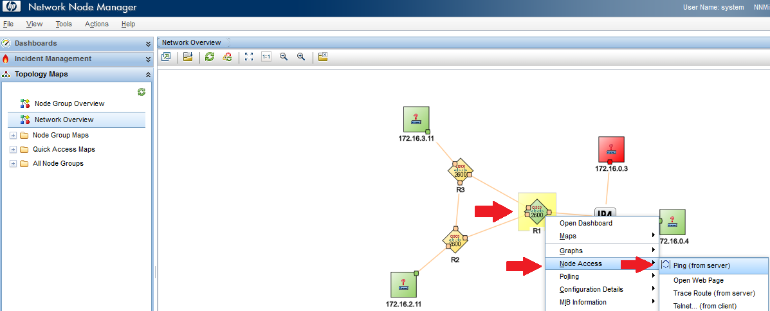

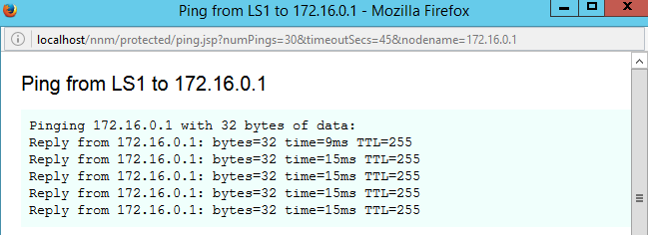

## Lab sheet 6.2: provide a screenshot showing the output of the Ping screen.

4. In the **Troubleshooting** click on **Layer 2 Neighbor View** screen, then select the IP of **R1**.

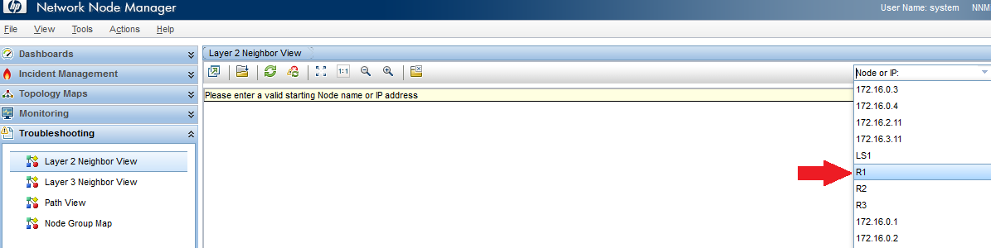

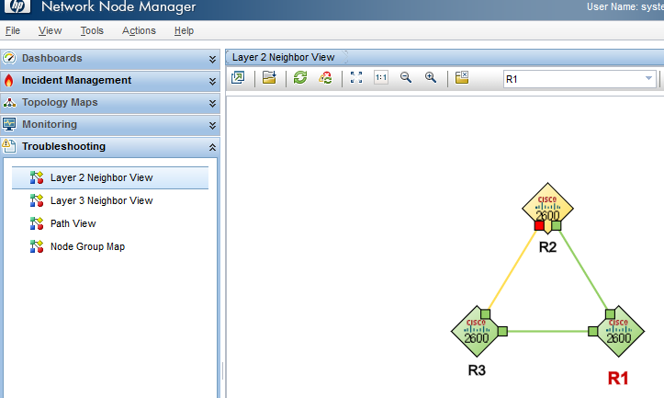

## Lab sheet 6.3: provide a screenshot showing the output of the Layer 2 Neighbor View screen.

5. Right-click on **R1**, then click on **MIB Information** -> **MIB Browser**.

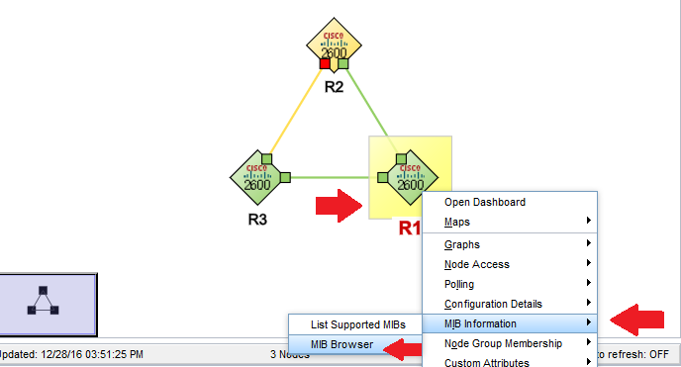

6. Click on SNMP Walk.

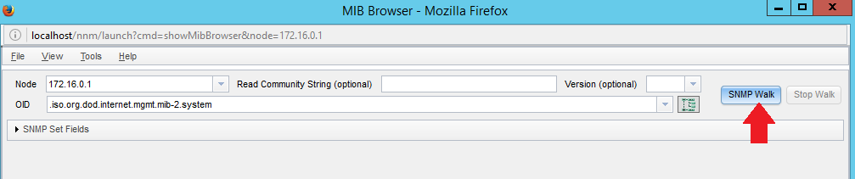

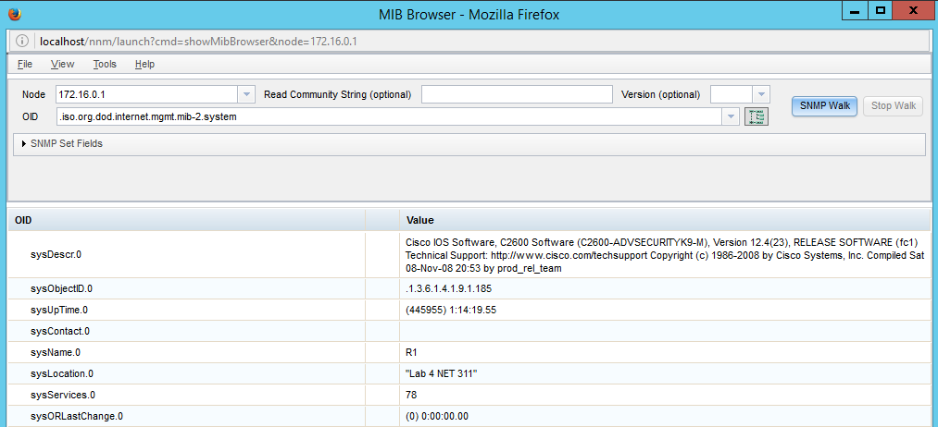

## Lab sheet 6.4: provide a screenshot showing the output of SNMP Walk in the MIB Browser.