 

**NAME: Md Akbal**

**STUDENT ID: 10702**

**WEEK 5 :It assignment**

EXERCISE :1

Write the HTML code

1 The italics tag

2 The Center tag

3 The paragraph tag

4 The Break tag

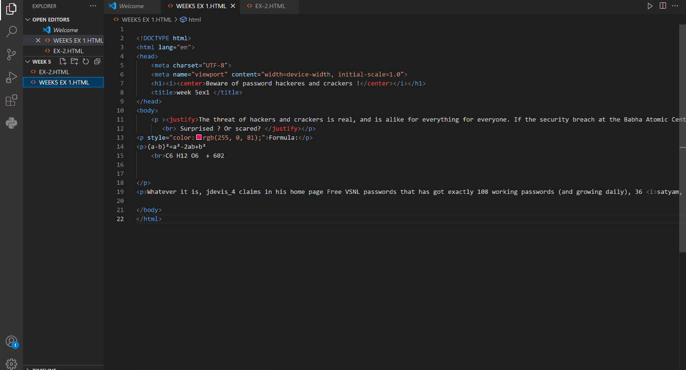

**OUTPUT:**

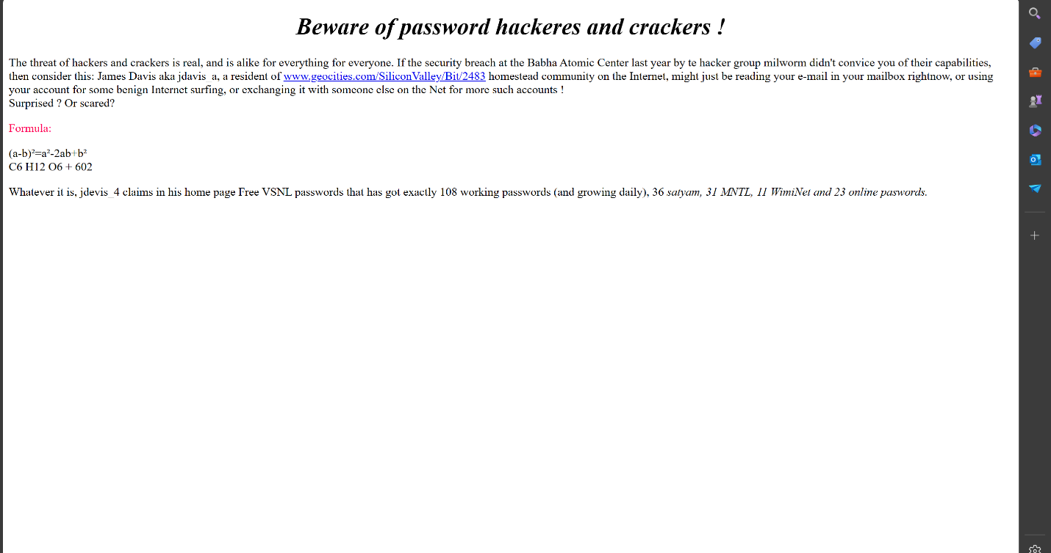

EXERCISE :2

2. Looking at the screen given below write the HTML code

1. Unordered Lists
2. Ordered Lists
3. Definition Lists
4. Heading tag

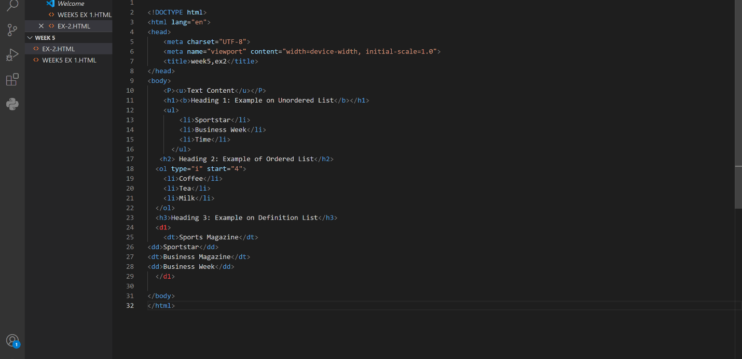

**OUTPUT:**

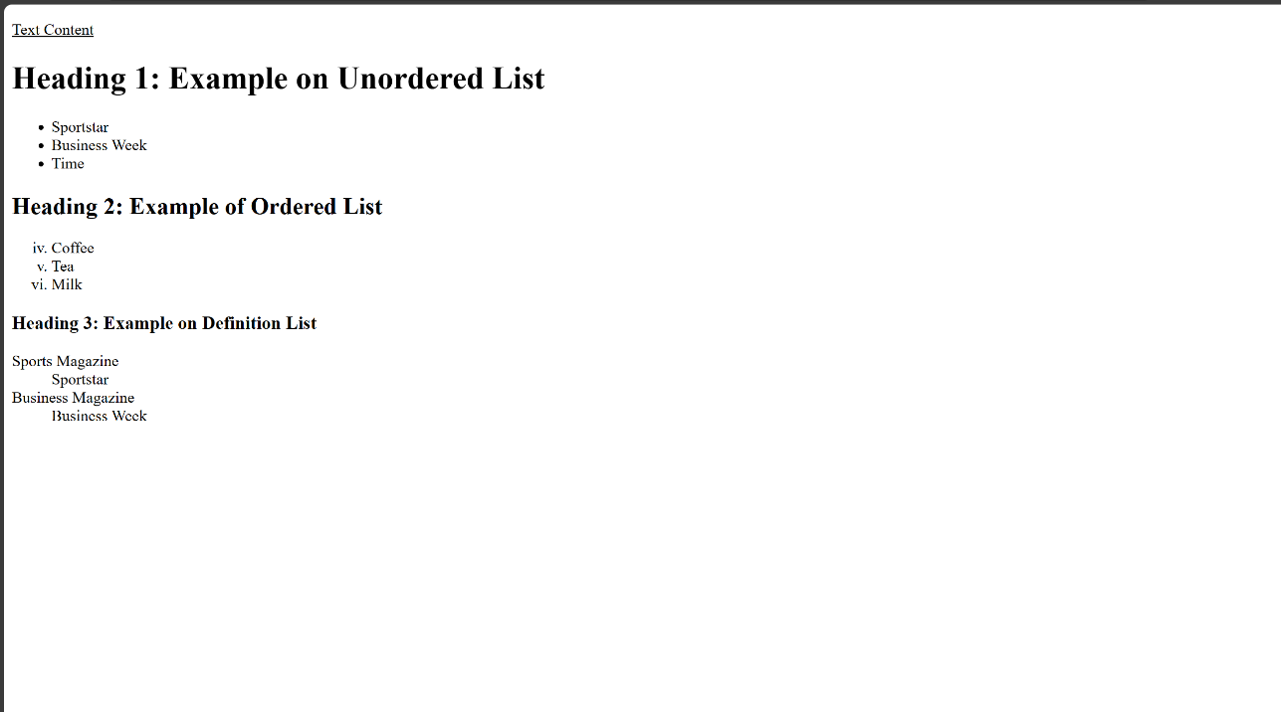

EXERCISE 3

Design a two web page according to the following

**Page 1 detail:**

Use “landscape.jpg” image as page background and display the content on top of it. Text

content should visible, background image should not affect the text content.

**Page 2 detail:**

Use “BLACK color” as background color and display text content on top of it using

“WHITE color”

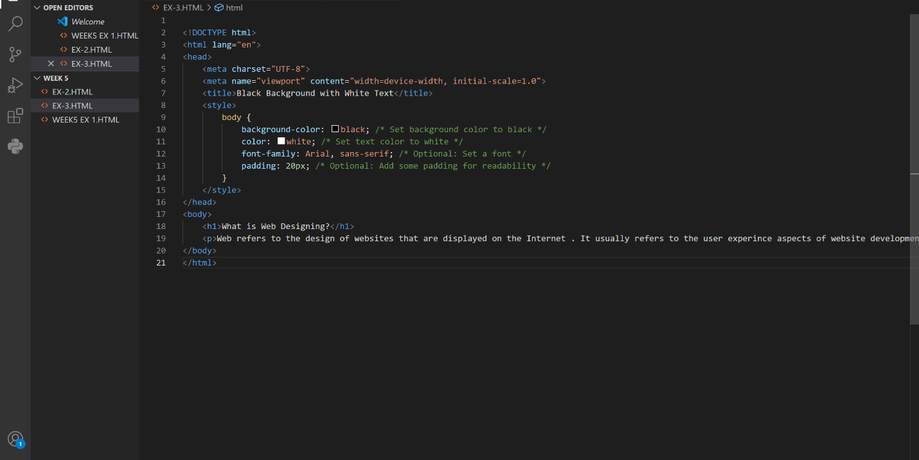

**OUTPUT:**

