Internet Technologies

Corse: BSc (Hons) CS & DF

STUDENT: Md Akbal

I’D: 10702

WEEK:8

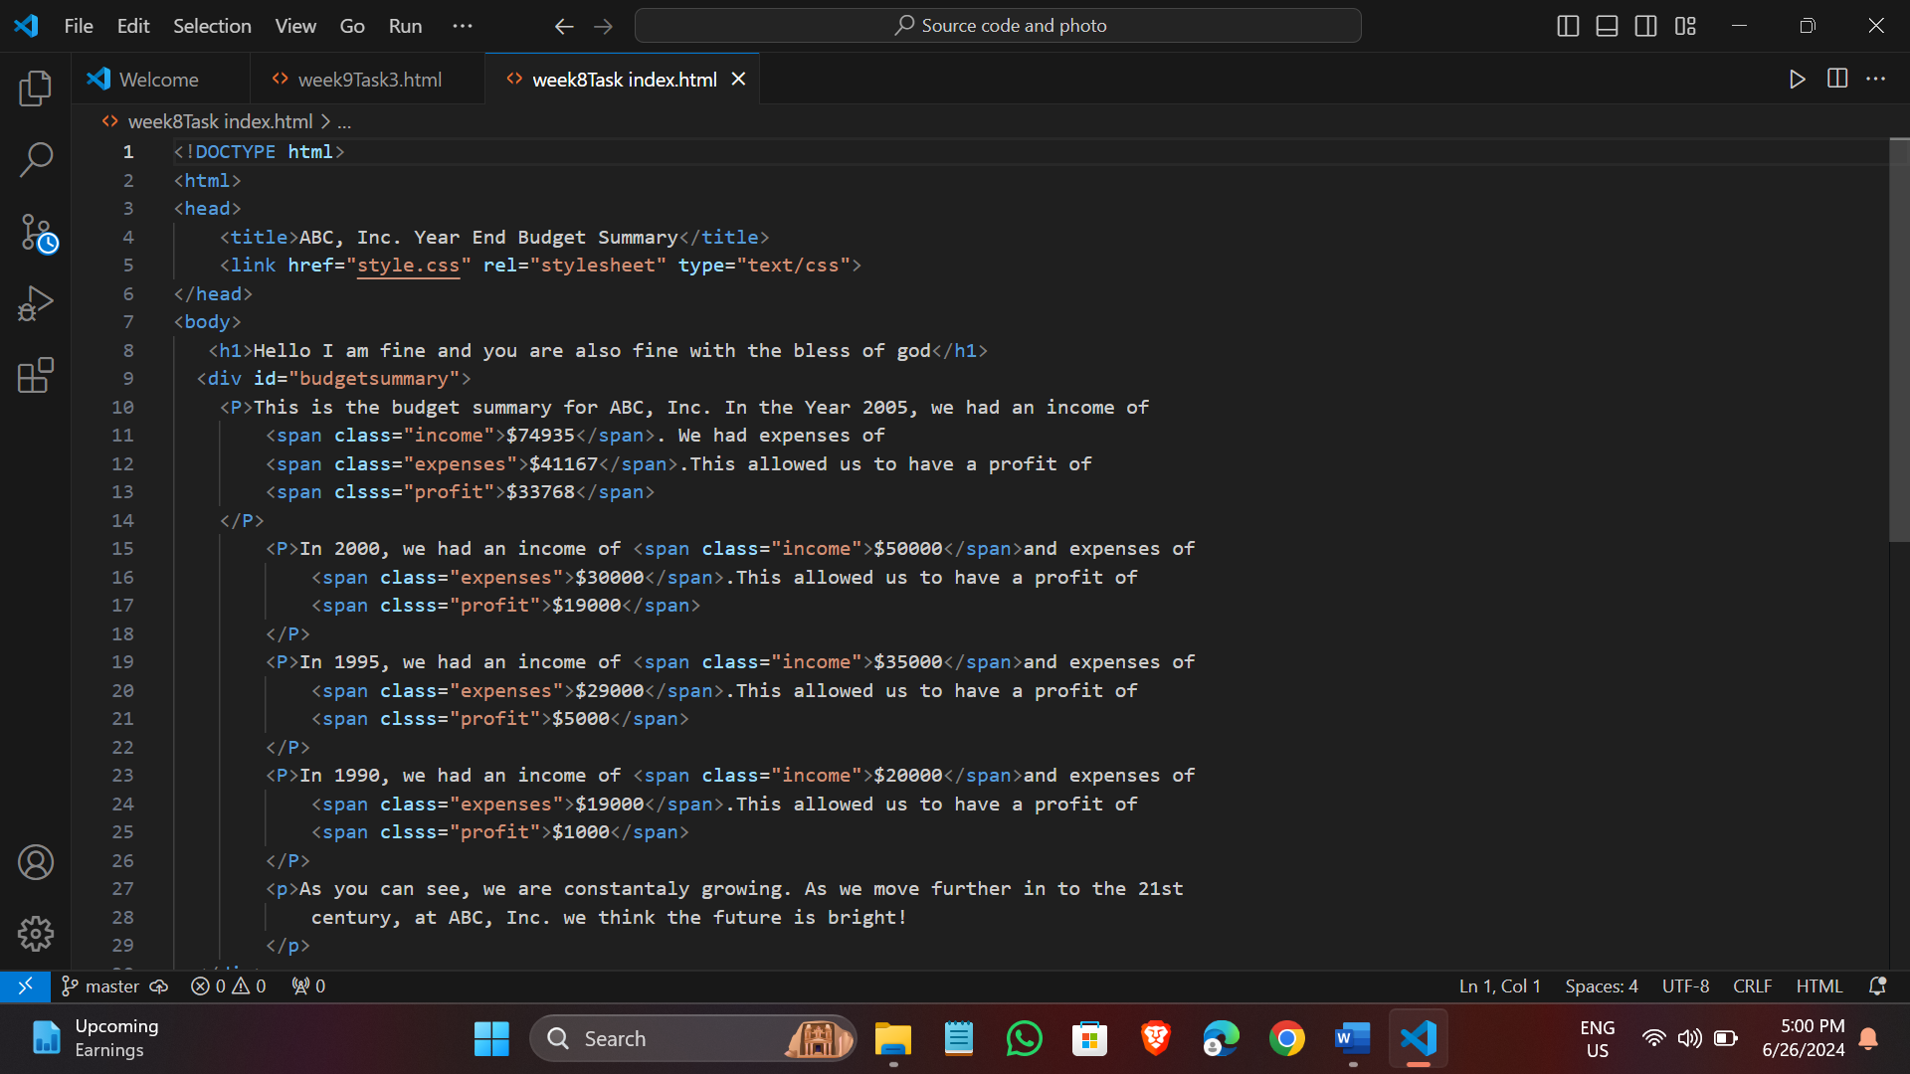

REFLRCTION:-

In my reflection, I will describe the experience of preparing and delivering the presentation, analyze its effectiveness, and discuss the lessons I learned from it. I am writing a reflection about the presentation I did. On the first day, the teacher assigned us to groups. And after that, we formed group and appointed one person as the group leader. The group leader of my group was Pratha. There were a total or four members in my group, whose names were Osama, Sulakshan, Pratha and Sonam. The name of my group was Firewall. And after that, the teacher told us form group and choose a topic on the same day.

The topic or my group’s presentation was “The Life of Vincent van Gogh.” I mad good slides for the presentation, but since my Eid holiday fell during the week or the presentation, I went home and couldn’t practice with my friends. This lack or practice was evident when I gave the presentation. On the day of the presentation, just before it started, I conducted a demo presentation within my group. The demo went well within the group, but I hadn’t practiced enough myself, unlike my friends who had practiced well. During the presentation, I believed I would do well, but it didn’t turn out as well as I had hoped. My group members did will because they had practiced thoroughly. On the day of the presentation, our group did the demo 3 to 4 times. Although I contributed well to my group, I couldn’t present well myself.

During the presentation, three groups presented together, and my group was scheduled second. When it was our turn, my group member Sulakshan Joshi went first to give the introduction part of the presentation, and he spoke quite well. And after that, it was Pratha sharma, and she did well too. Third was Sonam jha turn, and she also did well. Finally, it was my turn, and I also presented. After our group finished the presentation, the teacher asked some questions related to our topic and gave us good suggestion along with pointing out our weaknesses. But the group presentation went well, and the group members were also good. Everyone worked together on everything, and they were cooperative friends. The group presentation went well, so we expect good marks from the teacher. I learned many significant things from the group presentation.

And finally, if I were to say what I want, from the group presentation, I learned a lot. It’s important to learn from each other’s experience and word together closely. Through the presentation, I also identified my weaknesses and learned a great deal. I feel confident about doing well in the future as well. After doing this presentation, our practice was also good. Now, I can move forward confidently knowing that I have had good practice.