**Optimization**

An allocation of limited resources in an optimal manner, under given circumstances obtaining best outcome.

In other words, a process of finding the conditions that returns optimum (maximum or minimum) of a function.

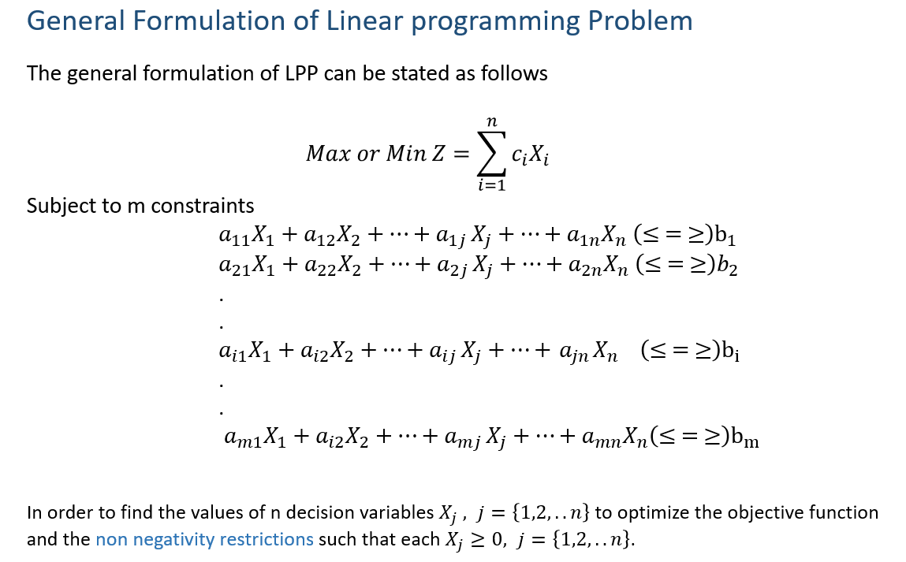 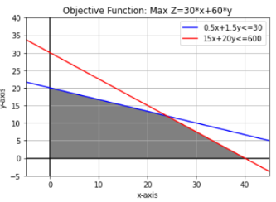

**Aircraft Capacity Planning**

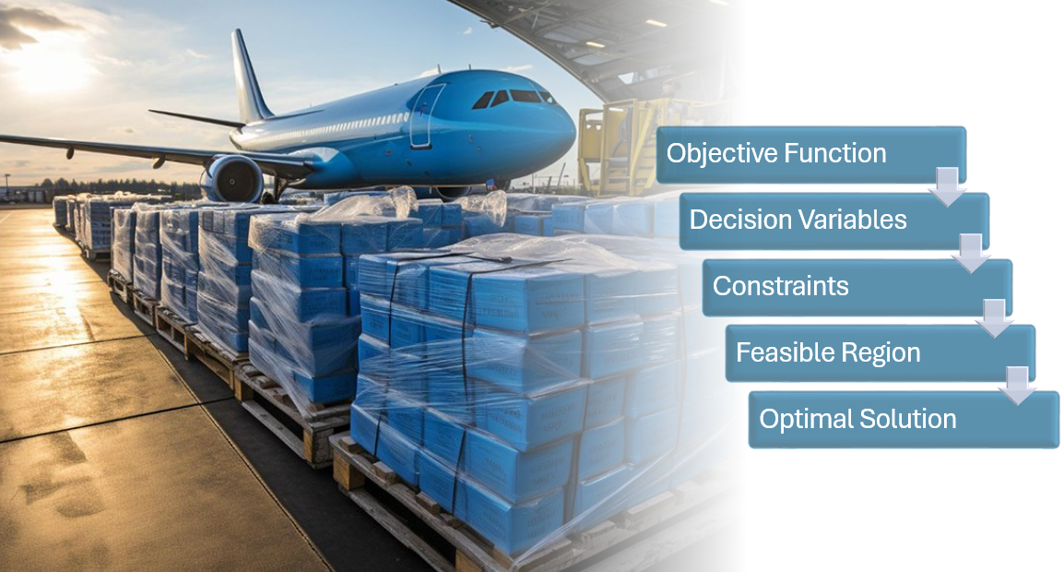

|  |  |  |  |  |  |  |  |  |  |  |  |  |  |
| --- | --- | --- | --- | --- | --- | --- | --- | --- | --- | --- | --- | --- | --- |
| A Cargo plane has three compartments for storing cargo: Front, Center and Rear  These compartments have the following limits on both weight and space.   |  |  |  | | --- | --- | --- | | **Compartment** | **Weight Capacity – tons** | **Space Capacity – cubic meters** | | Front | 10 | 6800 | | Center | 16 | 8700 | | Rear | 8 | 5300 |   Furthermore, the weight of the cargo in the respective compartments must be in the same proportion of that compartment’s weight capacity to maintain the balance of the plane. | |
|  |  |

The following four cargoes are available for shipment on the next flight:

|  |  |  |  |
| --- | --- | --- | --- |
| **Cargo** | **Weight – tons** | **Volume – cubic meters/ton** | **Profit - $/tons** |
| C1 | 18 | 480 | 310 |
| C2 | 15 | 650 | 380 |
| C3 | 23 | 580 | 350 |
| C4 | 12 | 390 | 285 |

Any proportion of these cargoes can be accepted. The objective is to determine how much of each cargo C1,C2, C3 and C4 should be accepted and how to distribute each among the compartments so that the total profit is maximized.

Objective Function and Decision Variables

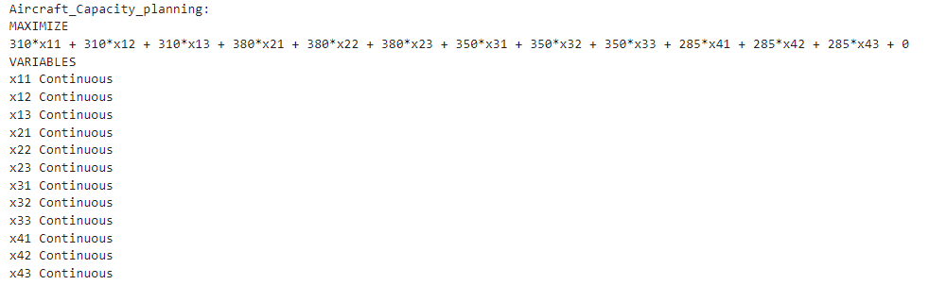

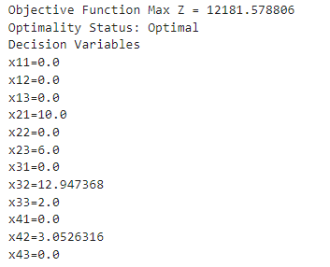

**Sensitivity Analysis**

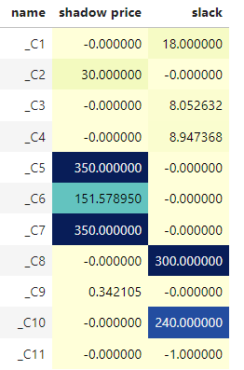

### **Shadow Price** - How much the objective function will improve if we increase the right-hand side (RHS) of a constraint by one unit.

* With #Cargo 2. Optimal Value is
* For a unit increase in #Cargo 2- . Optimal Value is .

### **Slack** - Unused RHS

* Unused Space capacity in compartments cubic meters