### **Travelling SalesMan Problem**

### **Objective**

Data - Tourism data with tourist spot name, category, latitude and longitude

* Get distance between each pair of tourist spot using coordinates in KM.
* Plot a directed graph to represent/visualize the distance from a tourist spot/point to all other spots.
* Assume we have tourist spots coordinates within a city, How can we cover all the spots by travelling minimal distance possible.
  + Use Travelling Sales Man Problem approach.

**Find the shortest possible route that visits each city exactly once and returns to the starting city.**

* + Visualize the shortest path and calculate the shortest distance in KM.

### **Visualize distance between cities using Networkx**

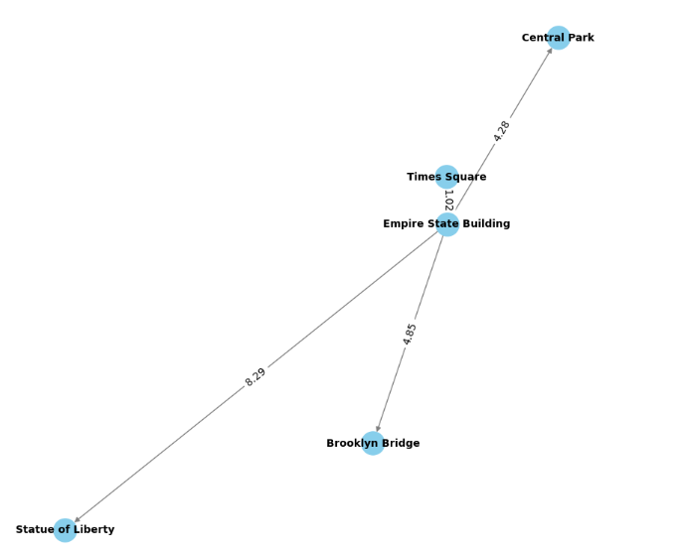

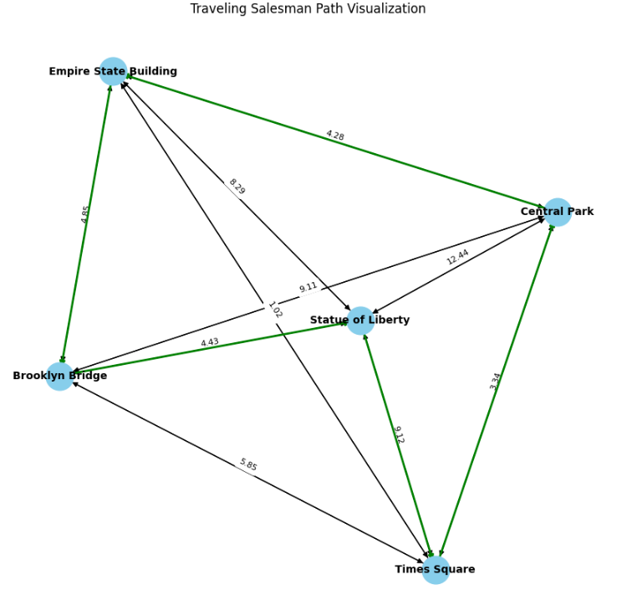

By enabling **nx-cugraph,** networkx execution time is

*NX_CUGRAPH_AUTOCONFIG=True*

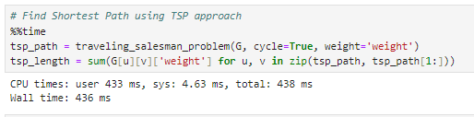

Else 1.56sec

**Google Earth Path using KML file.**

