Scoring

1. pyAHP - description

Github - https://github.com/pyAHP/pyAHP/tree/master

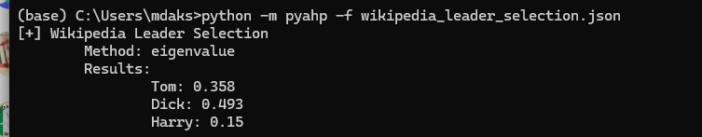

1. Suitability score -https://pro.arcgis.com/en/pro-app/latest/help/analysis/business-analyst/understanding-suitability-analysis.htm

https://en.wikipedia.org/wiki/Suitability_analysis

-run this results - https://michaelminn.net/tutorials/python-suitability/

3.learning to rank - https://everdark.github.io/k9/notebooks/ml/learning_to_rank/learning_to_rank.html

# 4.LSP Decision in ranking

5. python library pymcdm - weighted product method of scoring in EV car data- WPM.py