- Total Loan Applications
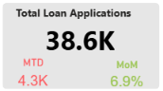
The bank processed 38.6K loan applications, with a 6.9% month-over-month increase, indicating growing customer demand. The current month's 4.3K applications suggest that lending activity remains strong.
Recommendation:
Continue marketing campaigns to maintain the positive growth in loan applications.
- Funded Amount and Received Amount
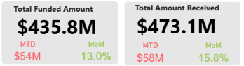
The bank funded $435.8M in loans, and the funded amount increased by 13% compared to the previous month, showing higher customer demand for loans.
Recommendation:
The bank should continue promoting loan products to keep the loan demand growing. At the same time, every loan application should be checked carefully before approval.
- Interest Rate
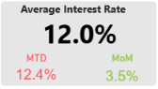
The average interest rate increased by 3.5% compared to the previous month. This may help increase the bank's interest income
Recommendation:
The bank should regularly review interest rates based on customer demand and market conditions. This will help attract new customers while maintaining steady income.
- Average DTI (Dept-to-Income)
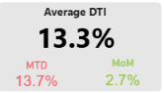
The Debt-to-Income Ratio increased by 2.7% compared to the previous month. This means customers are taking on slightly more debt, so the bank should continue monitoring their repayment capacity.
Recommendation:
The bank should regularly monitor customers with higher Debt-to-Income Ratios before approving new loans. This will help reduce the risk of future payment problems.
- Good Loans
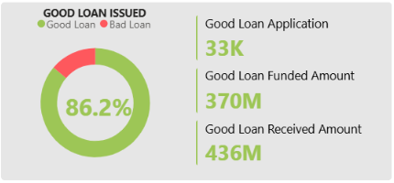
The bank has a Good Loan Rate of 86.2%, which shows that most customers are paying their loans on time. This indicates a healthy loan portfolio and good credit quality.
Recommendation:
The bank should continue following its current loan approval process because it is helping maintain a high percentage of good loans. This will support stable business growth.
- Bad Loans
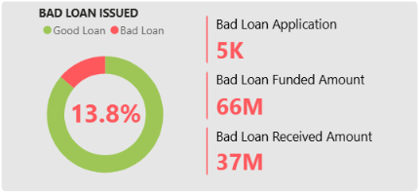
The bank has a Bad Loan Rate of 13.8%, which means a small group of customers failed to repay their loans. Although the percentage is lower than good loans, it still affects the bank's profit.
Recommendation:
The bank should strengthen the loan approval process by carefully checking customer income, credit history, and repayment ability. This can help reduce the number of bad loans.

Loan Status
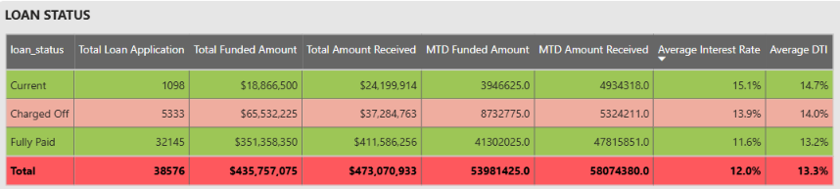
Most of the loans are Fully Paid, with 32,145 applications and $411.6M received from customers. This shows that most borrowers are repaying their loans successfully, which is a positive sign for the bank.
Recommendation:
The bank should continue supporting customers with a good repayment history while closely monitoring active loans. This will help maintain a healthy loan portfolio and improve customer trust.
- Total Loan
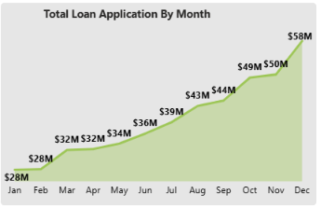
The total funded amount shows a steady increase throughout the year, growing from $28M in January to $58M in December. This indicates that loan demand increased consistently over time.
Recommendation:
The bank should review the reasons behind the strong performance in the last few months and use similar strategies in future marketing campaigns. This can help maintain steady loan growth throughout the year.
- Total Loan Application By Months
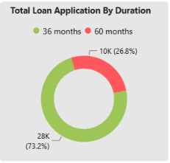
Most customers (73.2%) preferred the 36-month loan duration, while only 26.8% selected the 60-month loan duration. This shows that customers generally prefer shorter loan repayment periods.
Recommendation:
The bank should continue promoting 36-month loan plans, as they are preferred by most customers. This can help maintain strong loan demand and improve customer satisfaction.
- Total Loan Applications

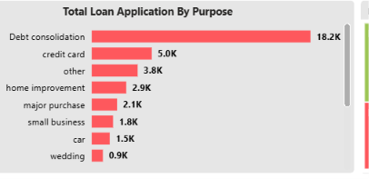
Debt Consolidation is the most common loan purpose with 18.2K applications, which is much higher than any other category. This shows that many customers are using loans to combine and manage their existing debts.
Recommendation:
The bank should review the lower-performing loan categories and understand customer needs. Special offers or better loan features may help increase applications in these segments.
- Loan Details
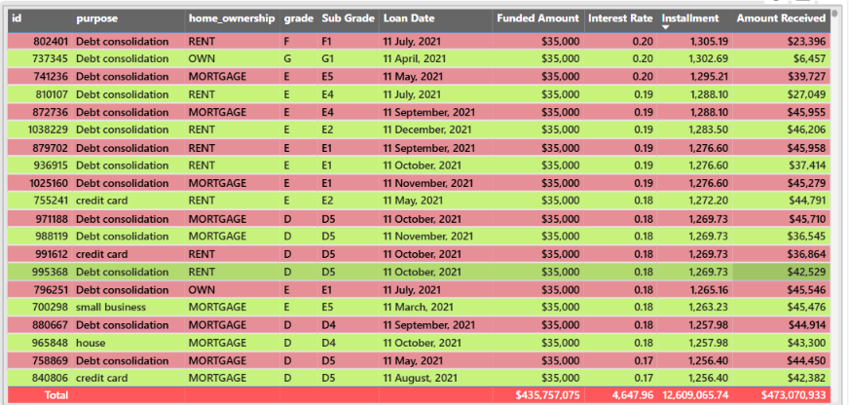
The table includes customers with different home ownership types, loan grades, and interest rates. This shows that the bank provides loans to different customer groups based on their credit profile and eligibility.
Recommendation:
The bank should regularly review loan grades, interest rates, and repayment performance to ensure loans are offered to the right customers. This will help maintain a healthy loan portfolio and improve overall loan quality.

