1.Data Understanding
The dataset was explored to understand its structure, columns, data types, and summary statistics. The number of rows and columns was also checked to get a clear overview of the data. This step helped in understanding the dataset before starting data cleaning and further analysis.

2. Data Cleaning
The dataset was cleaned by removing duplicate records and handling missing values using suitable methods. This improved the quality of the data and made it ready for accurate analysis.
Removed Duplicate Data
- Checked the dataset for duplicate records.
- Removed duplicate rows to make sure every record was unique.
Handled Missing Values
- Checked for missing values in the dataset.
- Replaced missing values using a suitable method to keep the data complete

3. Feature Engineering
New columns were created to improve the analysis and provide better business insights. Policy Year, Vehicle Age, Vehicle Age Group, Premium Category, and Claim Ratio were added using the existing data. Vehicle Age and Premium were grouped into different categories to make the analysis easier and more meaningful. These new columns helped in understanding vehicle condition, premium levels, claim performance, and customer risk more effectively.

4. Exploratory Data Analysis (EDA)
Exploratory Data Analysis (EDA) is the process of examining, summarizing, and visualizing a dataset before performing advanced analysis or building dashboards. The primary objective of EDA is to understand the structure of the data, identify missing values, detect outliers, discover patterns, and reveal relationships between variables.

EDA helps transform raw data into meaningful insights and ensures that the dataset is clean, reliable, and suitable for business analysis.

1.Vehicle Age Distribution
Most vehicles are new or have a low age (1–10 years), showing that customers mainly insure newer vehicles. As vehicle age increases, the number of insured vehicles decreases. Only a small number of vehicles are older than 30 years.
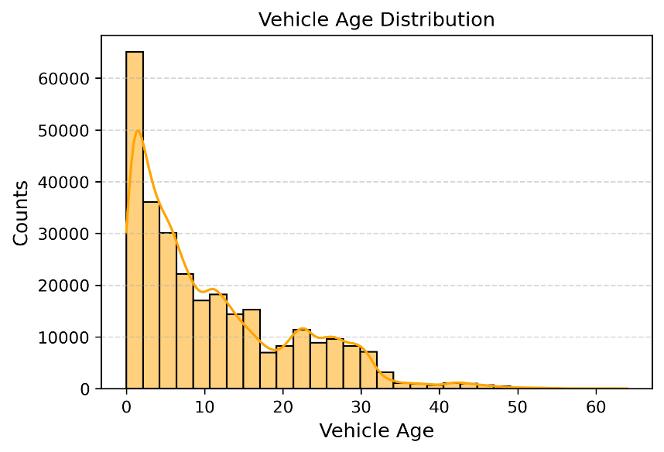
Recommendation
The company should continue focusing on newer vehicles while reviewing insurance plans for older vehicles, as they may have different risk levels.

2. Top 10 Vehicle Brands
Toyota has the highest number of insured vehicles in the dataset. Isuzu and Nissan also have a good number of vehicles, while the other brands have fewer vehicles. This shows that most customers prefer a few popular vehicle brands.
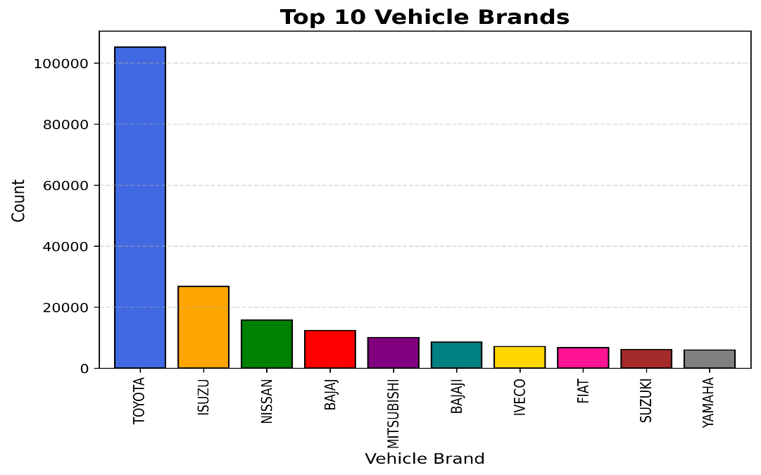
Recommendation
The company should offer special plans and customer benefits for popular brands like Toyota, Isuzu, and Nissan to increase customer satisfaction and policy renewals.

3. Vehicle Types Distributions
Most insurance policies are for Trucks, Pick-ups, and Automobiles, making them the most common vehicle types in the dataset. On the other hand, Tankers, Tractors, Special Construction vehicles, and Trade Plates have the lowest number of insurance policies.
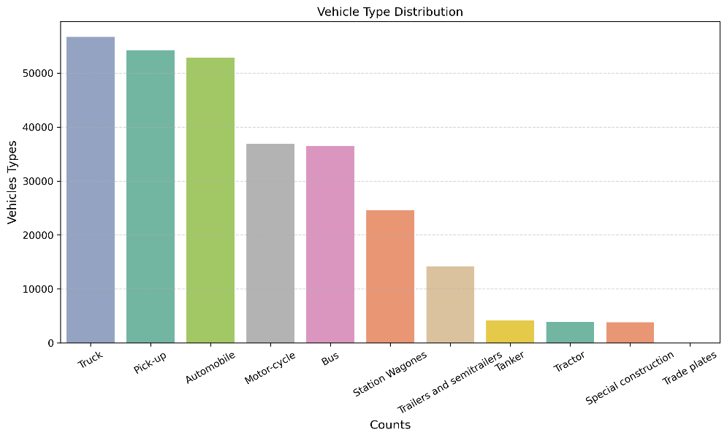
Recommendation
The company should create insurance plans based on different vehicle types and focus more on the most common vehicles such as Trucks, Pick-ups, and Automobiles.

4. Premium Amount v/s Claim Amount
Most insurance policies are for Trucks, Pick-ups, and Automobiles, making them the most common vehicle types in the dataset. On the other hand, Tankers, Tractors, Special Construction vehicles, and Trade Plates have the lowest number of insurance policies.
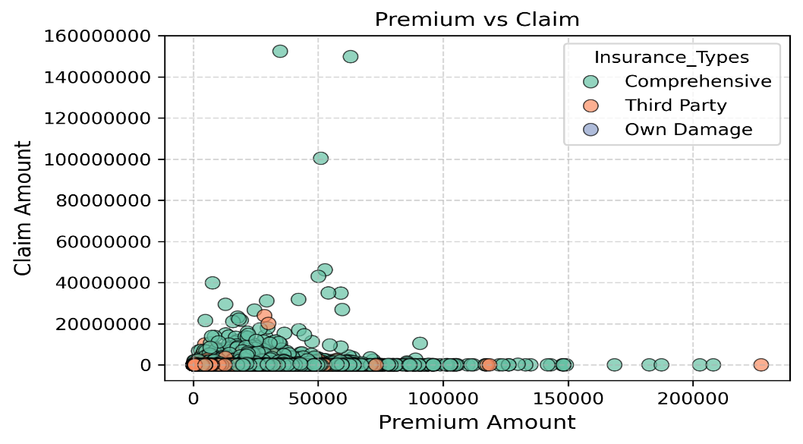
Recommendation
The company should regularly monitor policies with high claim amounts and improve risk assessment to reduce future losses. This can help in setting fair premium prices and controlling claim costs.

5. Vehicles Types v/s Premium
Tanker vehicles have the highest average premium, followed by Truck and Bus. On the other hand, Motor-cycle and Trade Plates have the lowest average premium. This shows that premium amounts are different for each vehicle type.
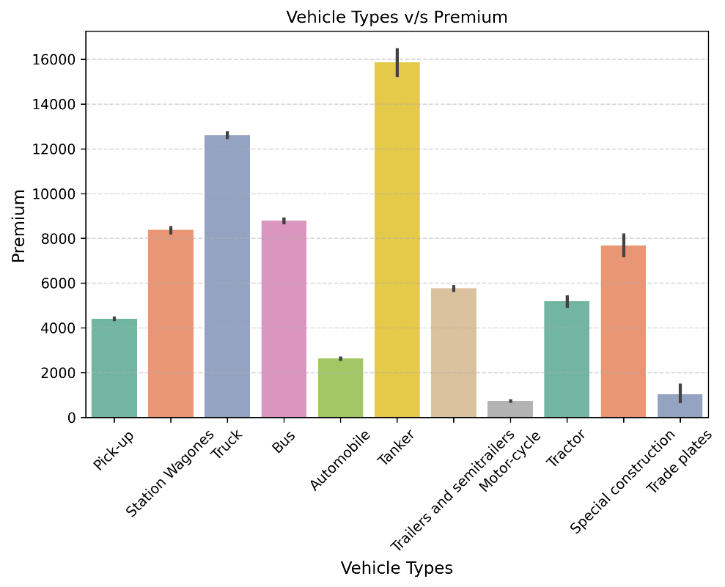
Recommendation
The company should set premium prices based on the risk and usage of each vehicle type. High-risk vehicles should be reviewed regularly to ensure the premium is fair and matches the level of risk.

6. Top 10 Brands v/s Claim Amount
Toyota has the highest total claim amount among all vehicle brands, followed by Isuzu and IVECO. The remaining brands have much lower claim amounts, showing that claims are mainly concentrated in a few popular brands.
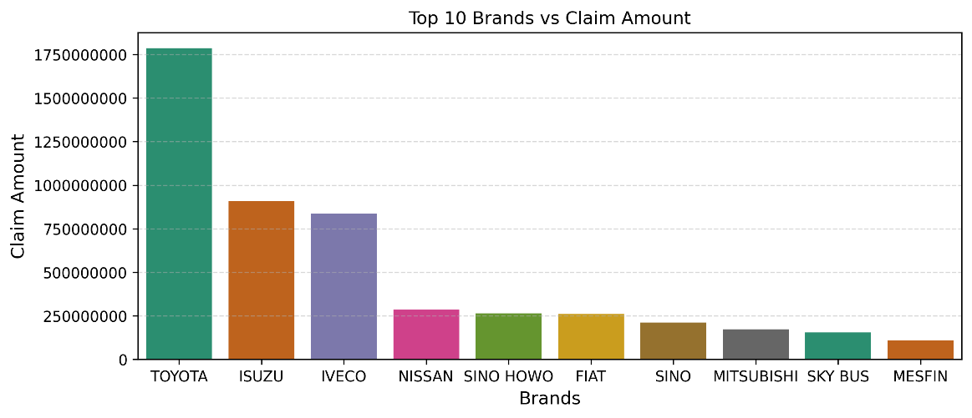
Recommendation
The company should regularly monitor brands with high claim amounts, especially Toyota, Isuzu, and IVECO. Better risk assessment and claim management for these brands can help reduce future claim costs.

7. Vehicle Age vs Claim Category
Vehicles in the Low Premium category have the highest average vehicle age in both No Claim and Claim Paid groups. Vehicles in the High Premium category have the lowest average vehicle age. This shows that older vehicles are mostly insured with lower premiums.
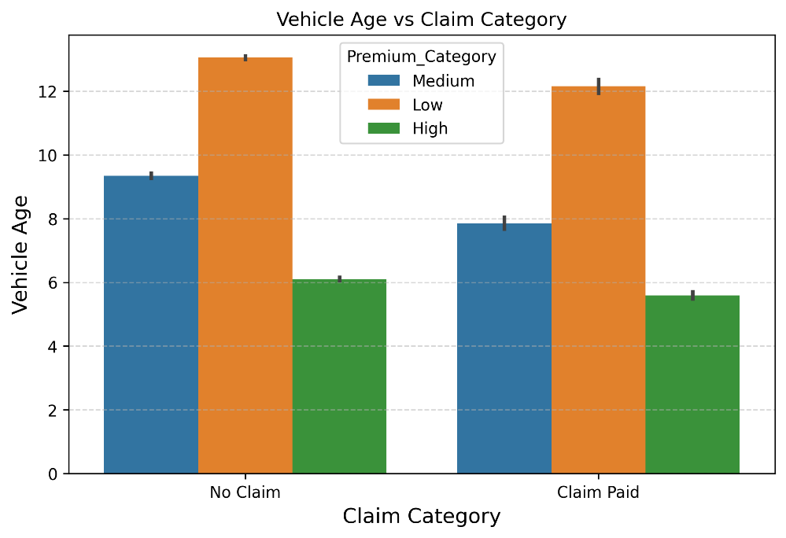
The company should review premium plans based on vehicle age and claim history. This can help provide fair pricing and improve risk management for different vehicle groups.

8. Top 5 Usage Types
General Cartage has the highest total claim amount among all usage types. Own Goods and Fare Paying Passengers also have high claim amounts, while Private and Own Service have much lower claim amounts.
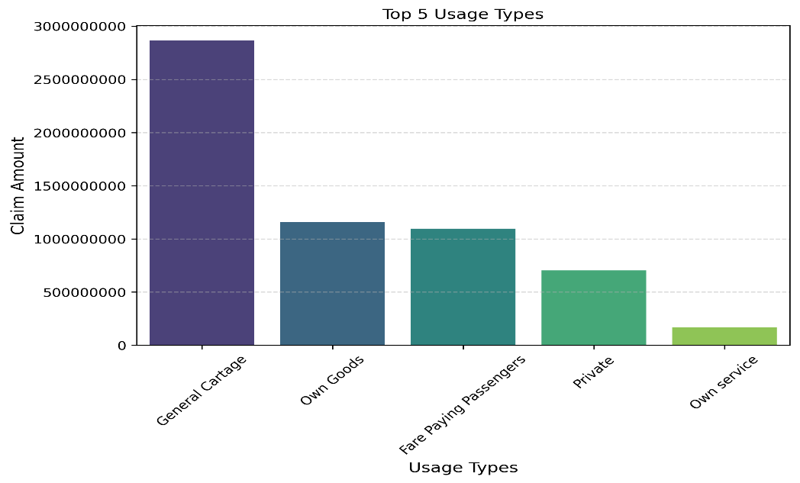
Recommendation
The company should closely monitor General Cartage vehicles and improve risk assessment for commercial usage types. This can help reduce claim costs and improve claim management.

9. Vehicle Age v/s Claim Amounts
Claim amounts are generally higher for newer vehicles and decrease as vehicle age increases. However, there is a large spike around 18 years, showing that a few vehicles of this age have very high claim amounts.
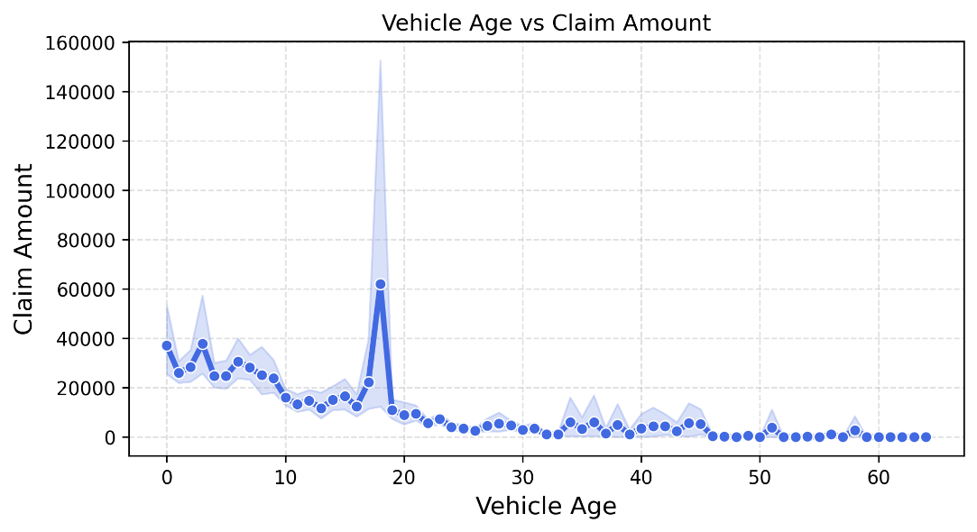
Recommendation
The company should closely monitor vehicle ages with high claim amounts, especially around 18 years, and review their premium and risk assessment. This can help reduce future claim costs and improve pricing accuracy.

10. Brand, Vehicle Types and
Most policies have low to medium premium amounts, while only a small number of policies have very high premiums. The chart also shows several high premium outliers, which means a few customers pay much higher premiums than others.
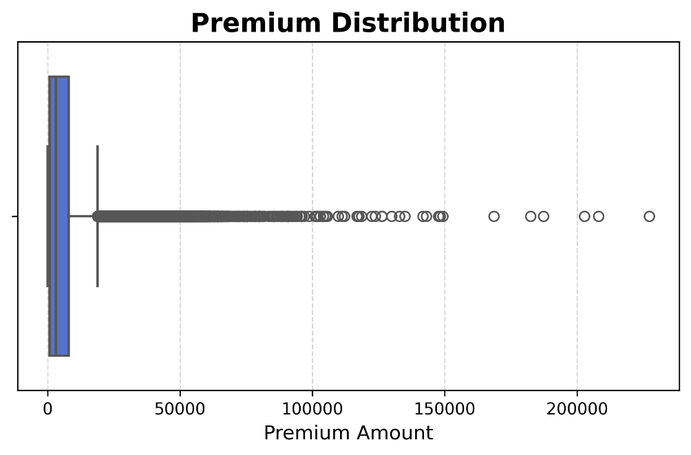
Recommendation
The company should review high premium policies regularly to ensure that the premium is based on the correct level of risk. This can help maintain fair pricing and improve customer satisfaction.

Datasets

