AWS – Amazon Bedrock & Generative AI Lecture Notes

Artificial Intelligence
Artificial Intelligence includes developing programs that imitate cognitive thinking of humans and can take decisions based on learned experience.
Machine Learning
It is a subset of artificial intelligence which deals with using algorithms to train models that can provide statistical predictions based on learned patterns in the input data. It is divided into three broad categories namely,
- Supervised
  - Training data is labelled.
    - Example of classification use case be “spam filter” for emails, i.e. classifying emails into spam or non-spam based on their content.
    - Example of regression use case be “sales prediction”; i.e. determining future sales of a Walmart store based on historical purchases.
- Unsupervised
  - Training data is unlabeled.
    - Example of clustering includes “clustering customers” to provide targeted ads or discounts to prevent churns in certain groups.
    - Example of association includes “recommending or finding the next probable product of purchase” based on basket pattern learning.
- Reinforcement Learning
  - Models are trained to work in a defined environment with state-action-reward method of learning.
    - Example is “self-driving cars” or “container optimization problem.” I.e. stacking shopping pallets optimally.
Deep Learning
It is a subset of machine learning which includes use of neural networks or multi-layer perceptron’s that are inspired by human brain and uses back-propagation algorithm for training. In general, when a neural network has > than three layers (including input and output layer) is generally referred as “deep”.
Common use cases include “self-driving cars” and “recommendation engines.”
Generative AI
It is a branch of artificial intelligence which used deep learning models to generate high quality text and image data. Popular examples include GPT models from OpenAI and Claude from Anthropic.
Terminology used in Generative AI
- Foundation Models
These are pre-trained deep learning models which are provided by popular organizations (private and public) that can be used to develop Generative AI based applications. They are also referred to as LLM’s or Large Language Models.

- Prompt
Inputs to Foundation model or LLM’s is generally referred to as “prompt”. A prompt can be text or image or multi-modal depending upon the type of foundation model used.
- Completion
Output of a LLM is also called “completion”.
- Inference
The process of prompt being passed to Foundation model followed by its completion is called “inference”.

Challenges in Traditional Deep Learning solved by Generative AI
Imagine training traditional models for following tasks:
- Text Generation
- Summarization
- Information Extraction
- Q&A
- Chatbot
In traditional deep learning and machine learning we would need to develop individual models for each of these above tasks that would expect different labeled datasets specially designed for each of these tasks. This problem of curating data and training individual models is solved by Foundation models and Generative AI.

Foundation models are trained on large amounts of unlabeled data from the internet and thus can perform all the above tasks using prompts, inference, and completion. However, do note that training a foundation model is very expensive and requires large computation power and expertise; and thus is possible only for a few large organizations.

Workings of Foundation Model

- Foundation model receives input in the form of prompt (e.g. human readable text prompt.
- The text from the prompt is converted into tokens by the model Tokenizer. Tokens are numbers assigned to the words/punctuations etc. in natural language.

- The tokens are passed to the foundation model in a “context window”. The context window or length of context as a short term memory for the foundation model to determine the context of the prompt.

- The foundation model then proceeds with the inference where each token is predicted one after another until the “max output tokens limit” or the “sequence stop” is reached.

- The output tokens are passed to the Detokenizer which converts the output tokens into human readable words or text output also known as “completion”.

Key Things to Remember in Generative AI

Context length refers to the number of tokens model can accept as input at a time. The higher the context length, the better the ability of the model to build the context from a long text. Here are a few examples of context lengths of popular foundation models.

(as of 9th May 2024)
Model Name | Provider | Context Length (Tokens)
gpt-4-turbo | OpenAI | 128000
gpt-3.5-turbo | OpenAI | 16385
Claude 3 Opus | Anthropic | 200000
Claude 3 Sonnet | Anthropic | 200000
Claude 3 Haiku | Anthropic | 200000
Llama 2 7B/13B/70B | Meta | 4096
Llama 3 8B/70B | Meta | 8000
Gemini 1.5 | Google | 10000000
Gemma 2B/7B | Google | 8196

Temperature refers to the model ability to randomize input or in other words give creative output to the user query. The higher the temperature the more creative the completion and at zero temperature the more factual the completion.
Parameters refers to the trainable weights within the LLM.
e.g 7B or 7 billion parameters
Offerings from Amazon Web Services in Generative AI

- EC2 Trainium (Trn1n) and EC2 Inferentia2 (Inf2)
  - Trainium - High performance and cost-effective training of LLM’s and diffusion models.
  - Inferentia2 – High performance and lowest cost per inference for LLM’s and diffusion models.
- AWS SageMaker JumpStart
Pretrained, open-source models available to deploy with custom configurations.
- Amazon Bedrock
Fully managed serverless configuration for using foundation models provided by leading companies.
- AWS Code Whisperer
Code generation model from Amazon.

Amazon Bedrock

Options available in Amazon Bedrock

- Using foundation models as is with API, CLI or Console
- Chat, Text and Image playground on Console.
- Custom model – fine-tune with “Purchase Provisioned Throughput.”

- Inference Parameters Control
  - Randomness and Diversity
    - Temperature: Varies between 0 to 1 or 0 to 5 depending on the foundation model. Closer to zero value indicates less random output and vice versa.
    - Top K: Consider Top K probable tokens as available choices while completions.
    - Top P: Consider the sum of probabilities of tokens no more than mentioned value as available choice while completions.
  - Length
    - Max Completion Length: Is used to control the maximum tokens per completion. Can be used to control the output token costs.
    - Stop Sequence: Stop words that can be added to the request which as halt while completions. Note that the stop word will not appear in completion.
  - Repetition (Available with AI21Labs only)
    - Presence Penalty (0-5): Higher value is used to lower the probability of tokens appearing more than once in a completion.
    - Count Penalty (0-1): Higher value is used to lower the probability of tokens appearing more than once in a completion. Proportional to number of appearances.
    - Frequency Penalty (0-500): Higher value is used to lower the probability of tokens appearing more than once in a completion. Normalized to the length of response.
    - Penalize Special Tokens: Penalty on use of special tokens like punctuation, emojis etc.

Amazon Bedrock Pricing (https://aws.amazon.com/bedrock/pricing/)

It’s all about tokens!
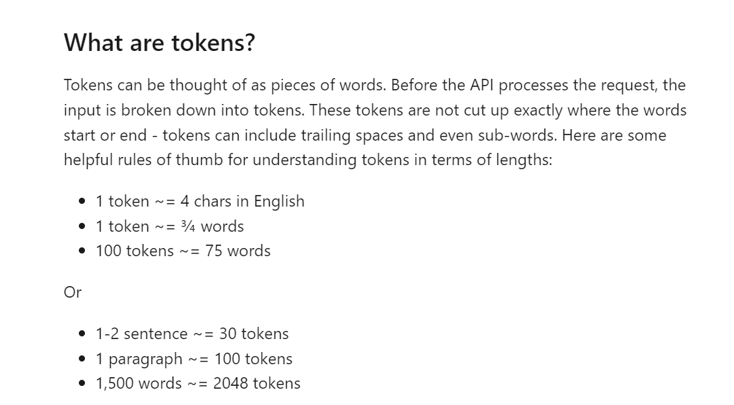
(https://help.openai.com/en/articles/4936856-what-are-tokens-and-how-to-count-them)

Two types of pricing options available
- On-Demand
  - Text Generation Models
  - Image Generation Models
  - Embedding Models
- Purchased Provisioned Throughput (Guaranteed availability)
  - Custom Models

Amazon Bedrock Use Cases

Use Case 1:

Use Case 2:

