CSci 241 Term Project
Online Bookstore Proposal
Min Dan, Di Liu, Jianing Li, Zibing Wang

- Problem Statement
In our project, we are to design and develop a simple Online Bookstore system with several common functions and transactions. For example, in the system, a customer could visit the online bookstore after register, update his/her profile, search a book, read its information, browse through the store’s collection, make a selection and submit a request to the system. The bookstore administrator is able to approve or reject the request that has been made, according to the inventory left. If the stock of some book requested cannot satisfy the request, the administrator might reject the request or approve it when the bookstore increase enough stock later. Note, the business problem does not include customer payment and book delivery actions.
- Proposed Solution
Our Online Bookstore system will be developed with a web front-end based on J2EE framework, OOP design pattern, Oracle database and Tomcat web server. The system will be compromised of six subsystems namely as follow:
- The Profile subsystem, which manage user profile information
- The Security subsystem, which manage user’s account and password
- The Inventory subsystem, which manage book information and stock
- The Transaction subsystem, which handle book requests(approval or rejection)
- The Façade subsystem, which is used to test the business problem without webpages
- The GUI subsystem, which are web front-end for users.
And we will create related tables for these subsystems in a bookstore database built in Oracle.

- Use Case
Use Case 1: User Registration
Identification: When user access the website at the first time
Description: The user needs to add some personal information into the database in order to create an account. The information is dividing into two parts. One part is stored into user table in bookstore database via Security subsystem while the other is stored into profile table via Profile subsystem. The information of security part should include username, password. The information for the profile part should include First Name, Last Name, Email, Phone number, Home address, Organization

Actor: Customer
Step: Go to register page, and input user’s information in a form and submit
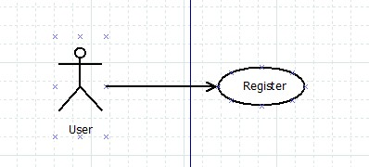
Figure 1. Use Case 1

Use Case 2: Book search and request
Identification: When a user makes a request
Description: Customers search and find books they want by entering book name in the user interface, and then submit a request within specific quantity of the selected books. These requests are recorded into the database and reviewed by Administrator. Administrator can either approve or reject the request according to the book stock information.
Actors: customer, administrator
Steps:
1. When the customer search the book in view inventory page
- input book name or ISBN to search
- find the book wanted and enter quantity needed
- confirm the order

2. When the administrator see a request in view transaction page
- approve or reject the request
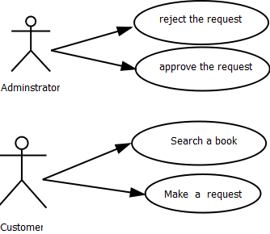
Figure 2. Use Case 2 Book Seach and Request

Use Case 3: Add to Inventory
Identification: To increase the inventory
Description: In order to fulfill two certain kinds of requirements-- new book stock and book requests, it may cause the inventory increasing.
Actors: Administrators
Steps:
- For new books arriving, increase the inventory for new books stock in add inventory page
- Input the ISBN
- Input the Title
- Input the Quantity

- For books requested, view and increase those books inventory
- Login to the system as the administrator
- Search and Find the required book in view inventory page
- Update its quantity

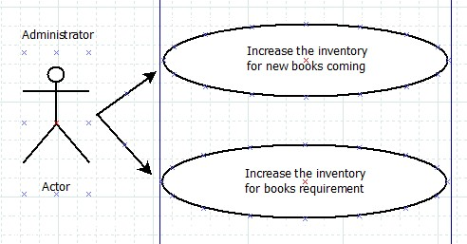
Figure 3. Use Case 3 Add to inventory

