

Document | Bring up report
Project | Flexi Teer
PCB | Rev2.0
PCB SN | #1...#5
Authors | MD Anderson,  Dennis Yaskevich
Date | ongoing
Version | ongoing

1. Orientation

1.1 What is the purpose of this document
This document describes the initial bring up (verification) testing of the FlexiTeer rev.2 hardware. All of test performed and the issues detected during the testing must be reflected in this document.

1.2 Who should read this document
This is deeply technical document more inclined to electronics design. It mainly useful for the engineer who is designing the second revision of hardware to see at glance all of the issues the previous revision had.

1.3 Requisite documents
Table below contains the relevant design documentation and it’s current versions as of writing of this document.
Document name | Link to the document | Latest updated on
Schematic_Flexi-TEER_2023-02-18.pdf | GitHub | 2023-02-18
PCB Layout | oshwlab.com | 2023-02-18

1.4 Test environments
Currently 2 people are working on the project.
Test environment | Test engineer | Equipment available | Test to be performed
Boston Children Hospital | MD Anderson | To be completed | Shorts and resistance measurement
Hackerspace Krakow | Dennis Yaskevich | USB Microscope NB-MIKR-300 | Visual inspection  Shorts and resistance measurement

2. Basic hardware testing

2.1 Visual inspection
Test equipment:
        - USB Microscope NB-MIKR-300

To be completed by Dennis

2.2 Shorts and resistance measurement
Test equipment:
  - Multimeter
Resistance measurement to be performed on to powered off unit according to the table below.
Signal name | Meas. point | Expected value | Actual value | Status
Q33_6 | BT6 vs GND | >1k | Over Load | OK
Q3_2 | BT5 vs BT6 | >1k | 12.3M Ohms | OK
Q3_2 | BT5 vs GND | >1k | 15.2M Ohms | OK
VBAT | BT3 vs BT6 | >1k | 14M Ohms | OK
VBAT | BT3 vs GND | >1k | 82k Ohms | OK
VIN | Left side of R1 vs GND | >1k | Overload | OK
+5V | TP31 vs GND | >1k | 8.16k Ohms | OK
+3V3 | TP30 vs GND | >1k | 8.55k Ohms | OK
-5V | TP29 vs GND | >1k | 230k Ohms | OK

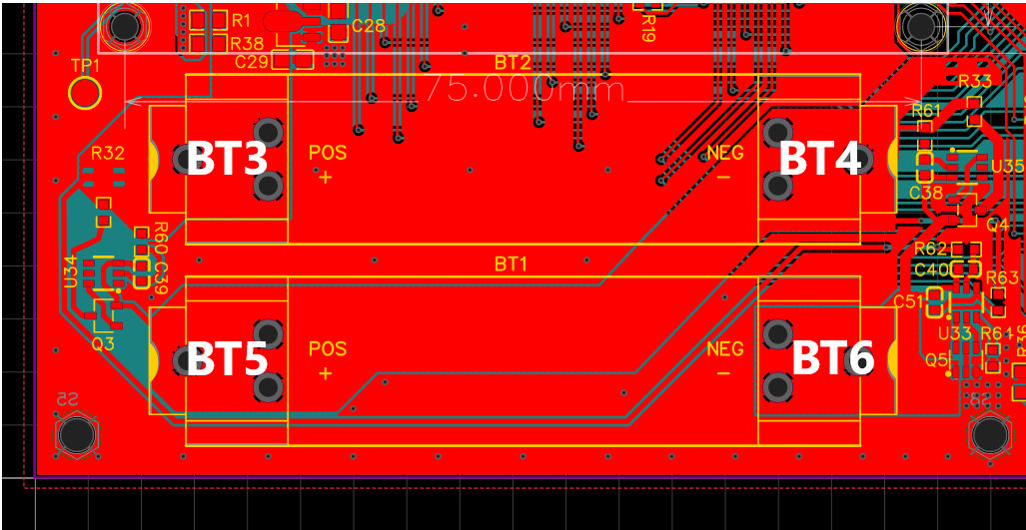

2.3 Power up and voltage measurement

Test equipment:
  - Multimeter
  - lab power supply / 9V wall adapter

Issue E1 is detected when inserting the batteries. To be investigated by DY
Suggested temporary solution: Solder shorting 0 Ohm resistors R1 and R38. Wire can be soldered instead of this resistors. Apply 9V input power to the CON1 with 100mA current limit if possible.
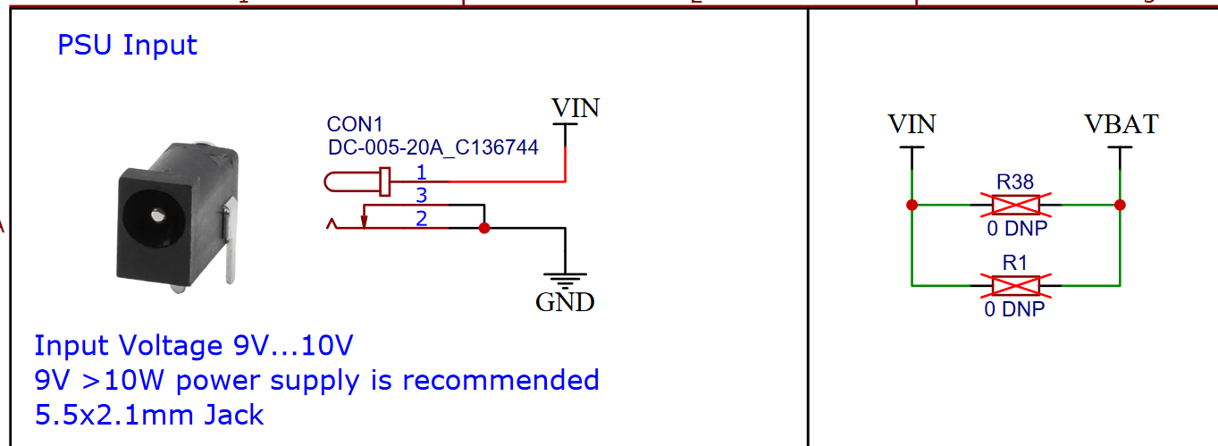
If no overcurrent / smoke is detected after the power is applied, measure the following voltages:

Rail name | Meas. point | Expected value, V |  |  | Ref. | Actual value | Status
Rail name | Meas. point | Min. | Nom. | Max. | Ref. | Actual value | Status
VIN | R1 vs GND | 8 | 9 | 10 |  | 9.01 | OK
+5V | TP31 vs GND | 4.5 | 5 | 5.5 |  | 4.98 | OK
+3V3 | TP30 vs GND | 3.0 | 3.3 | 3.5 |  | 3.26 | OK
-5V | TP29 vs GND | -5.5 | -5 | -4.5 |  | -4.8 | OK
+1V65 | TP27 vs GND |  | 1.65 |  |  | 1.62 | OK
+2V5 | TP25 vs GND |  | 2.5 |  |  | 2.48 | OK

Set status as OK if measured voltage is within the expected values range.

Bilevel Converter Module

Evaluating BiLevel converter and transform to make signals go between -5 and 5 volts to toggle MUX ICs.
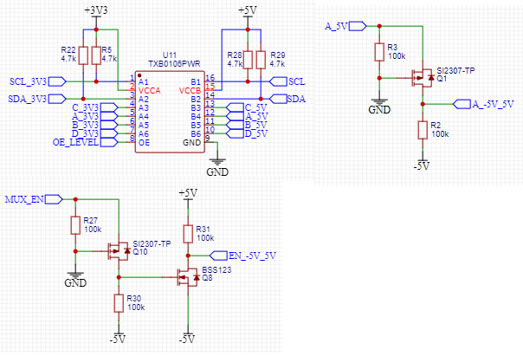
Rail name | Meas. point | Expected value, V |  |  | Ref. | Actual value | Status
Rail name | Meas. point | Min. | Nom. | Max. | Ref. | Actual value | Status
A in | A_3V3 vs GND |  | 3.3 |  |  | 3.34 | Ok
A shifted | A_5V vs GND |  | 5 |  |  | 4.37 | Ok
A -5_5 | A_-5V_5V vs GND |  | -5 and 5 |  |  | -4.75 and +4.35 | Ok
MUX in | MUX_EN vs GND |  | 3.3
MUX_EN -5_5 | EN_-5V_5V vs GND |  | -5 and 5
OE enb | OE_LEVEL vs GND |  | 3.3 |  |  | 2.77 | High enough to work, but odd its so low.

Everything appears to be functional with this module.

MUX

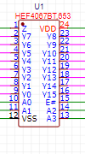

Resistance Measurements
Meas. point | Expected Value, Ω | Measured Value | A | B | C | D | Status
Y0 vs Z | 0 | 0 | LOW | LOW | LOW | LOW | Ok
Y1 vs Z | Over Load | Over Load | LOW | LOW | LOW | LOW | Ok
Y4 vs Z | 0 | 0 | LOW | LOW | HIGH | LOW | Ok
Y10 vs Z | Over Load | Over Load | LOW | LOW | HIGH | LOW | Ok

MUX enable, a,b,c,d pins appear to function properly. Channels are switching to proper channels given A,B,C,D logic inputs.

AC Generation

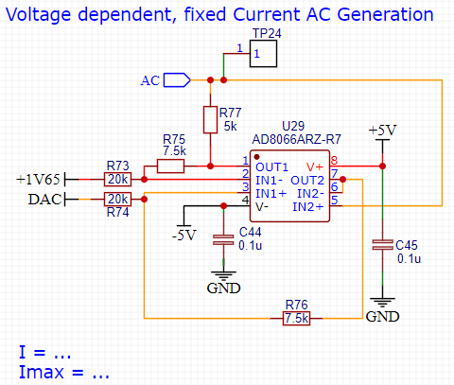
Test Number | Meas. point | Expected value, V |  |  | DAC | Actual value | Status
Test Number | Meas. point | Min. | Nom. | Max. | DAC | Actual value | Status
1 | TP24 vs GND |  | 0.533 |  | 2.24 | .550 | Ok
2 | TP24 vs GND |  | -0.583 |  | 0.994 | -0.580 | Ok

Arduino defaults to 8bit for DAC. Hardware is 10bit so I added in a code line to make it 10bit input. I put a 12k resistor in as a sub for ‘cell load’ and ran it at around 12Hz (the target frequency) and it worked very well. I believe this module is functioning very well and super close to simulation predictions. Here is a conversion chart between DAC and the ADC on pins A0 and A2 respectively. 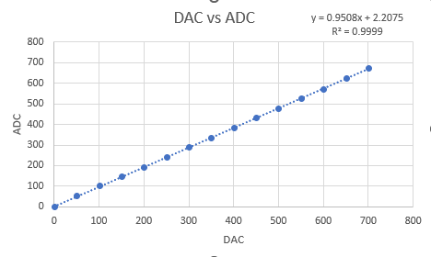

Here is proof I generated a symmetric AC wave through the 12k resistor. Looks great! (values of 426 and 626 were used as 1.62V (the ref voltage) was projected to be 526).
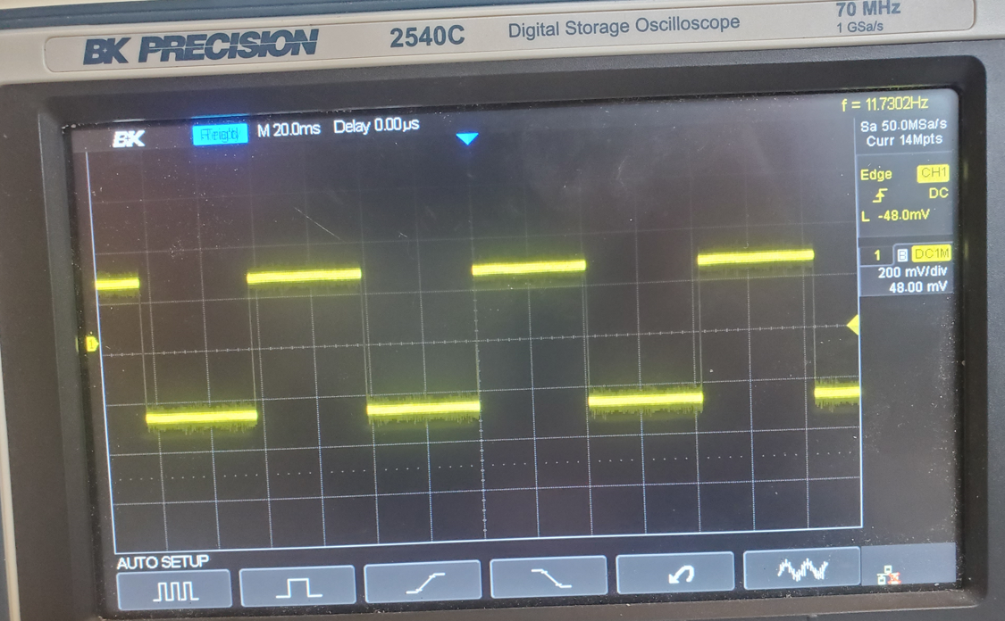

Summary

Assembly issues

No | Issue description | Date/Author | Status
A1 | Low humming coming from bilevel converter. Some outputs (C and A) stuck at 2.3V no matter what 3V3 corresponding input is.  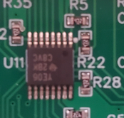 | 15.08.23 MD Anderson | Swapped to different board and noise was not present and bilevel converter worked properly.  Pin 13 looked not soldered properly. Measuring this pin removes the noise.  ----------  Manual touch up to be applied to pin 13
A2

Electronics issues

No | Issue description | Date/Author | Status
E1 | After inserting the second battery the PCB trace starts burning  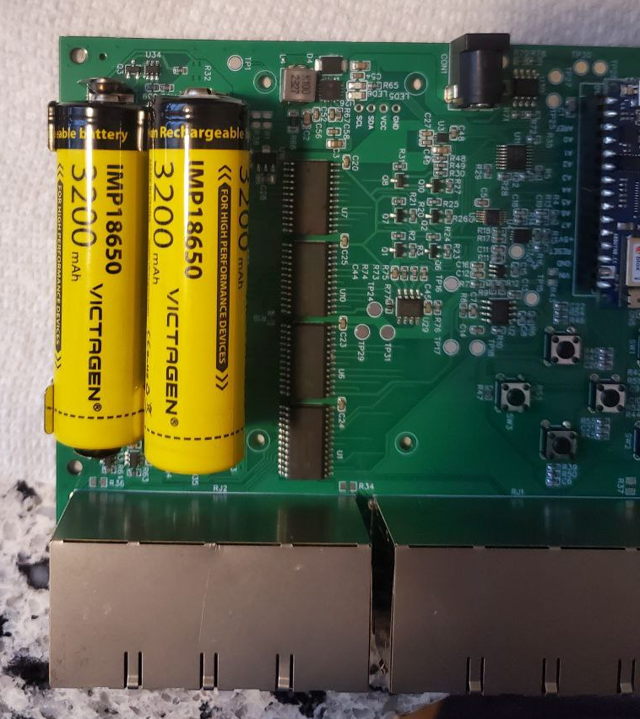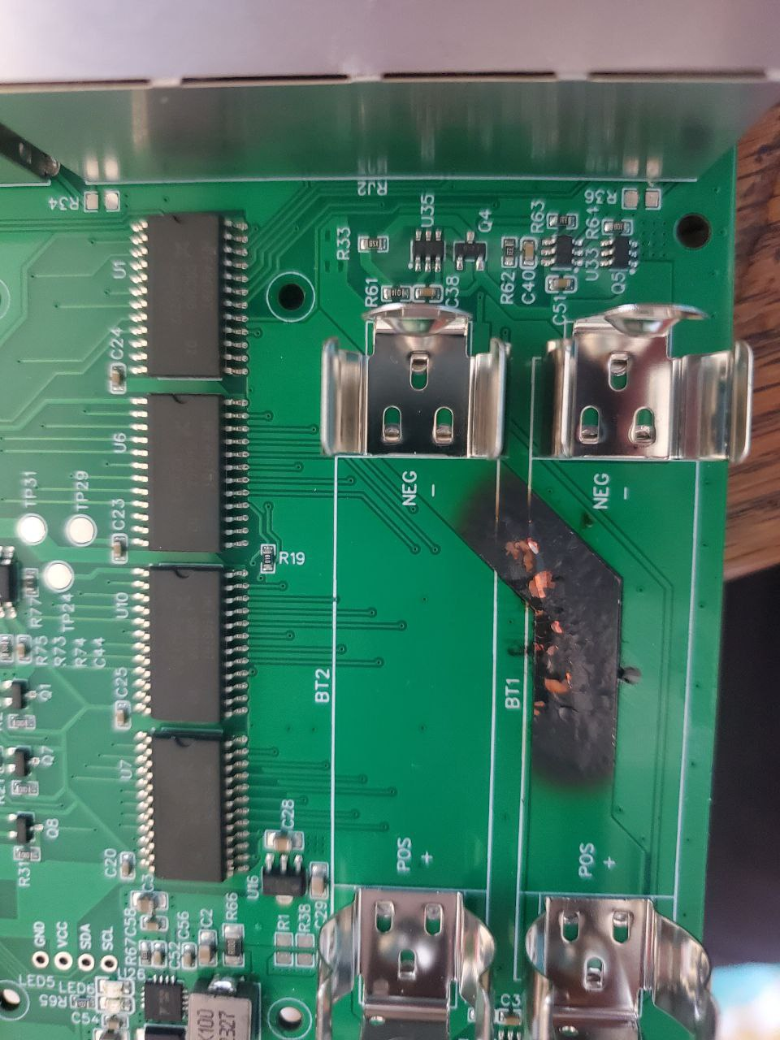 | 02.08.23 MD Anderson | When the battery is inserted the battery holder jaws move to the sides, and this causes shorting of the bottom battery  --------  Spacing to be increased in the future PCB revision  ---------  Quick and dirty solution – insert insulator between the battery holders
E2 | L4 inductance to be increased to 22uH. Eval board and old datasheet has this value.  L4 MDA7030-100M (C2847485) → MDA7030-220M (C2847487). Pin to pin replacement | 16.08.23 DY | I will use on the samples the value that I will find. For future documentation 22uH will be used.
E3 | Need to take away aref as the pin for the D_3V3 pin. Even though documentation says it can be a GPIO, it is unclear how to do it. Its easier to modify and use one premapped for that usage.  This pin is not included in the Arduino GPIO library and it can only be used by initializing it on the registers level:  Source  Schematic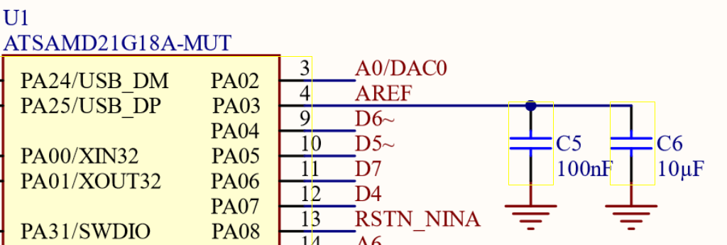 | 15.08.23 MD Anderson | Should be updated in next prototype: we can apply permanent pull up to PD signal, and route the MUX controll signal to A7 pin of the arduino. Another option is pull up enable pin on bilevel converter.  --------  For now I would attempt to use this pin at the register level. If it turns out to be too complex, then manual rework and sap to A7 pin would be a solution
E4

