Michael Dandrea

CV00

CV solution for input 00:

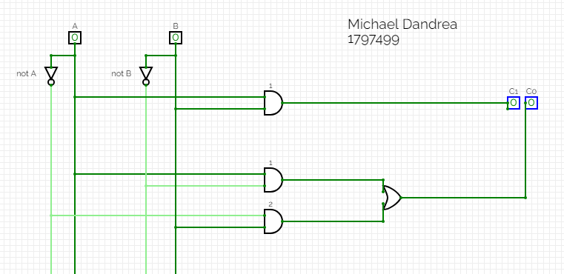

CV solution for input 01:

CV solution for input 10:

CV solution for input 11:

Idea to truth table:

The idea was to add two binary numbers and output the result, so there are two inputs, and two parts for the output, as we need two bits to represent the number 2 in binary.

K-map and Schematic:

The K-maps represent the outputs for C1 and C0 respectively, which came directly from the truth tables. This was used to find the equations needed to draw the circuit. This example shows the output when both A and B are 1.