The goal of this program was to make C3 be able to work with 2d arrays.

The following are the updated programs:

Make_data_2d:

Read_data_2d:

Add_data_2d:

Utilities:

The following screenshots show the programs compiling and passing valgrind on the ci:

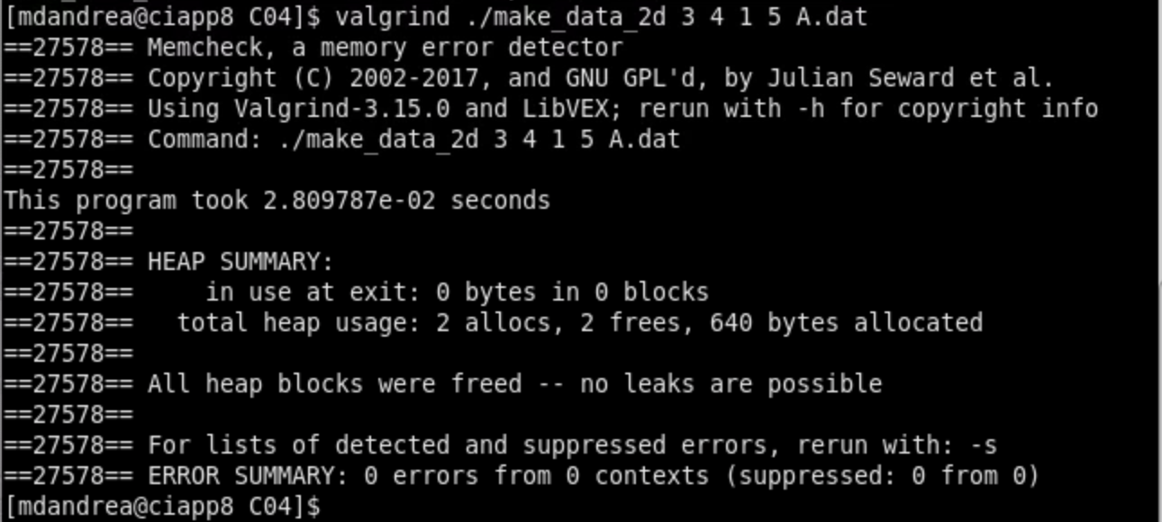

Overall, this program was a bit difficult to write. The hardest part for me was figuring out how to initialize the 2d array from the file. I got a bit of help from chatgpt with this, and it made me realize I was using fread wrong, but I now understand how it works.