Michael Dandrea

ML00 Report

Running this on google collab, I was able to get 98% accuracy like the example.

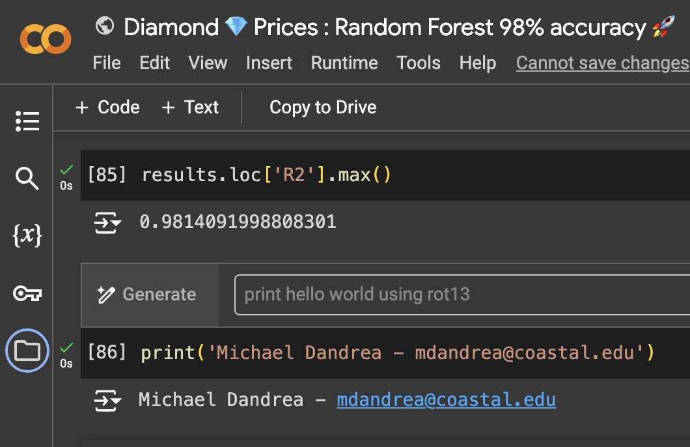

I already had a miniconda environment on my laptop, so I did not have to do anything for that. However, I did have to get the Jupyter Notebooks extension for VS Code. I did also have to install sklearn and kagglehub to my miniconda environment. I did this using pip install sklearn and pip install kagglehub.

This is it running on vscode:

