ScoutBox: Finding Niche Engineering Jobs with SearchApi, Ollama and Cloud LLMs
Searching job boards, Google, LinkedIn and Facebook consumes a disproportionate amount of time, because broad queries bring back generic full-stack or AI engineer roles, evergreen vacancies, old roles that have been reposted as new, and employers whose details still need checking. When the same search and application routine is repeated every week, the few results that justify the search in the first place are easily lost among the rest.

Background
ScoutBox is the self-hosted web application that I built to automate that routine. It finds niche vacancies and companies worth investigating by letting a candidate profile and a set of narrow campaigns guide the searches across public sources. Whatever comes back is then assessed, so that specific vacancies are kept in Opportunities while companies that show relevant activity but have no verified opening go to Hidden Leads.
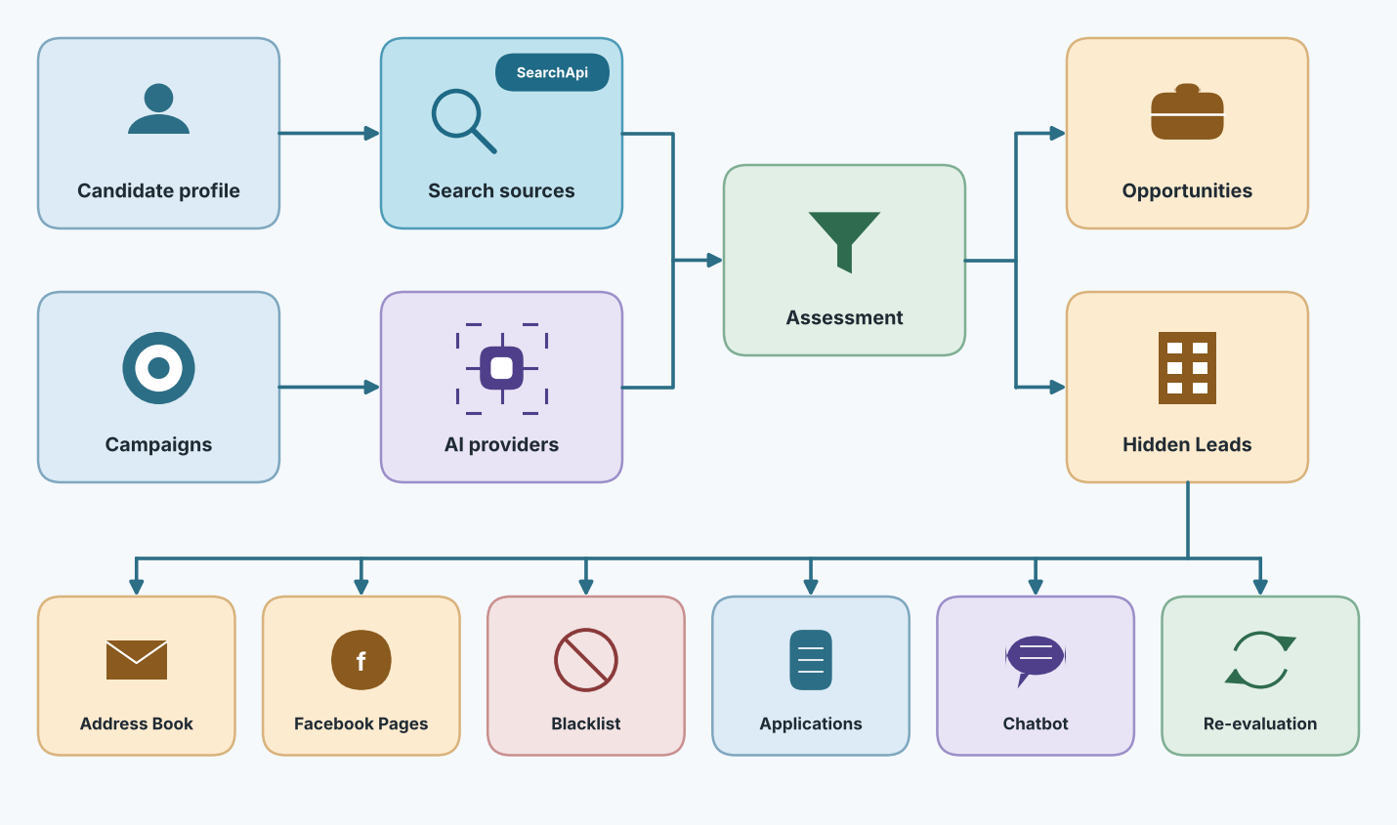
Figure 1. ScoutBox overview.
ScoutBox is a Django web service that uses PostgreSQL for durable records, while Redis, Celery workers and beat run the background searches. The search, page-fetch and local or cloud AI steps sit between those workers and the review and outreach views. The About page draws this as the diagram below, which is a useful map whenever a campaign appears stuck, because it tells me which process owns each step.
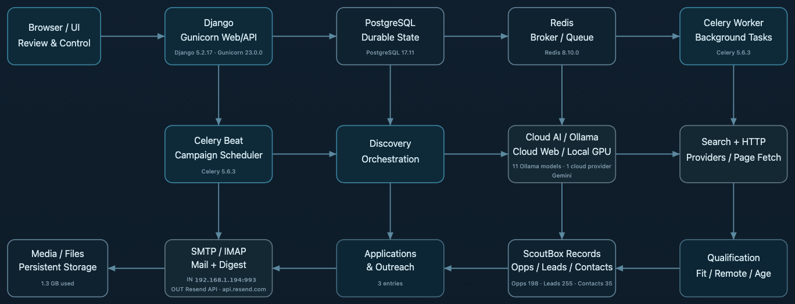
Figure 2. System architecture from the About page.
ScoutBox started with public web search and Ollama running Qwen locally. As I used it, I added further engines, support for OpenAI, Gemini and OpenRouter, finer control over the AI stages, re-evaluation and the application tools. One loop that ran up $40 of cloud AI usage in a single morning demonstrated early why request limits matter, and they have been part of ScoutBox ever since. The local model configuration, in which the model can be changed per stage and a fallback selected, is shown below.
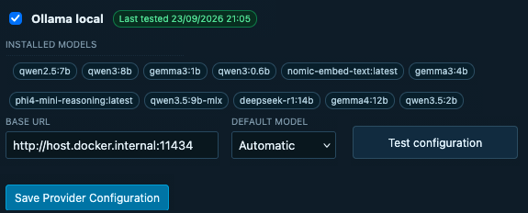
Figure 3. Local Ollama models in AI configuration.
SearchApi came later, once it was clear that the public engines could not give me structured vacancies or a reliable choice of market. Its Google Jobs engine now supplies structured job entries, while the Web, Forums, News and Local engines widen discovery, and the rest of the pipeline treats its results like any other source.
All of this becomes visible in the Opportunities view, which is the list I consult most often. It combines a search box and filters for campaign, location and focus with the assessed records themselves, each of which shows its summary, fit score, Company Info and Post Age badges, remote status and a link back to the source page.
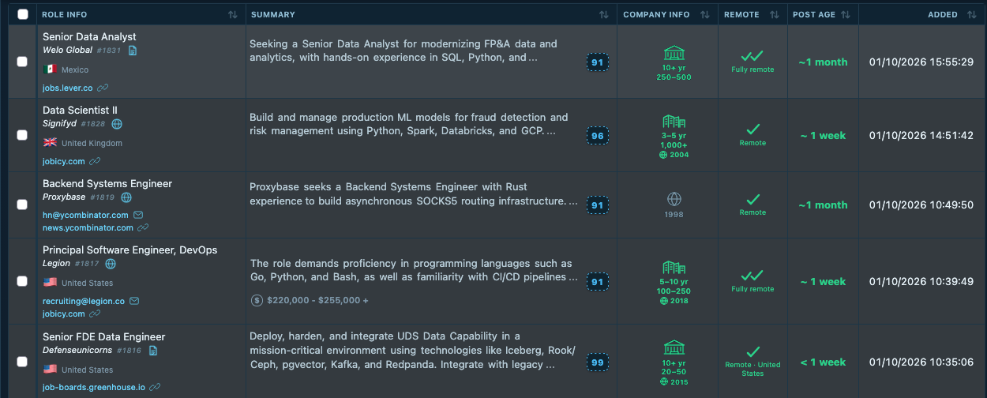
Figure 4. The Opportunities view.

Core Concepts
Several terms recur throughout the article and are defined here before the individual screens are examined. The Candidate Profile holds the resumes, priorities and preferences that every assessment is measured against, while Campaigns steer discovery by naming a focus, a market, a schedule and the sources that may be used. Search Sources decide where ScoutBox looks, and they fall into the groups shown in the first diagram: SearchApi, the public web engines, forums and communities, ATS and career pages, job boards, and social or public pages.
Discovery itself runs in one of two modes. In Local AI Discovery, the search sources find URLs and the local Ollama model reads and judges the fetched pages, whereas in Cloud Web Discovery a configured cloud provider uses its own web research route to find and verify candidates, which costs tokens but reaches pages that the public engines miss.
Whatever survives the assessment lands in one of four lists. Opportunities are concrete, current vacancies with a source and a fit score. Hidden Leads are companies or projects that show relevant technical activity without an advertised role. The Address Book collects careers inboxes and named contacts found along the way, and Facebook Pages keeps public pages discovered during the search. From any of these, Applications & Outreach holds the drafts, documents and status history for the roles and companies I decide to pursue, and the chatbot, re-evaluation, tracking links and diagnostics support that review from the side.

Profile and Campaigns
The candidate profile stores the resumes, skills, role ideas, languages and locations, together with descriptions of the high, medium and lower priority work that I am looking for. Because the priority descriptions give the assessor far more context than a single generic job title would, they guide query planning and fit scoring while still leaving room for an unusual role whose title does not match any of them.
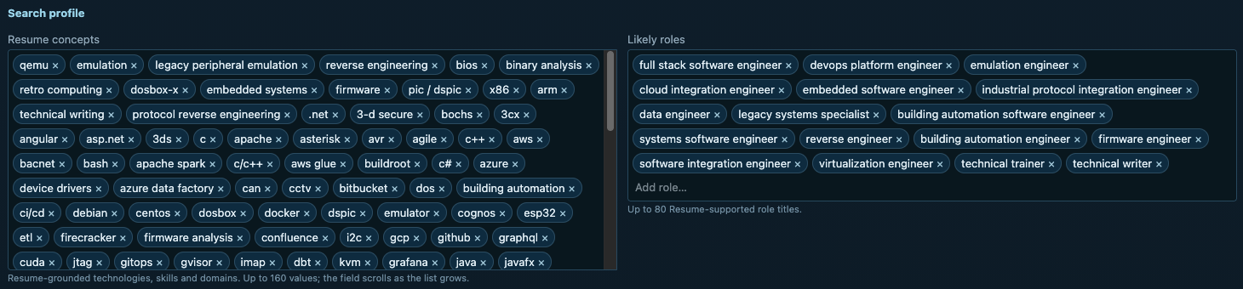
Figure 5. Resume concepts and likely roles.
The resumes themselves are uploaded on the Candidate Profile page, which has a Resumes panel and a Cover Letters panel, each with an Upload control beneath its list. I keep five resumes that are each aimed at a different kind of work, namely embedded, software engineering, retro computing, technical writing and virtualization, plus one cover letter, all of them ordinary .docx files. ScoutBox parses the text of every uploaded resume into the search profile, which is where the resume-grounded concepts shown above come from, and the same panel offers two shortcuts: Autopopulate Candidate Profile, which fills the priority text and concepts from the documents, and Auto-create Campaign Templates, which turns each resume into a campaign template whose generation date the list records. The same documents are later offered as the source for tailoring.
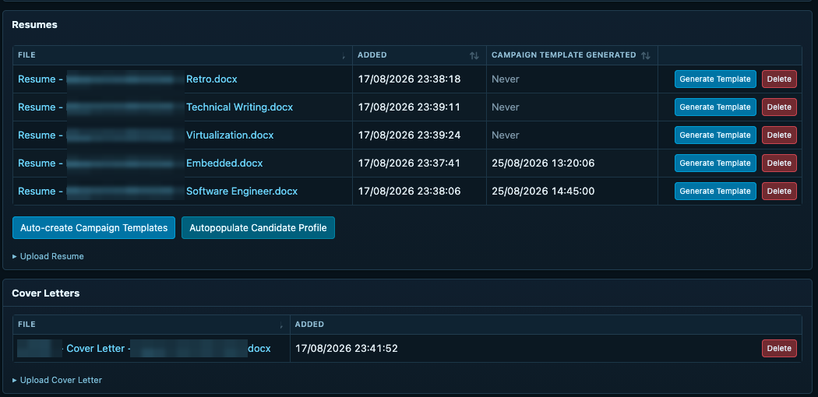
Figure 6. Resume and cover letter uploads.
Engagement Preferences covers remote or on-site work, contract or full-time options, company sizes, hiring-process preferences and minimum pay. These guide planning and scoring rather than acting as hard filters, so a strong role that misses one preference is still shown and merely scored lower.
A campaign sets its own focus, market, source choices, schedule and search limits, which is why I keep separate campaigns for embedded software, emulation, reverse engineering, technical writing and CV-based discovery. Django serves the UI and the records that PostgreSQL stores, while Redis and Celery run the searches in the background, and the dashboard shows the stage and progress of each active campaign.
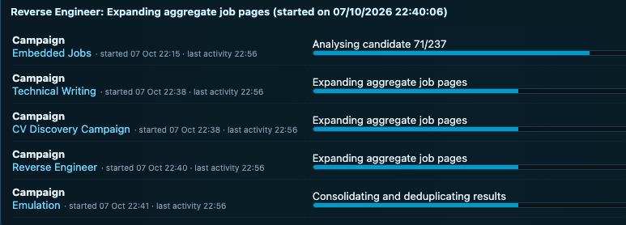
Figure 7. Campaign progress on the dashboard.
One search might find a firmware role at an arcade company, while another might find a company that builds emulators for legacy shipboard peripherals but has no open position. ScoutBox keeps the former as an Opportunity and the latter as a Hidden Lead, and because both retain their source links, fit, summaries and evidence, I can inspect them later without inventing a vacancy that the company never advertised.

Search Sources
SearchApi is best understood in the context of the sources that ScoutBox already consults. Configuration > Search Sources lists 161 configured sources in thirteen categories, from hosted career pages such as Ashby, Greenhouse, Lever and Workday, through developer communities, general web engines and regional engines, to the major job sites of twenty-odd countries, remote boards, startup boards and public social sources, each with its own checkbox, priority, weight and daily budget. Configuration > Search Sources > Forums enables 57 engineering forums and mailing lists, from 6502.org and the Vintage Computer Federation to Nordic DevZone and the Yocto lists, which is where the niche signals that no job board carries are most likely to surface. The remaining tabs under Search Sources select the Discovery Markets, custom domains, schedule and limits, and the Facebook options.
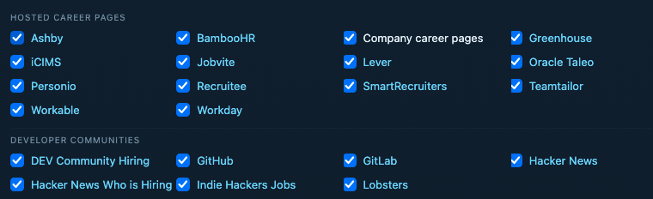
Figure 8. Hosted career pages and developer communities in Search Sources.
The remaining categories on the same page are summarized below.
Category | Sources | Examples
Hosted career pages / ATS | 14 | Ashby, BambooHR, Company career pages, Greenhouse, Jobvite, Lever, Oracle Taleo …
Developer communities | 7 | DEV Community Hiring, GitHub, GitLab, Hacker News, Hacker News Who is Hiring, Indie Hackers Jobs, Lobsters
General web search | 8 | Bing, Brave Search, DuckDuckGo, Ecosia, Google, Mojeek, Startpage …
Regional / language search | 3 | Baidu, Naver, Yandex
Major job sites | 35 | Arbetsförmedlingen Platsbanken, CareerBuilder, Careers24, Cliclavoro Italy, Daijob, Dice, FINN Jobs …
Remote-focused boards | 9 | FlexJobs, Himalayas, Jobicy, Jobspresso, Remote OK, Remotive, Virtual Vocations …
Startup / technology jobs | 3 | Built In, Wellfound, YC Work at a Startup
Singapore / APAC | 3 | JobStreet, JobsDB, SEEK
Public community / social | 6 | Bluesky, Facebook public posts, LinkedIn public posts, Mastodon, Reddit, Welcome to the Jungle
Search APIs / SERP | 7 | ChatGPT Research, Google AI Mode, Google Forums, Google Jobs, Google Local, Google News, Google Web
Low-value marketplaces (off by default) | 7 | Fiverr, Freelancer, Guru, PeoplePerHour, Truelancer, Upwork, Workana
Table 2. Search source categories configured in ScoutBox.
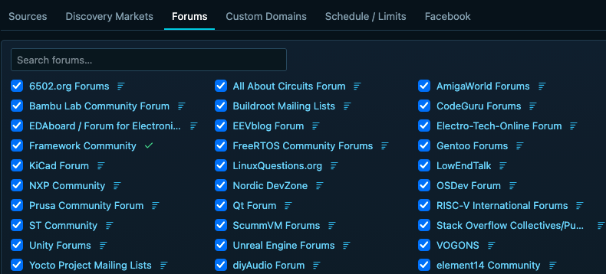
Figure 9. Part of the Forums tab.
The full set of 57 forums and mailing lists enabled in this installation is listed below.
6502.org Forums | English Amiga Board | NXP Community | TI E2E Community
All About Circuits Forum | Espressif Community | Nordic DevZone | The Things Network Forum
AmigaWorld Forums | Fedevel Forum | OSDev Forum | Tindie Project Communities
Arch Linux Forums | Framework Community | OpenWrt Forum | Unity Forums
Arduino Forum | FreeRTOS Community Forums | PTT CodeJob | Unreal Engine Forums
AtariAge Forums | Gentoo Forums | Pine64 Forum | VOGONS
Bambu Lab Community Forum | Hackaday Community | Prusa Community Forum | Vintage Computer Federation Forums
Buildroot Mailing Lists | Hackaday.io Projects | Qt Forum | Voron Design Forum
CodeGuru Forums | Hashnode Discussions | RISC-V International Forums | WebHostingTalk
Crowd Supply Project Communities | KiCad Forum | Raspberry Pi Forums | Yocto Project Mailing Lists
DaniWeb Community | LinuxQuestions.org | Retro Computing Forum | diyAudio Forum
Debian User Forums | LowEndTalk | Reverse Engineering Stack Exchange | element14 Community
EDAboard / Forum for Electronics | Mbed OS Community Archive | ST Community
EEVblog Forum | Microchip Community | ScummVM Forums
Electro-Tech-Online Forum | Mikrocontroller.net Forum | Stack Overflow Collectives/Public Search
Table 3. Forums and mailing lists enabled under Search Sources > Forums.
In code, every source is a row of the same model with a source_type that names its adapter, and portal/services/search.py keeps a registry that maps each type to one function with a common signature. The planner picks providers for a campaign run from the enabled sources by priority, weight, recent health and remaining budget, and then calls each adapter in the same way, which is why adding SearchApi meant adding adapters rather than changing the pipeline:
ADAPTERS={'search_api':search_searchapi,'public_engine':search_public_engine,
'ats':search_ats,'board_feed':search_board_feed,'forum':browse_forum}

def run_search_plan(campaign,queries,market):
sources=select_providers(campaign,market) # enabled, weight, health, budget
for src in sources:
adapter=ADAPTERS[src.source_type]
for q in queries[:src.queries_per_rotation]:
rows,size=adapter(q,limit=MAX_RESULTS,source=src,market=market)
log_search_activity(src,q,market,len(rows),size)
yield from normalize_rows(rows,source=src,engine=src.name)

SearchApi Integration
Before SearchApi, ScoutBox's search layer relied on public engines that it fetched and parsed as ordinary web pages, an approach that depended entirely on the engines continuing to tolerate automated traffic. The HTML changes without notice, several engines rate-limit or block automated traffic after a few hundred requests, and none of them offers a job-specific index or a dependable way to say which country a query is for. Over one two-week window in September and October, Yandex answered 11,733 requests with six usable results, DuckDuckGo refused almost half of its requests, and Brave, Ecosia and Mojeek returned nothing at all.
What I wanted instead was a stable, documented API in front of Google's own index, which is what SearchApi provides: a single key and daily allowance, JSON responses with named fields, an explicit country, language and location on every request, and separate engines for Jobs, Web, Forums, News and Local that ScoutBox can enable independently. SearchApi therefore joins the existing public engines, company career pages and direct hiring sources in the campaign search plan, where provider selection weighs the enabled sources, the query type, recent health and the remaining allowance, and Search Activity records the provider, query, result count and timing of every call that is actually made.
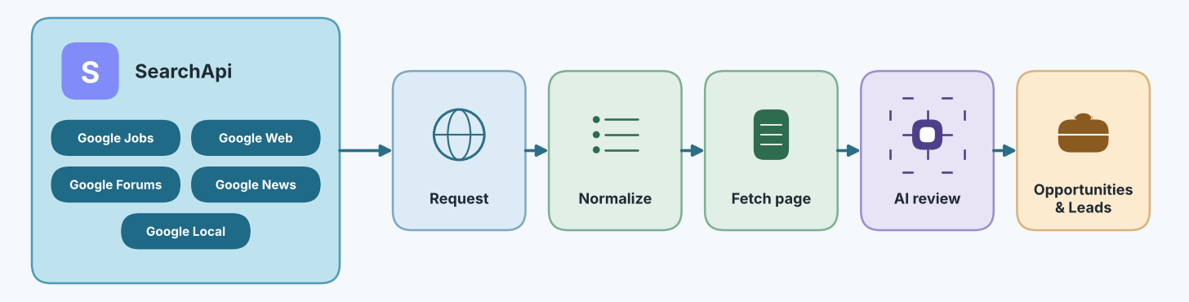
Figure 10. SearchApi engines and the record pipeline.
Each SearchApi engine serves a different purpose in this setup:
- Google Jobs: Search vacancies by role and market and return structured job entries.
- Google Web: Find job pages, employer sites and more general search hits.
- Google Forums and News: Find discussions and recent signals about organizations or work.
- Google Local: Find businesses that might become Hidden Leads, although a listing is never taken as evidence of a vacancy.
Optional research adapters exist as well, although they were not enabled in the pictured setup. The selector lets me test and enable each engine on its own while all of them share one configured SearchApi account and its daily allowance.
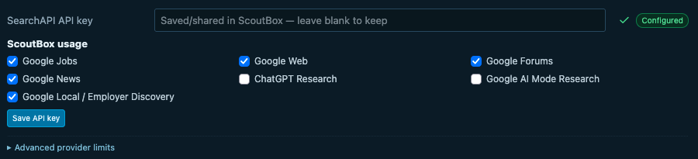
Figure 11. SearchApi engine settings.
The common request goes to https://www.searchapi.io/api/v1/search with an engine and a query, plus the country, language or location where they are relevant. ScoutBox also calls /api/v1/me to validate the account and /api/v1/locations to resolve a place name, while the key itself stays in configuration.
In portal/services/search.py, Google Jobs reuses the shared request function and then normalizes its own response shape:
def search_searchapi_google_jobs(query,limit=10,source=None,market=None):
data,size=_searchapi_request(source,'google_jobs',query,limit=limit,market=market)
return _searchapi_job_rows(data,limit),size

The Web adapter uses engine='google' and reads organic_results. Both feed a common ScoutBox record that retains the engine through which it was acquired, so a saved Opportunity can always be traced back to the engine that found it.

Google Jobs
A plain keyword search shows why I wanted more than title matching: this Google Careers search for embedded engineer returns a forward-deployed Gen AI role, a mismatch that is a useful reminder to inspect the role itself rather than trust the words that matched.
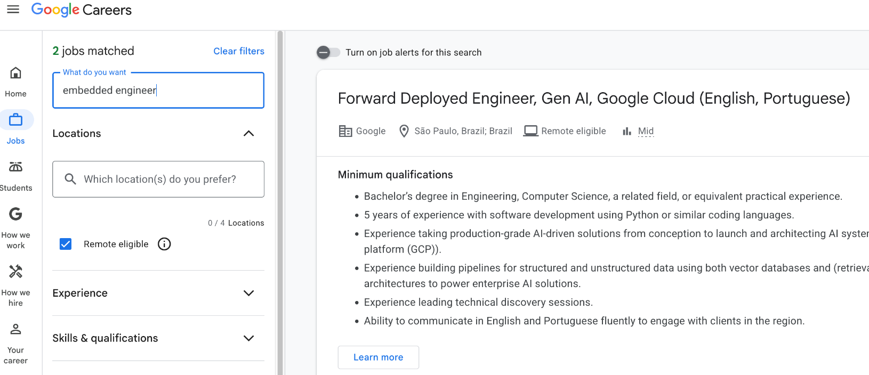
Figure 12. A keyword search on Google Careers.
Configuration > Search Sources > SearchApi includes a direct test, which exercises the adapter before a full campaign is run. A query for embedded firmware returned five parsed results, each with its role fields and source link.
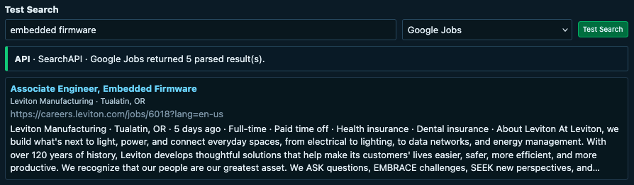
Figure 13. Google Jobs test search.
Asking a local LLM to inspect general Google hits, or asking a chatbot for jobs, can help with one-off discovery, but a recurring campaign needs stable fields and a source URL. A general page may hold several jobs, headquarters addresses, related-role links and an old cached listing, which is exactly the kind of page on which a small model attaches the wrong location or apply URL to the current role.
SearchApi's google_jobs response has a jobs array whose entries carry title, company_name, location, description, posting information and application links. ScoutBox picks a usable apply link, unwraps redirects, rejects duplicate or search-engine URLs, and keeps a source and location hint, which leaves the LLM free to judge fit instead of reconstructing the basic vacancy from a snippet.
The relevant normalizer begins by reading each job and selecting its application link, after which the rest of the function validates and deduplicates the URL before building the common record:
for item in (data.get('jobs') or []):
apply_link,apply_source=_searchapi_apply_link(item)
url=unwrap_search_result_url(apply_link)
...
title=' '.join(str(item.get('title') or '').split())
company=' '.join(str(item.get('company_name') or '').split())
location=' '.join(str(item.get('location') or '').split())

Jobs supplies structured vacancies, while Web and the other sources still catch the specialist work and the companies that never appear in a well-indexed job feed.

SearchApi Performance
To see what SearchApi actually changed, I exported the diagnostic bundle for 24 September to 8 October, the two weeks around the day on which the SearchApi engines went live (28 September). The table counts every provider request in that window together with the Opportunities and Hidden Leads that ScoutBox eventually saved from each source. The public engines ran for the whole fortnight, whereas SearchApi ran for ten days of it.
Source | Requests | Results returned | Opportunities saved | Hidden Leads saved | Avg. latency
SearchApi · Google Web | 2,382 | 6,094 | 18 | 32 | 5.4 s
SearchApi · Google Jobs | 652 | 124 | 5 | 0 | 12.1 s
SearchApi · Forums, News, Local | 276 | 747 | 1 | 1 | 4.6 s
Naver | 22,860 | 80,491 | 60 | 102 | 6.8 s
Bing | 9,302 | 25,750 | 0 | 2 | 6.8 s
Yandex | 11,733 | 6 | 0 | 1 | 6.2 s
DuckDuckGo | 4,753 | 621 | 0 | 5 | 18.7 s
Table 1. Provider requests and saved records, diagnostic export 24 September to 8 October 2026. Latency is the request-weighted average of the daily provider statistics.
The most informative measure is the yield. The 3,310 SearchApi requests, which were about 5% of the 66,878 provider requests in the window, produced 24 Opportunities and 33 Hidden Leads, or roughly 7 Opportunities and 10 leads per thousand requests. The general public engines, which together sent about 50,000 requests, produced 60 Opportunities and 110 leads, or about 1 Opportunity and 2 leads per thousand, and even Naver, the busiest of them, only came as close as about 3 Opportunities per thousand.
The SearchApi records also look different. Whereas the other sources are 59% United States, the SearchApi set is spread across Norway, Singapore, Italy, Canada, Australia and the United Kingdom, because every request carries an explicit Discovery Market for which Google then answers. The two SearchApi Opportunities that I marked for application, the ARCADEXR firmware role and Neara's hardware interface role, both arrived through SearchApi Google Web on 28 September, which was the first day it ran. The mean fit score of the SearchApi records was 89.6 against 86.5 for the rest, and the Web engine's 5.4-second average response was quicker than Bing, Naver and Yandex, all of which ScoutBox fetches and parses as web pages.
Two limitations should be noted. Google Jobs returns a short, structured list rather than volume, which makes it the precise engine that works best beside Web. Most of the SearchApi errors in the window were ScoutBox's own guards, which reject a request that lacks a Discovery Market or carries an unsupported country code, together with a few requests that ran past ScoutBox's 25-second read timeout.

Search Activity
Search Activity records every request that ScoutBox sends to a provider. Each row records the provider, the query as it was sent, the market and language, the number of results, the latency and the response size, which makes it easy to tell whether a quiet campaign is planning poorly or simply being ignored by an engine. The queries themselves are composed by the query-planning stage, which pairs a role phrase with a technology term and a market, and often narrows the search to one board with a site: operator, as in site:weworkremotely.com "virtual hardware engineer" gcp Canada remote. In the view below, Naver covers the Korean market, while a Facebook page validation and a forum browse of a community's JSON feed sit between the searches.
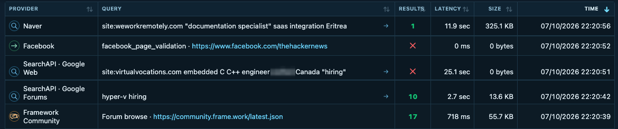
Figure 14. Search Activity across providers.
The SearchApi rows in the same view show how the market steering works in practice. Each request carries the Discovery Market's country and language, and when the multilingual option is on, the planner writes part of the query in that language, which is how systems software engineer "επιμέρους Greece came to be sent for the Greek market. A Google Forums query such as hyper-v hiring returns ten community hits in under three seconds, whereas a site: query that Google answers with nothing is recorded with zero bytes rather than being retried.

LLM Configuration
ScoutBox has two discovery modes, Local AI Discovery and Cloud Web Discovery, and Configuration > AI & Discovery decides which stages each one may use. In Local AI Discovery, the search sources find URLs and Ollama analyzes the fetched pages. I can assign Qwen as the primary model and Gemma as the fallback, and set input or output caps for URL discovery, first filtering, job-description analysis, company research and freshness, while Cloud Web Discovery can use a configured provider's own research route and OpenAI, Gemini and OpenRouter remain available for the stages that support them. A SearchApi request does not by itself spend cloud LLM tokens, because the selected discovery and AI settings decide that. The model test below, which checks each stage against its primary and fallback model, reported all eleven stages usable.
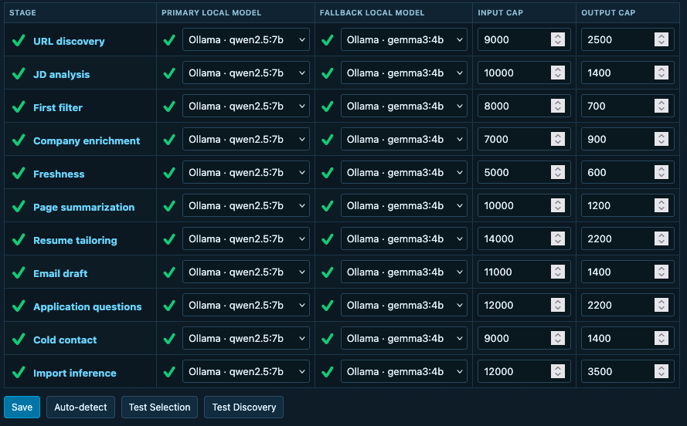
Figure 15. AI stages after a model test.
AI Requests exposes the actual stage, runtime, model, prompt and response preview, token counts, status and duration of every call, which means that a planning request and a page summary can be inspected separately whenever a campaign behaves oddly.
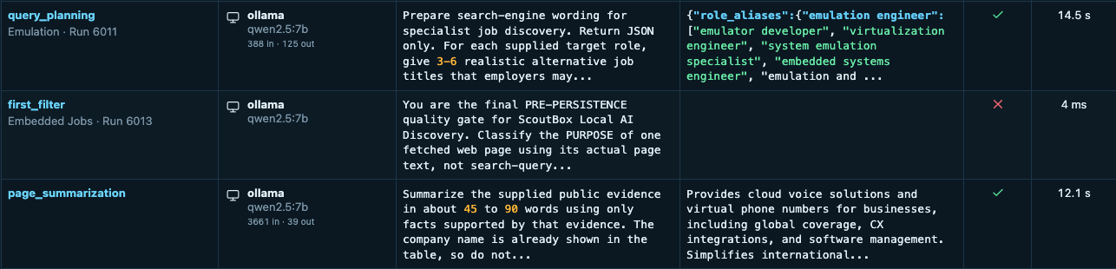
Figure 16. AI Requests log.
ScoutBox tries to establish whether a page contains one current opening or merely a company page, an expired posting or a related-jobs panel. Its Post Age badge favors a JobPosting schema datePosted, an explicit date on the current page, or the timestamp of the specific forum post, and it can ask the configured model to interpret a relative phrase such as “posted six days ago” that appears in the cleaned page text. An HTTP Last-Modified value or a page update counts as supporting audit evidence rather than as the job's posting date. The displayed buckets include < 3 days, ~ 1 week, ~ 1 month, Likely Old, unknown and, where the source supports it, Evergreen.
Company Info is separate research in which ScoutBox looks for a founded year and employee information with source evidence, converts headcount to broad bands, and may use the RDAP registration of a defensible company-owned domain as a domain age, which is deliberately not treated as the company's founding date. It avoids using a job board's domain for this, and information that cannot be found stays unknown. The list badges let me sort or inspect these signals instead of treating a record that was added recently as a job that was posted recently.
The domain age itself comes from RDAP, the registry protocol that replaced WHOIS, and the condensed logic below shows the steps that matter. ScoutBox first reduces the page URL to its registrable domain and refuses job boards and hosting platforms, then asks the IANA bootstrap file which registry is authoritative for the top-level domain, and finally reads the registration event from that registry's answer. For Ixitech, this resolved ixitech.com to rdap.verisign.com, found a registration date of 27 December 2012 and recorded 13 years, even though the company itself reports a founding year of 1984, which is exactly why the two values are kept apart.
def domain_age(url):
host=registrable_domain(url) # ixitech.com, not www.ixitech.com
if host in JOB_BOARD_DOMAINS or not company_owned(host):
return None # a board's domain says nothing here
tld=host.rsplit('.',1)[1]
base=iana_rdap_bootstrap()[tld] # https://rdap.verisign.com/com/v1/
data=get_json(f'{base}domain/{host}',timeout=10)
for ev in data.get('events',[]):
if ev.get('eventAction')=='registration':
registered=parse_date(ev['eventDate'])
return {'domain_age_years':(today()-registered).days//365,
'domain_registered_at':registered.date(),
'domain_age_domain':host,
'domain_age_endpoint':f'{base}domain/{host}',
'domain_age_source':'iana_authoritative_rdap'}
return None

Location needs similar care, because one page can name the job's remote market, the headquarters, several offices and another recommended vacancy. ScoutBox gives priority to the current role's scoped location or its structured JobPosting data, keeps the source hints and marks headquarters or market fallbacks as such, whereas a small local model that simply picked the first place name would be far less useful here.

AI Request Examples
The AI Requests log records every call with its stage, model, runtime and timing, and the diagnostic export keeps the full prompt and reply for manual re-evaluations. Here are five calls from the same two weeks, each trimmed to the interesting part. The local ones ran on Qwen 2.5 7B through Ollama, while the cloud ones ran on Gemini 3.5 Flash Lite with web verification enabled.
1. Summarize a fetched posting page_summarization · Qwen 2.5 7B, local · 24.8 s · 1,421 tokens in / 336 out
Input | Fetched text of the ARCADEXR "Embedded System Engineer" page found by SearchApi Google Web: "The bulk of the role is onboarding: taking real arcade cabinets and getting them connected to our online infrastructure. That process can involve modifying or replacing harnessing, hijacking I/O, modifying or replacing electrical systems, writing firmware to handle custom game behaviour…"
Response | Role / Need: ArcadeXR is seeking an Embedded Systems Engineer to develop firmware  for real arcade machines, both for onboarding existing cabinets and creating  original games…  Technical Areas: embedded firmware development, harnessing and integrating  electrical systems, optimizing camera feeds, and building robust I/O frameworks…  I2C and SPI.  Engagement Clues: hands-on… both production-grade systems and rapid prototypes.  Caveats: …a non-traditional embedded engineering role that involves both  operational maintenance and creative prototyping. $90,000 - $130,000 per year.

2. Research the company behind a role company_enrichment · Qwen 2.5 7B, local · 36.9 s · 724 tokens in / 98 out
Input | Company research for Neara, the employer of the "Hardware Interface Autonomy Engineer" role. Input is the retained page evidence plus the instruction to report only what the evidence supports and mark the rest as not specified.
Response | What they do: Develop autonomous cleaning robots  Products/technology: ROS-based hardware drivers, sensor suite (lidars, cameras,  ToFs), embedded control systems  Location: Singapore + other locations  Founded / Founded by / Size: Not specified  Relevant activity: hardware-software integration, sensor driver maintenance,  low latency optimization

3. Re-check a stored Opportunity with web verification first_filter · Gemini 3.5 Flash Lite, cloud · 4.1 s · 13,003 in / 1,119 out · 1 web search
Input | "You are ScoutBox's manual OPPORTUNITY FILTER. Re-check one already stored row… Treat the stored company, role and URL as the identity anchor… independently recalculate candidate fit from 0-100… Return highlight: a natural 25-40 word technical synopsis…" followed by the candidate scope and the retained page text: "Linux Kernel Consultant (Remote/Anywhere)… Contribute directly to mainline Linux kernel development: schedulers, power management, device drivers and core subsystems…"
Response | { "purpose": "job_opportunity", "fit_score": 92, "fit_confidence": 90,  "highlight": "Contribute directly to mainline Linux kernel development  across device drivers, power management, and core subsystems while  consulting with global clients on open-source solutions.",  "identity": { "company_name": "Collabora", "company_confidence": 100 },  "remote": { "status": "fully_remote", "label": "Remote/Anywhere" },  "exceptional_interest": true,  "exceptional_interest_reason": "A rare opportunity to work professionally on  mainline Linux kernel development as a consultant with an industry-leading  open-source firm." }

4. Decide whether a Hidden Lead is really a vacancy first_filter · Gemini 3.5 Flash Lite, cloud · 4.6 s · 11,028 in / 851 out · 1 web search
Input | "You are ScoutBox's manual HIDDEN LEAD FILTER… set convert_to_opportunity=true ONLY when the evidence clearly proves one specific current vacancy…" with the retained page text, which starts as shop navigation ("VECTOR Meet Vector Aware Helpful Create with OSKR Shop Subscription…") before reaching "Firmware Engineer At Anki you will be welcomed to an open, inclusive, and diverse organization…"
Response | { "purpose": "job_opportunity", "confidence": 95, "fit_score": 90,  "convert_to_opportunity": true, "conversion_title": "Firmware Engineer",  "conversion_url": "https://anki.bot/pages/firmware-engineer",  "company_info": { "products_technology": "Anki Vector, Cozmo, ESP32 firmware,  C/C++, FreeRTOS, ESP-IDF", "employee_count_or_range": "11-50" },  "apply_via": { "channel": "email", "reason": "The posting explicitly lists  instructions to send resumes… " },  "remote": { "label": "Remote across US / Optional Onsite in Pittsburgh" } }

5. Rate an Address Book contact without the internet first_filter · Qwen 2.5 7B, local · 20.0 s · 8,950 in / 412 out · no internet
Input | "You are ScoutBox's manual ADDRESS BOOK RE-EVALUATION. Decide how worthwhile this stored contact is for direct networking… Use only the retained ScoutBox evidence below." The evidence is a recruiting contact at Mirantis found on a bare-metal networking job page, plus the stored company summary: "Kubernetes-native AI infrastructure and bare-metal orchestration… Rust, Go, OpenStack, DPU platforms… Campbell, CA (Global / Remote)… 500-1000 employees".
Response | { "purpose": "company_outreach_target", "confidence": 75, "actionable": true,  "profile_relevant": true, "fit_score": 85, "fit_confidence": 90,  "fit_reason": "The candidate has extensive experience in embedded systems,  virtualization, and cloud infrastructure, which aligns well with the  company's focus on Kubernetes and bare-metal orchestration. The role of a  Senior Software Engineer in Bare Metal as a Service/Datacenter Networking  is a good match…" }

Two observations follow from these five calls. The local model is slower, but because it is only ever asked to read one page or one record, the 20 to 45 seconds are spent on judgment rather than on inventing a list. The cloud passes return a strict JSON shape with confidences and reasons, which is what allows ScoutBox to record the before and after of a re-evaluation instead of a bare yes or no.

What ScoutBox Finds
For a compact demonstration, I search Opportunities for arcade. The filtered result is an Embedded System Engineer role at ARCADEXR whose summary mentions firmware and I/O work on arcade machines, which tells me more about this campaign's fit than the generic title alone, and from the record I can open the underlying posting, inspect the fit score and decide whether to follow up.
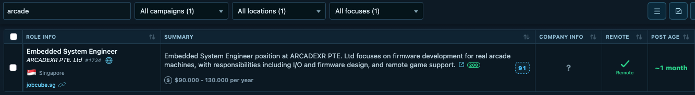
Figure 17. The arcade search in Opportunities.
The Embedded Firmware focus view shows more than one example, with roles that involve RTOS and vehicle control, wireless devices, mobile SDKs, IoT testing, server firmware and device drivers, each of which keeps its source link and fit value.
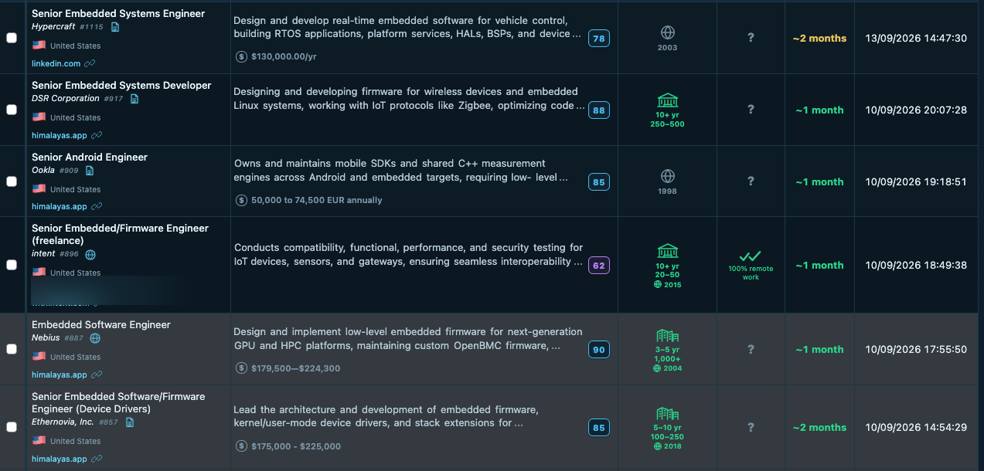
Figure 18. The Embedded Firmware focus view.
Hidden Leads holds Ixitech, whose page describes an emulator for legacy shipboard peripheral equipment. That is a company lead rather than a job offer, and because it came through DuckDuckGo it also shows why I still keep the other engines in the mix. Another recent lead, Redscan, which appears under malware with malware analysis and reverse engineering work, was saved from SearchApi Google Web.
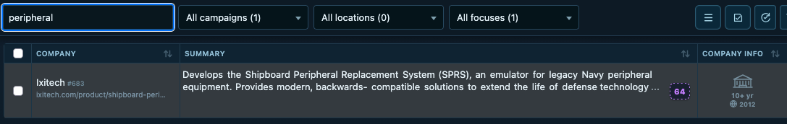
Figure 19. Ixitech in Hidden Leads.
The border of the fit badge carries a meaning of its own. A dashed border marks a score that still comes from the initial local pass, whereas a solid border marks one that a re-evaluation with web verification has confirmed, which is why Ixitech and Vocso show a dashed 64 and 71 in the list below while OpenIPC and Novami show a solid 88 and 90.
Alongside Ixitech, the list includes OpenIPC's embedded video firmware, Novami's emulation work, hardware-verification companies and smaller retro-computing projects. Although some of these companies mention hiring, ScoutBox keeps each company record as a lead until a specific role has been verified.
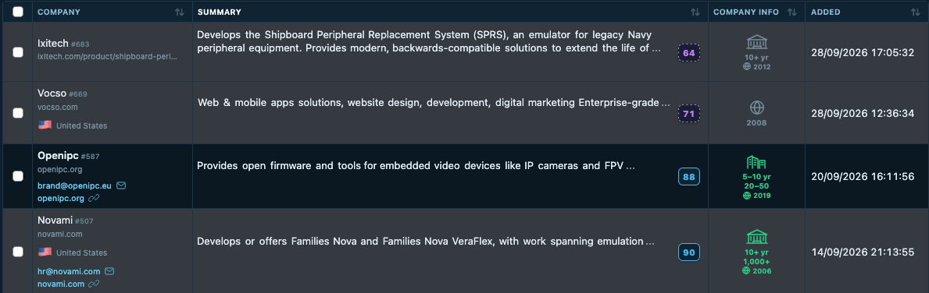
Figure 20. More emulation-related Hidden Leads.
The Global Activity Map gives a geographic view of the opportunities and leads for which there is enough location evidence to place them. I use it to notice where a campaign is finding results before going back to the records for the actual job or company details, bearing in mind that search indexes are incomplete and that different runs may turn up different pages.
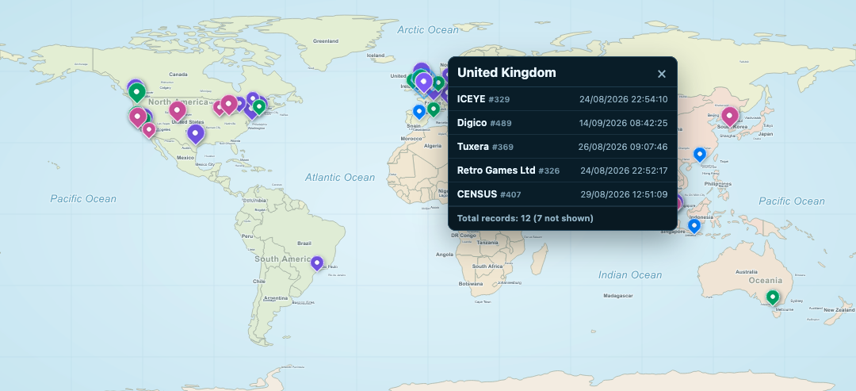
Figure 21. The Global Activity Map.

Applying and Reaching Out
Everything that ScoutBox finds ends up in Applications & Outreach once I decide to act on it. The list keeps one entry per application or outreach draft with its company, contact or URL, status, applied date and channel, and each entry records which Hidden Lead or Opportunity it was prepared from.
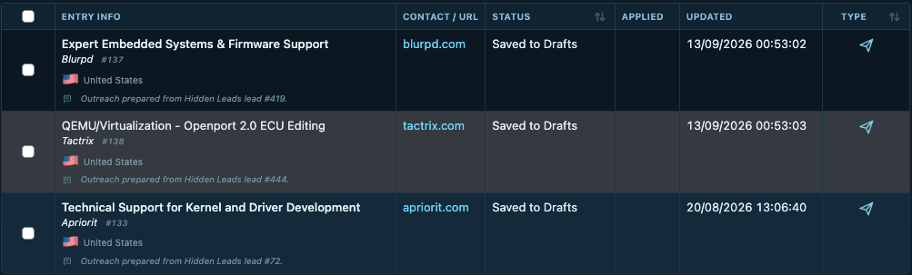
Figure 22. The Applications & Outreach list.
Opening an entry leads to the Email and Application view, which keeps a subject, an editable body, the source documents, earlier drafts and the tailoring history next to the opportunity and can personalize an email, tailor a selected resume or cover letter, and draft application answers. I review each output against the source CV and the job page so that a model neither invents experience nor quietly changes the CV layout. Saving a draft can place it in the configured mail Drafts folder, while sending remains a separate action that I take myself.
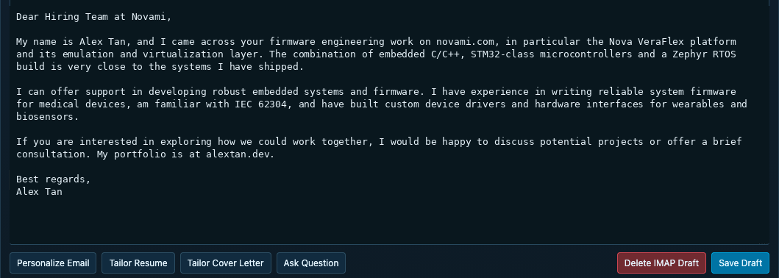
Figure 23. The email draft view.
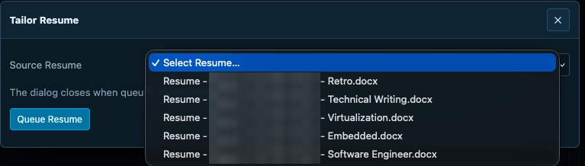
Figure 24. The resume tailoring dialog.
The Address Book stores general careers addresses and specific contacts, while a blacklist keeps unwanted companies or URLs from recurring and the recycle bin supports review and restoration. Public Facebook pages provide another way of finding organizations, and if I want to know whether a link in an email was clicked, the Tracking Links menu can be connected to an external module or container that I code for that purpose.

Record Re-evaluation
Preferences change, and so do postings, which is why ScoutBox can re-evaluate a filtered set of opportunities instead of making me start a campaign again. I can limit the scope to records that were previously assessed with local AI, cloud AI or both, then choose the provider, model and instructions for the new pass. The history keeps the earlier and the new fit values together with the reason for the decision, after which a record can remain, move to the recycle bin or be restored later.
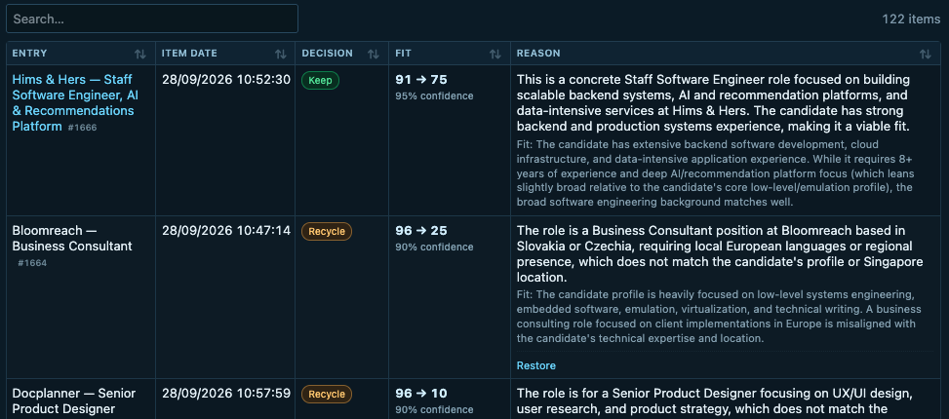
Figure 25. Re-evaluation history.
The screenshot shows one role that was kept after its score changed from 91 to 75 and another that was recycled after a larger change. The numbers are an aid to review rather than a promise that the model is always right. The useful part is being able to compare the stated reason with the actual posting and my current profile, since a real organization with no live vacancy often makes more sense as a Hidden Lead than as an Opportunity.

Chatbot
The chatbot answers questions against ScoutBox's current records and settings, so I can ask what looks interesting today or where a particular setting lives. Its provider and fallback are configured separately from discovery, and its sample answer, which is shown below, points back to a stored record rather than to anything it made up.
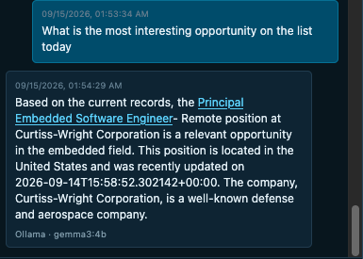
Figure 26. The chatbot.

Resource Usage
This installation uses an Apple M5 with 32 GB of unified memory, on which the local AI settings run Ollama with Qwen 2.5 7B as primary and Gemma 3 4B as fallback. SearchApi still handles the search request in the cloud while the Mac handles the selected page analysis locally, a division that lets me spend local compute on the judgment instead of asking Qwen to invent a list of jobs.
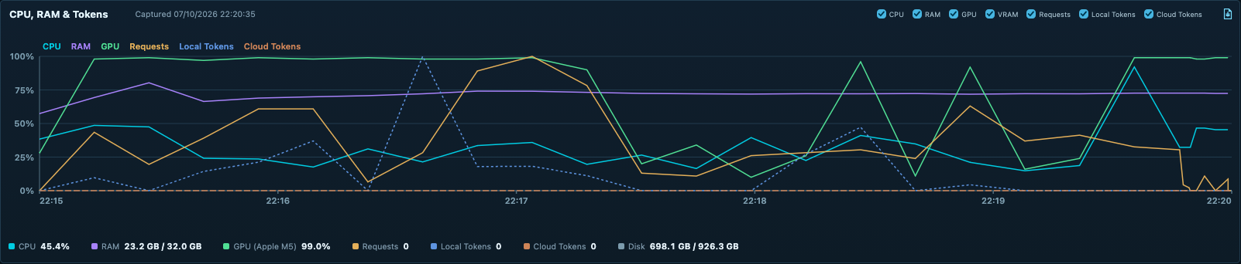
Figure 27. CPU, RAM and GPU during active campaigns.
The resource chart captures a busy five-minute stretch during which, according to the 35 timestamped samples that the diagnostic bundle holds for the same period, CPU reached 92% in one sample, RAM ranged from roughly 18 to 26 GiB, and the reported Apple M5 GPU utilization sat near 98–99% for much of the window. This is host telemetry taken during concurrent search and AI work rather than a benchmark of a single model call.
Host load is only half of the picture, because the same page also totals what the AI work actually consumed. Over the last 30 days this installation made 827,889 provider requests and fetched 2.1 million pages and queries, during which the models received 102.7 million input tokens and produced 10.1 million output tokens, together with 1,677 AI web searches and 182.6 GB of downloaded page data. The overwhelming share of those tokens went to the local Ollama models, where they cost electricity rather than money, which is the trade-off that makes a campaign-per-niche setup affordable; the cloud providers, which are reserved for re-evaluation and verification, account for only a small fraction of the total. SearchApi is similarly modest in volume: the Search Activity log counts 2,420 SearchApi requests in total, of which 1,730 went to Google Web, 509 to Google Jobs, 103 to Google Forums, 57 to Google News and 21 to Google Local, which is well within a single daily allowance and a small price for the structured results that the earlier comparison showed.
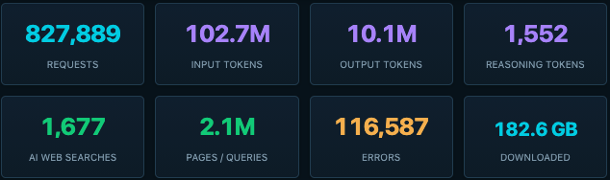
Figure 28. Resource Usage totals for the last 30 days.
The AI Requests captures show why a single duration would be misleading. In different runs, a Qwen 2.5 7B planning call took 14.5 seconds and a page summary 12.1 seconds, whereas a Gemma 3 4B planning call took 27.8 seconds and Qwen's multilingual first filtering and query planning took 42.5 and 40.1 seconds, and at heavier peaks I have also seen a local reply take more than a minute. Because these captures come from different runs than the resource chart, they do not tie a particular call to one GPU sample, which is why the AI request rows in the diagnostic export are the better basis for a latency distribution.
Figure 29. A Gemma 3 4B query-planning call.
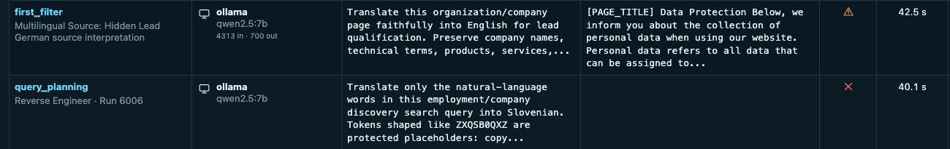
Figure 30. Qwen 2.5 7B multilingual requests.

Diagnostics
The notification bar at the top of every page provides the first level of monitoring. Its two dropdowns show the latest Opportunities and Hidden Leads with their counts, and the activity view with the running campaigns, a search quota warning when local providers are used up, and the last five alerts, which in the capture below are 403 responses from a job site and several forums.
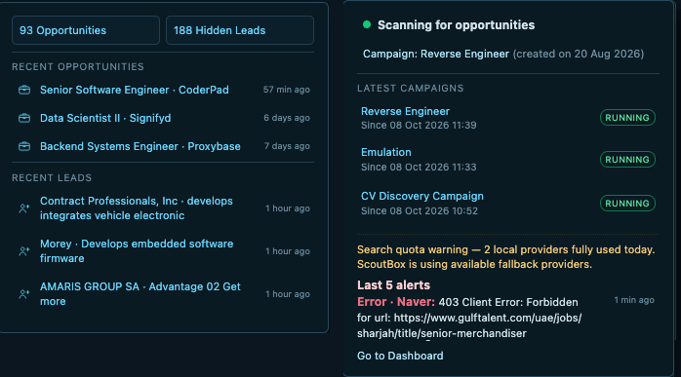
Figure 31. The notification dropdowns.
The dashboard shows which campaigns are running, Search Activity records the provider, query, number of results, elapsed time and outcome of each search, and AI Requests shows the stage, runtime or model, status and timing of each call. Diagnostics checks the database, queue, local model, mail, document conversion, search adapters and scheduler, which gives me a place to look when a run appears quiet or a result looks odd, without having to guess which worker did the work.
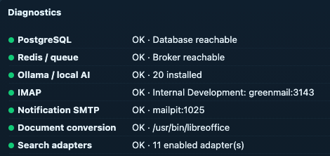
Figure 32. The Diagnostics panel.
For deeper analysis, Configuration > Maintenance offers Export Diagnostic Data, which packs the selected categories for a chosen period into one ZIP. The dialog lists what each category contributes and how large it is, from the configuration and campaign context through opportunities, hidden leads, contacts and mail, search and provider diagnostics, the discovery funnel, AI request diagnostics, resource usage and the jobs, errors and audit trail, so that I can leave out whatever a particular question does not need. Credentials are always redacted and personal details are replaced where they match the profile, which means the archive can be uploaded to an LLM with a question such as why a campaign stalled or why an engine stopped returning results, and the model can trace the answer through the same records that the article's comparison tables were built from.
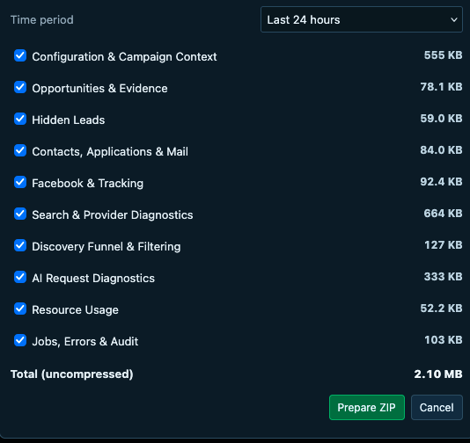
Figure 33. The Export Diagnostic Data dialog.
The support export includes compact audit entries, of which this one, recording recovery after a restart, is the kind of context that helps when I upload a reviewed diagnostic bundle to an LLM and ask it to trace an interrupted run:
{
"at": "2026-10-07T14:14:58.170Z",
"version": "0.11.152",
"action": "restart_recovery",
"summary": "Recovered 5 campaign run(s) after ScoutBox restart; queued 5 replacement run(s)."
}

The timestamp, version and action let me connect the audit entry with the Search Activity and AI Requests rows that surround it, although I review and redact a support bundle before uploading it anywhere. The About page also serves as a small manual, which explains the architecture and lists ScoutBox-specific inspection commands rather than generic container recipes: Django shell one-liners that query the Opportunity, CompanyLead and Contact models directly, migration and system checks, and Celery inspect calls that show which tasks are active or reserved on the discovery workers. It is particularly useful when I return to a self-hosted installation after a while away.
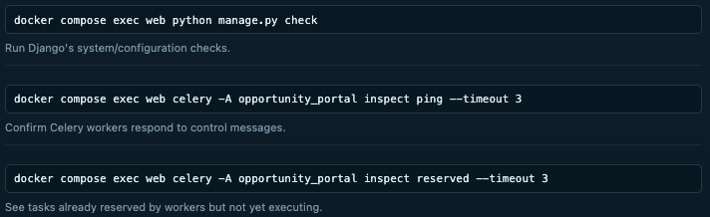
Figure 34. Celery inspection commands on the About page.
The following commands are also useful, the first two of which query the stored Opportunity and Hidden Lead records directly through the Django shell:
docker compose exec web python manage.py shell -c "
from portal.models import Opportunity
print(list(Opportunity.objects.filter(user_deleted=False, suppressed=False)
.values('id','title','company','status')[:20]))"

docker compose exec web python manage.py shell -c "
from portal.models import CompanyLead
print(list(CompanyLead.objects.filter(user_deleted=False, deleted_at__isnull=True)
.values('id','company','status','score')[:20]))"

docker compose logs --tail=200 redis # broker and queue connectivity
docker compose exec web python manage.py check # Django system checks
docker compose exec web python manage.py showmigrations portal
docker compose exec web celery -A opportunity_portal inspect active --timeout 3

The full list of troubleshooting commands is available on the About page.

Source Code
ScoutBox runs as a Docker Compose stack. On a MacBook with an M-series chip, I use initial_setup_macos.sh, Docker Desktop and a host Ollama that relies on Apple's Metal support, whereas on an Ubuntu machine with an NVIDIA GPU, initial_setup_ubuntu.sh can select the NVIDIA Compose overlay and run Ollama with GPU access. CPU-only, externally hosted and cloud models are options too, and the source selects the appropriate Compose profile for each. ScoutBox can also run on a PC without a GPU, provided that a cloud LLM has been configured, since discovery and assessment then run entirely through that provider; without either a local or a cloud model, the portal starts in read-only mode and shows the stored records without running new campaigns.
After setup has created the local configuration and started the services, I complete the profile, test SearchApi under Configuration > Search Sources, and then run one small campaign, having entered the SearchApi key in the UI or in the environment configuration. For a quick health check I use docker compose ps, followed by the About page's focused log commands when I need more detail. The first useful checks are whether the worker and scheduler are up, whether the selected search source returned anything, and whether an AI stage completed.
The source layout is fairly ordinary for a Django application. These are the main paths in the release package, with the SearchApi adapter and its job normalizer living in portal/services/search.py:
scoutbox/
README.md release notes and entry point
.env.example settings template; copy to .env
docker-compose.yml web, database, queue and workers
docker-compose.nvidia.yml NVIDIA GPU overlay
initial_setup_macos.sh Mac first setup
initial_setup_ubuntu.sh Ubuntu first setup
manage.py Django command entry
opportunity_portal/
settings.py Django configuration
celery.py background task app
portal/
models.py stored records and settings
views.py web endpoints
tasks.py scheduled and background work
services/
search.py search providers, including SearchApi
ai.py local and cloud model routing
location.py location evidence handling
diagnostics.py health and support export
templates/portal/ rendered pages
portal/static/ browser assets
scripts/ setup helpers
docs/ release notes

For a quick start, copy .env.example to .env and run ./initial_setup_macos.sh on a MacBook or ./initial_setup_ubuntu.sh on a PC with an NVIDIA GPU. Once the portal is up, begin by uploading a resume in Candidate Profile, let it populate the search profile, and then create a campaign or two from the generated templates. The SearchApi key, the cloud provider keys and every other setting can be entered in the portal afterwards, so nothing beyond the .env defaults is needed for the first run.

Downloads
SearchApi documentation for the engines used in this article:
- Google Jobs: https://www.searchapi.io/docs/google-jobs
- Google Web: https://www.searchapi.io/docs/google
- Google Forums: https://www.searchapi.io/docs/google-forums-api
- Google News: https://www.searchapi.io/docs/google-news
- Google Local: https://www.searchapi.io/docs/google-local-api
Ollama API: https://docs.ollama.com/api
- OpenAI API: https://platform.openai.com/docs/api-reference
- Gemini API: https://ai.google.dev/gemini-api/docs
- OpenRouter API: https://openrouter.ai/docs
ScoutBox source code: https://github.com/OWNER/ScoutBox

