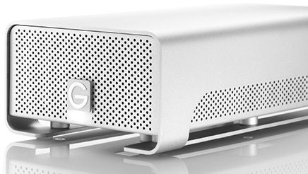

|  |  |
| --- | --- |
| **BRAND** | **G-TECHNOLOGY** |
| **CAPACITY** | **UPTO 1TB** |
| **INTERFACE** | **1xTHUNDERBOLT** |
| **HDD** | **4634RPM** |
| **TRNSFER RATE** | **300MB/s** |
| **PRICE** | **$345.95** |