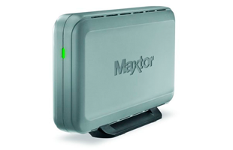

|  |  |
| --- | --- |
| **BRAND** | **MAXTOR** |
| **CAPACITY** | **UPTO 2TB** |
| **INTERFACE** | **2xTHUNDERBOLT** |
| **HDD** | **745RPM** |
| **TRNSFER RATE** | **234MB/s** |
| **PRICE** | **$234.95** |