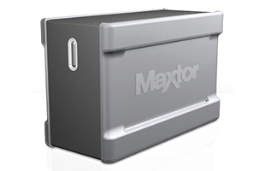

|  |  |
| --- | --- |
| **BRAND** | **MAXTOR** |
| **CAPACITY** | **UPTO 8TB** |
| **INTERFACE** | **2xTHUNDERBOLT** |
| **HDD** | **544RPM** |
| **TRNSFER RATE** | **844MB/s** |
| **PRICE** | **$733.95** |