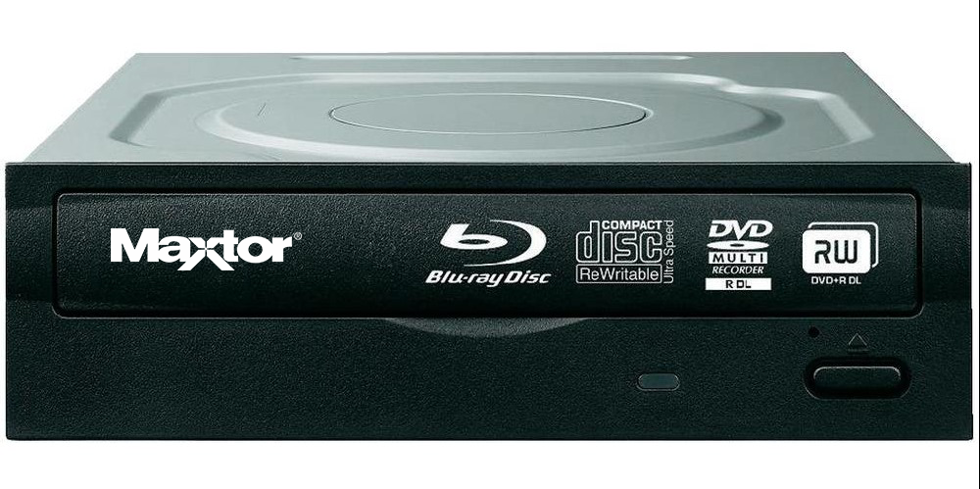

|  |  |
| --- | --- |
| **BRAND** | **MAXTOR** |
| **ACCESS TIME** | **DVD: 950MS CD: 850MS** |
| **INTERFACE** | **SATA** |
| **DATA BUFFER** | **3MB** |
| **PROCESSOR REQUIREMENT** | **PENTIUM 900 MHZ OR HIGHER** |
| **PRICE** | **$754.95** |