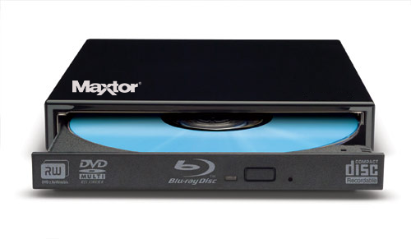

|  |  |
| --- | --- |
| **BRAND** | **MAXTOR** |
| **ACCESS TIME** | **DVD: 550MS CD: 450MS** |
| **INTERFACE** | **SATA** |
| **DATA BUFFER** | **5MB** |
| **PROCESSOR REQUIREMENT** | **PENTIUM 800 MHZ OR HIGHER** |
| **PRICE** | **$733.95** |