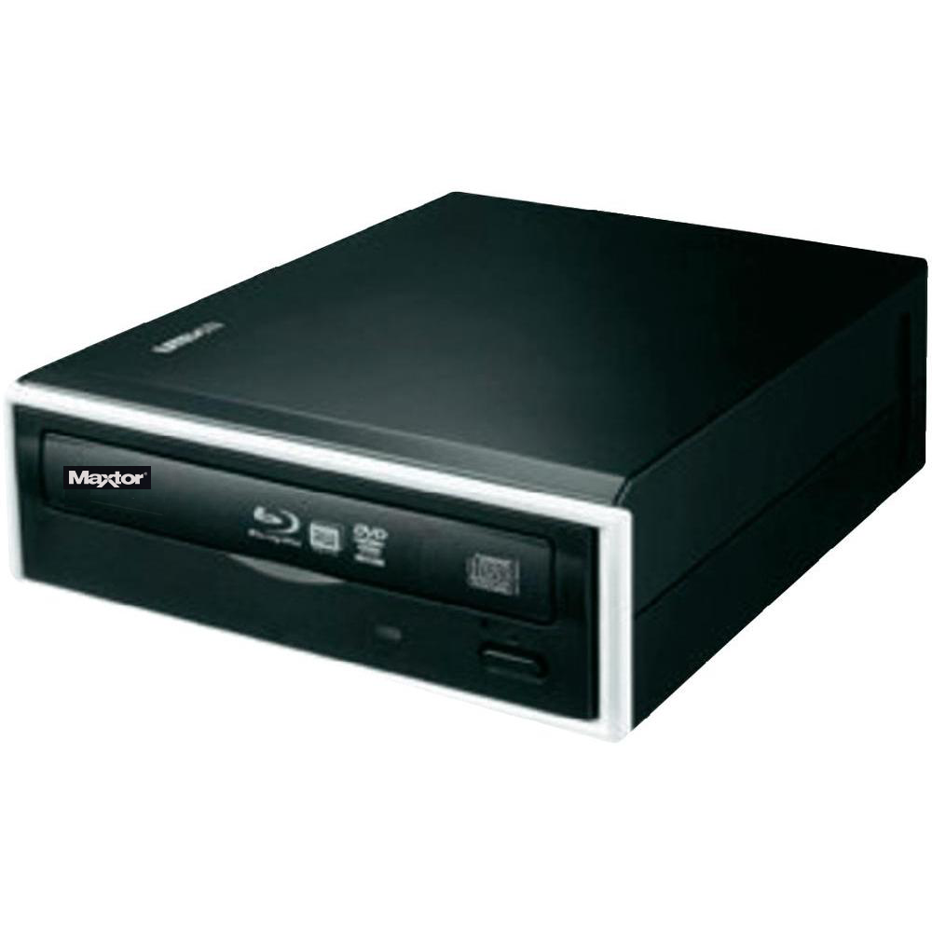

|  |  |
| --- | --- |
| **BRAND** | **MAXTOR** |
| **ACCESS TIME** | **DVD: 150MS CD: 250MS** |
| **INTERFACE** | **SATA** |
| **DATA BUFFER** | **9MB** |
| **PROCESSOR REQUIREMENT** | **PENTIUM 400 MHZ OR HIGHER** |
| **PRICE** | **$654.95** |