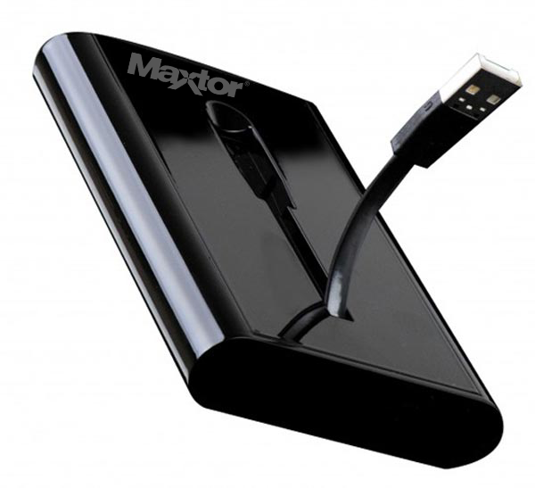

|  |  |
| --- | --- |
| **BRAND** | **MAXTOR** |
| **CAPACITY** | **UPTO 3TB** |
| **INTERFACE** | **1xUSB 3.0** |
| **HDD** | **2340RPM** |
| **TRNSFER RATE** | **UPTO 345MB/s** |
| **PRICE** | **$345.95** |