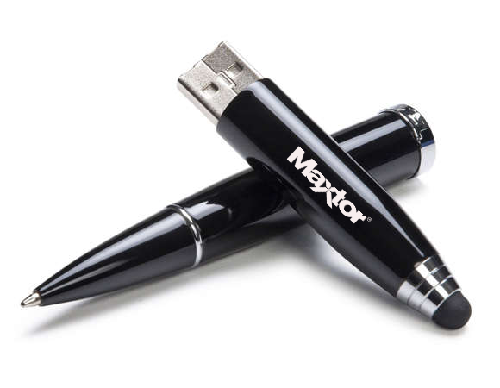

|  |  |
| --- | --- |
| **BRAND** | **MAXTOR** |
| **INTERFACE** | **HAIGH SPEED USB 2.0** |
| **PORT TYPE** | **TYPE A USB PORT** |
| **POWER SUPPLY** | **USB BUS POWER** |
| **CAPACITY** | **4GB** |
| **TECHNOLOGY** | **CHIP BOARD** |
| **WARRANTY** | **1 YEAR** |
| **PRICE** | **$232.95** |