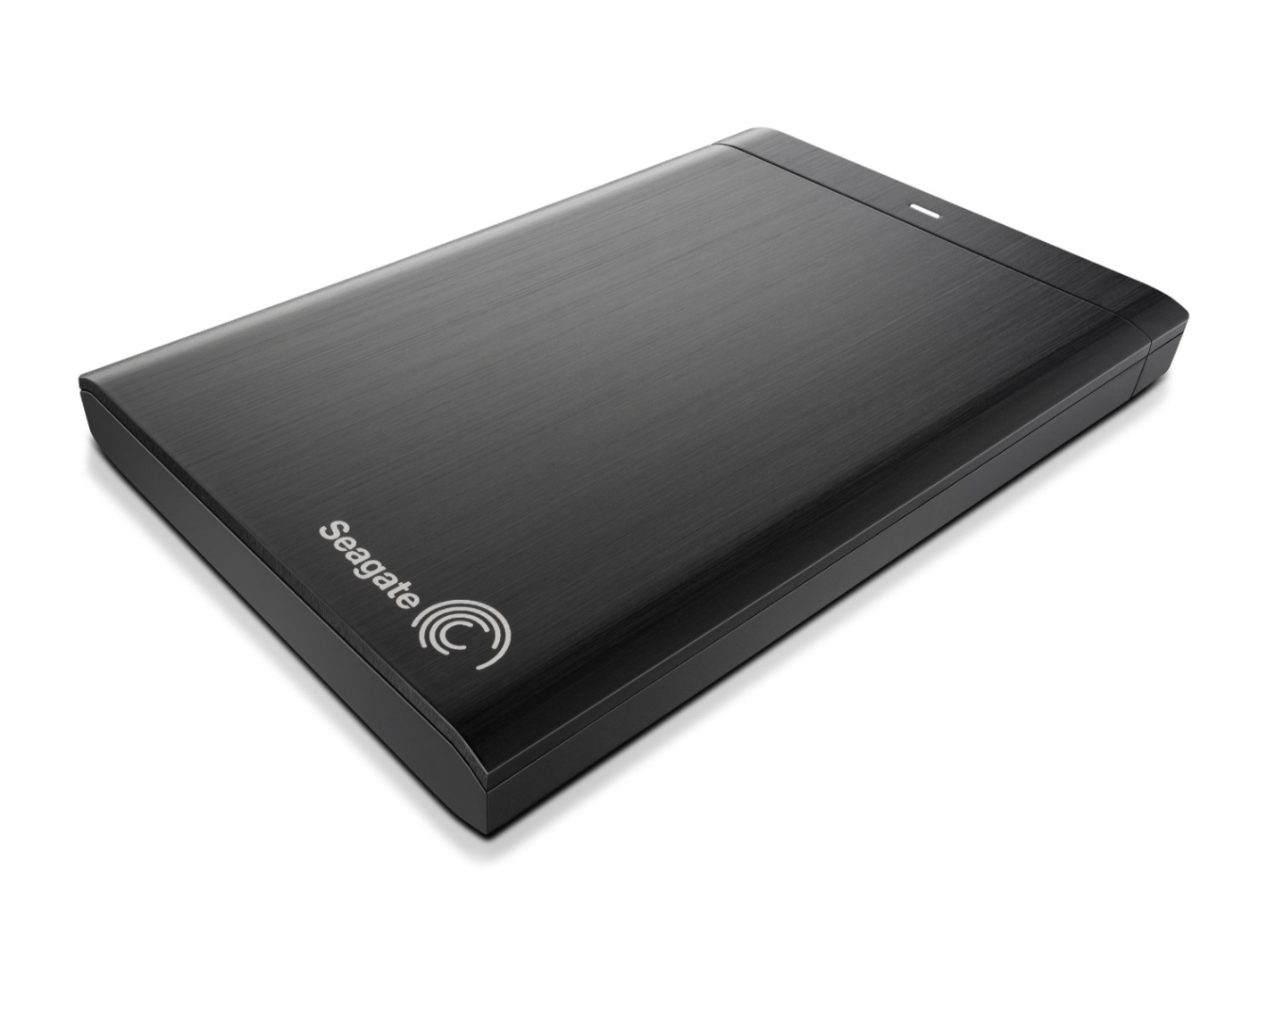

|  |  |
| --- | --- |
| **BRAND** | **SEAGATE** |
| **CAPACITY** | **UPTO 4TB** |
| **INTERFACE** | **1xUSB 3.0** |
| **HDD** | **6734RPM** |
| **TRNSFER RATE** | **UPTO 567MB/s** |
| **PRICE** | **$234.95** |