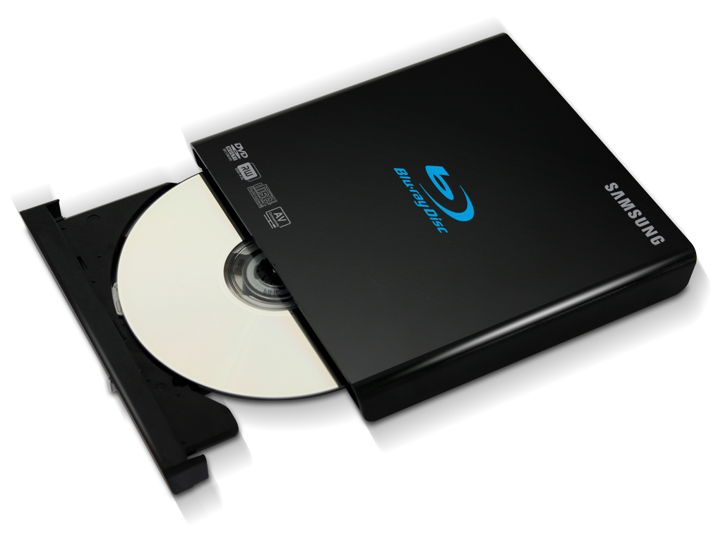

|  |  |
| --- | --- |
| **BRAND** | **G-TECHNOLOGY** |
| **ACCESS TIME** | **DVD: 850MS CD: 950MS** |
| **INTERFACE** | **SATA** |
| **DATA BUFFER** | **12MB** |
| **PROCESSOR REQUIREMENT** | **PENTIUM 400 MHZ OR HIGHER** |
| **PRICE** | **$649.95** |