

Lab Report

SUBMITTED TO

Azizul Hakim

Lecturer

Department of Computer Science and Engineering

Faculty of Science and Information Technology

Daffodil International University

SUBMITTED BY

Name: Md. Anisur Rahman Rony

ID: 162-15-7880

Section: E

Course Title: Computer Networks Lab

Course Code: CSE 314

Department: Computer Science & Engineering

Experiment-5

Title: “Router Configuration with OSPF (Open Shortest Path First)”

Objective: To learn how to configure router with OSPF (Open Shortest Path First) method.

Tools: Genetic Router-PT, Switches 2950-24, End devices, Copper Straight-Through cable, Serial DCE cable, CISCO Packet Tracer 7.1.1.

Screenshots of Router Configuration with OSPF (Open Shortest Path First)

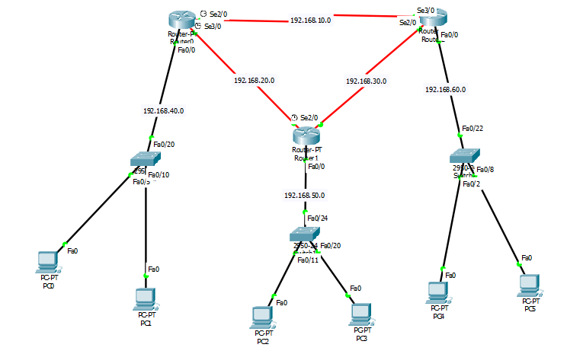

CLI Command for Router Configuration with OSPF (Open Shortest Path First)

**Router 0**

--- System Configuration Dialog ---

Would you like to enter the initial configuration dialog? [yes/no]: no

Press RETURN to get started!

Router>en

Router#conf t

Enter configuration commands, one per line. End with CNTL/Z.

Router(config)#int fa0/0

Router(config-if)#ip add 192.168.40.1 255.255.255.0

Router(config-if)#no shut

Router(config-if)#

%LINK-5-CHANGED: Interface FastEthernet0/0, changed state to up

%LINEPROTO-5-UPDOWN: Line protocol on Interface FastEthernet0/0, changed state to up

Router(config-if)#ex

Router(config)#int se2/0

Router(config-if)#ip add 192.168.10.1 255.255.255.0

Router(config-if)#clock rate 64000

Router(config-if)#no shut

%LINK-5-CHANGED: Interface Serial2/0, changed state to down

Router(config-if)#ex

Router(config)#int se3/0

Router(config-if)#ip add 192.168.20.1 255.255.255.0

Router(config-if)#clock rate 64000

Router(config-if)#no shut

%LINK-5-CHANGED: Interface Serial3/0, changed state to down

Router(config-if)#ex

Router(config)#ip dhcp pool rony1

Router(dhcp-config)#net 192.168.40.0 255.255.255.0

Router(dhcp-config)#default-router 192.168.40.1

Router(dhcp-config)#ex

Router(config)#

Router(config)#router ospf 1

Router(config-router)#network 192.168.10.0 0.0.0.255 area 0

Router(config-router)#network 192.168.20.0 0.0.0.255 area 0

Router(config-router)#network 192.168.40.0 0.0.0.255 area 0

Router(config-router)#ex

Router(config)#

**Router 1**

--- System Configuration Dialog ---

Would you like to enter the initial configuration dialog? [yes/no]: no

Press RETURN to get started!

Router>en

Router#conf t

Enter configuration commands, one per line. End with CNTL/Z.

Router(config)#int fa0/0

Router(config-if)#ip add 192.168.50.1 255.255.255.0

Router(config-if)#no shut

Router(config-if)#

%LINK-5-CHANGED: Interface FastEthernet0/0, changed state to up

%LINEPROTO-5-UPDOWN: Line protocol on Interface FastEthernet0/0, changed state to up

Router(config-if)#ex

Router(config)#int se3/0

Router(config-if)#ip add 192.168.20.2 255.255.255.0

Router(config-if)#no shut

Router(config)#

%LINEPROTO-5-UPDOWN: Line protocol on Interface Serial3/0, changed state to up

Router(config-if)#ex

Router(config)#int se2/0

Router(config-if)#ip add 192.168.30.1 255.255.255.0

Router(config-if)#clock rate 64000

Router(config-if)#no shut

%LINK-5-CHANGED: Interface Serial2/0, changed state to down

Router(config-if)#ex

Router(config)#ip dhcp pool rony2

Router(dhcp-config)#net 192.168.50.0 255.255.255.0

Router(dhcp-config)#default-router 192.168.50.1

Router(dhcp-config)#ex

Router(config)#

Router(config-router)#router ospf 1

Router(config-router)#network 192.168.20.0 0.0.0.255 area 0

Router(config-router)#network 192.168.30.0 0.0.0.255 area 0

Router(config-router)#

00:11:50: %OSPF-5-ADJCHG: Process 1, Nbr 192.168.40.1 on Serial3/0 from LOADING to FULL, Loading Done

Router(config-router)#network 192.168.50.0 0.0.0.255 area 0

Router(config-router)#ex

Router(config)#

**Router 2**

--- System Configuration Dialog ---

Would you like to enter the initial configuration dialog? [yes/no]: no

Press RETURN to get started!

Router>en

Router#conf t

Enter configuration commands, one per line. End with CNTL/Z.

Router(config)#int fa0/0

Router(config-if)#ip add 192.168.60.1 255.255.255.0

Router(config-if)#no shut

Router(config-if)#

%LINK-5-CHANGED: Interface FastEthernet0/0, changed state to up

%LINEPROTO-5-UPDOWN: Line protocol on Interface FastEthernet0/0, changed state to up

Router(config-if)#ex

Router(config)#int se3/0

Router(config-if)#ip add 192.168.10.2 255.255.255.0

Router(config-if)#no shut

Router(config-if)#

%LINK-5-CHANGED: Interface Serial3/0, changed state to up

Router(config-if)#ex

Router(config)#int se2/0

%LINEPROTO-5-UPDOWN: Line protocol on Interface Serial3/0, changed state to up

Router(config-if)#ip add 192.168.30.2 255.255.255.0

Router(config-if)#no shut

Router(config-if)#

%LINK-5-CHANGED: Interface Serial2/0, changed state to up

Router(config-if)#ex

Router(config)#i

%LINEPROTO-5-UPDOWN: Line protocol on Interface Serial2/0, changed state to up

Router(config)#ip dhcp pool rony3

Router(dhcp-config)#net 192.168.60.0 255.255.255.0

Router(dhcp-config)#def

Router(dhcp-config)#default-router 192.168.60.1

Router(dhcp-config)#ex

Router(config)#

Router(config)#router ospf 1

Router(config-router)#network 192.168.10.0 0.0.0.255 area 0

Router(config-router)#network 192.168.30.0 0.0.0.255 area 0

Router(config-router)#

00:13:37: %OSPF-5-ADJCHG: Process 1, Nbr 192.168.40.1 on Serial3/0 from LOADING to FULL, Loading Done

Router(config-router)#

00:13:39: %OSPF-5-ADJCHG: Process 1, Nbr 192.168.50.1 on Serial2/0 from LOADING to FULL, Loading Done

Router(config-router)#network 192.168.60.0 0.0.0.255 area 0

Router(config-router)#ex

Router(config)#

Result

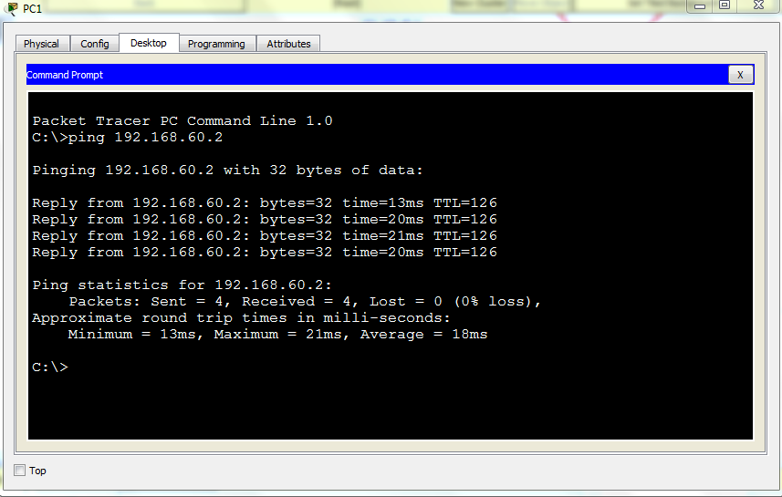

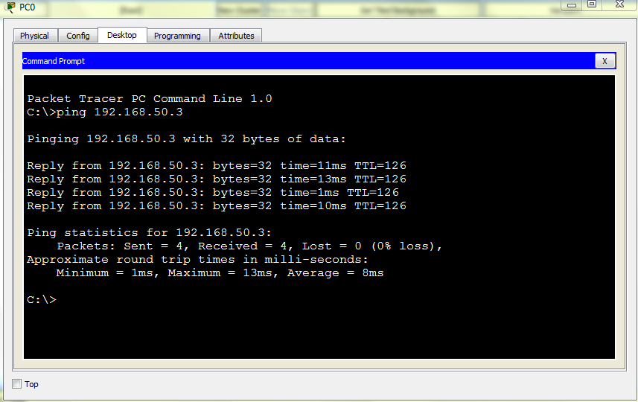

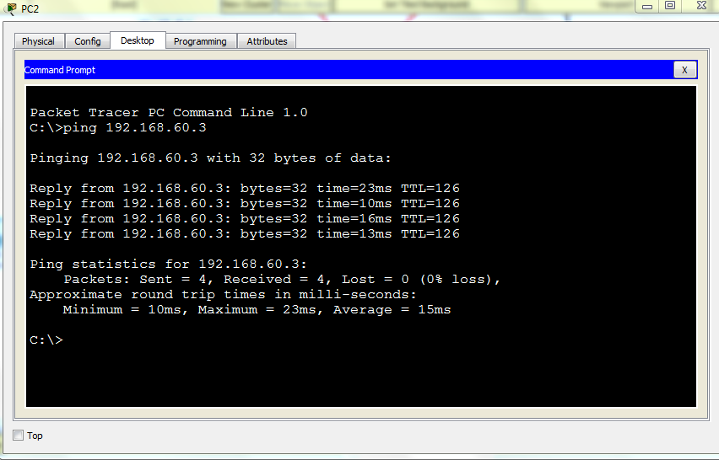

**End**