**Experiment-1**

**Title:-** Connecting device in different network using router.

**Objective :-** To learn the uses the router, subnet mask and gateway. And learn to configure the router using CLI to establish the connection between to devices via a router.

**Tools :-** Router, to end devices, straight through cable, CISCO Packet Tracer 7.0

**Topology :-**

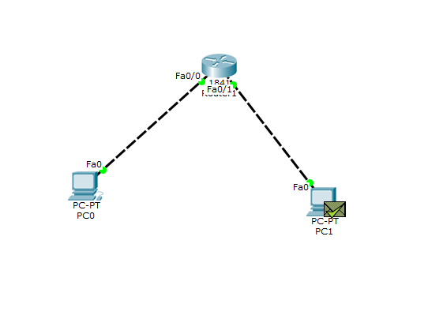

**CLI Code** :-

--- System Configuration Dialog ---

Continue with configuration dialog? [yes/no]: n

Press RETURN to get started!

Router>en

Router#config t

Router(config)#int f0/0

Router(config-if)#ip add 192.168.10.1 255.255.255.128

Router(config-if)#no shut

Router(config-if)#

%LINK-5-CHANGED: Interface FastEthernet0/0, changed state to up

%LINEPROTO-5-UPDOWN: Line protocol on Interface FastEthernet0/0, changed state to up

Router(config-if)#ex

Router(config)#int f0/1

Router(config-if)#ip add 192.168.10.129 255.255.255.128

Router(config-if)#no shut

Router(config-if)#

%LINK-5-CHANGED: Interface FastEthernet0/1, changed state to up

%LINEPROTO-5-UPDOWN: Line protocol on Interface FastEthernet0/1, changed state to up

Router(config-if)#^Z

Router#

%SYS-5-CONFIG_I: Configured from console by console

Router#

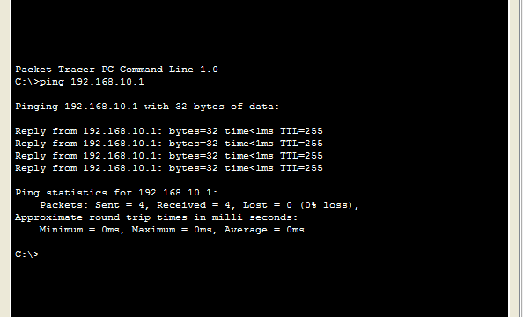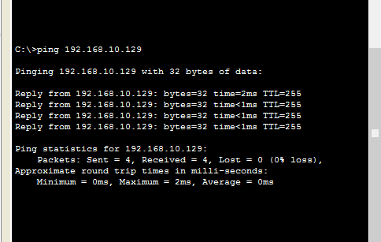**Result :-**