 | Daffodil International University (DIU)  Department of Computer Science & Engineering

LAB PROJECT

Module Name: Database Management System Lab
Module Code: CSE 312

GLOBAL CUSTODY

Project members:
Group # | Student ID | Name | Signature | Date
7 | 162-15-7880 | Md. Anisur Rahman Rony | ANISUR RAHMAN | 19/7/2018
7 | 162-15-7683 | Abdullah Al Foysal | Foysal | 19/7/2018

Module Tutor: Prof. Dr. Karim Mohammed Rezaul
Summer 2018
Section - E
Year -3, Semester -1

Contents
Section 1 Introduction 1
1.1 Purpose 1
Section 2 System Requirements 3
Section 3 Process Model Design 4
Section 4 Detailed Design 5
4.1 User Interface Design Overview 5
4.2 User Interface Navigation Hierarchy 5
Section 5 Technical Architecture 11
5.1 System Architecture 11
5.2 Technical Architecture Design 12
5.3 Performance Testing & Evaluation 18
Section 6 References 21
Section 7 Glossary 22
Section 8 Appendices 23

Section 1 Introduction

1.1 Purpose
The purpose of this system is to develop the condition of unexperienced investor or customer in investment who has sufficient assets to invest by a process global custody.
First of all, we have to know what is global custody and custodian process. The details about global custody are given below briefly:
GLOBAL CUSTODY is a term used within the investment banking industry in defining securities/monetary instruments that are traded internationally by Global Custodians. Those securities would be held in "Global Custody". Banks recognized as Global Custodians provide their customers with Global Custody services in respect to securities traded and settled not only in the country in which the Global Custodian is located but also in numerous other countries throughout the world.
A custodian bank, or simply custodian, is a specialized financial institution responsible for safeguarding a firm's or individual's financial assets and is not engaged in "traditional" commercial or consumer/retail banking such as mortgage or personal lending, branch banking, personal accounts, automated teller machines (ATMs) and so forth.
The role of a custodian in such a case would be to:
- Hold in safekeeping assets/securities such as stocks, bonds, commodities such as precious metals and currency (cash), domestic and foreign
- Arrange settlement of any purchases and sales and deliveries in/out of such securities and currency
- Collect information on and income from such assets (dividends in the case of stocks/equities and coupons (interest payments) in the case of bonds) and administer related tax withholding documents and foreign tax reclamation
- Administer voluntary and involuntary corporate actions on securities held such as stock dividends, stock splits, business combinations (mergers), tender offers, bond calls, etc.
- Provide information on the securities and their issuers such as annual general meetings and related proxies
- Maintain currency/cash bank accounts, effect deposits and withdrawals and manage other cash transactions
- Perform foreign exchange transactions
- Often perform additional services for particular clients such as mutual funds; examples include fund accounting, administration, legal, compliance and tax support services
- Asset managers are the firms that decide what to transact in, while the custodians handle settlement (the actual exchange of funds for securities or vice versa) and other post-trade activities such as corporate actions. An asset manager typically does not physically hold the securities it purchases.
By using this software, we will be able to implement of the global custody process.

Login Information

Login ID | globalcustody
Login Password | admin
User Name | admin

How to Use

- To use this software at first we have login using Login ID, Login Password and User Name which are mentioned above.
- Then Main Frame will be appeared where different global custody related terms, functionality and frames will be shown. Such as Customer, Custodian, Bank, Bonds, Assets, Settlements etc.
- In every frames there are five buttons. They are Insert, Update, Delete, Reset and Show Data.
- By using Insert button we can insert the new values of different attributes.
- By pressing Update button a new frame will be seen where we can update the information using old and new ID number.
- To delete any data we have to press Delete button using old ID number.
- To make empty the attribute or text field we can use Reset button.
- To show the inserted data in the table we can use Show Data button.

Section 2 System Requirements
Software/System Requirements Specifications to the design elements are given below:
- Java
- Java IDE
- MySQL Workbench

Section 3 Process Model Design

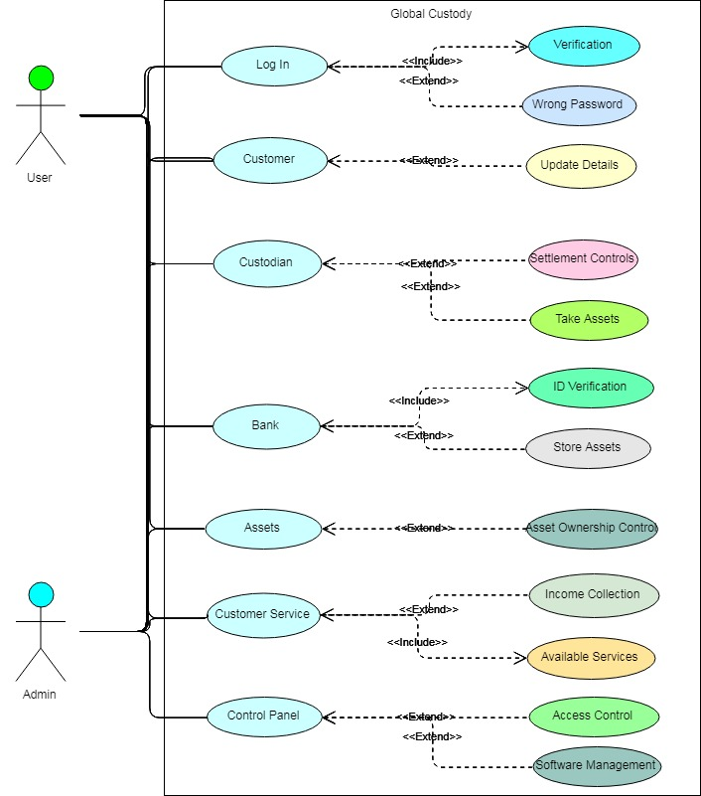

Figure: Use Case Diagram

Section 4 Detailed Design

4. User Interface Design Overview and User Interface Navigation Hierarchy

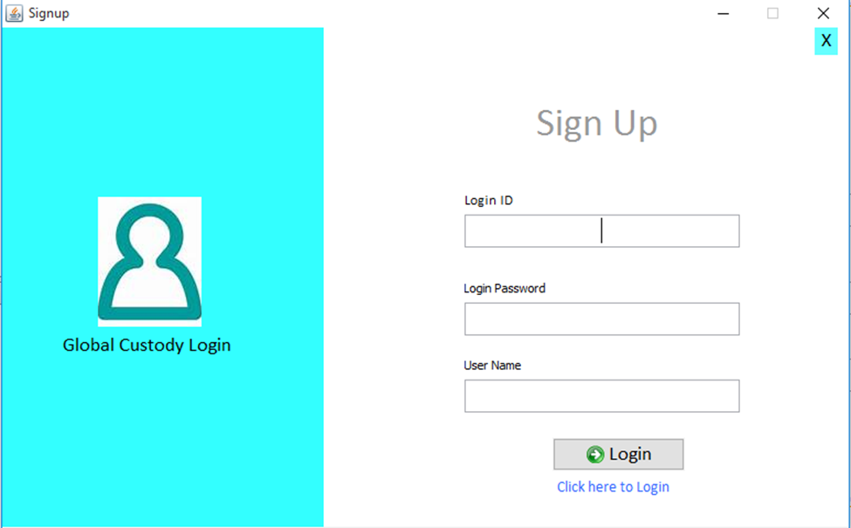

Figure: Login Form

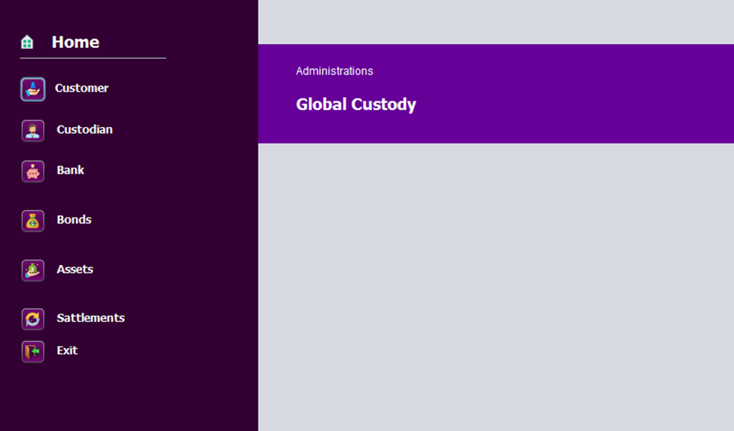
Figure: Main Frame

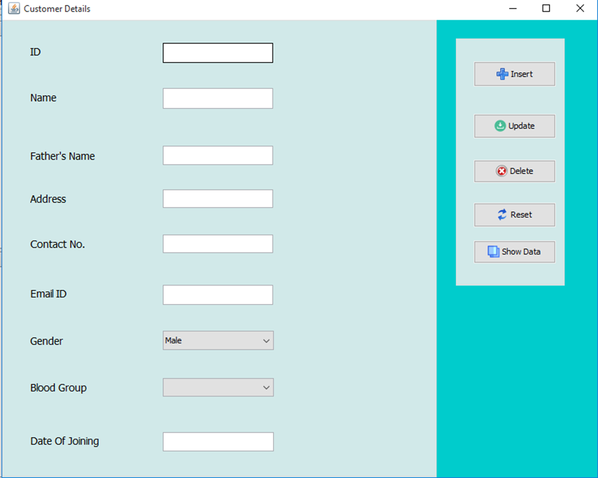
Figure: Customer Form

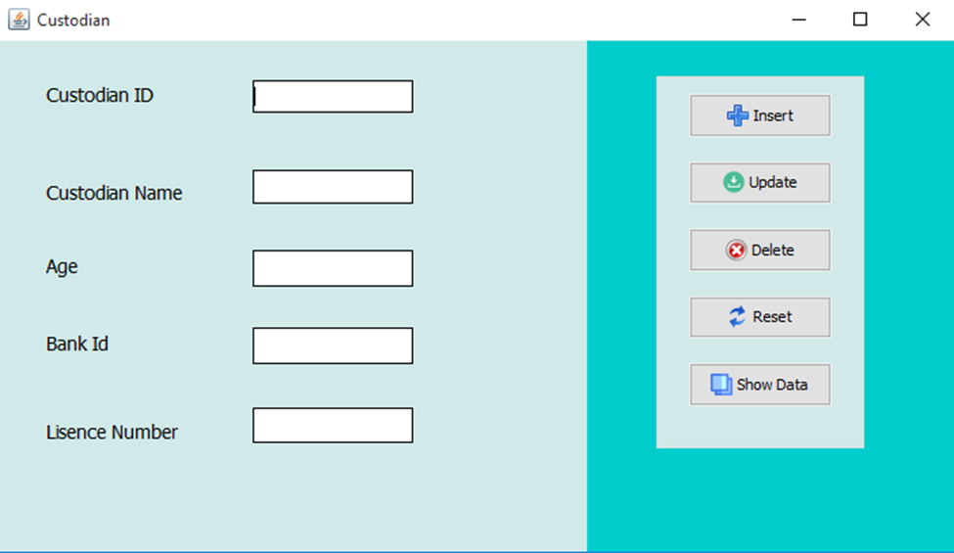
Figure: Custodian Form

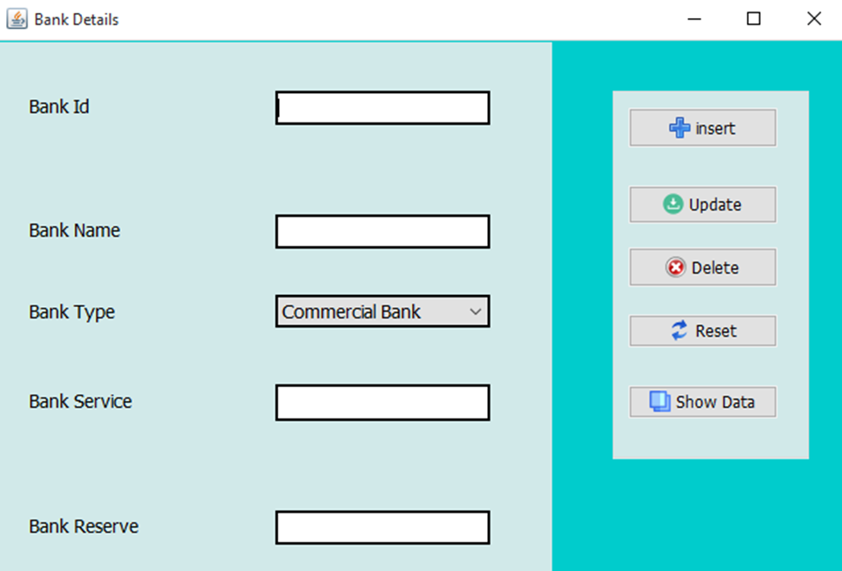
Figure: Bank Form
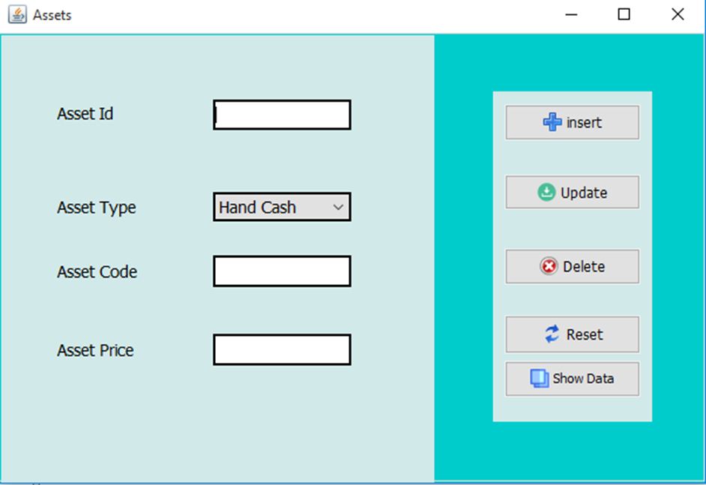

Figure: Asset Form

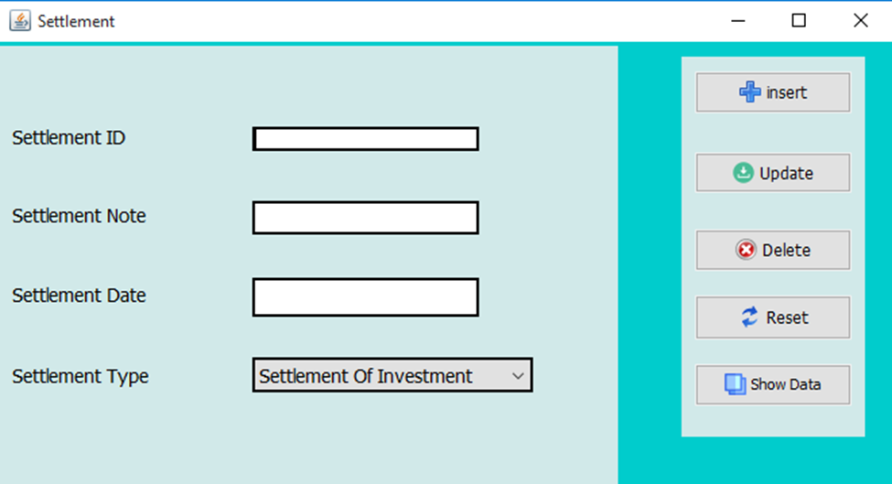

Figure: Settlement Form

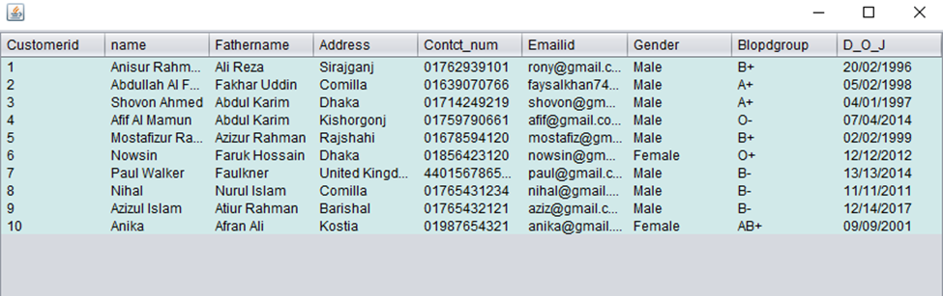
Figure: Customer Record
Figure: Customer Record

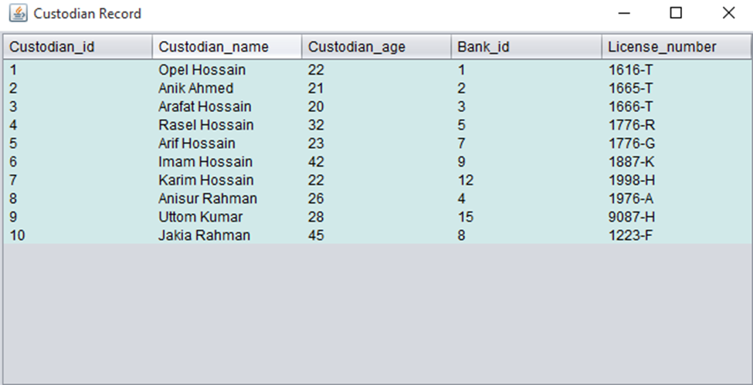

Figure 1: Custodian Record

Section 5 Technical Architecture

5.1 System Architecture
⇒ Operating System: Windows
⇒ Language: Java, SQL
⇒ Hardware: Averagely Configured System
⇒ Supporting Software: MySQL Workbench, NetBeans

5.2 Technical Architecture Design

5.2.1 Class Diagram

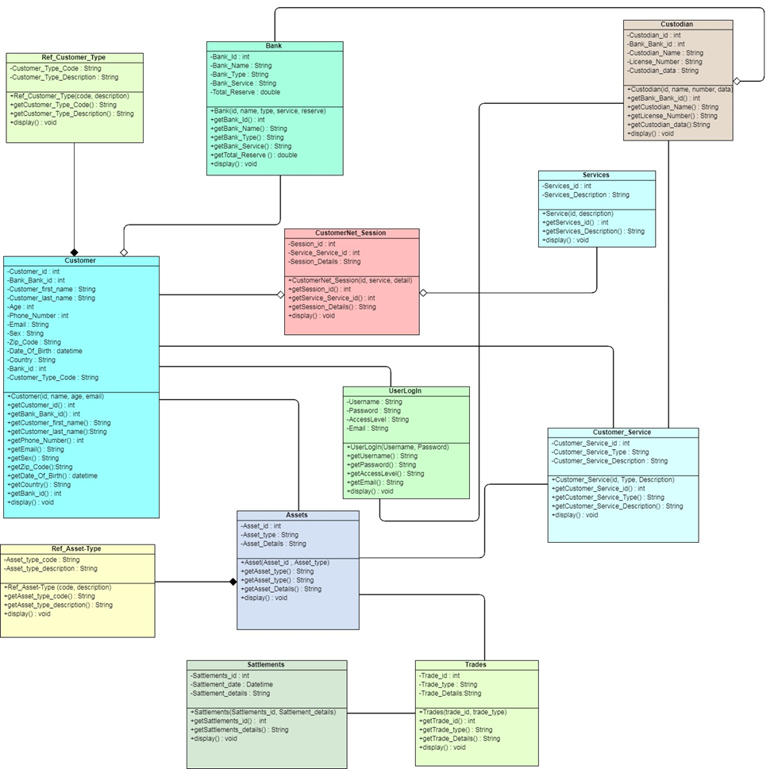

v

Figure: Class Diagram

5.2.2 Object Mapping

Schema:

Login: (Username, password, Email).

Customers: (Customer_id, Bank_id, Customer_Type_Code, Customer_first_name, Customer_last_name, Age, Phone_Number, Email, Sex, Zip_Code, Date_Of_Birth, Country, Bank_id, Customer_Type_Code).

Bank: (Bank_Id, Bank_Name, Bank_Type, Bank_Service, Total_Reserve).

Custodian: (Custodian_id, Bank_Bank_id, Custodian_Name, License_Number, Custodian_data).

Ref_Customer_Type: (Customer_Type_Code, Customer_Type_Description).

Services: (Services_id, Services_Description).

Assets: (Asset_id, Asset_type, Asset_Details).

CustomerNet_Session: (Session_id, Customer_ID, Services_Service_ID, Session_Details).

Custodians: (Custodian_ID, Bank_ID, Custodian_Name, License_Number, Custodian_Details).

Customer_Services: (Customer_Service_id, Custodian_Custodian_id, Customer_Service_Type, Customer_Service_Description).

Ref_Asset_Type: (Asset_Type_Code, Asset_Type_Description).

Settlements: (Settlement_ID, Trades_Trade_ID, Settlement_Date, Settlement_Details).

Trades: (Trade_ID, Asset_ID, Trade_Type, Trade_Details).

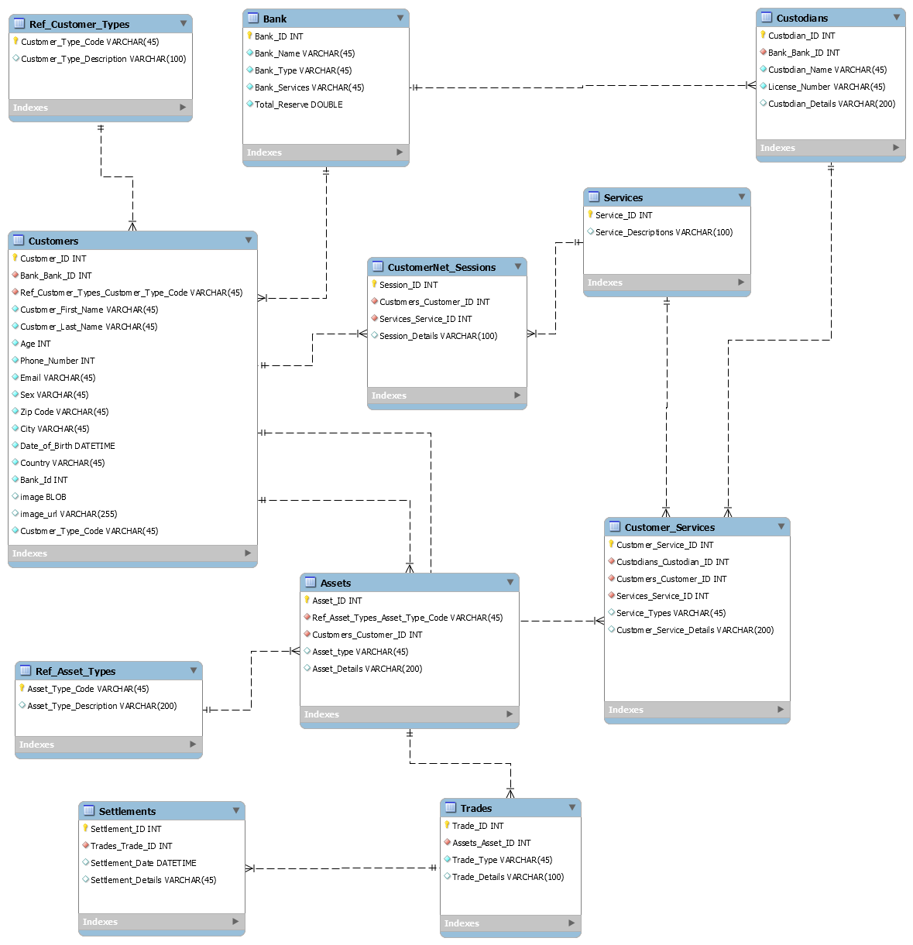

Figure: Database Schema

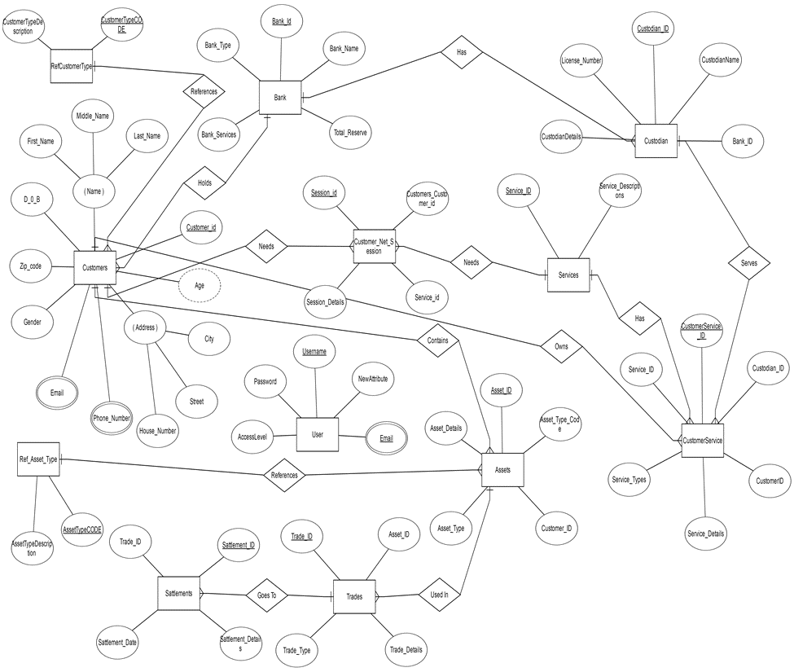

Figure: Entity Relationship Diagram (ERD Chen Notation)

5.2.3 Interface Control Document-

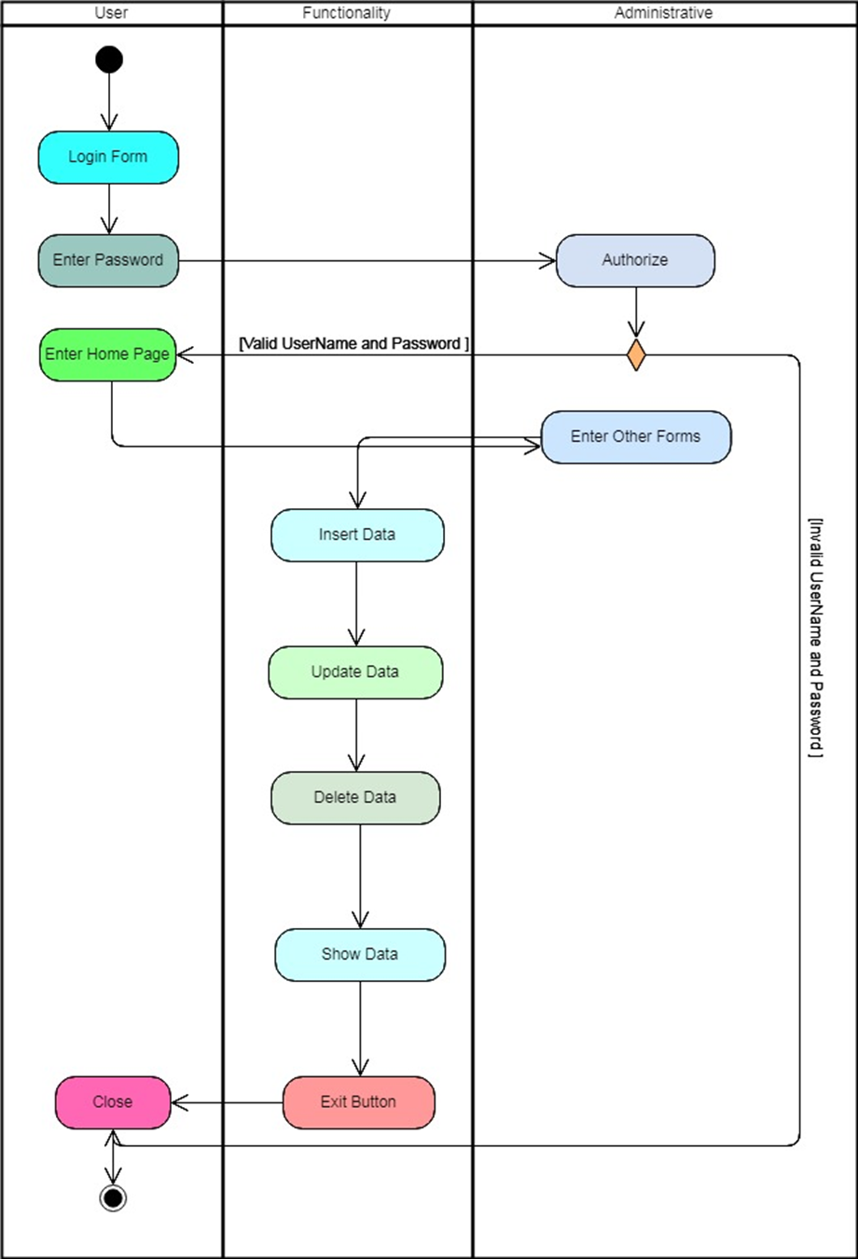

Figure 2: Activity Diagram

5.2.4 Sequence Diagram

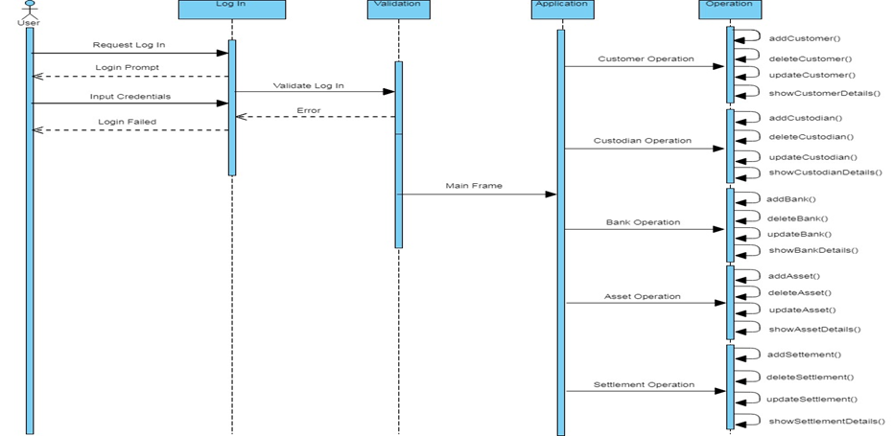

Figure: Sequence Diagram

5.3 Performance Testing & Evaluation

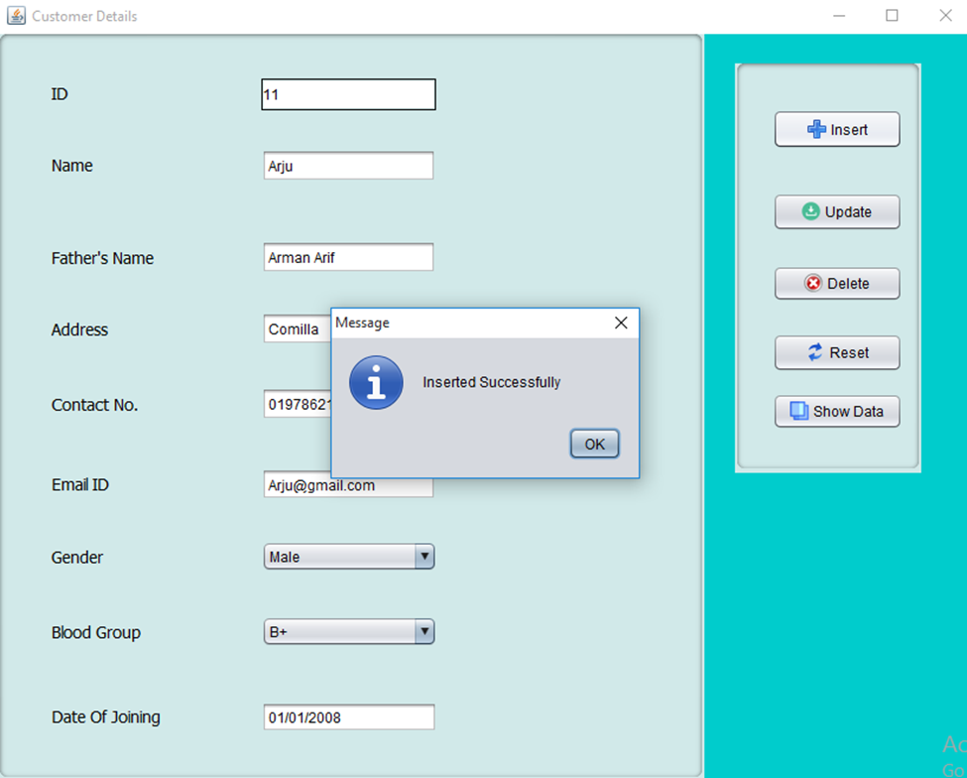
Figure: Insert Data

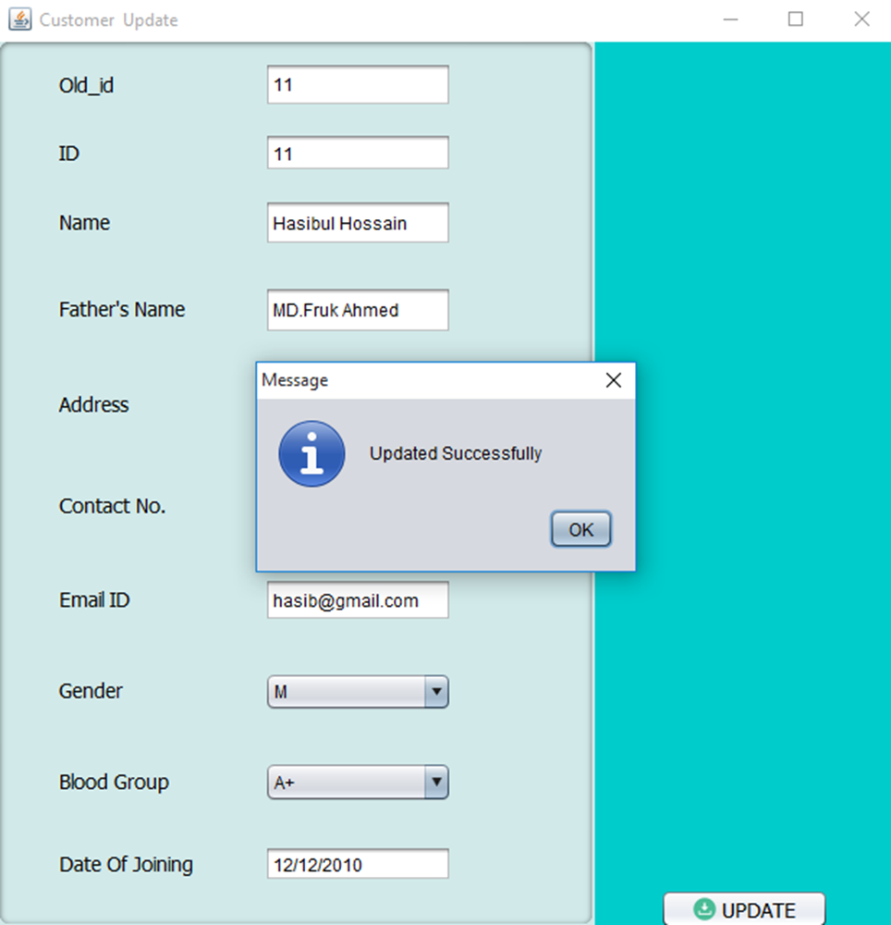

Figure: Update Data

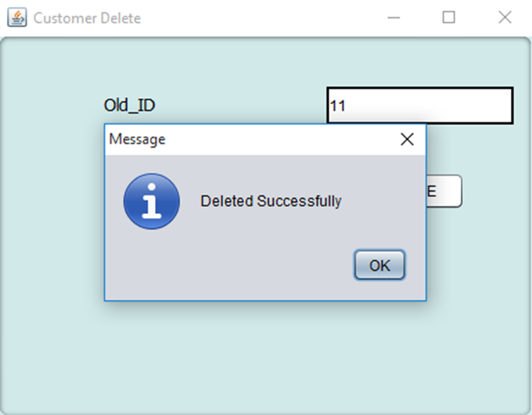
Figure: Delete Data

Section 6 References

Document No. | Document Title | Date | Author
1 | MySQL | 5-06-2018 | https://www.w3schools.com/sql/
2 | Java | 9-06-2018 | https://www.tutorialspoint.com/java/
3 | Java JFrame | 13-06-2018 | https://docs.oracle.com/javase/tutorial/uiswing/components/frame.html
4 | Java JFrame Design | 18-06-2018 | https://www.youtube.com/watch?v=XfqV5AbCqLU
5 | Java Netbeans Swing UI design | 20-07-2018 | https://www.youtube.com/watch?v=1nEluKUOic8
6 | ERD Chen Notation | 23-07-2018 | https://www.edrawsoft.com/chen-erd.php
7 | Database Schema | 3-07-2018 | https://www.tutorialspoint.com/dbms/dbms_data_schemas.htm
8 | Use Case Diagram | 5-07-2018 | https://online.visual-paradigm.com/diagrams.jsp#diagram:proj=0&id=4
9 | UML Class Diagram | 7-07-2018 | https://online.visual-paradigm.com/diagrams.jsp#diagramlist:proj=0&open
10 | Sequence Diagram | 12-07-2018 | https://online.visual-paradigm.com/diagrams.jsp#diagramlist:proj=0&new=SequenceDiagram
11 | Activity Diagram | 15-07-2018 | https://online.visual-paradigm.com/diagrams.jsp#diagramlist:proj=0&new=ActivityDiagram

Section 7 Glossary
Some terms and acronyms required to interpret the System Design document properly are given below:
Global Custody or Custodian:
A custodian bank, or simply custodian, is a specialized financial institution responsible for safeguarding a firm's or individual's financial assets and is not engaged in "traditional" commercial or consumer/retail banking such as mortgage or personal lending, branch banking, personal accounts, automated teller machines (ATMs) and so forth.
A custodian is a financial institution that holds customers' securities for safekeeping so as to minimize the risk of their theft or loss. A custodian holds securities and other assets in electronic or physical form. Since they are responsible for the safety of assets and securities that may be worth hundreds of millions or even billions of dollars, custodians generally tend to be large and reputable firms. A custodian is sometimes referred to as a "custodian bank."

Bond:
In finance, a bond is an instrument of indebtedness of the bond issuer to the holders. The most common types of bonds include municipal bonds and corporate bonds.
- Government Bond: A government bond is a debt security issued by a government to support government spending.
- Zero-Coupon Bond: A zero-coupon bond is a debt security that doesn't pay interest (a coupon) but is traded at a deep discount, rendering profit at maturity when the bond is redeemed for its full face value.
- Municipal Bonds: Municipal bonds are interest-bearing certificates issued by municipalities (states, cities, counties, school districts, parishes, etc.)
- Corporate Bond: A corporate bond is a debt security issued by a corporation and sold to investors. The backing for the bond is usually the payment ability of the company, which is typically money to be earned from future operations. In some cases, the company's physical assets may be used as collateral for bonds.
- Convertible Bond: A convertible bond is a type of debt security that can be converted into a predetermined amount of the underlying company's equity at certain times during the bond's life, usually at the discretion of the bondholder. Convertible bonds are a flexible financing option for companies and are particularly useful for companies with high risk/reward profiles. Convertible bonds are sometimes referred to as "CVs."

Settlement:
Settlement of securities is a business process whereby securities or interests in securities are delivered, usually against (in simultaneous exchange for) payment of money, to fulfill contractual obligations, such as those arising under securities trades.

Section 8 Appendices
At last we can say that by using this application one can be able to implement Global Custody process. It will be helpful for unexperienced investor or for those who wants to keep their asset safely and invest it perfectly through the banking process.

