Collabria CMS
Content Management User Guide

Version 1.1 — May 2026
collabriainc.com/admin

1 Getting Started

1.1 Accessing the Admin
Your content management address is:
https://collabria.com/admin
Bookmark this URL — it is the only address you need.

1.2 Logging In

The Collabria CMS login screen.
- Go to https://collabriainc.com/admin
- Click the "Login with GitHub" button
- You will be redirected to GitHub to confirm access — click "Authorize"
- You will be returned to the dashboard automatically

💡 Tip
If you see a GitHub login page asking for your username and password, sign in with your GitHub account credentials. Once authorised you will not need to log in again for several weeks.

1.3 The Dashboard
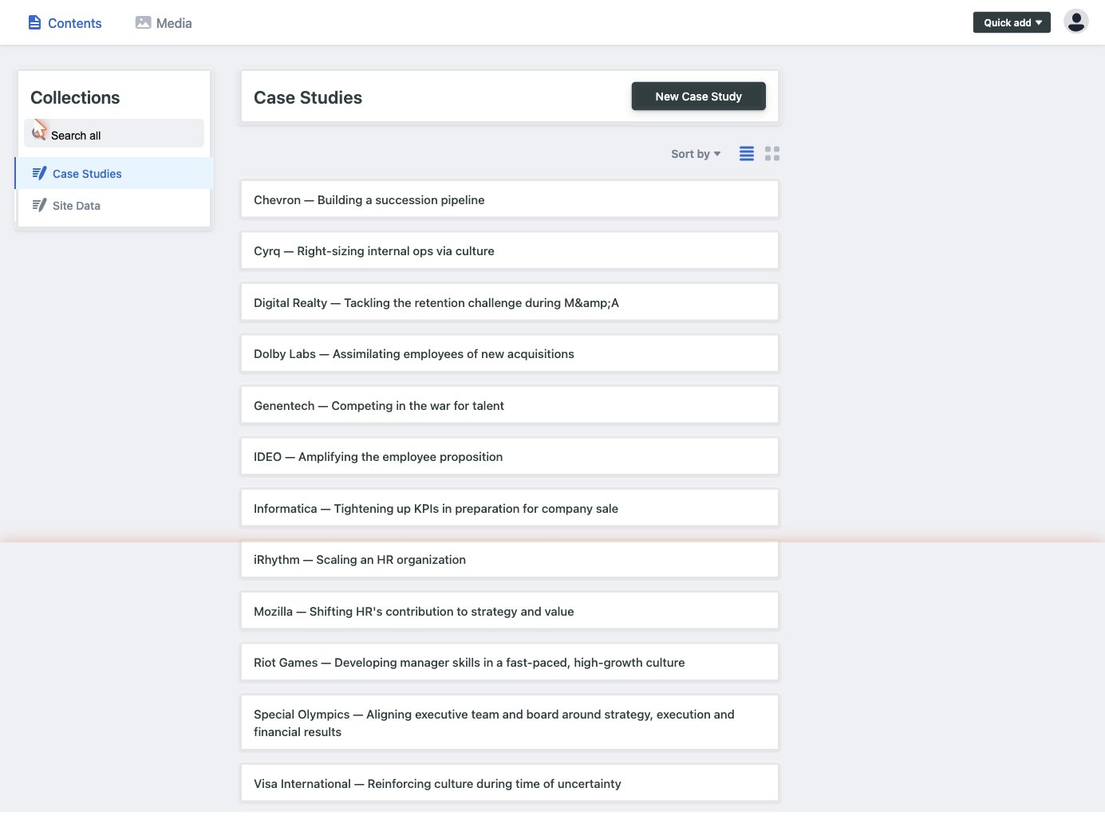
The CMS dashboard. Use the left sidebar to switch between sections.
Once logged in you will see two sections in the left sidebar:
- Case Studies — all client success stories shown on the Cases page
- Site Data — contains the Client List, Homepage Quotes, and Services

2 Case Studies
Case studies appear on the Cases page and as rotating quotes on the homepage. Each entry has a client name, a challenge quote, and a solution description.

2.1 Editing an Existing Case Study
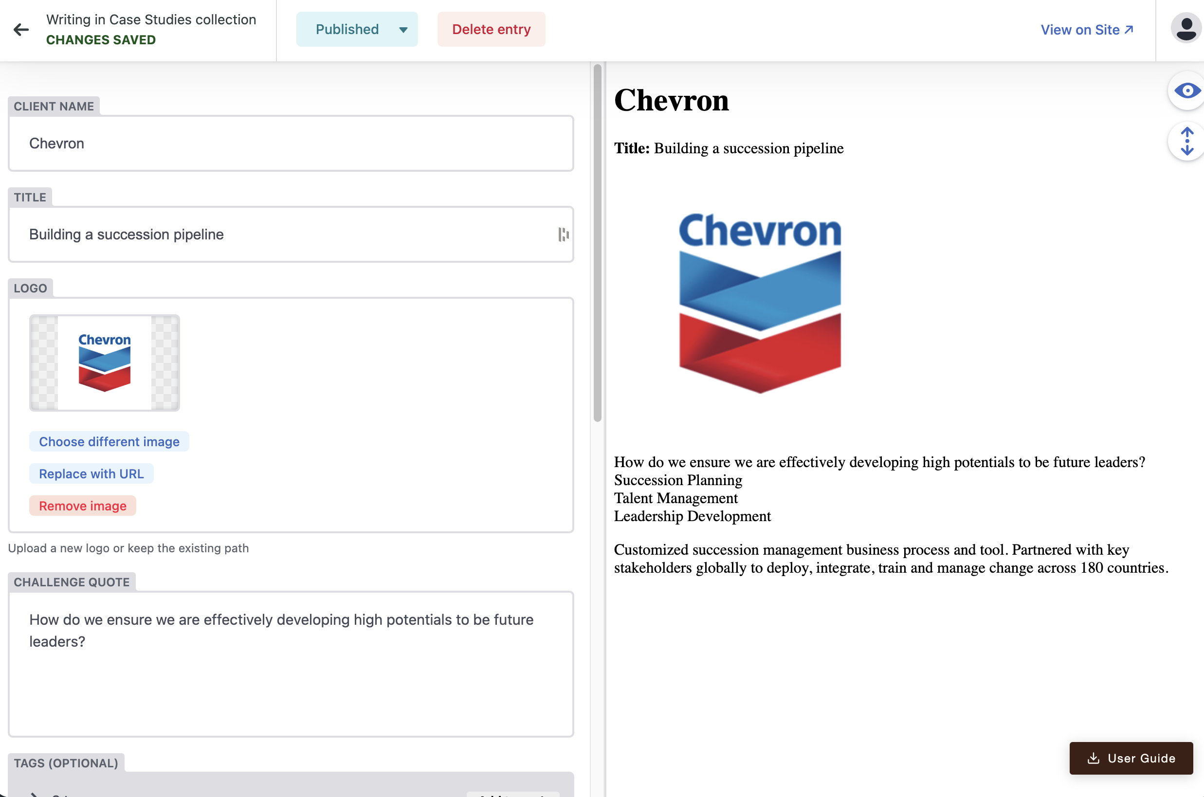
A case study open for editing. Left panel: fields. Right panel: live preview.
- Click "Case Studies" in the left sidebar
- Click any case in the list — shown as "Client — Title" e.g. "Genentech — Competing in the war for talent"
- Edit the fields as needed (see descriptions below)
- Click "Published" then "Publish" to make changes live
- Click "View on Site ↗" (top right) to confirm the change on the live website

Field descriptions:
CLIENT NAME: The company name displayed on the case card and story page
TITLE: A short phrase describing the engagement
LOGO: Click "Choose an image" to open the media library. Click "Upload" to add a new logo from your computer, or select an existing one. The file is saved automatically to the website.
CHALLENGE QUOTE: The client's challenge in their own words, shown in italics on the story page
TAGS (optional): Keywords shown as small chips — click the ">" arrow to expand each tag
SOLUTION: Full description of the work. Supports bold, italic, and bullet lists using the toolbar.

💡 Tip
To add a brand new logo: in the Logo field click "Choose an image" → "Upload" → select the file from your computer. Accepted formats: JPG, PNG. Best results with a square image and a white or transparent background.

2.2 Adding a New Case Study
- Click "Case Studies" in the left sidebar
- Click the "New Case Study" button (dark button, top right)
- Fill in all fields: Client Name, Title, Logo, Challenge Quote, Solution
- Add 2–3 relevant Tags using "Add tags +"
- Click "Published" → "Publish" when ready

2.3 Deleting a Case Study
- Open the case study you want to remove
- Click "Delete entry" (red button in the top bar)
- Confirm the deletion

⚠ Important
Deletion is permanent. The case study will be removed from the website on the next publish and cannot be recovered without developer assistance.

3 Site Data
Site Data contains three files that control different parts of the website. Click "Site Data" in the left sidebar to see them.

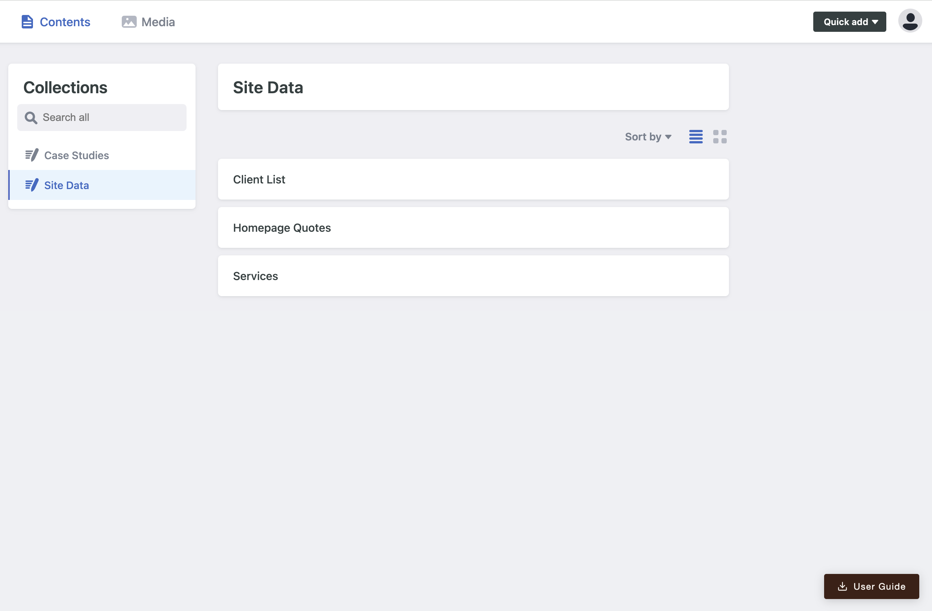
The Site Data section — Client List, Homepage Quotes, and Services.

3.1 Client List
The Client List controls the honeycomb grid on the Clients page.

How to open: Click "Site Data" → "Client List"

Each client row can be expanded with the ">" arrow to show two fields:
- COMPANY NAME — The name shown when the logo image cannot load
- LOGO — Click "Choose an image" to upload a new logo or select an existing one from the library

To upload a new logo:
- Expand the client row with ">"
- Click "Choose an image" in the Logo field
- Click "Upload" in the media library panel that opens
- Select the logo file from your computer (JPG or PNG recommended)
- The file uploads to the website automatically — click "Publish" to go live

To reorder clients:
- Drag the ≡ handle on the left of any row up or down
- Click "Published" → "Publish" to update the live site

To add a client:
- Scroll to the bottom and click "Add clients +"
- Enter the Company Name and upload or select a Logo
- Click "Published" → "Publish"

To remove a client:
- Click the × on the right side of the client row
- Click "Published" → "Publish"

3.2 Homepage Quotes
The five rotating quotes on the homepage hero section are managed here.

How to open: Click "Site Data" → "Homepage Quotes"

Each quote has three fields (click ">" to expand a row):
QUOTE: The full text of the quote. Quotation marks are added automatically by the website.
CLIENT NAME: The attribution shown beneath the quote, e.g. iRhythm
CASE SLUG: The URL identifier linking "Read the story" to the correct case page

Valid case slugs:
irhythm, cyrq, digital-realty, ideo, special-olympics, mozilla, genentech, riot-games, chevron, dolby, visa, informatica
To edit: Expand the row, update the fields, click "Published" → "Publish"
To reorder: Drag the ≡ handle, then Publish
To add: Click "Add quotes +", fill all three fields, then Publish

3.3 Services
The three service cards on the homepage are edited here: Leadership Alignment, Organizational Effectiveness, and Culture and Change.

How to open: Click "Site Data" → "Services"

Each service has the following fields (click ">" to expand):
TITLE: The service name shown as the card heading
LEAD SENTENCE: The bold introductory line (Leadership Alignment and Org. Effectiveness only)
PULL QUOTE: An italic quotation (Culture and Change only, replaces Lead Sentence)
BODY: The main description paragraph
BULLET POINTS: The three capability lines at the bottom. Use "Add item +" to add, × to remove, ≡ to reorder.

To edit a service: Expand the row, update the fields, click "Published" → "Publish"

⚠ Important
Do not add or remove services — the homepage layout is designed for exactly three. Only edit the content within existing service rows.

4 Publishing Changes
Every time you click "Publish":
- Your change (including any uploaded logos) is saved to the code repository
- The website rebuilds automatically — approximately 30 seconds
- The live site is updated

To confirm a change is live:
- Click "View on Site ↗" in the top-right corner of any editor
- This opens the relevant live page in a new browser tab
- If the change is not yet visible, wait 30 seconds and refresh

Save | Stores a draft in the CMS. Changes are NOT live yet.
Publish | Sends the change to the live website immediately.

5 Troubleshooting

Logo does not appear on the site
If you used the upload button, wait 60 seconds and hard-refresh the page (Cmd+Shift+R on Mac, Ctrl+Shift+R on Windows). If it still does not appear, try re-uploading the logo — the file name must not contain spaces or special characters.

Changes are not showing on the live site
Wait 60 seconds, then do a hard refresh:
- Mac: Cmd + Shift + R
- Windows: Ctrl + Shift + R

Logged out of the CMS
Return to https://collabria-astro.vercel.app/admin and click "Login with GitHub".

Logo upload fails or image looks wrong
- Make sure the file is JPG or PNG format
- Keep the file size under 2 MB for best results
- Use a square image with a white or transparent background
- Avoid spaces and special characters in the filename

Appendix 1: Collabria Architecture
Here's a complete picture of how everything fits together.

The Architecture

Framework: Astro (hybrid mode)
Astro runs at build time and generates static HTML for every page. "Hybrid mode" means most pages are pre-built (fast, served from CDN), but two API routes run as serverless functions on demand.
collabria-astro/
│
├── src/
│ ├── layouts/
│ │ └── Base.astro ← HTML shell shared by every page
│ │ (imports Nav, Footer, global CSS)
│ │
│ ├── components/
│ │ ├── Nav.astro ← left-rail navigation
│ │ ├── Footer.astro
│ │ └── PageHero.astro ← inner-page banner
│ │
│ ├── pages/ ← one file = one URL
│ │ ├── index.astro → /
│ │ ├── about.astro → /about
│ │ ├── cases.astro → /cases
│ │ ├── clients.astro → /clients
│ │ ├── contact.astro → /contact
│ │ ├── admin/
│ │ │ └── index.astro → /admin (Decap CMS UI)
│ │ ├── stories/
│ │ │ └── [slug].astro → /stories/irhythm, /stories/genentech…
│ │ │ (12 pages, auto-generated from markdown)
│ │ └── api/
│ │ └── auth/
│ │ ├── index.ts → /api/auth (serverless)
│ │ └── callback.ts → /api/auth/callback (serverless)
│ │
│ ├── content/
│ │ └── cases/ ← Astro Content Collections
│ │ ├── irhythm.md ← one file per case study
│ │ ├── genentech.md
│ │ └── … (12 total)
│ │
│ ├── data/ ← structured JSON/JS data files
│ │ ├── clients.json ← 61 clients (name + logo path)
│ │ ├── hero-quotes.json ← 5 rotating homepage quotes
│ │ ├── services.json ← 3 service descriptions
│ │ └── cases-preview.js ← summary list for homepage + cases page
│ │
│ └── styles/
│ └── global.css ← all CSS variables, nav, buttons, etc.
│
└── public/ ← static assets served as-is
├── logo.png
├── lisa-mroz.jpg
├── logos/ ← ~60 client logo images
└── collabria-*.pdf ← downloadable documents
How a page works at build time:
[slug].astro reads cases/*.md
↓
Astro builds /stories/irhythm, /stories/genentech… as static HTML
↓
Vercel serves them from CDN — no server involved at request time

The CMS
Tool: Decap CMS (git-based)
Decap is a single-page React app that runs entirely in the browser at /admin. It has no database — it reads and writes directly to the GitHub repository via the GitHub API.
Browser (Lisa)
│
│ visits /admin
▼
Decap CMS UI (JavaScript, runs in browser)
│
│ GitHub API calls (read/write files)
▼
GitHub repo: mdanna/collabria-astro
│
│ push detected
▼
Vercel (auto-deploy triggered)
│
│ astro build
▼
Live site updated (~30 seconds)
Authentication flow (the two serverless functions):
Lisa clicks "Login with GitHub"
│
▼
GET /api/auth ──→ redirects to GitHub OAuth page
│
Lisa clicks Authorize
│
▼
GET /api/auth/callback ←── GitHub sends back a code
│
│ exchanges code for access token (server-side, secret stays hidden)
│
▼
HTML page with postMessage → sends token back to Decap in the browser
│
▼
Decap is now authenticated, uses token for all GitHub API calls
What Decap can read/write:
CMS section | File it edits | Format
Case Studies | src/content/cases/*.md | Markdown + frontmatter
Client List | src/data/clients.json | JSON array
Homepage Quotes | src/data/hero-quotes.json | JSON
Services | src/data/services.json | JSON
Logo uploads | public/logos/*.jpg | Binary image

The Hosting
Platform: Vercel
GitHub repo (source of truth)
│
│ push to main branch
▼
Vercel build pipeline
- runs: npm run build (= astro build)
- outputs: static HTML + 1 serverless function bundle
│
▼
Vercel CDN (static pages) + Vercel Functions (OAuth endpoints)
│
▼
collabria-astro.vercel.app (soon: collabriainc.com)
Two types of output:
- Static pages (/, /about, /cases, /clients, /contact, /admin, /stories/*) — pre-built HTML, served from Vercel's CDN globally, near-instant load, zero server cost
- Serverless functions (/api/auth, /api/auth/callback) — run on demand in Node.js, only invoked during CMS login

The Full Flow when publishing a Page
1. Lisa edits a case study in /admin
2. Decap sends a GitHub API request: PATCH src/content/cases/irhythm.md
3. GitHub commits the change to main branch
4. Vercel detects the push → triggers a new build
5. Astro re-reads the markdown file
6. Generates new static HTML for /stories/irhythm
7. Deploys to CDN
8. Live site updated — total time ~30 seconds
No server is running permanently. No database. No hosting bill beyond Vercel's free tier (for this traffic level).

Appendix 2: How to publish the site to www.collabriainc.com
Here are the exact steps for IONOS:

Step 1 - Add the domain to Vercel first
- Go to your collabria-astro project in the Vercel dashboard
- Settings → Domains
- Add collabriainc.com and www.collabriainc.com
- Note the DNS values Vercel gives you (they should match what's below, but always use what Vercel shows)

Step 2 - Update DNS in IONOS
- Log in at ionos.com → Domains & SSL
- Click the ≡ menu next to collabriainc.com → DNS
- You'll see a list of existing DNS records
Delete or replace the existing A record for @ (it currently points to the old hosting), then:
Type | Name | Value | TTL
A | @ | 76.76.21.21 | 3600
CNAME | www | cname.vercel-dns.com | 3600
If IONOS doesn't allow a CNAME on www when an A record exists for @, delete the old www record first.
- Click Save

Step 3 - Wait
Propagation with IONOS typically takes 15–60 minutes. Vercel will automatically issue the SSL certificate once it detects the domain. You can monitor status in Vercel under Settings → Domains — it will show a green checkmark when active.

Step 4 - After it goes live, run these two updates
In the Vercel dashboard → collabria-astro → Settings → Environments → Production:
- Change SITE_URL from https://collabria-astro.vercel.app to https://collabriainc.com
In GitHub → github.com/settings/developers → Collabria CMS OAuth App:
- Change the Authorization callback URL to https://collabriainc.com/api/auth/callback
Then do one final redeploy so the new SITE_URL takes effect:
cd /Users/mario/collabria-astro && vercel --prod
That's it — collabriainc.com will serve the new Astro site with HTTPS and the CMS will continue working normally.
End of document

