Collabria CMS
Content Management User Guide

Version 1.0 — May 2026
collabria-astro.vercel.app/admin

1 Getting Started

1.1 Accessing the Admin
Your content management address is:
https://collabria-astro.vercel.app/admin
Bookmark this URL — it is the only address you need.

1.2 Logging In
[ Screenshot: The Collabria CMS login screen ]
The Collabria CMS login screen
- Go to https://collabria-astro.vercel.app/admin
- Click the "Login with GitHub" button
- You will be redirected to GitHub to confirm access — click "Authorize"
- You will be returned to the dashboard automatically

💡 Tip
If you see a GitHub login page asking for your username and password, sign in with your GitHub account credentials. Once authorised you will not need to log in again for several weeks.

1.3 The Dashboard
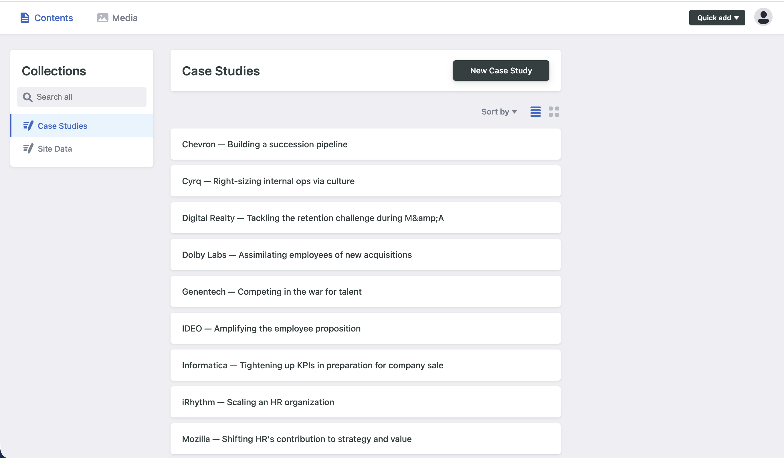
The CMS dashboard. Use the left sidebar to switch between sections.
Once logged in you will see two sections in the left sidebar:
- Case Studies — all client success stories shown on the Cases page
- Site Data — contains the Client List, Homepage Quotes, and Services

2 Case Studies
Case studies appear on the Cases page of the website and as rotating quotes on the homepage. Each entry has a client name, a challenge quote, and a solution description.

2.1 Editing an Existing Case Study
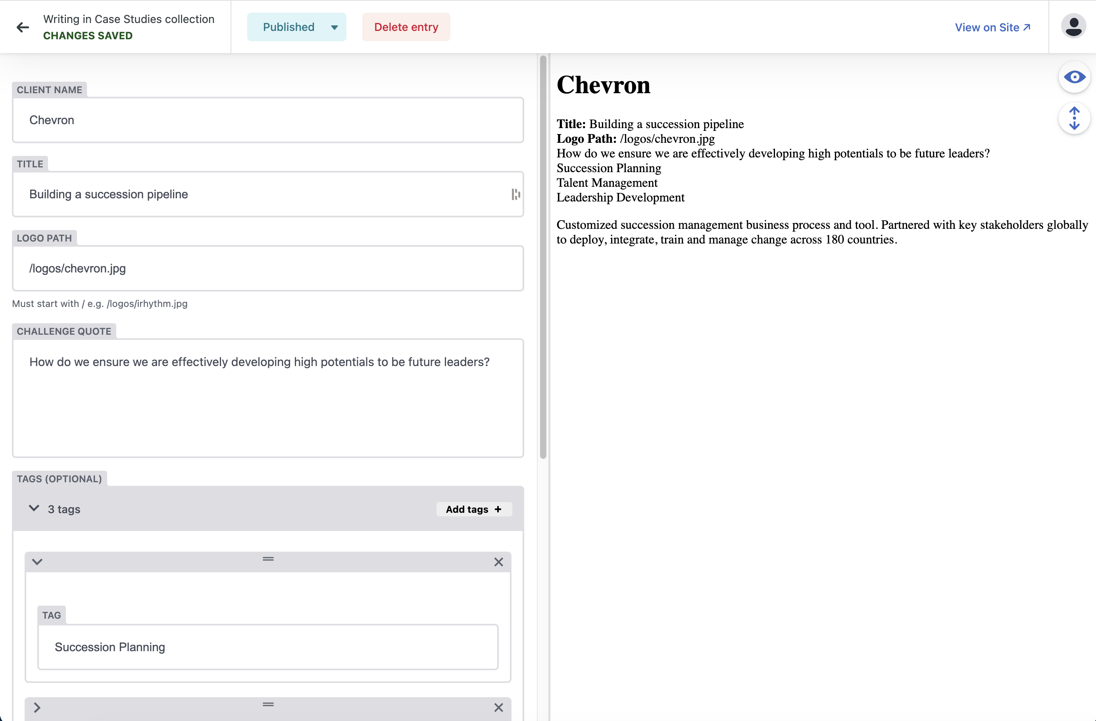
A case study open for editing. Left panel: fields. Right panel: live preview.
- Click "Case Studies" in the left sidebar
- Click any case in the list — shown as "Client — Title" e.g. "Genentech — Competing in the war for talent"
- Edit the fields as needed (see descriptions below)
- Click "Published" then "Publish" to make changes live
- Click "View on Site ↗" (top right) to confirm the update on the live website

Field descriptions:
CLIENT NAME: The company name displayed on the case card and story page
TITLE: A short phrase describing the engagement
LOGO PATH: Path to the client logo — must start with a forward slash, e.g. /logos/genentech.jpg
CHALLENGE QUOTE: The client's challenge in their own words, shown in italics on the story page
TAGS (optional): Keywords shown as small chips — click the ">" arrow to expand each tag
SOLUTION: Full description of the work done. Supports bold, italic, and bullet lists using the toolbar.

💡 Tip
For the Logo Path, use the format /logos/companyname.jpg — the logo file must already exist on the server. Contact your developer to upload a new logo file.

2.2 Adding a New Case Study
- Click "Case Studies" in the left sidebar
- Click the "New Case Study" button (dark button, top right)
- Fill in all fields: Client Name, Title, Logo Path, Challenge Quote, Solution
- Add 2–3 relevant Tags using "Add tags +"
- Click "Published" → "Publish" when ready

2.3 Deleting a Case Study
- Open the case study you want to remove
- Click "Delete entry" (red button in the top bar)
- Confirm the deletion in the dialogue that appears

⚠ Important
Deletion is permanent. The case study will be removed from the website on the next publish and cannot be recovered without developer assistance.

3 Site Data
Site Data contains three files that control different parts of the website. Click "Site Data" in the left sidebar to see them.

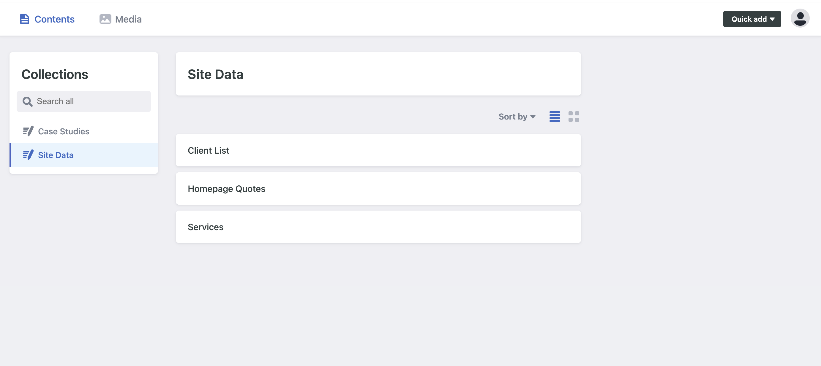
The Site Data section — contains Client List, Homepage Quotes, and Services.

3.1 Client List
The Client List controls the honeycomb grid on the Clients page (collabria-astro.vercel.app/clients).

How to open: Click "Site Data" → "Client List"

Each client row can be expanded with the ">" arrow to show two fields:
- COMPANY NAME — The name shown when the logo image cannot load
- LOGO PATH — Path to the logo image. Must start with / e.g. /logos/cisco.jpg

To reorder clients:
- Drag the ≡ handle on the left of any row up or down
- Click "Published" → "Publish" to update the live site

To add a client:
- Scroll to the bottom and click "Add clients +"
- Enter the Company Name and Logo Path
- Click "Published" → "Publish"

To remove a client:
- Click the × on the right side of the client row
- Click "Published" → "Publish"

💡 Tip
Logo paths are case-sensitive and must start with / Correct: /logos/cisco.jpg Incorrect: logos/Cisco.JPG

3.2 Homepage Quotes
The five rotating quotes on the homepage hero section are managed here.

How to open: Click "Site Data" → "Homepage Quotes"

Each quote has three fields (click ">" to expand a row):
QUOTE: The full text of the quote. Quotation marks are added automatically by the website.
CLIENT NAME: The attribution shown beneath the quote, e.g. iRhythm
CASE SLUG: The URL identifier linking "Read the story" to the correct case page

Valid case slugs:
irhythm, cyrq, digital-realty, ideo, special-olympics, mozilla, genentech, riot-games, chevron, dolby, visa, informatica
To edit: Expand the row, update the fields, click "Published" → "Publish"
To reorder: Drag the ≡ handle, then Publish
To add: Click "Add quotes +", fill all three fields, then Publish

3.3 Services
The three service cards on the homepage are edited here: Leadership Alignment, Organizational Effectiveness, and Culture and Change.

How to open: Click "Site Data" → "Services"

Each service has the following fields (click ">" to expand):
TITLE: The service name shown as the card heading
LEAD SENTENCE: The bold introductory line (Leadership Alignment and Org. Effectiveness only)
PULL QUOTE: An italic quotation (Culture and Change only, replaces Lead Sentence)
BODY: The main description paragraph
BULLET POINTS: The three capability lines at the bottom. Use "Add item +" to add, × to remove, ≡ to reorder.

To edit a service: Expand the row, update the fields, click "Published" → "Publish"

⚠ Important
Do not add or remove services — the homepage layout is designed for exactly three. Only edit the content within existing service rows.

4 Publishing Changes
Every time you click "Publish":
- Your change is saved to the code repository (GitHub)
- The website rebuilds automatically (approximately 30 seconds)
- The live site is updated

To confirm a change is live:
- Click "View on Site ↗" in the top-right corner of any editor
- This opens the relevant live page in a new browser tab
- If the change is not yet visible, wait 30 seconds and refresh

Save | Stores a draft in the CMS. Changes are NOT live yet.
Publish | Sends the change to the live website immediately.

5 Troubleshooting

Logo does not appear on the Clients page
Check the Logo Path starts with / and the filename matches exactly (case-sensitive).
Correct: /logos/cisco.jpg
Incorrect: logos/Cisco.JPG

Changes are not showing on the live site
Wait 60 seconds, then do a hard refresh:
- Mac: Cmd + Shift + R
- Windows: Ctrl + Shift + R

Logged out of the CMS
Return to https://collabria-astro.vercel.app/admin and click "Login with GitHub".

Need to upload a new client logo
Send the logo file (JPG or PNG, square format preferred, transparent or white background) to your developer. They will upload it and provide the Logo Path to use.

End of document

