**NUS MUFG DELL HumanITy Challenge 2024:**

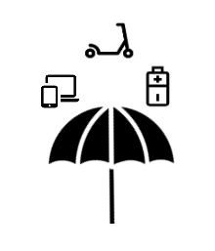

**R**emote **A**utomated **I**ntelligent **N**etwork

By

**MAX EFFORT**

Danial, Hasan, Chun Kit, Haziq

**Background:**

Electronic waste is a growing problem worldwide, with tons of discarded electronics ending up in landfills each year. However, many of these devices contain components that can still be salvaged and repurposed creatively to reduce waste and promote sustainability. A good example of this would be,“Singapore generates more than 60,000 tonnes of electrical and electronic waste (e-waste) each year, and the rate of e-waste generation is expected to increase in tandem with economic growth”, NEA SG.

**Key SDG Contributions:**

* **Goal 7** **(Affordable and Clean Energy):** 
  + **Target 7.1:** R.A.I.N ensures universal access to affordable, reliable, and modern energy services by monitoring and optimizing energy usage, making energy more accessible and efficient.
  + **Target 7.2:** R.A.I.N can integrate with renewable energy systems, increasing the share of renewable energy in the global energy mix and promoting cleaner energy sources.
  + **Target 7.3:** R.A.I.N improves energy efficiency through predictive maintenance and power usage tracking, contributing to a global increase in energy efficiency.
* **Goal 9 (Industry, Innovation, and Infrastructure):**
  + **Target 9.4:** R.A.I.N upgrades infrastructure by repurposing e-waste components, promoting sustainable industry practices and enhancing resource-use efficiency.
* **Goal 11 (Sustainable Cities and Communities):**
  + **Target 11.6:** R.A.I.N reduces the adverse environmental impact of cities by managing electronic waste more efficiently, leading to more sustainable urban living.
* **Goal 12 (Responsible Consumption and Production):**
  + **Target 12.2:** R.A.I.N achieves sustainable management and efficient use of natural resources by encouraging the reuse of electronic components.
  + **Target 12.5:** R.A.I.N reduces waste generation by repurposing e-waste components for new uses in the IoT system, aligning with waste prevention, reduction, recycling, and reuse.
* **Goal 13 (Climate Action):**
  + **Target 13.2:** R.A.I.N’s energy-saving features integrate measures to reduce greenhouse gas emissions from households, contributing to climate action strategies.
* **Goal 17 (Partnerships for the Goals):**
  + **Target 17.16:** R.A.I.N fosters effective partnerships by involving collaboration between stakeholders for e-waste collection and reward distribution, enhancing public, public-private, and civil society partnerships.

**Target**

Repurpose e-waste, extend the life of electronics, and help Singapore move towards a sustainable future.

**Why R.A.I.N?**

Seeing as the majority of the e-waste comprises household appliances/electronics, what if we could take that waste and make the house smarter/better?

**What is R.A.I.N?**

R.A.I.N repurposes working components from e-waste and integrates predictive maintenance for household electronics to create a modular & fully comprehensive home-based IoT system.

**How It Works**

The system's core is an Espressif ESP32 S3 board, which acts as the brain and cloud link via RainMaker by Espressif and ThinkSpeak. The system functions as a smart lighting system, smart cooling system, alert system, provides temporary backup lighting, and tracking of electricity usage. Using Tensorflow along with machine learning helps perform predictive maintenance for home electronics.



**Source of Parts**

* Temperature Sensor: From **refrigerators & AC units**
* Rechargeable Batteries: From **Personal Mobility Devices (PMDs)**
* LEDs: From **mobile phones**
* Speakers: From **mobile phones or standalone speakers**
* Camera: From **mobile phones**
* Light Sensor: From **mobile phones**
* Proximity/Motion Sensor: From **mobile phones**

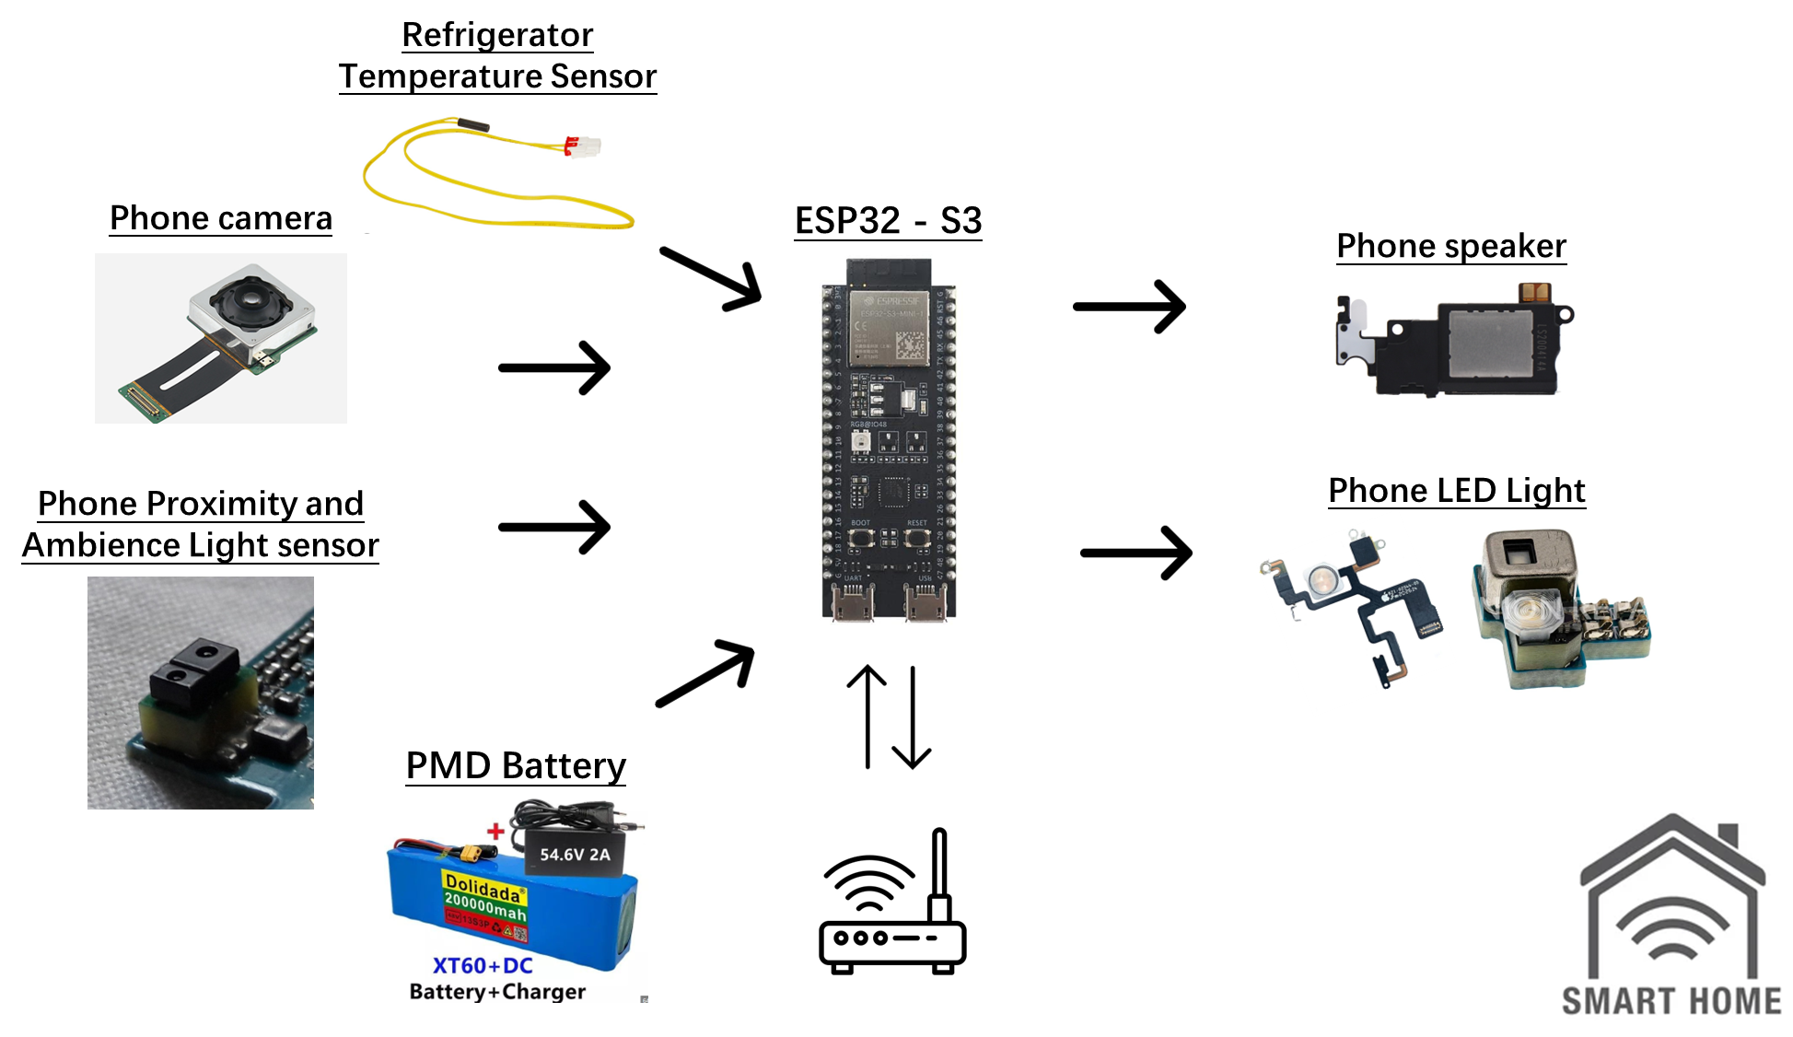

**System Components and Functionality**

1. Core Component: ESP32 Board

- Acts as the central hub with built-in WiFi and Bluetooth.

- Connects various sensors and devices to the cloud via RainMaker.

- Allows control via the ESP32 app.

1. Smart Lighting System

- Uses LEDs and light sensors from mobile phones.

- Auto-adjusts brightness based on ambient light and user preferences.

1. Smart Cooling System

- Uses temperature sensors from refrigerators/AC units.

- Automates control of fans or air conditioning systems.

1. Alert System

- Uses speakers for audio alerts (doorbell rings, smoke detection, intrusions).

- Uses a camera for security with real-time video feeds & motion detection alerts.

- Uses proximity/motion sensors to detect intrusions.

1. Temporary Backup Power

- Uses rechargeable batteries from PMDs.

- Provides essential lighting and power during outages.

1. Predictive Maintenance

- Uses TensorFlow for predictive maintenance.

1. Tracking of electricity usage

- Users can opt to have R.A.I.N to tag onto the home’s electrical meter, to have their usage monitored in real time.

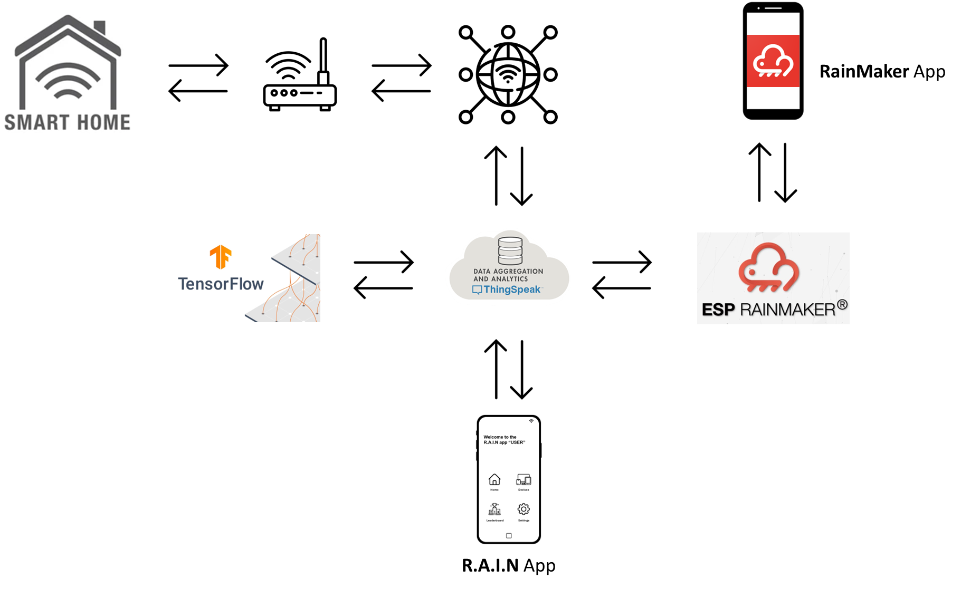

**Implementation**

- Extract components from e-waste, test for functionality, and interface with the ESP32 board.

- Develop custom firmware to manage communication between the ESP32 and RainMaker cloud service.

- Ensure seamless operation and control via the ESP32 app.

- Collect and rank electricity usage monthly.



**Mobile App Control & Monitoring**

* Users can control and monitor the R.A.I.N. system through the dedicated ESP32 app, which provides a user-friendly interface for managing the various smart home functions.
* Participating users can opt to have R.A.I.N tag onto the home’s electricity meter and be placed among other users in a “neighborhood leaderboard”; users who save more will rank higher. Top 3 will receive rewards

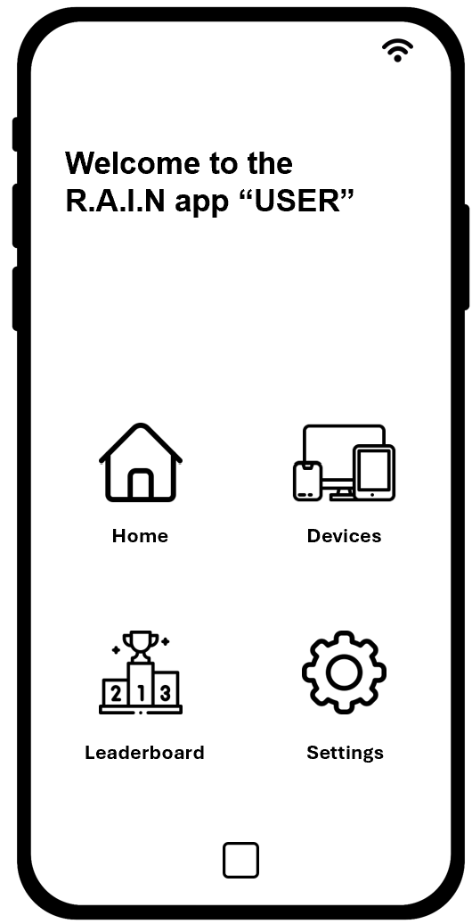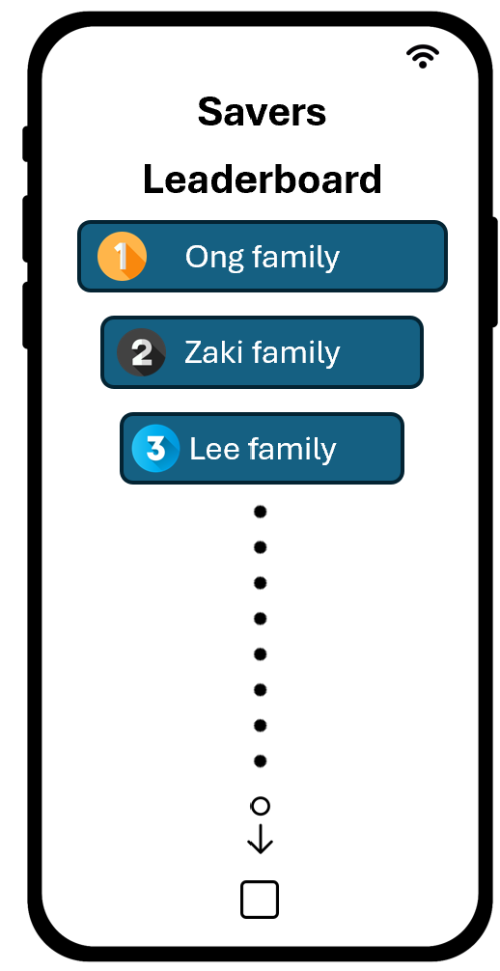

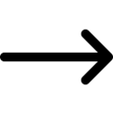



**Benefits**

- Environmental Impact: Reduces e-waste by repurposing components.

- Cost-Effective: Minimizes the cost of new hardware.

- Enhanced Home Automation: Provides smart home features.

- Energy Efficiency: Optimizes energy usage.

- Predictive Maintenance: Extends electronics lifespan and reduces maintenance costs.

- Data Analytics: Allows homeowners to monitor energy usage and make informed decisions.

**Conclusion**

RAIN is a forward-thinking way to tackle e-waste and improve home automation in Singapore. By using discarded electronic parts, RAIN promotes sustainability and enhances living with smart home systems, leading to a greener future and smarter living spaces.

