Contents

Introduction 1

Reason for the Project 1

Problem Statement 1

Aims & Objectives 1

Functional Requirements 2

Activity Diagram 2

➢ Member Registration 2

➢ Reservation of Car 3

➢ Customer Feedback 4

➢ Adding a New Car 5

➢ ER Diagram: 6

Technologies 7

➢ About PHP 7

➢ PHP Syntax 7

➢ Connecting PHP Application to MySQL Database 7

Snapshot Frontend 8

Conclusion 14

References Used 14

# Introduction

This project is designed so as to be used by Car Rental Company specializing in renting cars to customers. It is an online system through which customers can view available cars, register, view profile and book car.

# Reason for the Project

The advancement in Information Technology and internet penetration has greatly enhanced various business processes and communication between companies (services provider) and their customers of which car rental industry is not left out. This E-Car Rental System is developed to provide the following services:

* **Enhance Business Processes:** To be able to use internet technology to project the rental company to the global world instead of limiting their services to their local domain alone, thus increase their return on investment (ROI).
* **Online Vehicle Reservation:** A tools through which customers can reserve available cars online prior to their expected pick-up date or time.
* **Customer’s registration:** A registration portal to hold customer’s details, monitor their transaction and used same to offer better and improve services to them.
* **Group bookings:** Allows the customer to book space for a group in the case of weddings or corporate meetings (Event management)

# Problem Statement

A car rental is a vehicle that can be used temporarily for a fee during a specified period. Getting a rental car helps people get around despite the fact they do not have access to their own personal vehicle or don't own a vehicle at all. The individual who needs a car must contact a rental car company and contract out for a vehicle. This system increases customer retention and simplify vehicle and staff management.

# Aims & Objectives

* To produce a web-based system that allow customer to register and reserve car online and for the company to effectively manage their car rental business.
* To ease customer’s task whenever they need to rent a car.

# Functional Requirements

Requirement analysis is a software engineering technique that is composed of the various tasks that determine the needs or conditions that are to be met for a new or altered product, taking into consideration the possible conflicting requirements of the various users.

Functional requirements are those requirements that are used to illustrate the internal working nature of the system, the description of the system, and explanation of each subsystem. It consists of what task the system should perform, the processes involved, which data should the system holds and the interfaces with the user. The functional requirements identified are:

* **Customer’s registration:** The system should allow new users to register online and generate membership card.
* **Online reservation of cars:** Customers should be able to use the system to make booking and online reservation.
* **Automatic update to database once reservation is made or new customer registered:** Whenever there’s new reservation or new registration, the system should be able update the database without any additional efforts from the admin.
* **Feedbacks to customers:** It should provide means for customers to leave feedback

# Activity Diagram

Activity diagrams graphically represent the sequential business and operational workflows of a system. It is a dynamic diagram that shows the activity and the event that causes the object to be in the particular state. The workflows from activity diagram will serve as guide for system navigation in the final design phase of the system.

## **Member Registration**



Customer

Start



E

-

Car

Rental

System



Enter

details



]

Yes

[



Enter

username

and

password

Accept

terms

&

conditions



]

No

[



Username

exist?



Confirm

and

submit



Display

customer's

welcome

screen

Send

email

confirmation



End

***Figure 1:***  *Activity Diagram (Member Registration)*

## Reservation of Car

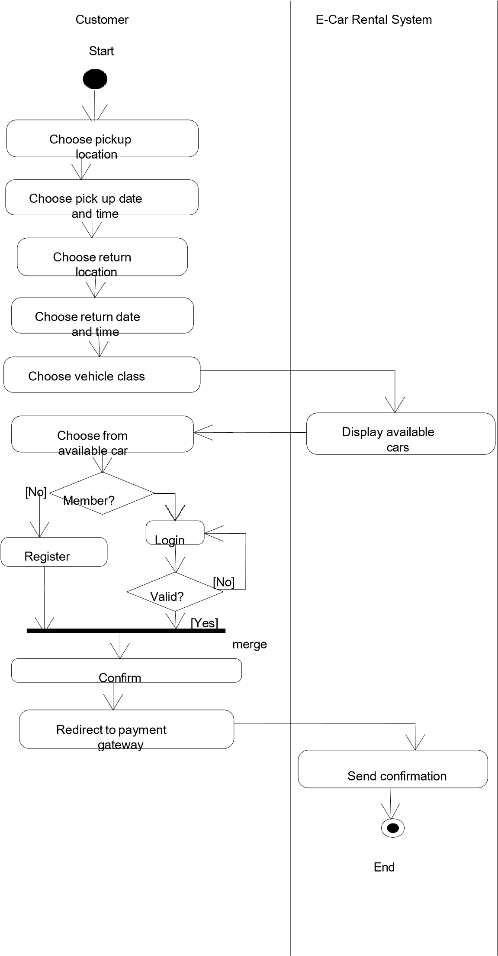

***Figure 2****: Activity Diagram (Car Reservation)*

## Customer Feedback



Customer

Start



E

-

Car

Rental

System



Enter

your

details



Enter

your

message/remark



Submit

feedback



Send

notification



End

***Figure 3:*** *Activity Diagram (User Feedback)*

## Adding a New Car



Staff



E

-

Car

Rental

System



Login



No

]

[



Login



Valid?



[

Yes

]



Enter

car

details



Add

to

inventory



Update

status

End

***Figure 4****: Activity Diagram (Add New Car)*

## ER Diagram:

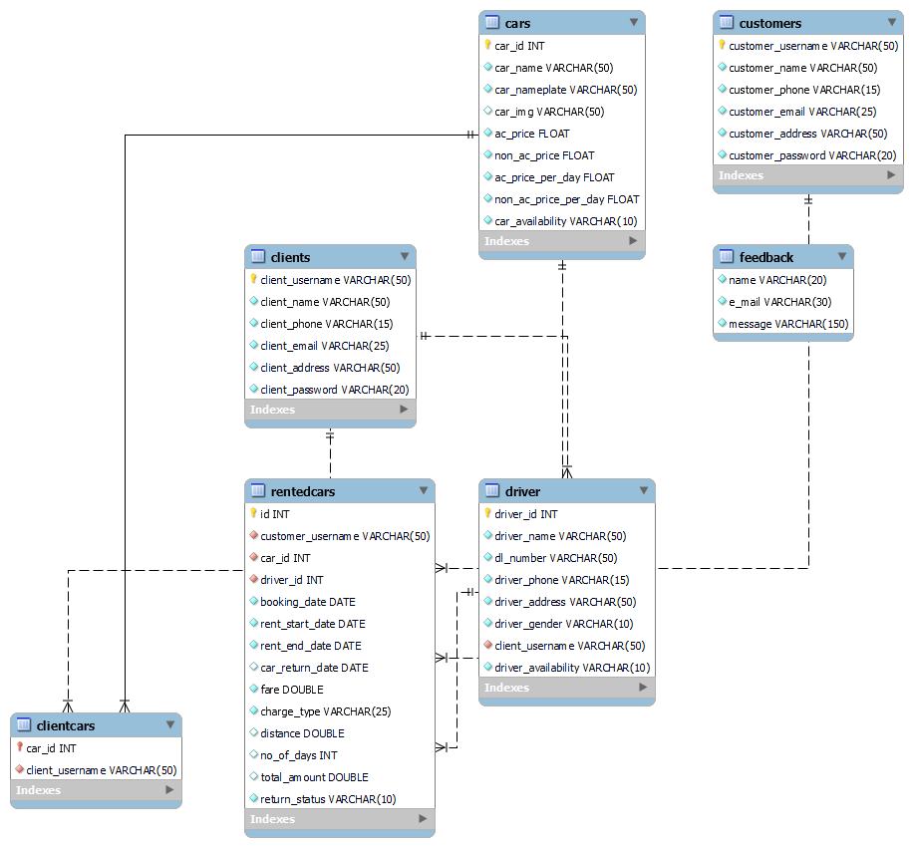

**Figure 5**: ER Diagram

# Technologies

## About PHP

**PHP:** Hypertext Pre-processor is a widely used, general-purpose scripting language that was originally designed for web development to produce dynamic web pages. For this purpose, PHP code is embedded into the HTML source document and interpreted by a web server with a PHP processor module, which generates the web page document.

## PHP Syntax

HTML and PHP code is written on the same page, and to distinguish PHP code from HTML, the PHP code is enclosed within **<? php ?>** Tags.

For example:

<html>

<head><title>php basics</title></head>

<body>

<h2>HELLO</h1>

<?php

echo "hello";

?>

</body>

</html>

In the above example PHP code is embedded within HTML. In this way PHP and HTML coding is combined on the same page.

Since PHP is a server side scripting language, the PHP coding cannot be seen by the end user through view source option, due to this feature PHP is very secure.

PHP is a parsed language; therefore PHP environment is necessary at the server for running PHP scripts

## Connecting PHP Application to MySQL Database

**Make a connection variable to the database:**

$con = mysql_connect ("localhost","servername","password");

**Select a database over that connection variable:**

$db = mysql_select_db("databasename",$con);

**Prepare a sql query to execute:**

$qry= Select * from abc;

**Run the sql query:**

$result=mysql_query($qry);

**Iterate over the result:**

while($row = mysql_fetch_array($result))

{

//some logic

}

# Snapshot Frontend

Home Page:

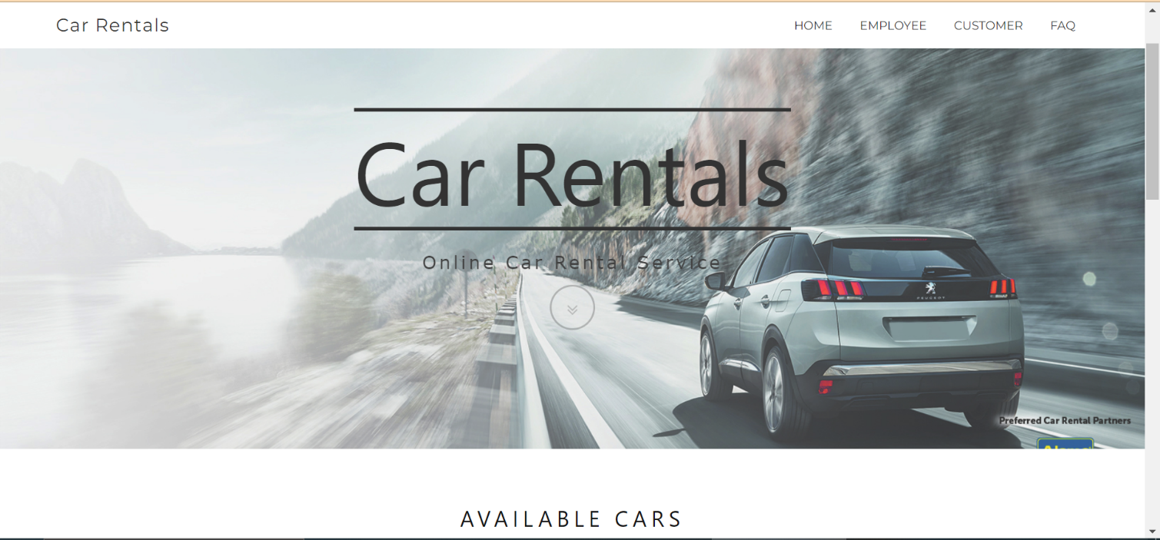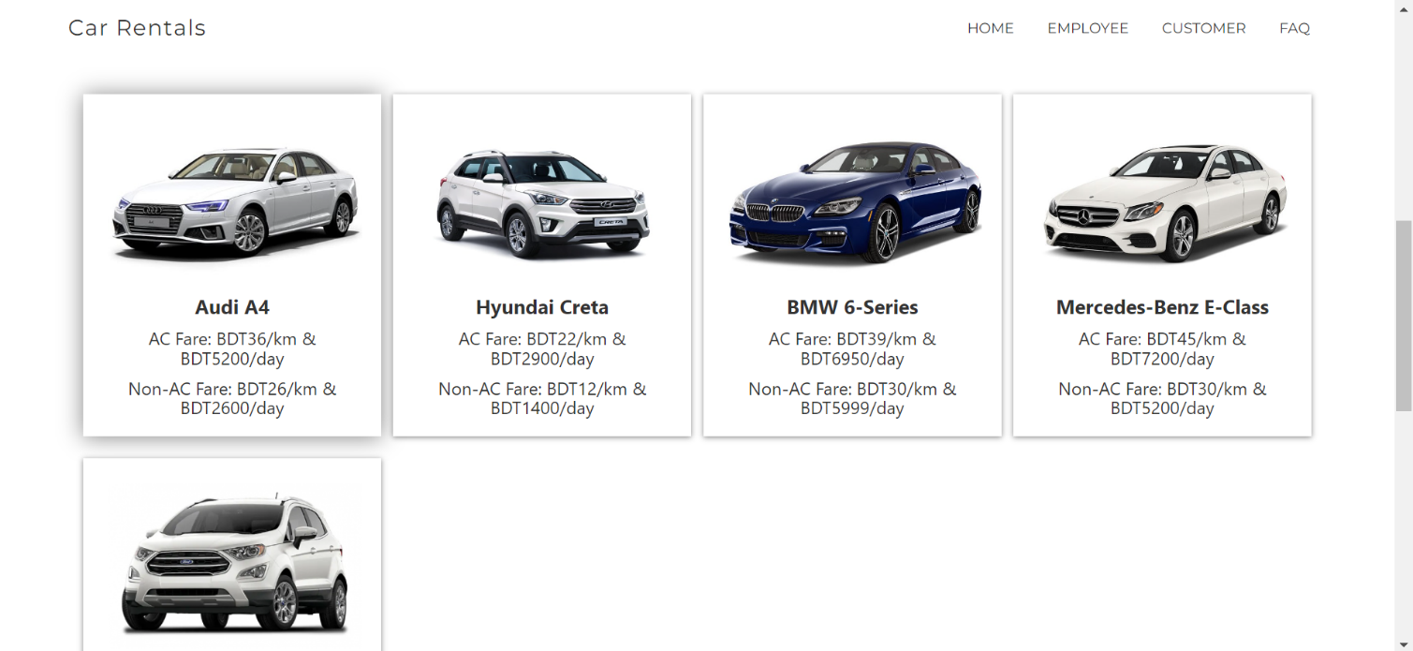

**Figure** 6: Home Page

**Login/Registration Page**

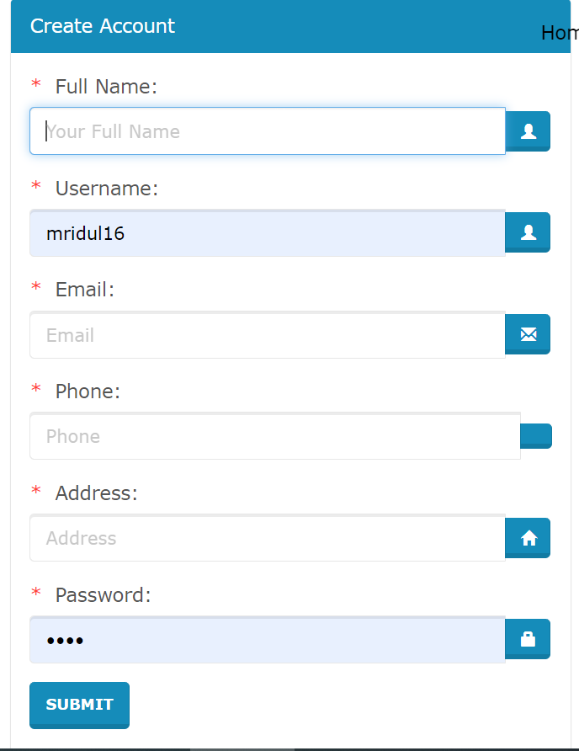

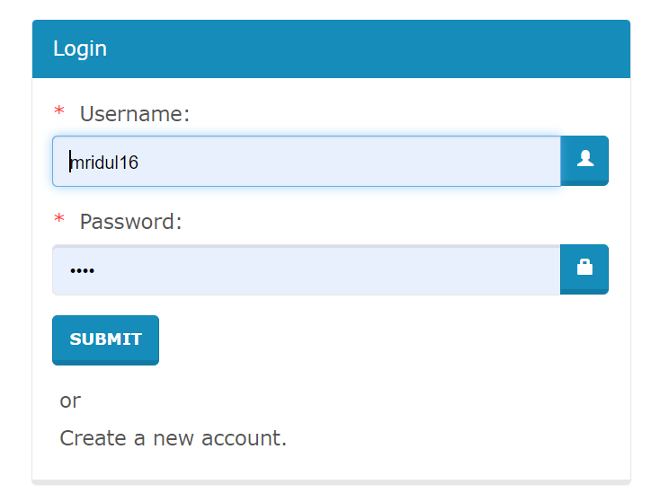

**Figure 8:** Login Form

**Figure 7:** Registration Form

**Booking Page:**

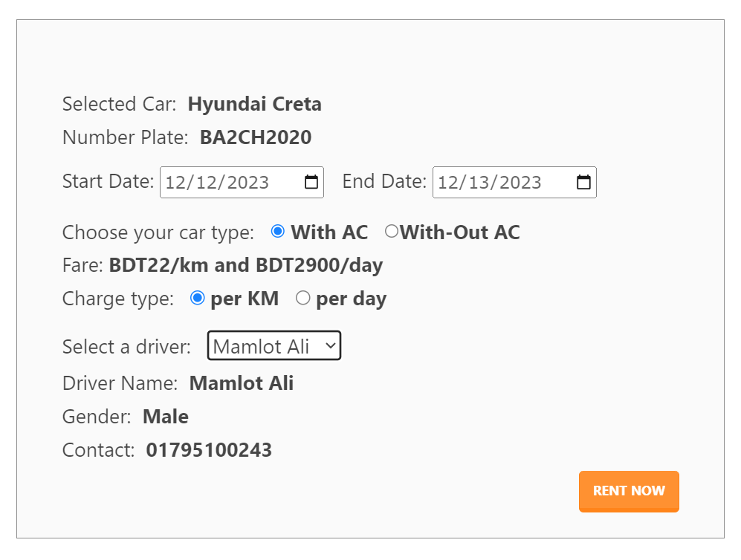

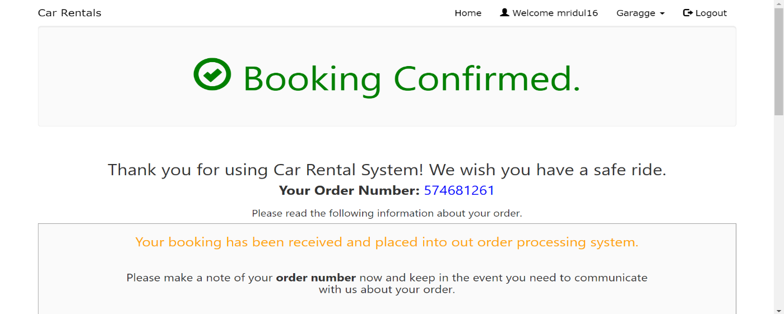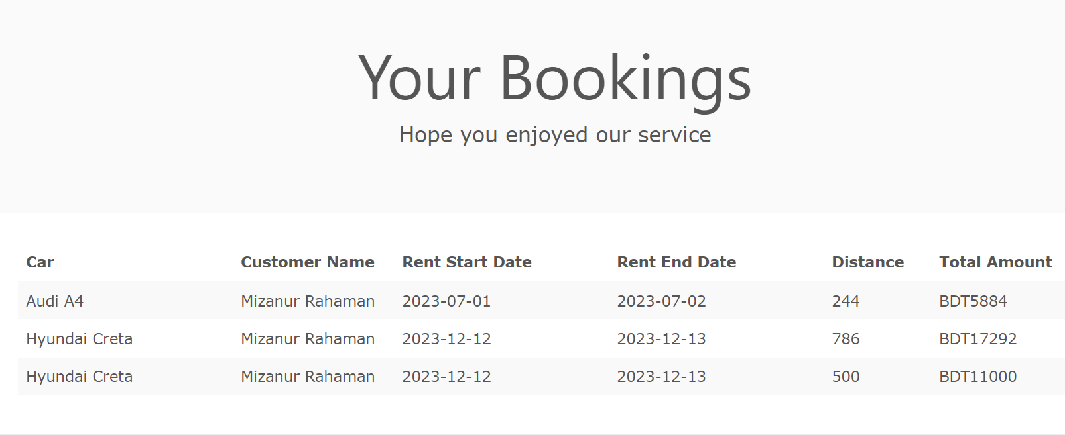**Garage/Return Page:**

**Figure 11:** Your Booking List

**Figure 10:** Booking - Confirmation Message

**Figure 9:** Booking Form

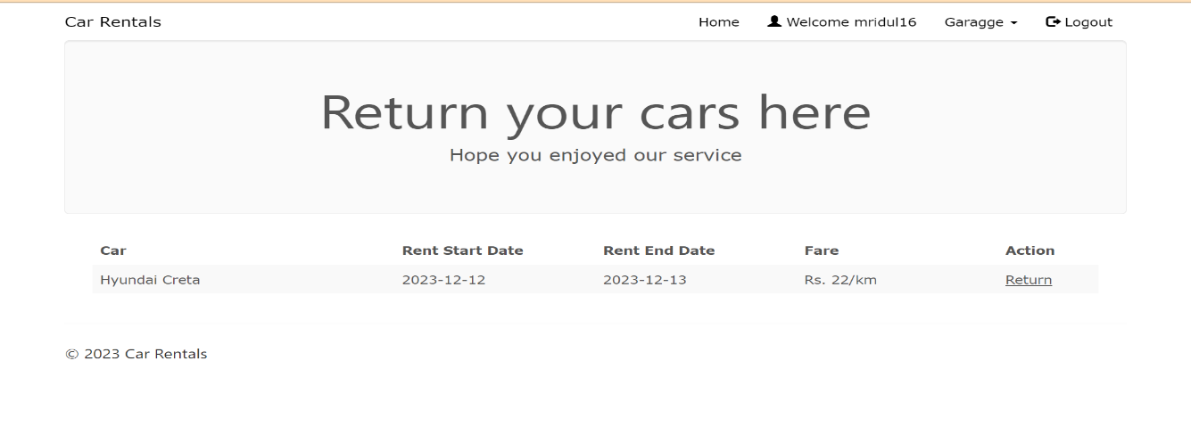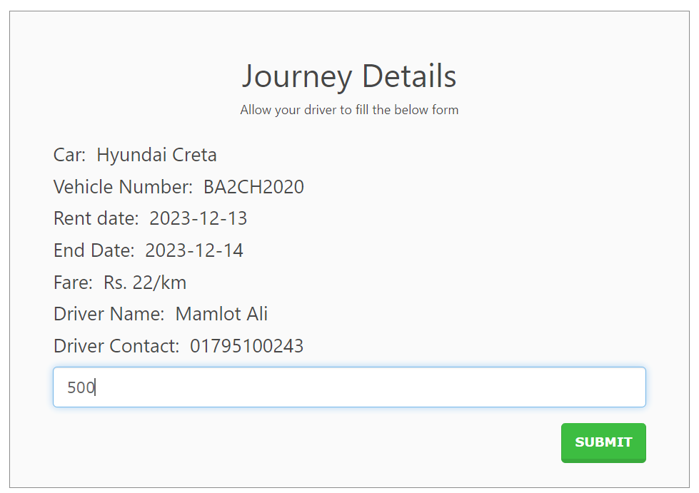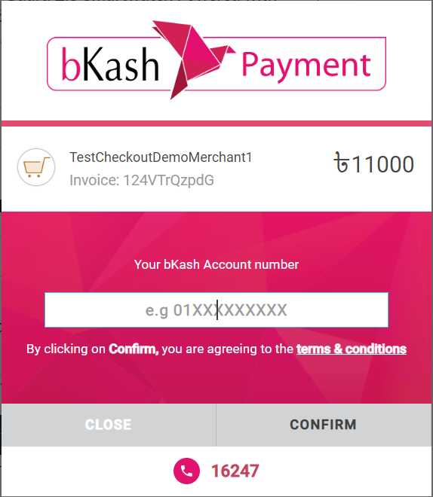

**Figure 13:** Payment

**Figure 12:** Journey Details

**Admin Page:**

**Add Driver:**

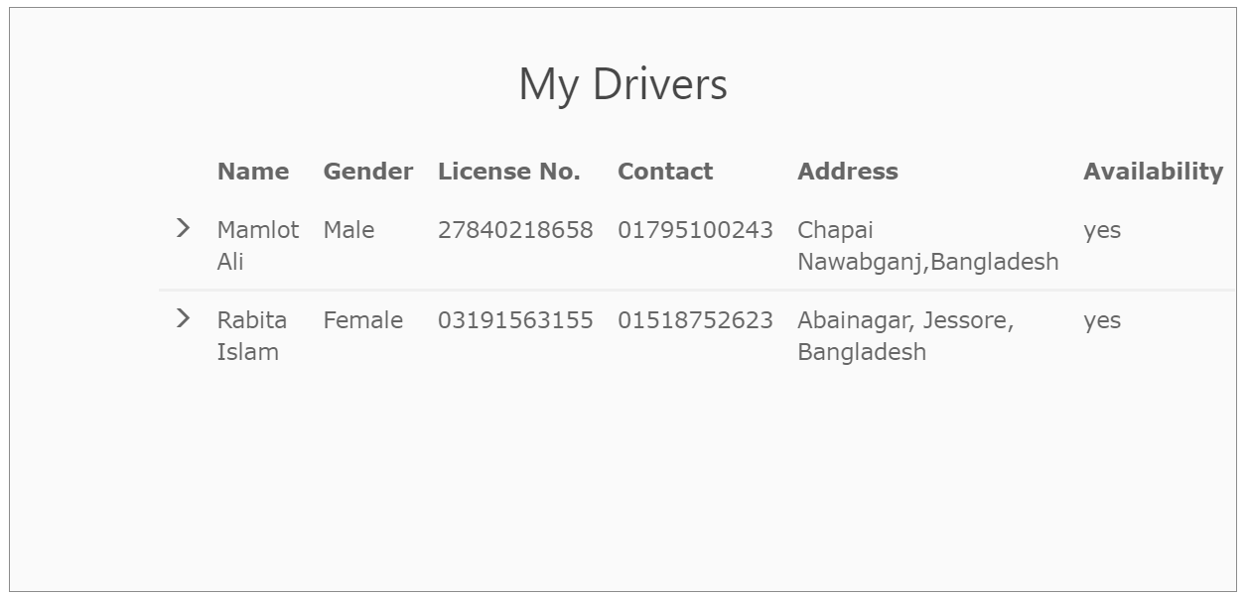 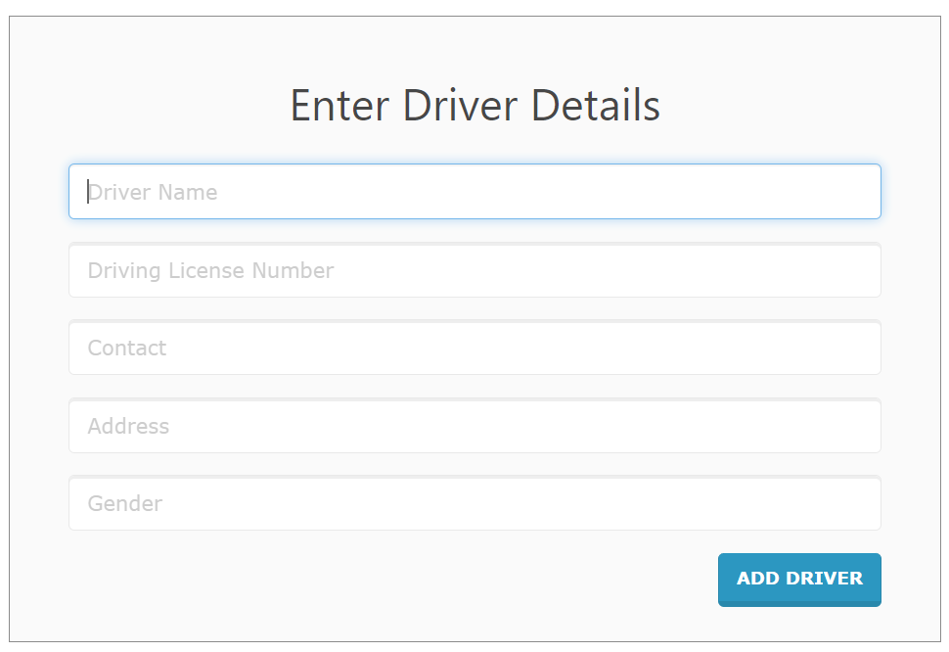

**Figure 15:** Driver List

**Figure 14:** Add Driver

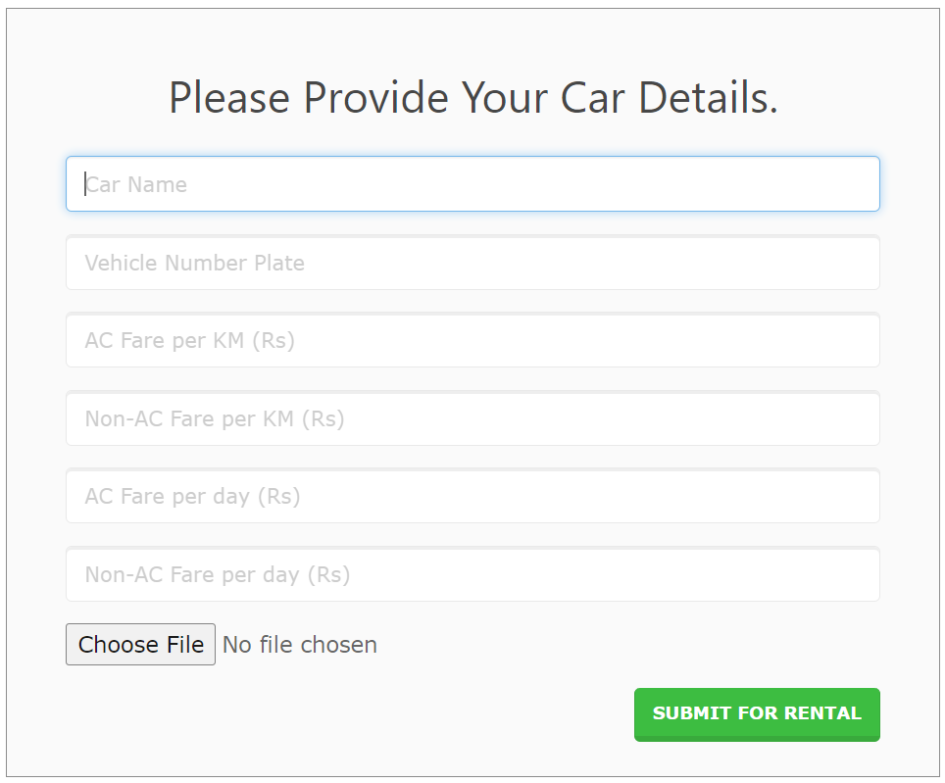**Add Car:**

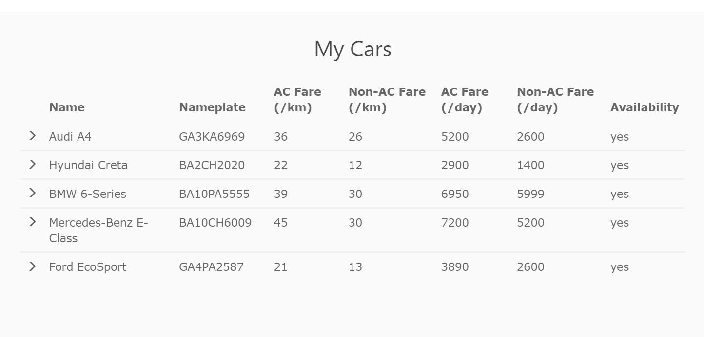

**Figure 17:**  Car List(Admin)

**Figure 16:**  Add Car Form

# Conclusion

Car rental business has emerged with a new goodies compared to the past experience where every activity concerning car rental business is limited to a physical location only. Even though the physical location has not been totally eradicated; the nature of functions and how these functions are achieved has been reshaped by the power of internet. Nowadays, customers can reserve cars online, rent car online, and have the car brought to their door step once the customer is a registered member or go to the office to pick the car.

The web based car rental system has offered an advantage to both customers as well as Car Rental Company to efficiently and effectively manage the business and satisfies customers’ need at the click of a button

# References Used

<http://www.carrentingsolutions.com/>

<http://www.imscart.com/car_rental_software.html>

[http://www.Wikipedia.org](http://www.wikipedia.org/)