**----------- - Hyperlink**

**House of xp**

We talk ideas/experience! (Feedback required)

Logo strike your next campaign over a coffee

Graphical representation banner

Human mind is very sensitive to partners it does business with.

It is your interaction at every stage that keeps them tied and connected

At house of experience, we preach emotions and innovation to bridge the gap between brands and customers

We embrace story as our route to impact the sphere

About us

What attracts you tends to leave a dent in your memory ?

House of Experience is a Roi driven experiential agency. We work on end-to-end projects from brief to inception. our subject experts from consulting, advertising, creative , communication and experiential bring innovations and emotions together. We believe in tinder matching the experience with numbers to make a memorable campaign and that’s where we are headed to. Since ideas can be in any form or structure. We provide 360-degree support to brands in their growth journey. Our services include Content & Creative, video production, Image management and Events.

We also loop these experiential campaigns with performance-based metrics to extract the juice of each penny spend.

Our partnership with brands at all levels

1. Taking your product in the market
2. Initiate interests and generate positive communication
3. Plan on smooth product purchase
4. Engage customers for a long-standing relation
5. Most importantly, we inspire internal stake holders for tomorrow’s vision

**Offerings**

**Content and Creative**

**Video Production**

**Image Management**

**Event and Production**

**Marketing Analytics**

1. **Content and creative**

**( Animated content to be placed at banner – Content is bold in centre. Similar creative to be made where all relative elements of content are floating around the centre “Content area” ultimately covering the frame highlighting “Content “ in centre. – Melvin)**

**We believe in breaking the usual pattern of displaying brands by adding humor making it interesting for brand’s customer .**

Engage with your subscribers and consumer by making your content and marketing campaigns more visual, interactive, and gamified

Our subject matter experts uses behavioral science to read your customer mind and heart to create a personalized customer experience through content and creative

Services:

Creative /social/pr/brand strategy and behavioral science/digital experience

1. **Video Production :**

Rotating banner/carasol ? Animated Video -melvin

* Animation.
* Stop motion.
* Mixed media.
* Screencast.
* Animated demo.
* Live action.
* Live stream.
* Interactive.

Most brands are driven by search engine optimization (seo) tactics and have almost forgotten about creating a personal experience with their customers.  Coming up with the best experiential marketing strategies is the first step towards creating an amazing experience for you and your customers.

Video stands as an essential tool in communicating your values to customers.

Each viewer has different needs and is looking for messages that are relevant to them. With personalized videos, each video experience might look completely different depending on each viewer’s needs and interests.

Using research, reading customer persona and world class idea we partner with brands to increase their customer engagement and achieve higher click through rates.

1. Image Management

*An image is the set of beliefs, ideas, and impression that a person holds regarding an object.*

*– Kotler*

*(creative of above content – Melvin)*

We follow the “Panchtatv” (five aspects of truth)

Appearance

Behaviour

Communication

Digital Presence

Emotional Balance

1. **Events (html) – page**

**Rotating banner/ Carousal / Animation content (melvin)**

Conferences and seminars, guerilla marketing, activations, mice activity, trade shows

Rewards and recognitions, leadership meets, boardroom meetings, incentive tours, employee value propositions, team building activities, corporate off sites

For partners : dealer and distributor meets, incentive tours

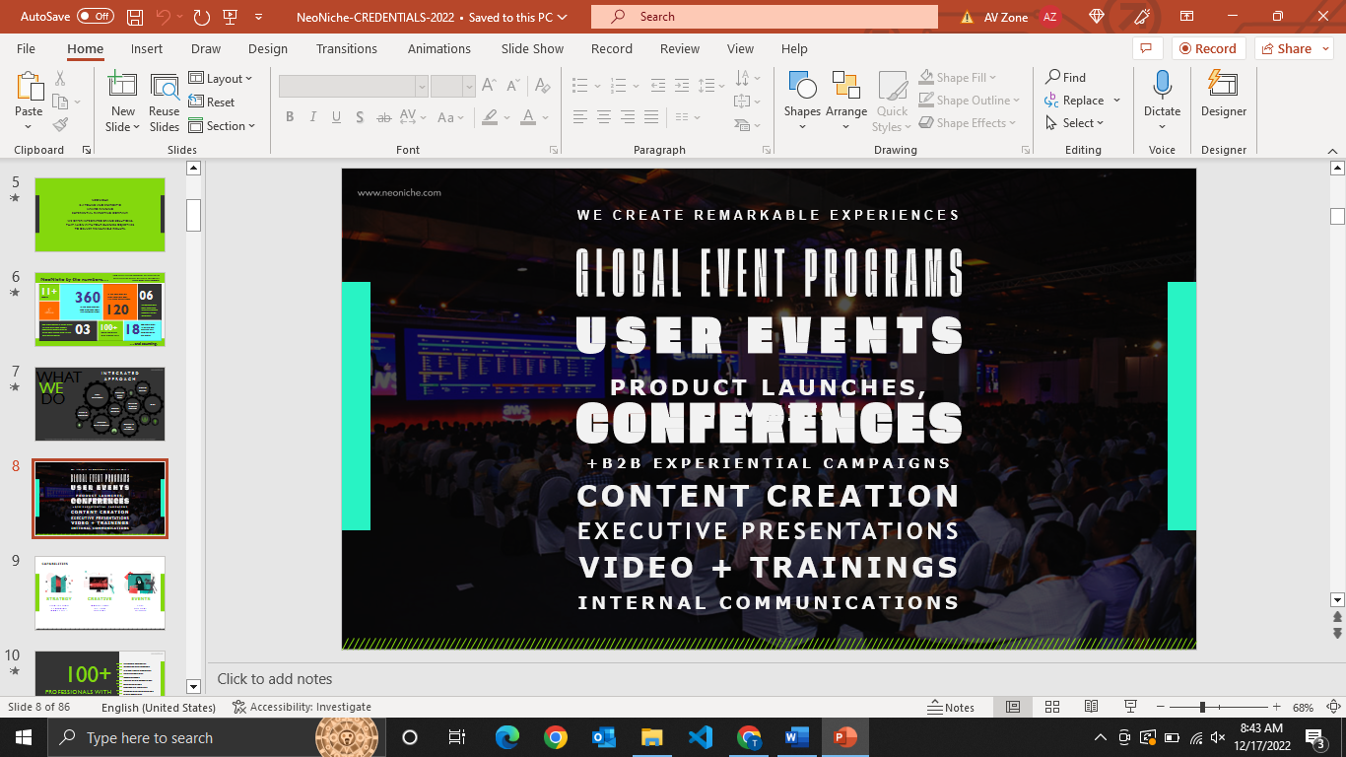

<https://www.gpjindia.com/?from_lang=1> (video)

Content and Events are two entwined twins

The landscape of events have changed over few years. We have been progressive to adapt quickly. We integrate technology with stories and emotions to provide world class experience.

From your internal stake holders to external stake holders, everyone needs a taste of physical experience to create a long-lasting memory.

We embrace technology for the betterment of tomorrow , provide world class experience to brands and their customers.

core concept lies in working for the betterment of the humans future . We partner up with brands for

1. Customer acquisition journey
2. Business expansion
3. Customer retention
4. Maintain a healthy relation with your customers

Reference website:

<https://www.spinxdigital.com/>

Case studies :

Https://www.bibs.co.in/blog/a-case-study-on-the-marketing-strategy-of-cred

1. Marketing analytics

(Similar image to be created – Melvin)

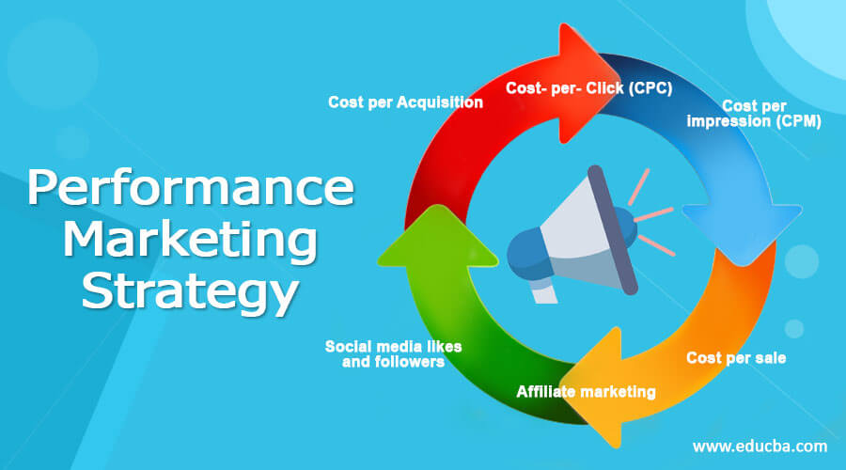

To make experience measurable we provide performance support in all facets of your campaign be it offline or online

Improve your roi with scalable ppc marketing

We align website traffic drivers to end goals. We utilize powerful content and behavioral science , to foster the needs of Brands.

Call to action (lead submission query )

<https://www.webfx.com/seo/services/ecommerce/>

Solutions:

* Ppc and paid search (google ads/ google shopping management/lead gen ppc/amazon ppc/google ads consulting)
* Seo services

Sample text effect

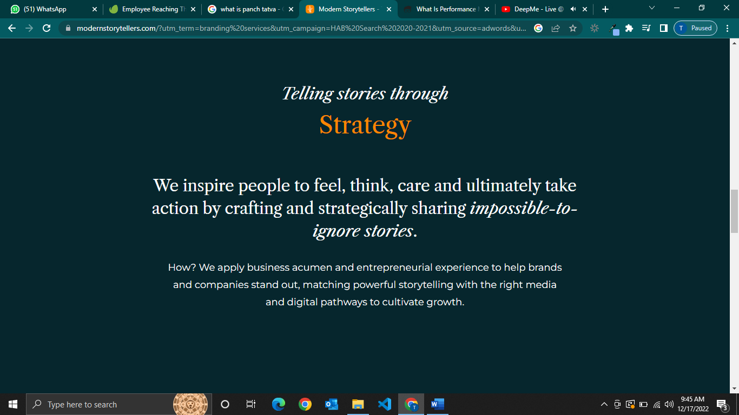

https://modernstorytellers.com/?utm_term=branding%20services&utm_campaign=HAB%20Search%202020-2021&utm_source=adwords&utm_medium=ppc&hsa_acc=5554482269&hsa_cam=10655092754&hsa_grp=105635752055&hsa_ad=618300511085&hsa_src=g&hsa_tgt=kwd-18128876&hsa_kw=branding%20services&hsa_mt=p&hsa_net=adwords&hsa_ver=3&gclid=EAIaIQobChMI5tGg7-T_-wIV1X0rCh3x8QFDEAMYASAAEgL-zfD_BwE

Page end content:

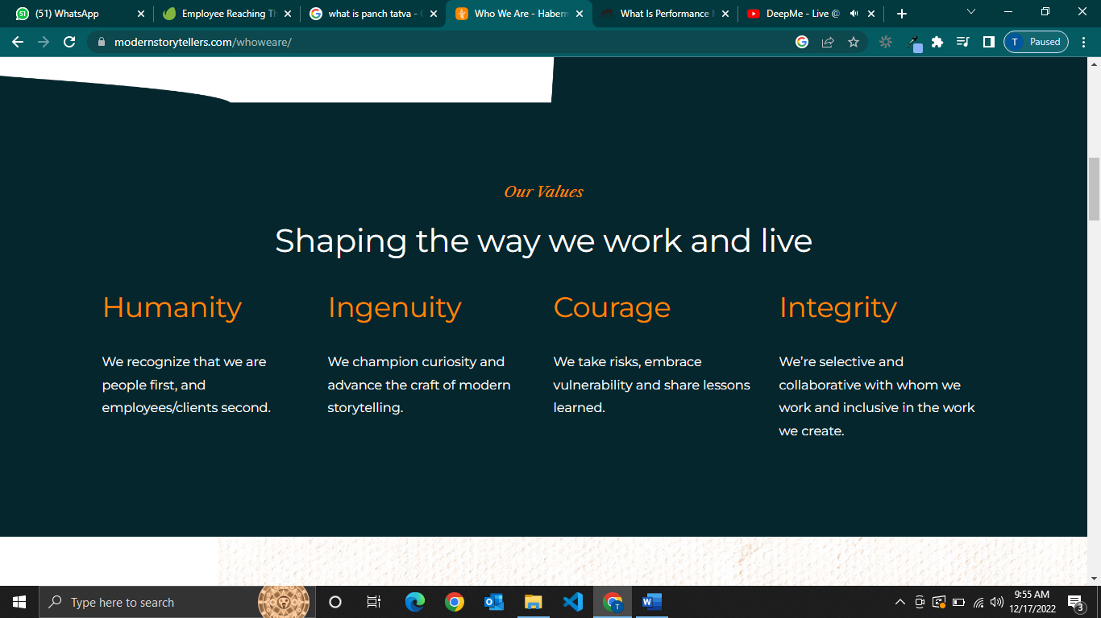

Footer:

Linkedin : <https://www.linkedin.com/company/houseofxp/>

Contact us

[info@houseofxp.com](mailto:info@houseofxp.com)

+917678084459

1202, Dheeraj Residency, Goregaon west , Mumbai - 400104

Social media content type:

* Educational.
* Inspirational.
* Interactive.
* Connecting.
* Promotional.
* Newsworthy.
* Entertaining.

