# Example (ACs):

* The application, by default, displays the home page.
* The home page contains a message welcoming the user and a link to the companies’ page.
* The companies page has to sections.   
  To the left, it should display a list of companies.  
  To the right it should display a form to create a company.
* The companies’ list displays a card for each company registered in the application:  
  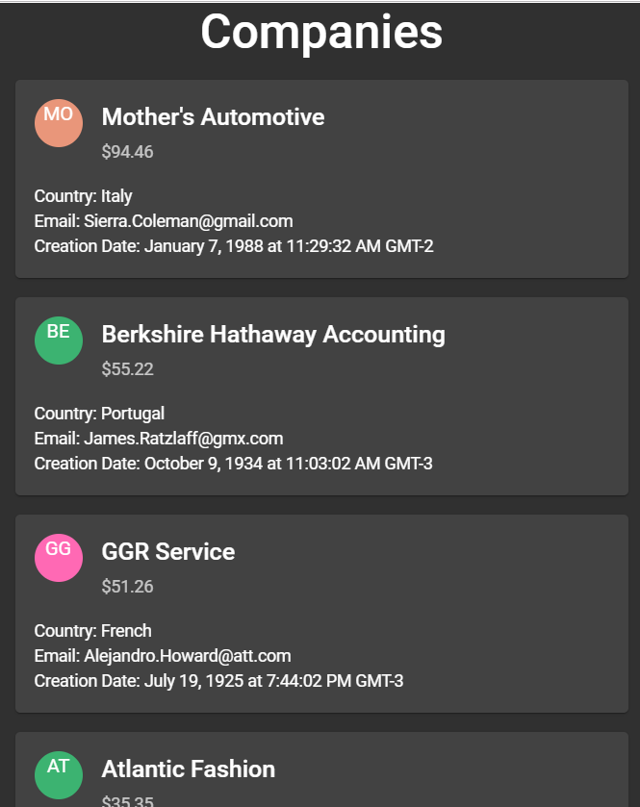
* A company card displays:  
  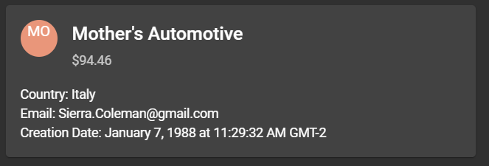
  + it’s stock logo
  + it’s name as the card title
  + it’s market value as subtitle.
  + On its body, it will display the company’s country name, it’s email and profile creation date and time.
* The company form allows the user to enter the following information:  
  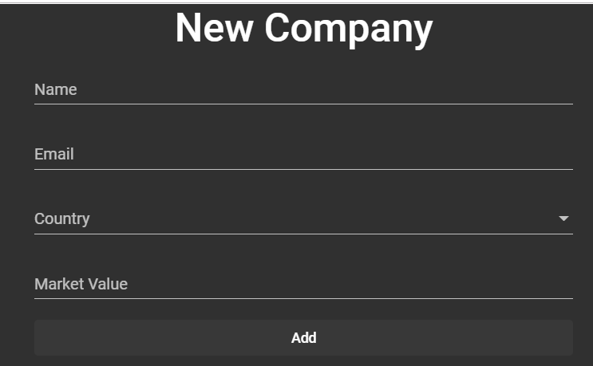
  + Company name, which is required.
  + Company email.
  + Select a country from the list of countries our application works with. Required
  + Specify its market value, which is a required decimal value.

# Specifications:

## CompanyComponent:

# Testing:

## State:

## Container:

## Presentational:

# References:

Besides the official documentation these are recipes for different common scenarios:

* <https://medium.com/google-developer-experts/angular-2-testing-guide-a485b6cb1ef0>
* <https://github.com/juristr/angular-testing-recipes>
* <https://dev.to/lysofdev/an-angular-testing-cheatsheet-5hj2>
* <https://ngxs.gitbook.io/ngxs/recipes/unit-testing>