**BIRLA INSTITUTE OF TECHNOLOGY & SCIENCE, PILANI WORK INTEGRATED LEARNING PROGRAMMES**

Cloud Computing (CSI ZG527 / SS ZG527 / SE ZG527) Second Semester 2020-2021

Assignment

|  |  |  |
| --- | --- | --- |
| Name | : | Mohammad Arif |
| Student No | : | 2020MT93541 |
| Assignment | : | Generate a word count for each unique keyword of any given text document using Mapreduce based program |

**Solution:**

*This project was developed using Hadoop program locally with maven Hadoop dependencies. The code is written in Java which* generates a word count for each unique keyword of any given text document using Mapreduce based program.

GITHUB for the code wit all dependencies and Java code: Project is also zipped with the submission.

<https://github.com/mdarif055/Intellij-Hadoop>

IntelliJ Set up with input sampleTestFile:

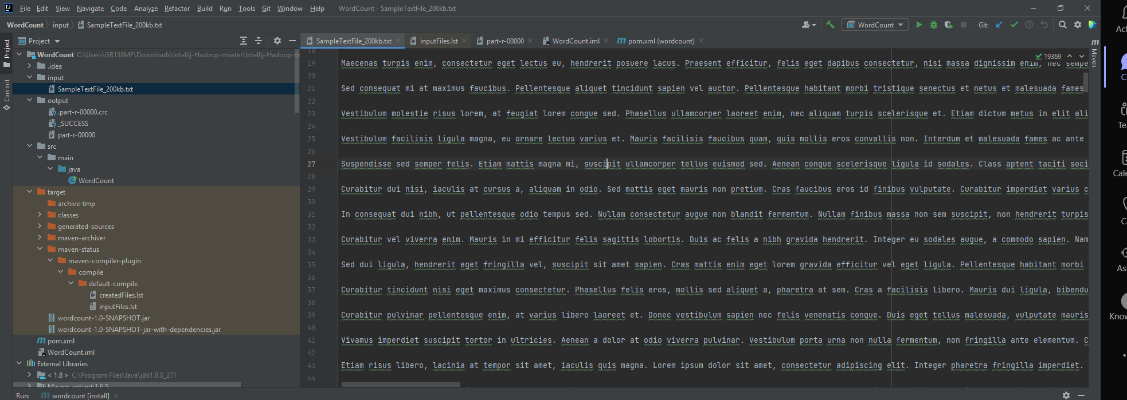

Building project and Java class:

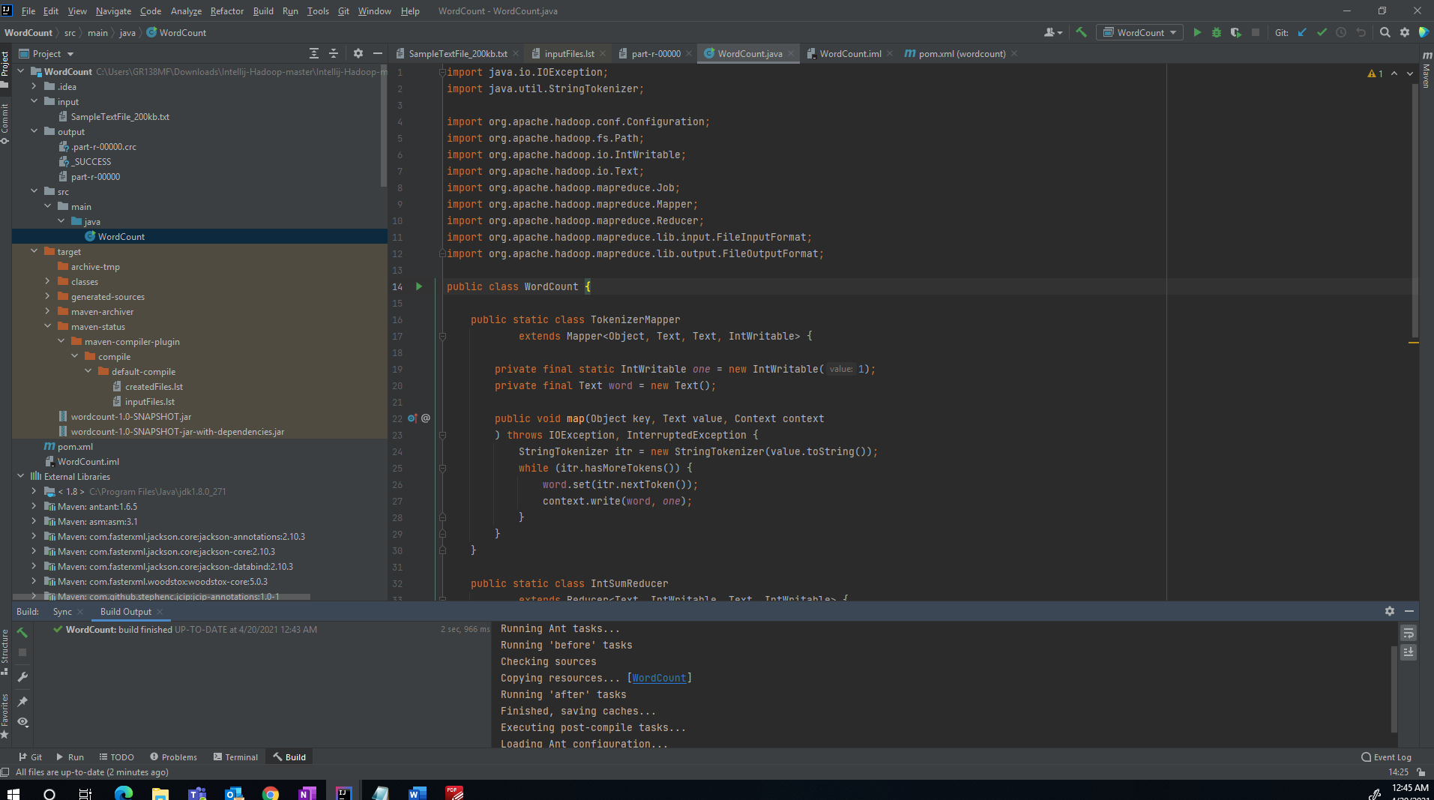

Output file after program executed:

