 East West University

**Lab Report**

**Semester:** Summer-2025

**Course Title:** Electrical Circuits **Course Code:** CSE209

**Sec:** 01

**Lab Report-6**

|  |  |
| --- | --- |
| **Student Name** | **Student Id** |
| Md. Arifur Rahman Razu | 2024-3-60-503 |

# Submitted by-

Name: Md. Arifur Rahman Razu

Id: 2024-3-60-503

# Submitted to-

Dr. Sarwar Jahan

Associate Professor

Department of Computer Science & Engineering

East West University

**Date of Performance: 12-08-5-2025 Date of Submission: 18-08-2025**

**Exp no: 6**

**Title: Verification of Thevenin’s theorem**

**Objective:**

1. To Verify The Thevenin’s theorem theoretically, experimentally, and using PSpice simulation.

**Theory:**

Thevenin’s theorem states that a linear two-terminal network can be replaced by an equivalent circuit containing a voltage source Eth in series with a resistance Rth. Eth is equal to the open circuit voltage between the terminals and Rth is the ratio of the open circuit voltage to the short circuit current through the terminals. Experimentally, Eth may be measured by measuring the open circuit voltage and Rth can be calculated by measuring the open circuit voltage and the short circuit current.

**Circuit Diagrams:**

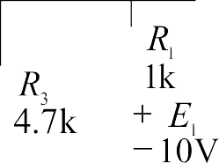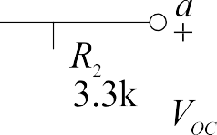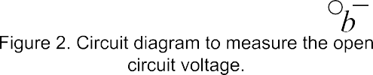

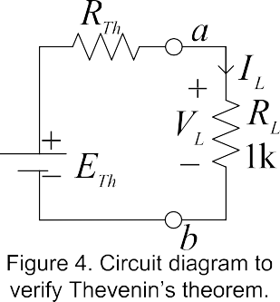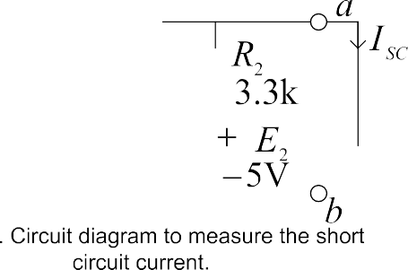

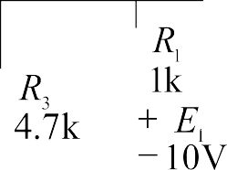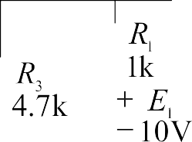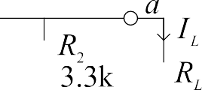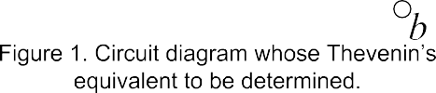

**Pre-Lab Report Questions:**

1. Theoretically calculate VL and IL in Figure 1. Then theoretically calculate VOC in Figure 2 and ISC in Figure 3. From the values of VOC and ISC, determine Eth and Rth. Theoretically calculate VL and IL in Figure 4. Verify the Thevenin’s theorem from calculated data?

Ans:

From Figure-1,

Applying mesh,

5.7I1 – I2 = -10 …………..(i)

-I1 + 5,3I2 -3.3I3 = 5…………(ii)

-33I2 +4.3I3 = 5………………(iii)

Solving eq (i), (ii) & (iii) ,

I2 = 2.73

I3 = 3.26

I3 =IL

VL = IL RL = 3.26 1 = 3.26v

From Figure-2,

Voc = I2 3 = 2.73 3.3 = 9.02v

From Figure-3,

Isc = I3 = 3.26

Eth = Voc = 9.02v

Rth = Voc/Isc = 9.02/3.26 = 2.8

From Figure-4,

IL = 9.02/2.8+1 = 2.4

VL = 2.4 1 = 2.4v

|  |  |  |  |  |  |  |
| --- | --- | --- | --- | --- | --- | --- |
|  |  |  |  |  |  |  |
| 10.3V | 4.99V | 3.29V | 3.4mA | 6.7V | 6.8mA | 0.96  3.2  4.4  0.95  0.95 |

|  |  |  |  |
| --- | --- | --- | --- |
|  |  |  |  |
| 6.7V | 0.99 | 3.37V | 3.6mA |



