

**East West University**

**Lab Report**

**Semester:** Summer-2025

**Course Title:** Electrical Circuits

**Course Code:** CSE209

**Sec:** 01

**Expt No: 03**

**Expt Name: Bias Point Detail Analysis of DC Circuit With Independent Sources Using PSpice Schematics.**

**Group No: 05**

**Submitted by-**

Md. Arifur Rahman Razu

2024-3-60-503

**Submitted to-**

Dr. Sarwar Jahan

Associate Professor

Department of CSE

East West University

**Date of Submission: 10-08-2025**



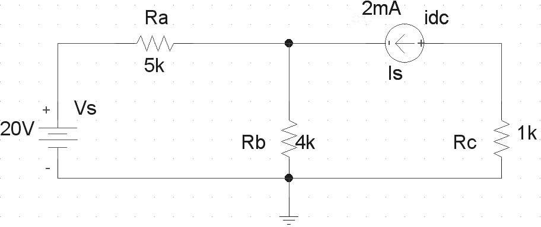



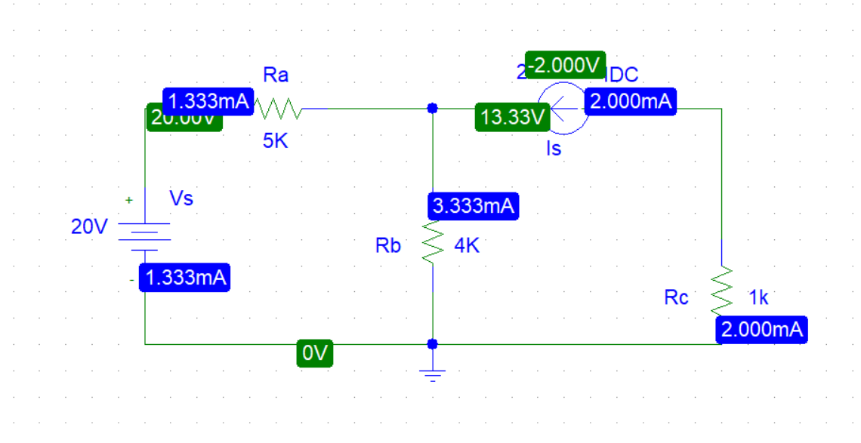

Lab Practice Problem:

(i)

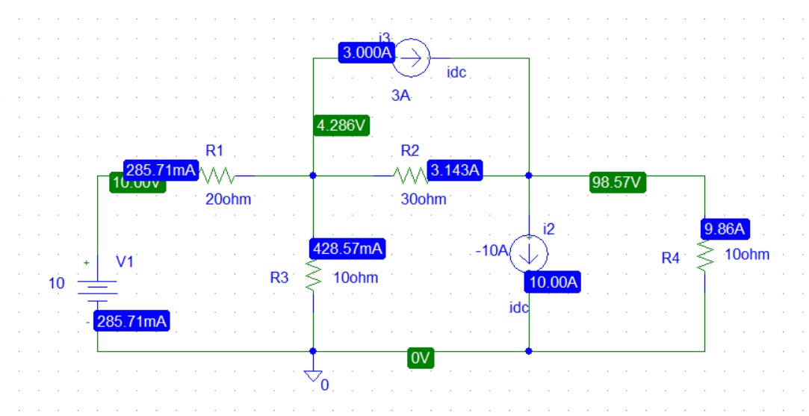



Post Lab :

1. Theoretically calculate all the currents and the voltages for the circuit shown in Figure 2.

Here, V1 = 10 V KCL at node 2:

{(V2 – V1) / 20} + {(V2 – V3) / 30} + V2 / 10 = -3

Or, -0.5 + 0.183 V2 - 0.033 V3 = -3

Or, 0.183 V2 - 0.033 V3 = -2.5 . . . . . . . . . . . . . . . . . . . . (1) KCL at node 3:

{(V3 – V2) / 30} + V3/ 10 = 3 – (-10)

Or, -0.033 V2 + 0 .133 V3 = 13 . . . . . . . . . . . . . . . . . . . . (2)

By solving equation equations (1) and (2), We get, V2= 4.150 V and V3= 98.774 V By using the value of V2, V3:

I1 = (V1−V2)/R1 = (10-4.2857)/20 = 285.71mA

I4 = (V2-V3)/R2 = (4.2857−98.57)/30 = (−94.2843)/30 = -3.142 A

I5 = V2/R3 =4.2857/10 = 428.57 mA

I6 = V3/R4 =98.57/10 = 9.857 A

2. Compare the theoretical solution of the circuit shown in Figure 2 with the solutions obtained from PSpice.

Values obtained from theoretical solution,

V1= 10 v,

V2= 4.150 v, V3= 98.774 v, i1= 285.71 mA, i4= -3.142 A, i5= 428.57 mA, i6= 9.857 A