

**East West University**

**Lab Report**

**Semester:** Summer-2025

**Course Title:** Electrical Circuits

**Course Code:** CSE209

**Sec:** 01

**Expt No: 05**

**Expt Name: Verification of Superposition Theorem.**

**Group No: 05**

**Submitted by-**

Md. Arifur Rahman Razu

2024-3-60-503

**Submitted to-**

Dr. Sarwar Jahan

Associate Professor

Department of CSE

East West University

**Date of Submission: 10-08-2025**

**Title:** Verification of Superposition Theorem.

**Objectives:**

1. To verify superposition theorem theoretically, experimentally and using PSpice simulation.

**Theory (Summary):**

The superposition theorem is used for linear circuits with multiple sources. It says that the voltage across or current through any element can be found by considering one source at a time and turning off the others (replacing voltage sources with short circuits). After finding the individual effects, we add them up algebraically to get the final result. In this experiment, we applied the superposition theorem to a circuit with three voltage sources and calculated the total current by adding the contributions from each source separately.

**Circuit Diagram:**

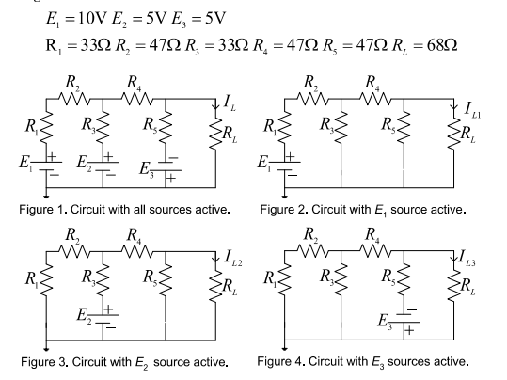

**Post-Lab:**

**1.** Theoretically calculate the values of IL, IL2 and IL3 of circuits from figure 1 through 4. From the calculated values , show that the superposition theorem holds, that is, IL = IL1 + IK2 + IL3

ANS:

Figure 1,

Applying KVL at mesh1 , mesh 2, and mesh 3

(33+47+33)i1 - 33i2 = 10-5 ….(1)

-33i1 + (33+47+47)i2 - 47i3 = 5+5 ….(2)

-47i2 + (47+68)i3 = -5 ….(3)

By solving

IL = i3 = -4.269 mA

Figure 2,

Applying KVL in mesh1,mesh2,mesh3,

(33+47+33)i1 - 33i2 = 10 …(1)

-33i1 + (33+47+47)i2 -47i3 = 0…(2)

-47i2 + (47+68)i3 = 0 ….(3)

By solving,

I3 = IL1 = 12.16 mA

Figure 3,

Applying KVL at mesh 1,2 and 3,

(33+47+47)i1 -33i2 = -5 …(1)

-33i1 + (33+47+47)i2 - 47i3 = 5 ….(2)

-47i2 + (47+68)i3 = 0 ….(3)

By solving it,

I3 =IL2 = 14.739 mA

Figure 4,

Applying KVL i8n mesh1 mesh 2 and mesh 3,

(33+47+33)i1- 33i2 = 0….(1)

-33i1 + (33+47+47)i2 -47i3 = 5….(2)

-47i2 + (47+68)i3 = -5 ….(3)

By solving it ,

I3 = IL3 = -31.168mA

Now,

IL1 + IL2 + IL 3 = 12.16 + 14.739 + (-31.168)mA

= -4.269 mA

= IL

The superposition theorem is verified.

**Experimental datasheet:**

|  |  |  |  |  |  |  |  |
| --- | --- | --- | --- | --- | --- | --- | --- |
| **Measured**  **Value of**  **E1 (V)** | **Measured**  **Value of**  **E2 (V)** | **Measured**  **Value of**  **E3 (V)** | **Measured**  **value of**  **IL with all sources**  **active**  **(mA)** | **Measured**  **value of**  **IL1 with**  **only E1**  **active**  **(mA)** | **Measured**  **value of**  **IL2 with**  **only E2**  **active**  **(mA)** | **Measured**  **value of**  **IL3 with**  **only E3**  **active**  **(mA)** | **Measured**  **values of**  **resistors**  **(Ω)** |
| 10V | 5V | -5V | -3mA | 14.5mA | 14.8mA | -32mA | R1=33 Ω  R2 = 46.5 Ω  R3=33 Ω  R4 = 46.Ω  R5=46 Ω  RL=67 Ω |

**Post Lab:**

1. Calculate the values of IL, IL1, IL2, and IL3 of the circuits of Figures 1 through 4 using the measured values of E1, E2, E3, R1, R2, R3, R4, R5, and RL. The calculated values show that the superposition theorem holds. Compare these calculated values of currents with the experimental values and comment on any discrepancy observed.

**Ans:**

Here,

E1 = 10V, E2 = 5V, E3 = -5V

R1 = 33 Ω, R2 = 46.5 Ω, R3 = 33 Ω, R4 = 46 Ω, R5 = 46 Ω and RL = 67Ω

$$i_{3}=I_{L}= ?$$

Applying KVL at mesh 1, 2 and 3,

$$\left(33+46.5+33\right)i_{1}-33i_{2}=10-5…\left(1\right)$$

$$-33i_{1}+\left(33+46+46\right)i_{2}-46i3=5+5…\left(2\right)$$

$$-46i_{2}+\left(46+67\right)i_{3}=-5…(3)$$

By solving equation (1), (2) and (3) we get,

Applying KVL at mesh 1, 2 and 3,

By solving equation (1), (2) and (3) we get,

$$i_{3}=I_{L1}=14.6 mA$$

Applying KVL at mesh 1, 2 and 3,

$$\left(33+46.5+33\right)i_{1}-33i_{2}=-5…\left(1\right)$$

$$-33i_{1}+\left(33+46+46\right)i_{2}-46i_{3}=5…\left(2\right)$$

$$-46i_{2}+\left(46+67\right)i_{3}=0…(3)$$

By solving equation (1), (2) and (3) we get,

$$i_{3}=I_{L2}=15 mA$$

Applying KVL at mesh 1, 2 and 3,

$$\left(33+46.5+33\right)i_{1}-33i_{2}=0…\left(1\right)$$

$$-33i_{1}+\left(33+46+46\right)i_{2}-46i_{3}=5…\left(2\right)$$

$$-46i_{2}+\left(46+67\right)i_{3}=-5…(3)$$

By solving equation (1), (2) and (3) we get,

$$i_{3}=I_{L3}=-32.8mA$$

Now,

$I_{L1}+I_{L2}+I_{L3}=\left(14.6+15-32.8\right)mA=$-3.2mA = $I_{L}$

Hence, the Superposition theorem is verified.

|  |  |
| --- | --- |
| **Calculated values** | **Experimental Values** |
| $$I_{L1}= 14.6mA$$ | $$I_{L1}= 14.5mA$$ |
| $$I_{L2}= 15mA$$ | $$I_{L2}= 14.8mA$$ |
| $$I_{L3}=-32.8mA$$ | $$I_{L3}=-32mA$$ |
| $$I_{L}=-3.2mA$$ | $$I_{L}=-3mA$$ |

There is discrepancy because in experimental values there is error while measuring the exact value and also we did not got the exact value of the resistors. That is what the values are different.

1. Solve the circuits of Figures 1 through 4 using PSpice. Include the PSpice circuits with only currents shown. The PSpice solution show that the superposition theorem holds. Compare the PSpice solutions with the theoretical solutions and comment on any discrepancy found.

Ans:

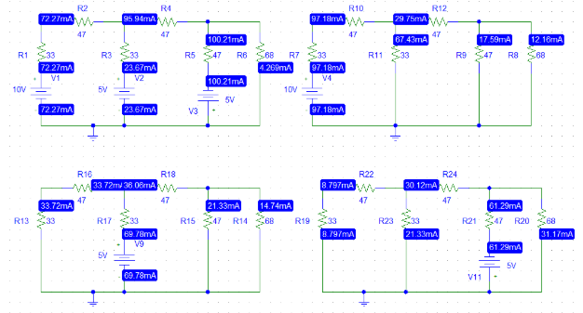

Here,

$$I_{L1}= 12.16mA$$

$$I_{L2}= 14.739mA$$

$$I_{L3}=31.168mA= -31.168mA (At opposite direction)$$

So,

$I_{L1}+I_{L2}+I_{L3}=\left(12.16+14.739-31.168\right)mA=$-4.269mA = $I_{L}$

So, it holds the superposition theorem.

**Comparison between PSpice solutions with the theoretical solutions,**

|  |  |
| --- | --- |
| **PSpice values** | **Theoretical Values** |
| $$I_{L1}= 12.16mA$$ | $$I_{L1}= 12.16mA$$ |
| $$I_{L2}= 14.739mA$$ | $$I_{L2}= 14.739mA$$ |
| $$I_{L3}=-31.168mA$$ | $$I_{L3}=-31.168mA$$ |
| $$I_{L}=-4.269mA$$ | $$I_{L}=-4.269mA$$ |

So, there is no discrepancy between PSpice values and theoretical values.

**Discussion:**

