Key Concept of Economics

Land:

**Definition:** Land is one of the four factors of production (along with labor, capital, entrepreneurship). It represent all natural resources that are available for economic use.

**Example:** A farmer uses land to grow rice – the soil, sunlight, and water help produce crops.

Labor:

**Definition:** Labor is the work done by people in exchange for payment.

**Example:** A teacher works in a school to educate students and earns a salary.

Capital:

**Definition:** Capital is wealth in the form of money, machine, tools, building, or equipment used to produce more goods and services.

**Example:** A taxi driver uses a car to carry passengers and earn money.

Entrepreneurship:

**Definition:** Entrepreneurship is the initiative and risk-taking ability of a person who starts and runs a business.

**Example:** Elon Mask started companies like Tesla by investing money, hiring workers, and taking risk to produce new technology.

Scarcity:

**Definition:** Scarcity is the basic economic problem of having limited resources to meet unlimited needs and wants.

**Example:** A country has a limited land to grow foods, people wants more houses, factories, and roads.

Rationing Device:

**Definition:** Rationing device is a method used to distribute scarce resources, goods or services among people who want them.

**Example:** During fuel shortages, the government limits how many petrol each person can buy.

Positive economics:

**Definition:** Positive economics based on fact that can be tested.

**Example:** 55% of the students at EWU are female.

Normative economics:

**Definition:** Normative economics based on opinion and value judgement.

**Example:** The income tax should be lowered.

Microeconomics:

**Definition:** Microeconomics focused on the behavior and decision-making of individual economic agents – such as a person, a firm, a market.

**Example:** A factory deciding how many workers to hire depending on production costs.

Macroeconomics:

**Definition:** Macroeconomics focused on the behavior and decision-making of multiple economic agents – such as markets, countries.

**Example:** A country increasing its total production of goods and services, measured by GDP.

Models:

**Definition:** An economic model is a theoretical framework that uses assumptions, variables, and relationships to explain economic behavior and outcomes.

**Example:** Explains how global supply and demand affect petrol prices.

Relationship between two variables:

**Definition:** The relationship between two variables in economic is the way in which one economic factor changes in response to changes in another.

**Example:** As income increases, consumption of goods also increases.

Opportunity cost:

**Definition:** Opportunity cost is value of the next best alternative that you give up when you make a choice. In other words, its what you sacrifice to get something else.

**Example:** Spending money on a vacation instead of saving for a new laptop – the laptop is the opportunity cost.

Marginal decision making:

**Definition:** Marginal decision making is the process of deciding whether to take one more or one less unit of action by comparing the additional benefit to the additional cost.

**Example:** Imagine you are studying for an exam. You have already studied two hours, and you are thinking about studying for one more hour.

Here, The MB is that you might understand the topic better and score higher.

And The MC is that you will loss one hour of rest or free time.

If the benefit of that extra hour is greater than the cost, you will choose to study more, If not, you will stop.

Marginal Benefit:

**Definition:** MB in economics refers to the additional benefit or satisfaction a person recives from consuming one more unit of a good or service.

Marginal Cost:

**Definition:** MC in economics refers to the additional cost incurred when producing one more unit of a good or service.

Efficiency:

**Definition:** Efficiency is the optional use of resources to achieve the maximum output or benefit with minimum waste.

**Example:** Using machines and labor to produce more products with fewer raw materials.

Incentives:

**Definition:** Incentives is something that motivates or encourages a person or business to take a particular action. It can be a reword or a punishment.

**Example:** Drivers pay fines for breaking traffic rules.

Exchange:

**Definition:** Exchange is the process of giving one thing and receiving another in return.

**Example:** Paying money to buy a book from a bookstore.

Trade:

**Definition:** Trade in economics is the exchange of goods and services between people, businesses, or countries.

**Example:** Country A exports wheat and imports cars from country B. Country B exports cars and imports wheat from country A. This allows both countries to get what they need more efficiently by specializing in what they do best.

Production Possibilities Frontier (PPF)

PPF:

**Definition:** The Production Possibility Frontier (PPF) shows the maximum possible output combinations of two goods or services that an economy can produce given its resources and technology, when all resources are fully and efficiently utilized.

1. **Limit of my work.**
2. **Resources and technology fixed.**

Assumption:

**Definition:** An assumption in economics is an idea we accept as true to make it easier to study how the economy works.

1. **Fixed resources.**
2. **Closed economy -> there is no trade.**

The Straight Line PPF:

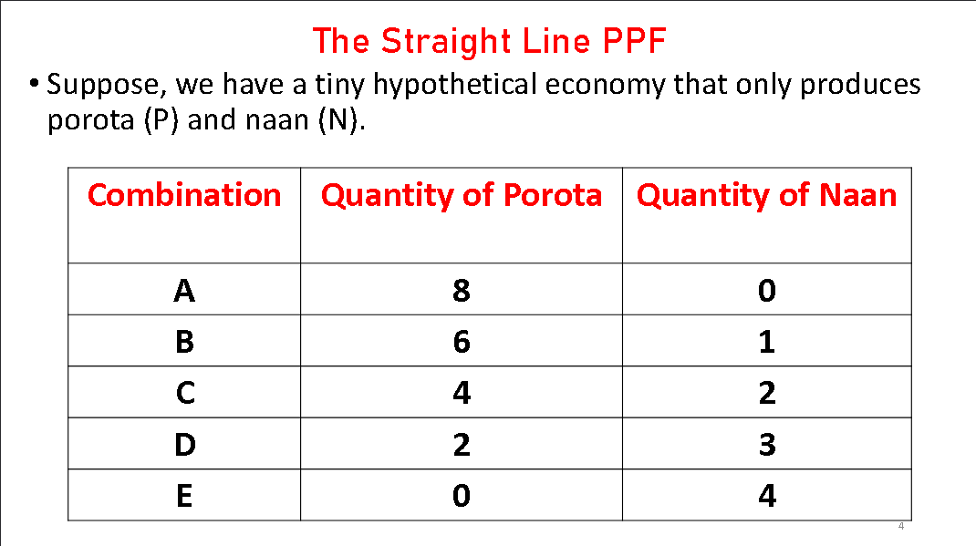

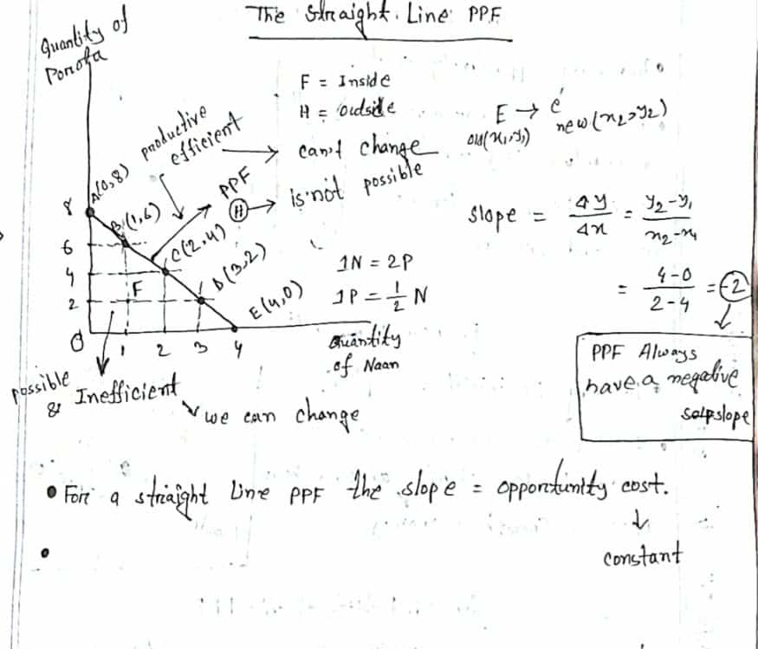

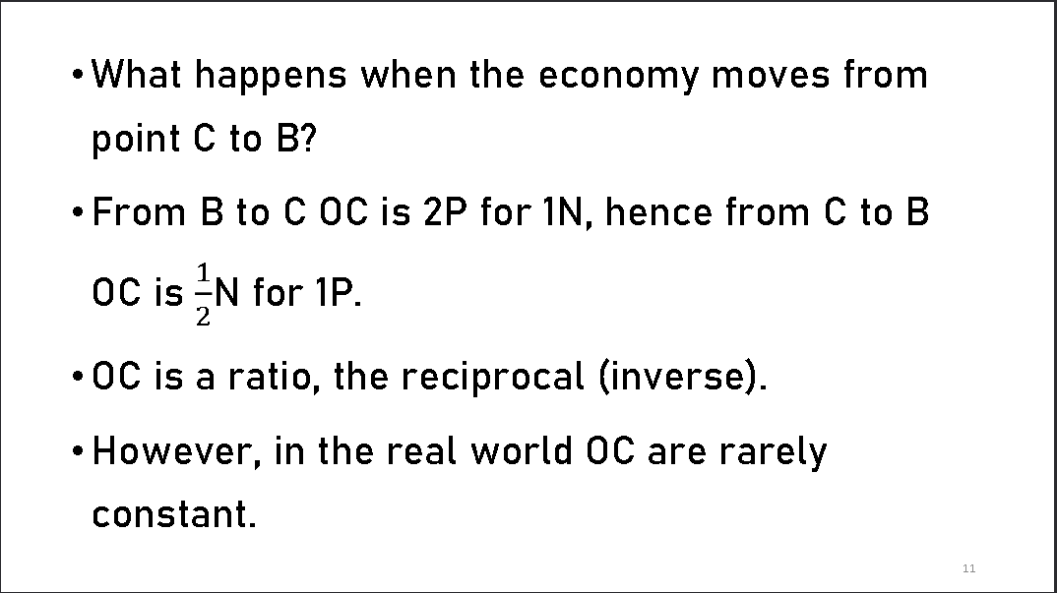

The Bowed – Outward PPF: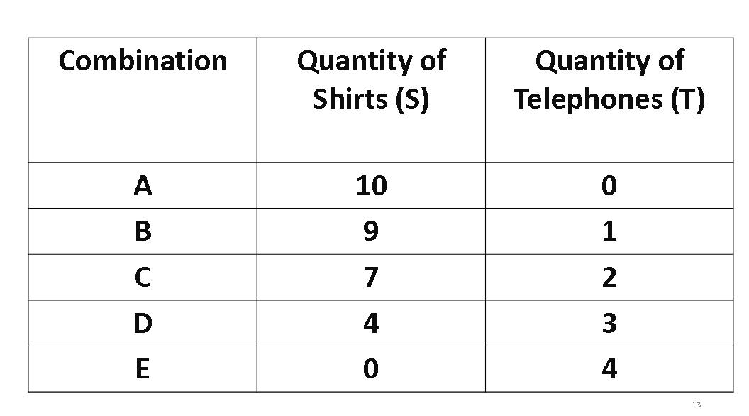

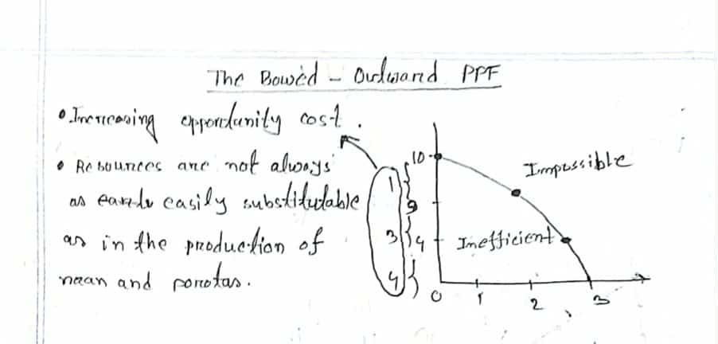

Economic Growth:

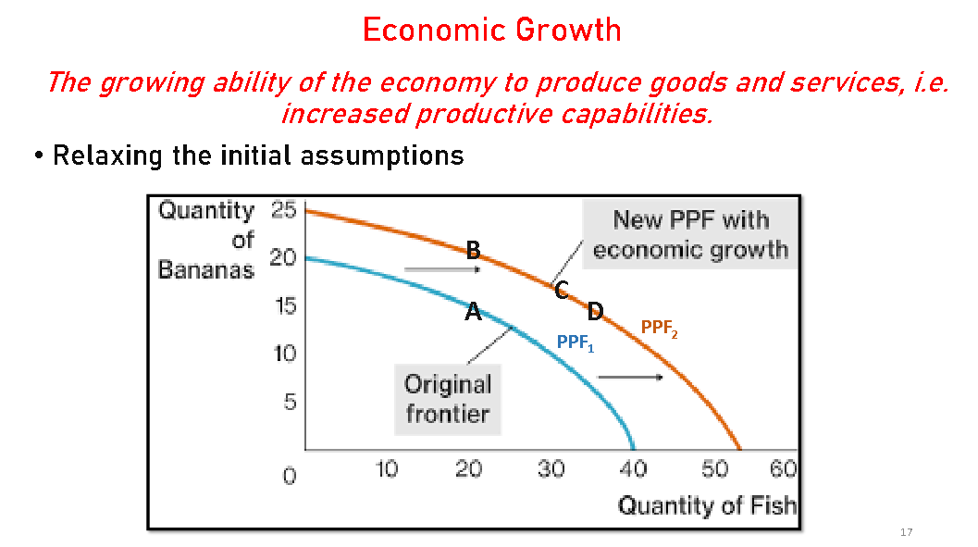

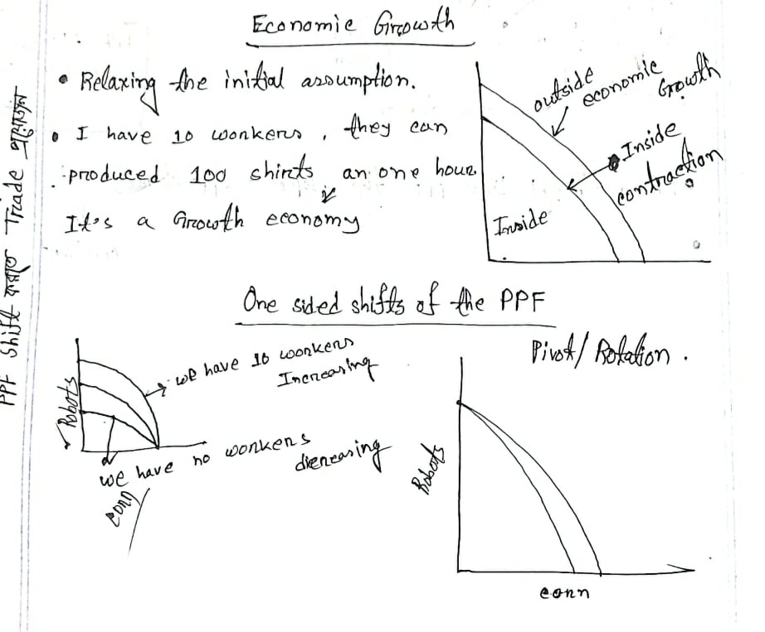

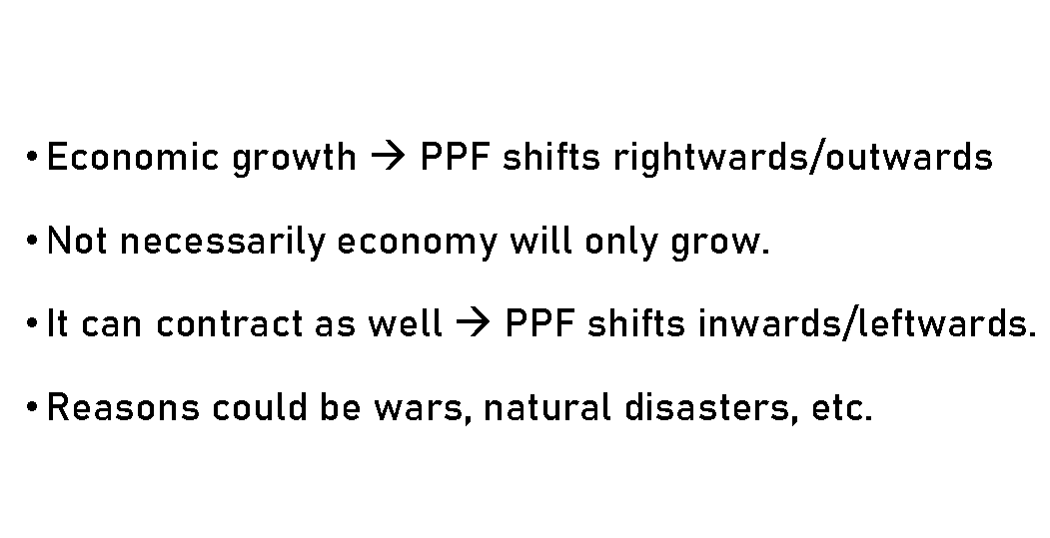

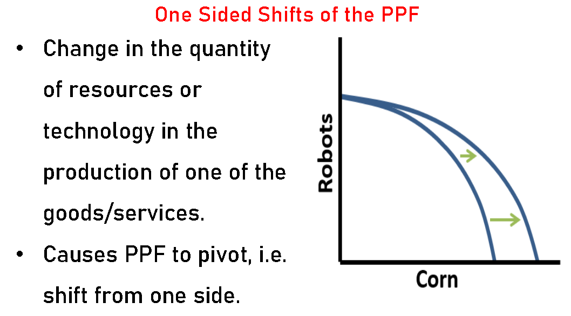

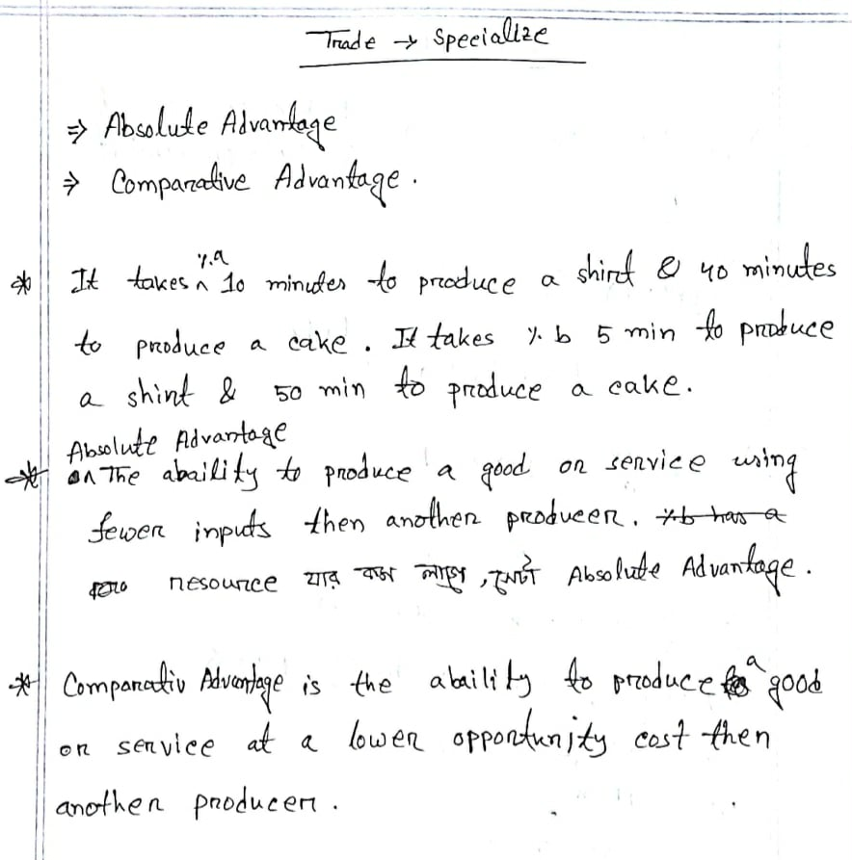

Supply & Demand

Demand:

**Definition:** Demand is the willingness and ability of buyers to purchase different quantities of a good/service at different prices during a specific time period.

1. **The Law of Demand** states that – as the price of a good rises the quantity demanded of that good falls, ceteris paribus. **(Quantity demand depends on price)**
2. **Demand and quantity demanded are not same.**

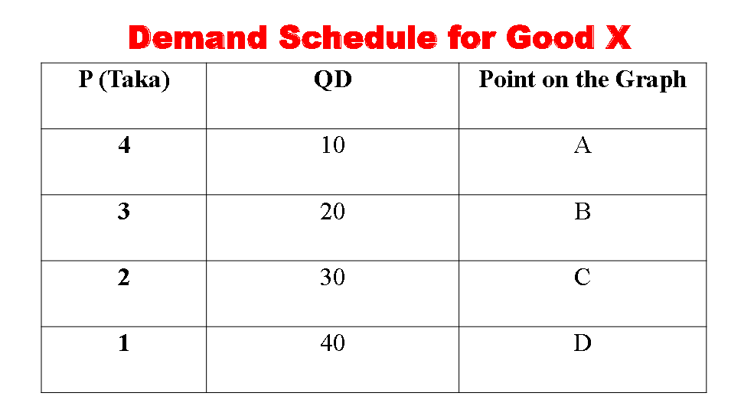

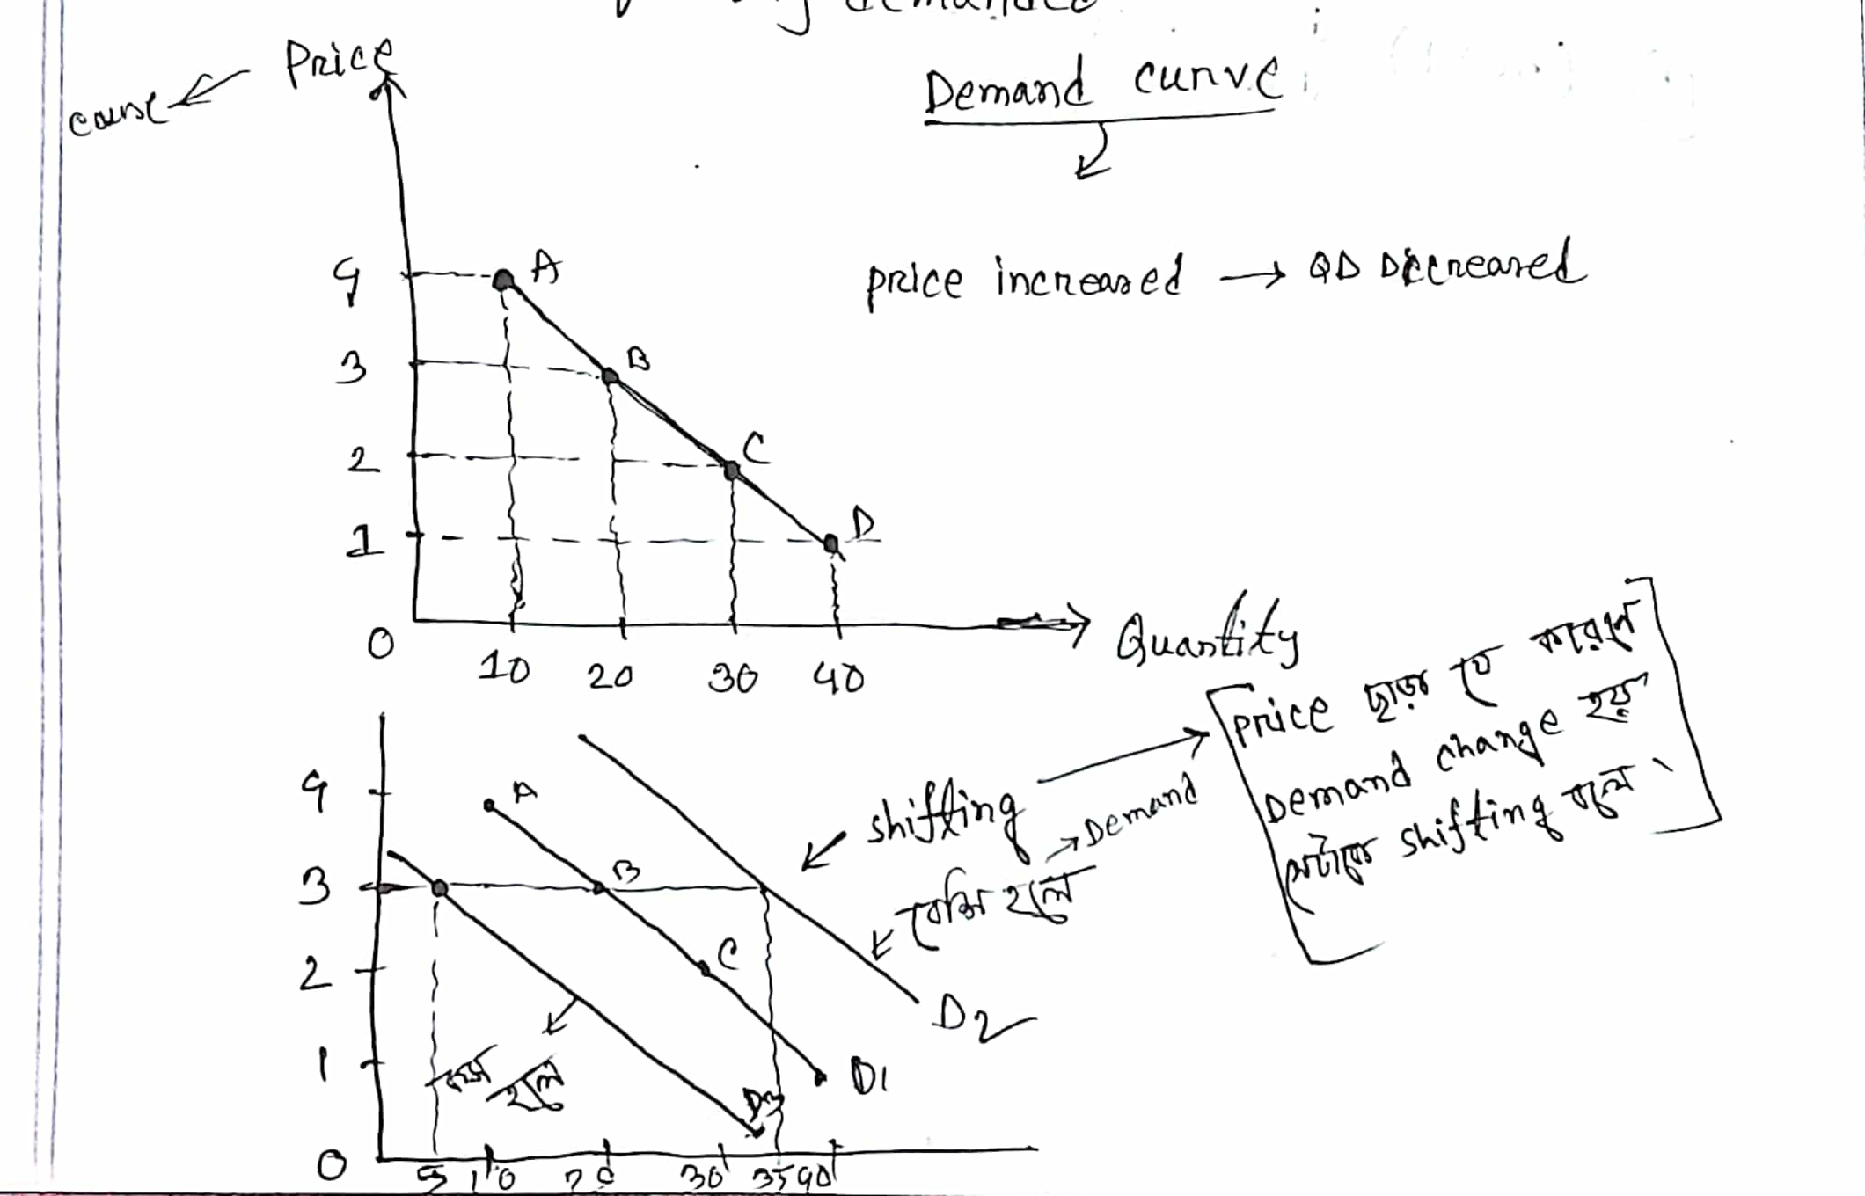

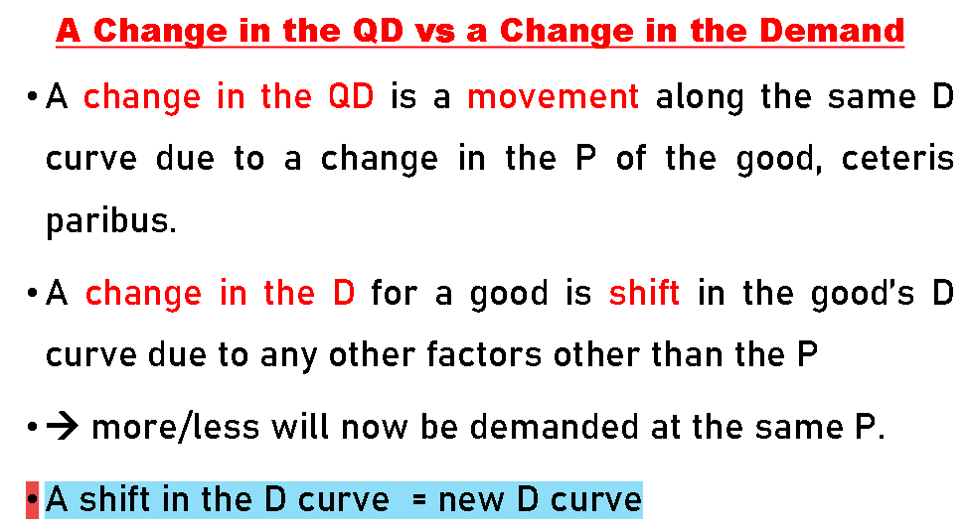

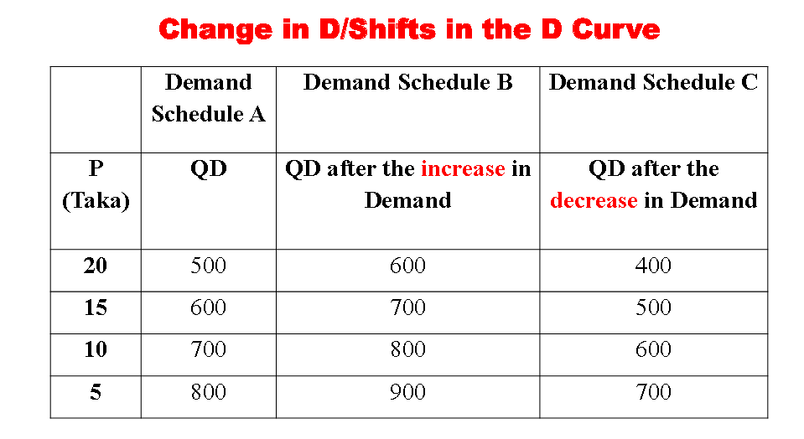

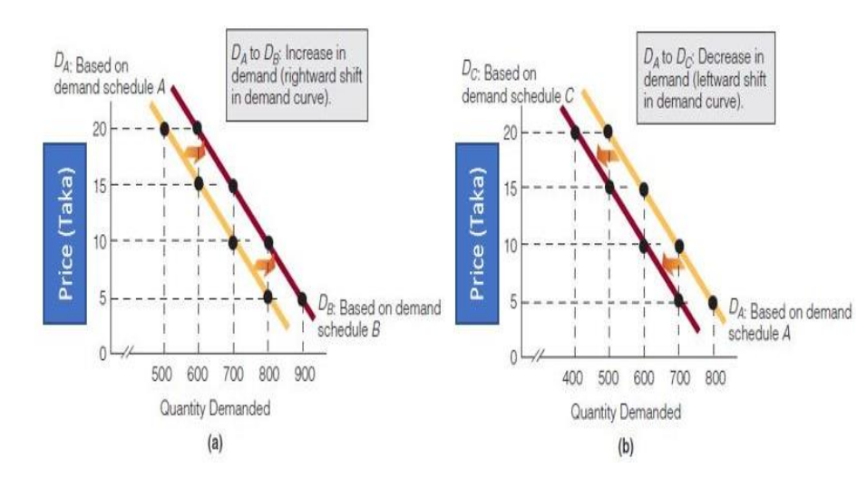

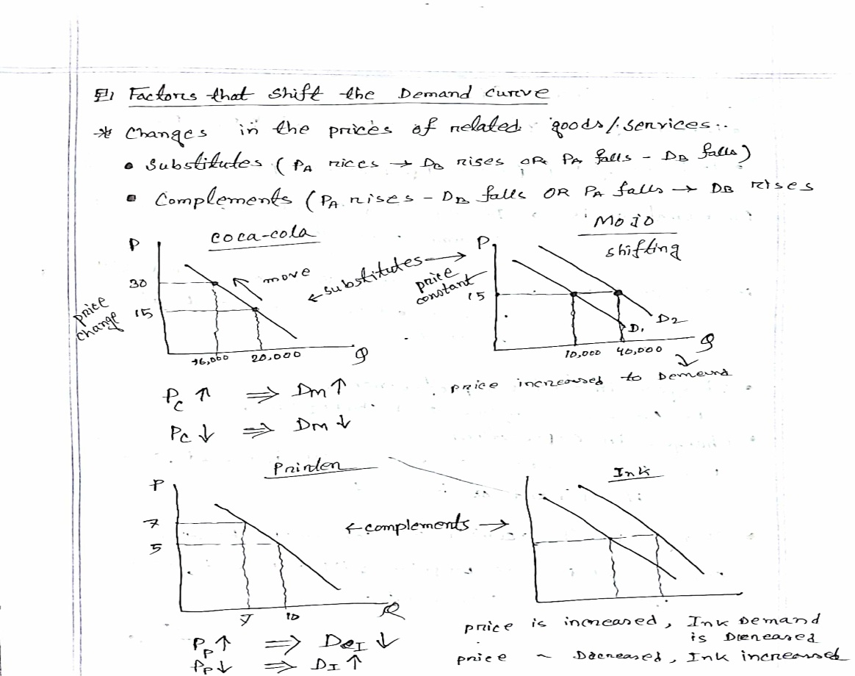

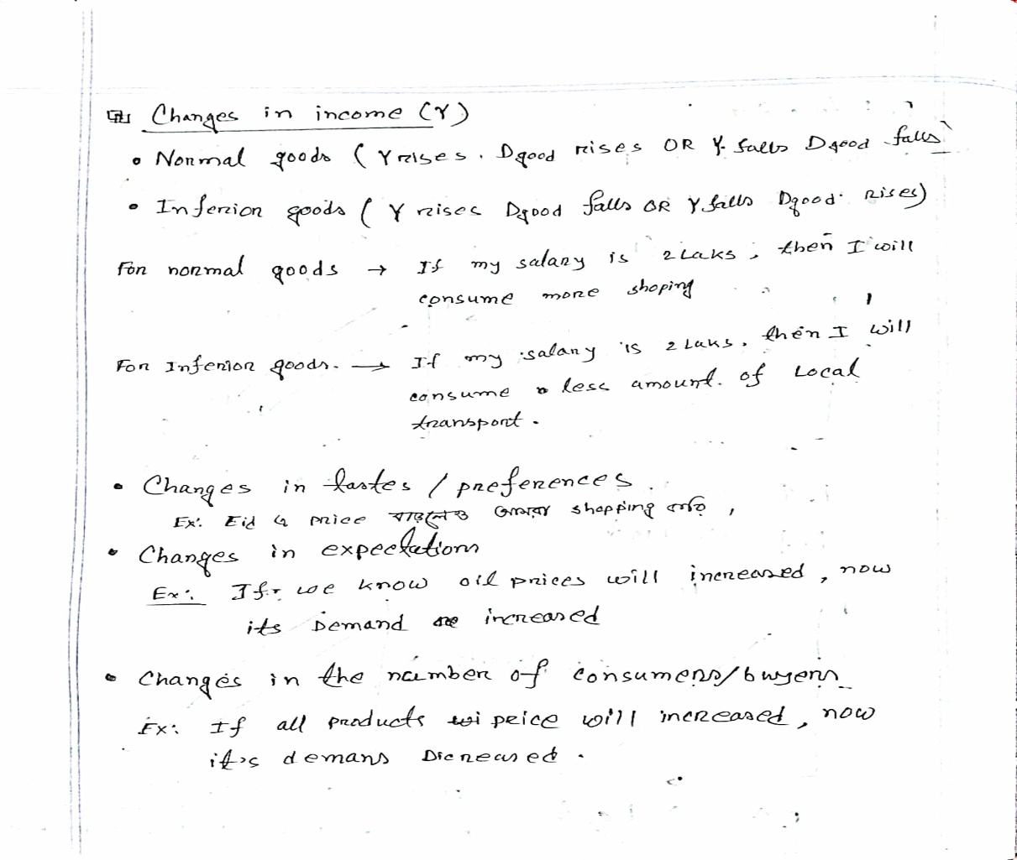

Supply:

**Definition:** Supply is the willingness and ability of sellers to produce and offer to sell different quantities of a good at different prices during a specific time period.

1. **The Law of Supply** states that as the price of a good rises, the quantity supplied of the good rises, ceteris paribus. **(Depends on price and quantity supply)**

