



Department of

Computer Science and Engineering (CSE)

**Course Code:** CSE-3216

**Course Title:** Digital Image Processing Sessional

**SUBMITTED BY**

Name: Md. Arik Rayhan ID: 20104033

Batch: 11th Year: 3rd Semester: 2nd Section: Odd

Session: 2020-2021

1

**SUBMITTED TO**

Md. Nazmus Salehin

Lecturer, Dept. of CSE, BAUET

Md. Abul Ala Walid

Lecturer, Dept. of CSE, BAUET

**INDEX**

|  |  |  |
| --- | --- | --- |
| **Task No** | **Chapter Name** | **Page** |
| 1 | Python Basics | 1-4 |
| 2 | Basic Image Pixel Operations | 5-8 |
| 3 | Grayscale Image Transformation | 8-14 |
| 4 | Image Histogram | 15-17 |
| 5 | Smoothing Filters | 18-22 |
| 6 | Sharpening Filters | 23-25 |
| 7 | Edge Detection | 26-29 |
| 8 | Segmentation | 30-35 |

**Task-01:** Take three float values in three variables by user input and find out the sum of three values.

# Code:

a = float(input("Enter the first number: "))

b = float(input("Enter the second number: "))

c = float(input("Enter the third number: ")) sum = a + b + c

print("The sum of three numbers is: ", sum)

# Input/Output:

Enter the first number: 8 Enter the second number: 12 Enter the third number: 12

The sum of three numbers is: 32

**Task-02:** Take three lists, print them and find out the sum of three lists.

# Code:

list1 = [1, 2, 3, 4, 5]

list2 = [6, 7, 8, 9, 10]

list3 = [11, 12, 13, 14, 15]

print("List 1: ", list1) print("List 2: ", list2) print("List 3: ", list3)

#sum of all elements in the list sum = 0

for i in list1: sum = sum + i

for i in list2: sum = sum + i

for i in list3: sum = sum + i

print("Sum of all elements in the list: ", sum)

# Input/Output:

List 1: [1, 2, 3, 4, 5]

List 2: [6, 7, 8, 9, 10]

List 3: [11, 12, 13, 14, 15]

Sum of all elements in the list: 120

**Task-03:** Print the sum of first 100 numbers using for loop, while loop and do while loop

# Code:

# For loop sum = 0

for i in range (1, 101): sum += i

print ("The sum of first 100 numbers using for loop is: ", sum)

# While loop sum = 0

i = 1

while i <= 100: sum += i

i += 1

print ("The sum of first 100 numbers using while loop is: ", sum)

# Do while loop sum = 0

i = 1

while True:

sum += i i += 1

if i > 100:

break

print ("The sum of first 100 numbers using do while loop is: ", sum)

# Input/Output:

The sum of first 100 numbers using for loop is: 5050 The sum of first 100 numbers using while loop is: 5050

The sum of first 100 numbers using do while loop is: 5050

**Task-04:** Print the Fibonacci series using for loop.

# Code:

a = 0

b = 1

print("Fibonacci series using for loop: ") for i in range(1, 20):

print(a, end = " ") c = a + b

a = b

b = c

# Input/Output:

Fibonacci series using for loop:

0 1 1 2 3 5 8 13 21 34 55 89 144 233 377 610 987 1597 2584

**Task-05:** Take three strings as user input, print them and concatenate them.

# Code:

a = input("Enter the first string: ")

b = input("Enter the second string: ")

c = input("Enter the third string: ") print("The three strings are: ", a, b, c)

print("The concatenated string is: ", a + b + c)

# Input/Output:

The three strings are: My name is User The concatenated string is: My name isUser

**Task-06:** Perform String Slicing operation: Slice from the Start, Slice to the End and slicing using Negative Indexing.

# Code:

a = "Digital Image"

print ("The string is: ", a)

print ("Slicing from the start: ", a[:7]) print ("Slicing to the end: ", a[7:])

print ("Slicing using negative indexes: ", a[-5:-1])

# Input/Output:

The string is: Bangladesh Army Slicing from the start: Bangl Slicing to the end: desh Army

Slicing using negative indexes: Arm

**Task-07:** Determine the grade of a student using if..else logic if subject number is taken as user input

# Code:

marks = int(input("Enter the marks: ")) if marks >= 90:

print("Grade: A") elif marks >= 80:

print("Grade: B") elif marks >= 70:

print("Grade: C") elif marks >= 60:

print("Grade: D") elif marks >= 50:

print("Grade: E") else:

print("Grade: F")

# Input/Output:

Enter the marks: 81 Grade: B

**Task-08:** Determine the grade of a student using switch..case logic if subject number is taken as user input.

# Code:

grade_dict = {

range(90, 101): "A",

range(80, 90): "B",

range(70, 80): "C",

range(60, 70): "D",

range(50, 60): "E",

range(0, 50): "F"

}

marks = int(input("Enter the marks: ")) for key in grade_dict:

if marks in key:

print("Grade:", grade_dict[key]) break

# Input/Output:

Enter the marks: 98 Grade: A

**Task-09:** Take four NumPy arrays (nparray1, nparray2, nparray3, nparray4). Define nparray1= [[1,2,3,4], [5,6,7,8]]), nparray2 = [5,6,7,8], nparray3 as zeros of dimension (3,4) and nparray4 as ones of dimension (3,7). Now perform NumPy array slicing: selecting 1st 2 rows and 1 st two columns, first element, middle element, and last element individually.

# Code:

import numpy as np

nparray1 = np.array([[1, 2, 3, 4], [5, 6, 7, 8]])

nparray2 = np.array([5, 6, 7, 8]) nparray3 = np.zeros((3, 4)) nparray4 = np.ones((3, 7)) print("nparray1: ", nparray1) print("nparray2: ", nparray2) print("nparray3: ", nparray3) print("nparray4: ", nparray4)

print("Slicing nparray1: ", nparray1[:2, :2]) print("Slicing nparray2: ", nparray2[0]) print("Slicing nparray3: ", nparray3[1, 2]) print("Slicing nparray4: ", nparray4[2, 6]) **Input/Output:**

nparray1: [[1 2 3 4]

[5 6 7 8]]

nparray2: [5 6 7 8]

nparray3: [[0. 0. 0. 0.]

[0. 0. 0. 0.]

[0. 0. 0. 0.]]

nparray4: [[1. 1. 1. 1. 1. 1. 1.]

[1. 1. 1. 1. 1. 1. 1.]

[1. 1. 1. 1. 1. 1. 1.]]

Slicing nparray1: [[1 2]

[5 6]]

Slicing nparray2: 5

Slicing nparray3: 0.0

Slicing nparray4: 1.0

**Task-10:** Take a 5x6 NumPy array and flip the 5x6 NumPy array.

# Code:

import cv2

import numpy as np

import matplotlib.pyplot as plt img = cv2.imread('photo.jpg')

array = np.array([[255, 0, 1, 100, 25, 101], [10, 200, 70, 80,

120, 150], [95, 30, 30, 81, 96, 77], [87, 89, 220, 250, 100,

10], [18, 7, 221, 21, 8, 15]])

temp = array.copy()

array = np.flip(array, 0)#vertical array = np.flip(array, 1)#horizontal print(temp)

print(array)

# Input/Output:

[[255 0 1 100 25 101]

[ 10 200 70 80 120 150]

[ 95 30 30 81 96 77]

[ 87 89 220 250 100 10]

[ 18 7 221 21 8 15]]

[[ 15 8 21 221 7 18]

[ 10 100 250 220 89 87]

[ 77 96 81 30 30 95]

[150 120 80 70 200 10]

[101 25 100 1 0 255]]

**Task-11:** Take a grayscale image and generate the mirror image of the original image. Show input and output image side by side in a subplot with a title.

# Code:

import cv2

import numpy as np

import matplotlib.pyplot as plt img = cv2.imread('photo.jpg')

#step-3: Create another matrix with same dimentions img_gray=cv2.cvtColor(img,cv2.COLOR_BGR2GRAY) height=img_gray.shape[0]#no of rows width=img_gray.shape[1]#no of colums img_flip=np.zeros((height,width))

#step-4: flip img_gray on y-axis for i in range(height):

for j in range(width): img_flip[i][j]=img_gray[i][width-j-1]

#show the image in subplot plt.subplot(1,2,1) plt.imshow(img_gray,cmap='gray') plt.title('Original Image') plt.subplot(1,2,2) plt.imshow(img_flip,cmap='gray') plt.title('Mirrored Image')

# Input/Output:

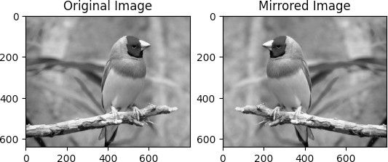

**Task-12:** Take a grayscale image and generate the flipped image of the original image. Show input and output image side by side in a subplot with a title.

# Code:

import cv2

img = cv2.imread("photo.jpg")

array = np.flip(array, 0)#vertical array = np.flip(array, 1)#horizontal

img_gray=cv2.cvtColor(img,cv2.COLOR_BGR2GRAY) height=img_gray.shape[0]#no of rows width=img_gray.shape[1]#no of colums img_flip=np.zeros((height,width))

#step-4: flip img_gray on y-axis for i in range(height):

for j in range(width): img_flip[i][j]=img_gray[i][width-j-1]

img_gray=cv2.cvtColor(img,cv2.COLOR_BGR2GRAY) #flip the image

img_flip=np.flip(img_gray,0) #show the image in subplot plt.subplot(1,2,1) plt.imshow(img_gray,cmap='gray') plt.title('Original Image') plt.subplot(1,2,2) plt.imshow(img_flip,cmap='gray') plt.title('Flipped Image') **Input/Output:**

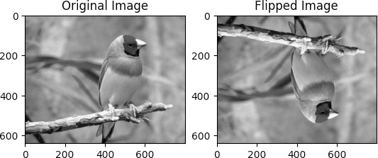

**Task-13:** Take an 8-bit grayscale image and apply Thresholding such that the pixel having intensity values below 150 will be replaced by 0 and pixels having intensity value equal or above 150 will be replaced by 255. Display input and output image side by side in a subplot with a title.

# Code:

import cv2

import numpy as np

array = np.array([[9,5,6,7,2],[1,1,0,1,2],[50,21,25,99,100],[1 50,255,250,130,200],[145,135,139,190,180]])

temp = array.copy() #thresholding the array

for i in range(array.shape[0]):

for j in range(array.shape[1]): if array[i][j] < 150:

array[i][j] = 0 else:

array[i][j] = 255

print(temp) print(array) **Input/Output:**

[[ 9 5 6 7 2]

[ 1 1 0 1 2]

[ 50 21 25 99 100]

[150 255 250 130 200]

[145 135 139 190 180]]

|  |  |  |  |  |  |
| --- | --- | --- | --- | --- | --- |
| [[ | 0 | 0 | 0 | 0 | 0] |
| [ | 0 | 0 | 0 | 0 | 0] |
| [ | 0 | 0 | 0 | 0 | 0] |

[255 255 255 0 255]

[ 0 0 0 255 255]]

**Task-14:** Take an 8-bit grayscale image and apply Thresholding such that the pixel having intensity values below 50 will be replaced by 0 and pixels having intensity value above 150 will be replaced by 255. Display input and output image side by side in a subplot with a title **Code:**

import cv2

import numpy as np

array = np.array([[9,5,6,7,2],[1,1,0,1,2],[50,21,25,99,100],[1 50,255,250,130,200],[145,135,139,190,180]])

temp = array.copy() #thresholding the array

for i in range(array.shape[0]):

for j in range(array.shape[1]): if array[i][j] < 50:

array[i][j] = 0 if array[i][j] > 150:

array[i][j] = 255

print(temp) print(array)

# Input/Output:

[[ 9 5 6 7 2]

[ 1 1 0 1 2]

[ 50 21 25 99 100]

[150 255 250 130 200]

[145 135 139 190 180]]

[[ 0 0 0 0 0]

[ 0 0 0 0 0]

[ 50 0 0 99 100]

[150 255 255 130 255]

[145 135 139 255 255]]

**Task-15:** Take a 5x6 NumPy array and apply negative image operations (calculate image bit dynamically). Convert the input and output NumPy array into an image and show them side by side in a subplot with a title

# Code:

import cv2

import numpy as np

import matplotlib.pyplot as plt img = cv2.imread('photo.jpg')

array = np.array([[255, 0, 1, 100, 25, 101], [10, 200, 70, 80,

120, 150], [95, 30, 30, 81, 96, 77], [87, 89, 220, 250, 100,

10], [18, 7, 221, 21, 8, 15]])

temp = array.copy() max_pixel = np.max(array)

max_pixel = (2**(np.ceil(np.log2(max_pixel))))-1 for i in range(0, 5):

for j in range(0, 6):

array[i][j] = max_pixel-array[i][j] plt.figure(figsize=(10, 10))

plt.subplot(1, 2, 1) plt.title('Original Image') plt.imshow(temp, cmap='gray') plt.subplot(1, 2, 2) plt.imshow(array, cmap='gray') plt.title('Negative Image') **Input/Output:**

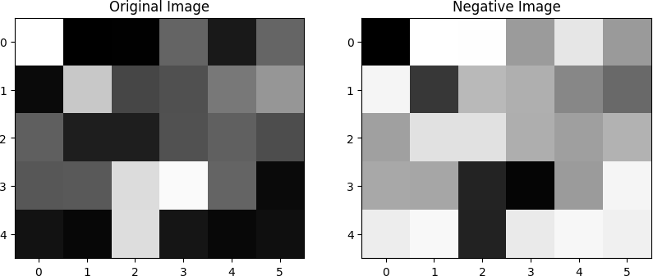

**Task-16:** Take a grayscale image and apply negative image operations (calculate image bit dynamically). Show input and output image side by side in a subplot with a title. Use PyPlot to plot the negative transformation curve (r on the x-axis and s on the y-axis).

# Code:

import cv2

import numpy as np

import matplotlib.pyplot as plt img = cv2.imread('photo.jpg')

#negative of an image

img_gray = cv2.cvtColor(img, cv2.COLOR_BGR2GRAY) temp = img_gray.copy()

max_pixel = np.max(img_gray)

max_pixel = (2**(np.ceil(np.log2(max_pixel))))-1 #L-1 = 255

height = img_gray.shape[0] width = img_gray.shape[1]

for i in range(0, height): for j in range(0, width):

img_gray[i][j] = max_pixel-img_gray[i][j]

plt.figure(figsize=(10, 10))

plt.subplot(1, 2, 1) plt.title('Original Image') plt.imshow(temp, cmap='gray') plt.subplot(1, 2, 2) plt.imshow(img_gray, cmap='gray') plt.title('Negative Image')

# Input/Output:

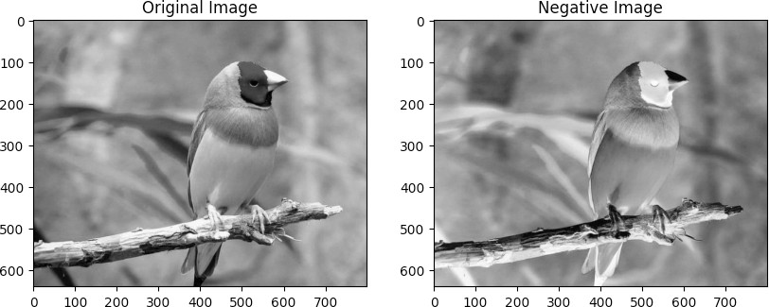

**Task-17:** Take a grayscale image and apply log transformation image operations (C = 1 and C = L/ (log10 (1+r))). Show input and output image side by side in a subplot with title. Use PyPlot to plot log transformation curve (r in x-axis and s in y-axis).

# Code:

import cv2

import numpy as np

import matplotlib.pyplot as plt img = cv2.imread('photo.jpg')

# logarithmic transformation

img_gray = cv2.cvtColor(img, cv2.COLOR_BGR2GRAY) img_gray_CL=img_gray.copy()

temp = img_gray.copy()

max_pixel = np.max(array)

L = 2**(np.ceil(np.log2(max_pixel))) C=L/np.log(1+L)

height = img_gray.shape[0] width = img_gray.shape[1]

for i in range(0, height): for j in range(0, width):

img_gray[i][j] = np.log(1+img_gray[i][j]) img_gray_CL[i][j]=C*img_gray[i][j]

plt.figure(figsize=(10, 10))

plt.subplot(1, 3, 1) plt.imshow(temp, cmap='gray') plt.title('Original image') plt.subplot(1, 3, 2) plt.imshow(img_gray, cmap='gray') plt.title('Logarithmic C=1') plt.subplot(1, 3, 3) plt.imshow(img_gray_CL, cmap='gray')

plt.title('Logarithmic C=L/log(1+L)') # plot logarithmic plotting

img_gray = cv2.cvtColor(img, cv2.COLOR_BGR2GRAY) height = img_gray.shape[0]

width = img_gray.shape[1] r = np.unique(img_gray) s1 = np.zeros(len(r))

s2 = np.zeros(len(r))

for i in range(0, len(r)): s1[i] = np.log(1+r[i]) s2[i] = C*s1[i]

plt.figure(figsize=(10, 10))

plt.subplot(1, 2, 1) plt.plot(r, s1) plt.title('Logarithmic C=1') plt.subplot(1, 2, 2) plt.plot(r, s2)

plt.title('Logarithmic C=L/log(1+L)')

# Input/Output:

**Task-18:** Take a grayscale image and apply gamma transformation image operations (γ = 0.2, γ = 0.4, γ = 0.6, γ= 1.0, γ = 1.5, γ = 2.5, γ = 5.0). Show input and output image side by side in a subplot with a title. Use PyPlot to plot the gamma transformation curve for each γ value individually (r on the x-axis and s on the y-axis).

# Code:

import cv2

import numpy as np

import matplotlib.pyplot as plt img = cv2.imread('photo.jpg')

img_gray= cv2.cvtColor(img, cv2.COLOR_BGR2GRAY) img_gray_20 = img_gray.copy()

img_gray_40 = img_gray.copy() img_gray_60 = img_gray.copy() img_gray15 = img_gray.copy() img_gray25 = img_gray.copy() img_gray50 = img_gray.copy()

height = img_gray.shape[0]

width = img_gray.shape[1]

for i in range(0, height): for j in range(0, width):

img_gray_20[i][j] = np.power(img_gray[i][j], 0.20) img_gray_40[i][j] = np.power(img_gray[i][j], 0.40) img_gray_60[i][j] = np.power(img_gray[i][j], 0.60) img_gray15[i][j] = np.power(img_gray[i][j], 1.5) img_gray25[i][j] = np.power(img_gray[i][j], 2.5) img_gray50[i][j] = np.power(img_gray[i][j], 5)

plt.figure(figsize=(10, 10))

plt.subplot(3, 3, 1) plt.imshow(img_gray_20, cmap='gray') plt.title('Gamma = 0.20')

plt.subplot(3, 3, 2) plt.imshow(img_gray_40, cmap='gray') plt.title('Gamma = 0.40')

plt.subplot(3, 3, 3) plt.imshow(img_gray_60, cmap='gray') plt.title('Gamma = 0.60')

plt.subplot(3, 3, 4) plt.imshow(img_gray, cmap='gray') plt.title('Original Image Gamma = 1') plt.subplot(3, 3, 5) plt.imshow(img_gray15, cmap='gray') plt.title('Gamma = 1.5')

plt.subplot(3, 3, 6) plt.imshow(img_gray25, cmap='gray') plt.title('Gamma = 2.5')

plt.subplot(3, 3, 7) plt.imshow(img_gray50, cmap='gray') plt.title('Gamma = 5')

# plot power-law plotting

img_gray = cv2.cvtColor(img, cv2.COLOR_BGR2GRAY) r = np.unique(img_gray)

s= np.zeros(len(r)) s_20 = np.zeros(len(r)) s_40 = np.zeros(len(r)) s_60 = np.zeros(len(r)) s_15 = np.zeros(len(r)) s_25 = np.zeros(len(r)) s_50 = np.zeros(len(r))

for i in range(0, len(r)): s[i] = np.power(r[i], 1)

s_20[i] = np.power(r[i], 0.20)

s_40[i] = np.power(r[i], 0.40)

s_60[i] = np.power(r[i], 0.60)

s_15[i] = np.power(r[i], 1.5)

s_25[i] = np.power(r[i], 2.5)

s_50[i] = np.power(r[i], 5)

plt.figure(figsize=(10, 10))

plt.subplot(3, 3, 1) plt.plot(r, s_20) plt.title('Gamma = 0.20')

plt.subplot(3, 3, 2) plt.plot(r, s_40) plt.title('Gamma = 0.40')

plt.subplot(3, 3, 3) plt.plot(r, s_60) plt.title('Gamma = 0.60')

plt.subplot(3, 3, 4) plt.plot(r, s)

plt.title('Original Image Gamma = 1') plt.subplot(3, 3, 5)

plt.plot(r, s_15) plt.title('Gamma = 1.5')

plt.subplot(3, 3, 6) plt.plot(r, s_25) plt.title('Gamma = 2.5')

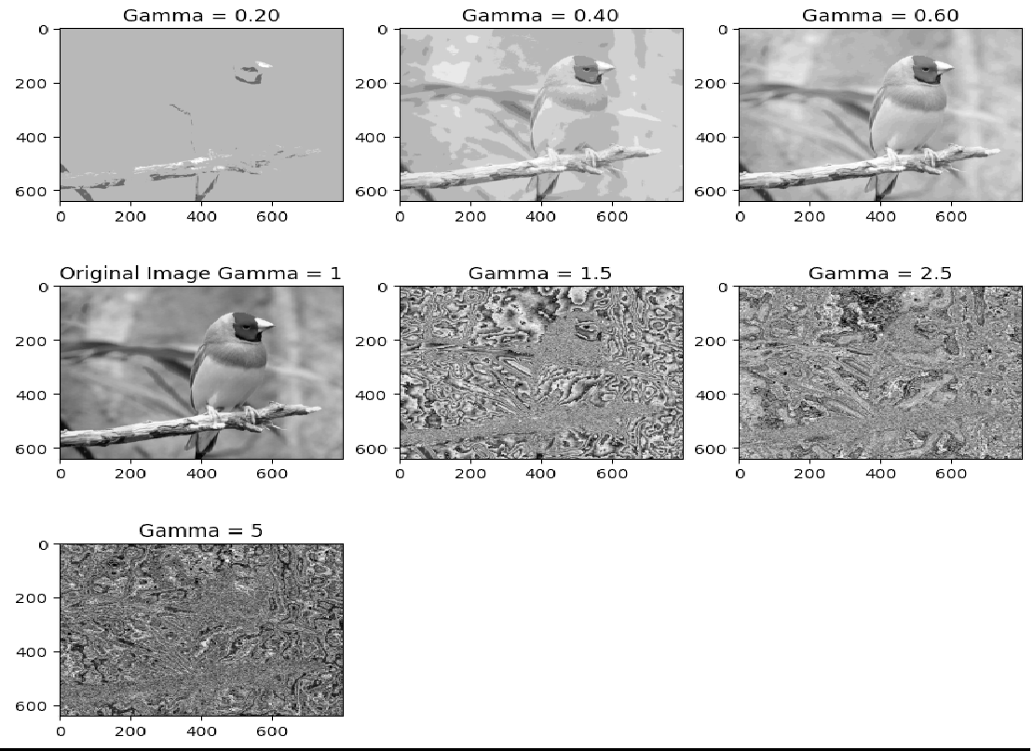plt.subplot(3, 3, 7) plt.plot(r, s_50) plt.title('Gamma = 5') **Input/Output:**

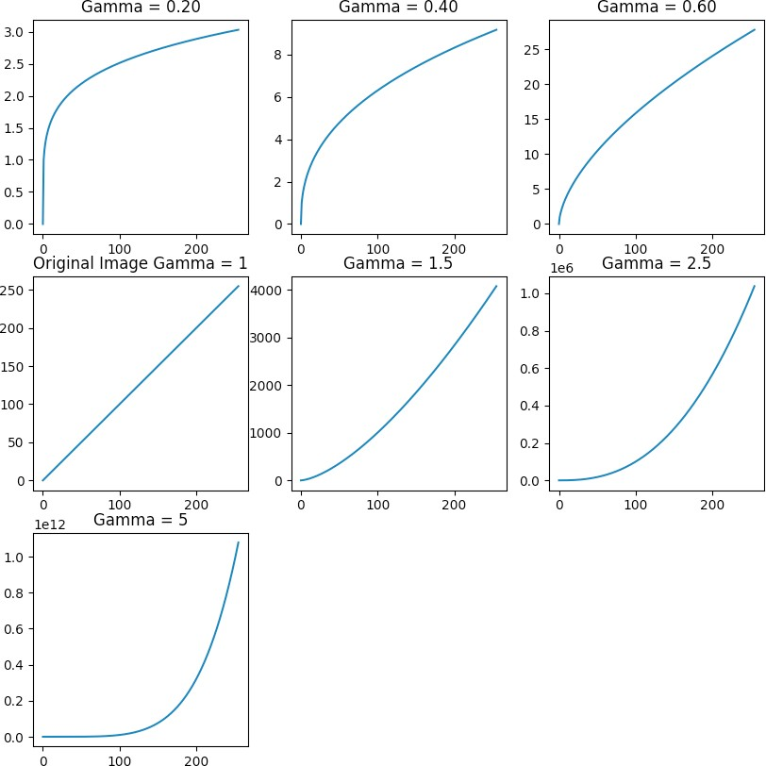

**Task-19:** Take a 5x6 NumPy array and plot the histogram of the array with proper labels (with and without built in histogram function). Show both histograms side by side in a subplot with a title. Show both input and output NumPy array into an image and show them side by side in a subplot with a title.

# Code:

import cv2

import numpy as np

import matplotlib.pyplot as plt img = cv2.imread('photo.jpg')

array = np.array([[255, 0, 1, 100, 25, 101], [10, 200, 70, 80,

120, 150], [95, 30, 30, 81, 96, 77], [87, 89, 220, 250, 100,

10], [18, 7, 221, 21, 8, 15]])

hist = np.zeros(256)

for i in range(array.shape[0]):

for j in range(array.shape[1]): hist[array[i, j]] += 1

hist2, bins = np.histogram(array, 256, [0, 256]) plt.figure(figsize=(15,5))

plt.subplot(1,3,1) plt.plot(hist) plt.title('Histogram') plt.subplot(1,3,2)

plt.plot(hist2)

plt.title('Histogram with built-in function') plt.subplot(1,3,3)

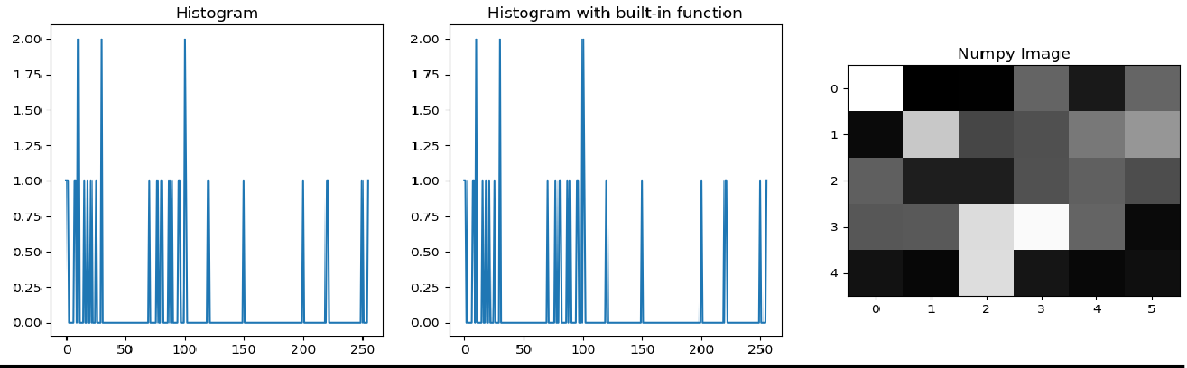plt.imshow(array, cmap='gray') plt.title('Numpy Image') **Input/Output:**

**Task-20:** Take an 8-bit grayscale image and plot the histogram of the image with proper labels (with and without built in histogram function). Show both histograms side by side in a subplot with a title.

# Code:

import cv2

import numpy as np

import matplotlib.pyplot as plt img = cv2.imread('photo.jpg')

array = np.array([[255, 0, 1, 100, 25, 101], [10, 200, 70, 80,

120, 150], [

95, 30, 30, 81, 96, 77], [87, 89, 220, 250, 1

00, 10], [18, 7, 221, 21, 8, 15]])

hist = np.zeros(256)

for i in range(array.shape[0]):

for j in range(array.shape[1]): hist[array[i, j]] += 1

hist2, bins = np.histogram(array, 256, [0, 256]) img_gray = cv2.cvtColor(img, cv2.COLOR_BGR2GRAY) hist = np.zeros(256)

for i in range(img_gray.shape[0]):

for j in range(img_gray.shape[1]): hist[img_gray[i, j]] += 1

hist2, bins = np.histogram(img_gray, 256, [0, 256]) plt.figure(figsize=(10,5))

plt.subplot(1,2,1) plt.bar(range(256), hist)

plt.title('Histogram') plt.subplot(1,2,2) plt.bar(range(256), hist2)

plt.title('Histogram with built-in function')

# Input/Output:

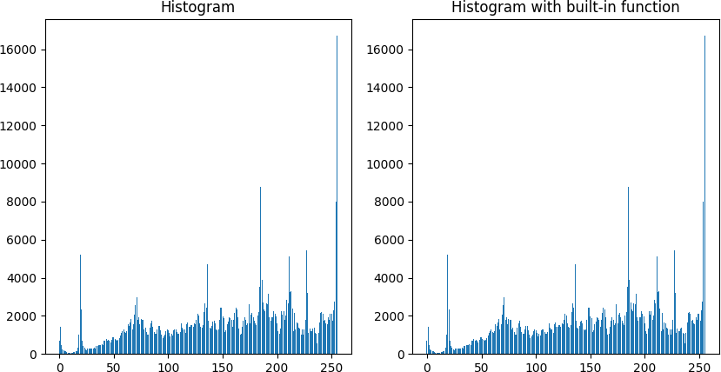

**Task-21:** Take an 8-bit grayscale image and plot the histogram equalized image as well as its histogram with proper labels (with and without built in histogram function). Show both histograms side by side in a subplot with a title. Show both equalized image side by side in a subplot with a title.

# Code:

import cv2

import numpy as np

import matplotlib.pyplot as plt img = cv2.imread('photo.jpg')

img_gray = cv2.cvtColor(img, cv2.COLOR_BGR2GRAY) hist = np.zeros(256)

for i in range(img_gray.shape[0]):

for j in range(img_gray.shape[1]): hist[img_gray[i, j]] += 1

# Histogram equalization cdf = np.zeros(256) cdf[0] = hist[0]

for i in range(1, 256):

cdf[i] = cdf[i-1] + hist[i] cdf = cdf * 255 / cdf[255]

img_eq = np.zeros(img_gray.shape) for i in range(img_gray.shape[0]):

for j in range(img_gray.shape[1]): img_eq[i, j] = cdf[img_gray[i, j]]

#histogram of the equalized image hist1 = np.zeros(256)

for i in range(img_eq.shape[0]):

for j in range(img_eq.shape[1]): pixel = round(img_eq[i, j]) hist1[pixel] += 1

plt.figure(figsize=(10,10)) plt.subplot(2,2,1) plt.imshow(img_gray, cmap='gray') plt.title('Original Image') plt.subplot(2,2,2) plt.imshow(img_eq, cmap='gray') plt.title('Equalized Image') plt.subplot(2,2,3) plt.bar(range(256), hist)

plt.title('Histogram of Original Image') plt.subplot(2,2,4)

plt.bar(range(256), hist1) plt.title('Histogram of Equalized Image')

# Input/Output:

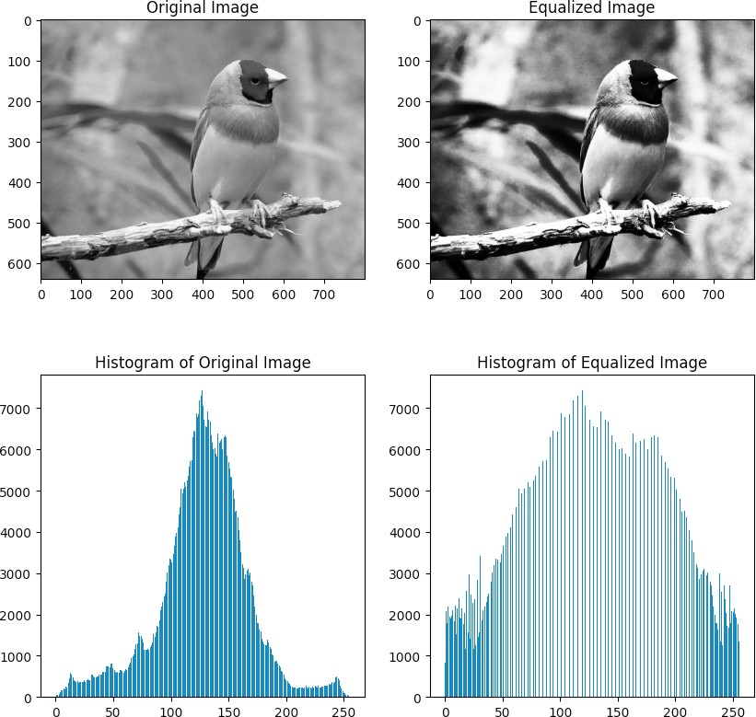

**Task-22:** Take a 6x6 NumPy array apply convolution operation of the array. Use zero padding and consider a 3x3 mask/kernel for convolution (with and without built in function). Show both input and output array. Show both input and output NumPy array into an image and show them side by side in a subplot with a title.

# Code:

arr = np.array([[255, 0, 1, 100, 25, 101], [10, 200, 70, 80, 1

20, 150], [95, 30, 30, 81, 96, 77], [87, 89, 220, 250, 100, 10

], [18, 7, 221, 21, 8, 15],[10,40,33,227,189,3]],np.uint8)

temp = np.array([[255, 0, 1, 100, 25, 101], [10, 200, 70, 80,

120, 150], [95, 30, 30, 81, 96, 77], [87, 89, 220, 250, 100, 1

0], [18, 7, 221, 21, 8, 15],[10,40,33,227,189,3]],np.uint8)

#use zero padding on array

arr = np.pad(arr, 1, 'constant', constant_values=0)

#use 3x3 gaussian filter manually

filter = np.array([[1, 2, 1], [2, 4, 2], [1, 2, 1]])/16 ans=arr.copy()

for i in range(1, arr.shape[0]-1):

for j in range(1, arr.shape[1]-1):

ans[i, j] = round(np.sum(arr[i-1:i+2, j- 1:j+2]*filter))

#remove zero padding

ans = ans[1:ans.shape[0]-1, 1:ans.shape[1]-1] print(ans)

print()

#using built-in function

conv2 = cv2.filter2D(arr, -1, filter) #remove zero padding conv2

conv2 = conv2[1:conv2.shape[0]-1, 1:conv2.shape[1]-1] print(conv2)

plt.figure(figsize=(10,10)) plt.subplot(1,3,1) plt.imshow(temp, cmap='gray') plt.title('Original Image') plt.subplot(1,3,2) plt.imshow(ans, cmap='gray')

plt.title('Image after convolution') plt.subplot(1,3,3)

plt.imshow(conv2, cmap='gray')

plt.title('Image after convolution with built-in function')

# Input/Output:

|  |  |  |
| --- | --- | --- |
| [[ 78 | 62 | 39 50 61 55] |
| [ 73 | 88 | 70 76 96 82] |
| [ 58 | 83 | 96 109 102 65] |
| [ 49 | 88 | 137 137 83 33] |
| [ 26 | 70 | 128 127 73 24] |
| [ 10 | 31 | 71 101 79 27]] |

|  |  |  |
| --- | --- | --- |
| [[ 78 | 62 | 39 50 61 55] |
| [ 73 | 88 | 70 76 96 82] |
| [ 58 | 83 | 96 109 102 65] |
| [ 49 | 88 | 137 137 83 33] |
| [ 26 | 70 | 128 127 73 24] |
| [ 10 | 31 | 71 101 79 27]] |

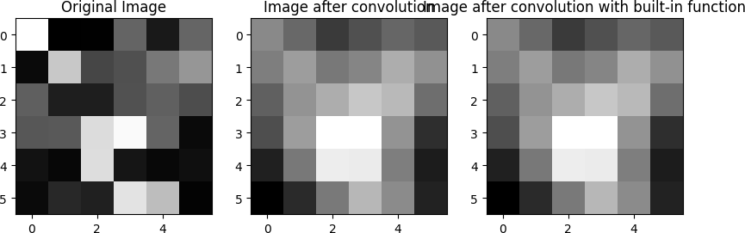

**Task-23:** Take an 8-bit grayscale image and apply smoothing operation by using mean filter (with and without built in image smoothing function). Show both input and output image side by side in a subplot with a title.

# Code:

import cv2

import numpy as np

import matplotlib.pyplot as plt img = cv2.imread('photo.jpg')

img_gray = cv2.cvtColor(img, cv2.COLOR_BGR2GRAY)

#apply mean filter with 3x3 kernel size manually filter = np.ones((3,3))/9

ans = img_gray.copy() #use zero padding on ans

ans = np.pad(ans, 1, 'constant', constant_values=0) for i in range(1, ans.shape[0]-1):

for j in range(1, ans.shape[1]-1):

ans[i, j] = round(np.sum(ans[i-1:i+2, j- 1:j+2]*filter))

#remove zero padding

ans = ans[1:ans.shape[0]-1, 1:ans.shape[1]-1]

#apply mean filter with 3x3 kernel size with built-in function

plt.title('Original Image') plt.subplot(1,3,2) plt.imshow(ans, cmap='gray') plt.title('Mean filter manually') plt.subplot(1,3,3) plt.imshow(conv2, cmap='gray') plt.title('Mean filter built-in') **Input/Output:**

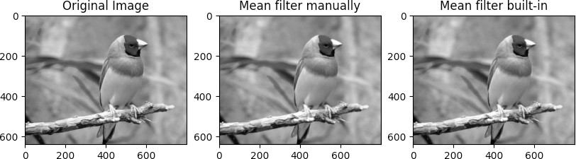

**Task-24:** Take an 8-bit grayscale image and apply smoothing operation by using weighted averaging filter (with and without built in image smoothing function). Show both input and output image side by side in a subplot with a title.

# Code:

import cv2

import numpy as np

import matplotlib.pyplot as plt img = cv2.imread('photo.jpg')

img_gray = cv2.cvtColor(img, cv2.COLOR_BGR2GRAY)

#apply weighted average filter with 3x3 kernel size manually filter = np.array([[1, 2, 1], [2, 4, 2], [1, 2, 1]])/16

ans = img_gray.copy() #use zero padding on ans

ans = np.pad(ans, 1, 'constant', constant_values=0) for i in range(1, ans.shape[0]-1):

for j in range(1, ans.shape[1]-1):

ans[i, j] = round(np.sum(ans[i-1:i+2, j- 1:j+2]*filter))

#remove zero padding

ans = ans[1:ans.shape[0]-1, 1:ans.shape[1]-1]

#apply weighted average filter with 3x3 kernel size with built

-in function

plt.title('Original Image') plt.subplot(1,3,2) plt.imshow(ans, cmap='gray')

plt.title('Weighted average filter manually') plt.subplot(1,3,3)

plt.imshow(conv2, cmap='gray') plt.title('Weighted average filter built-in') **Input/Output:**

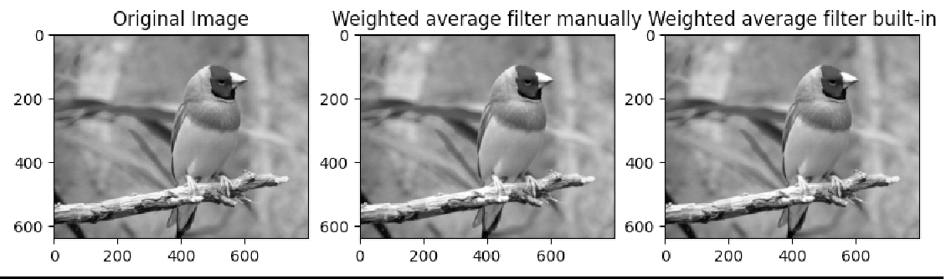

**Task-25:** Take an 8-bit grayscale image and apply smoothing operation by using gaussian filter (with and without built in image smoothing function). Show both input and output image side by side in a subplot with a title.

# Code:

import cv2

import numpy as np

import matplotlib.pyplot as plt img = cv2.imread('photo.jpg')

img_gray = cv2.cvtColor(img, cv2.COLOR_BGR2GRAY)

#apply gaussian filter filter with 3x3 kernel size manually filter = np.array([[1, 2, 1], [2, 4, 2], [1, 2, 1]])/16

ans = img_gray.copy() #use zero padding on ans

ans = np.pad(ans, 1, 'constant', constant_values=0) for i in range(1, ans.shape[0]-1):

for j in range(1, ans.shape[1]-1):

ans[i, j] = round(np.sum(ans[i-1:i+2, j- 1:j+2]*filter))

#remove zero padding

ans = ans[1:ans.shape[0]-1, 1:ans.shape[1]-1]

#apply gaussian filter filter with 3x3 kernel size with built- in function

conv2 = cv2.filter2D(img_gray, -1, filter)

plt.figure(figsize=(10,10)) plt.subplot(1,3,1) plt.imshow(img_gray, cmap='gray') plt.title('Original Image')

plt.subplot(1,3,2) plt.imshow(ans, cmap='gray')

plt.title('Gaussian filter filter manually') plt.subplot(1,3,3)

plt.imshow(conv2, cmap='gray') plt.title('Gaussian filter filter built-in') **Input/Output:**

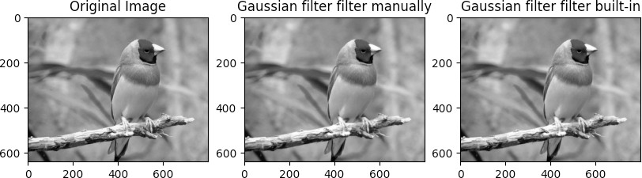

**Task-26:** Take an 8-bit grayscale image and apply sharpening operation by using laplacian filter (with and without built in image sharpening function). Show both input and output image side by side in a subplot with a title.

# Code:

import cv2

import numpy as np

import matplotlib.pyplot as plt

# Load the input image

img = cv2.imread('photo.jpg', cv2.IMREAD_GRAYSCALE)

# Define the composite Laplacian filter

filter = np.array([[0, -1, 0], [-1, 4, -1], [0, -1, 0]])

# Apply the composite Laplacian filter manually ans = img.copy()

ans = np.pad(ans, 1, 'constant', constant_values=0) for i in range(1, ans.shape[0]-1):

for j in range(1, ans.shape[1]-1):

ans[i, j] = np.clip(round(np.sum(ans[i-1:i+2, j- 1:j+2]*filter)), 0, 255)

ans = ans[1:ans.shape[0]-1, 1:ans.shape[1]-1]

# Apply the composite Laplacian filter using built-in function img =np.pad(img, 1, 'constant', constant_values=0)

conv2 = cv2.filter2D(img, -1, filter)

img = img[1:img.shape[0]-1, 1:img.shape[1]-1]

# Display the input and output images side by side plt.figure(figsize=(15,10))

plt.subplot(1,3,1) plt.imshow(img, cmap='gray') plt.title('Input Image') plt.subplot(1,3,2) plt.imshow(ans, cmap='gray')

plt.title('Sharpened Image (Manual)') plt.subplot(1,3,3)

plt.imshow(conv2, cmap='gray') plt.title('Sharpened Image (Built-in)') plt.show()

# Input/Output:

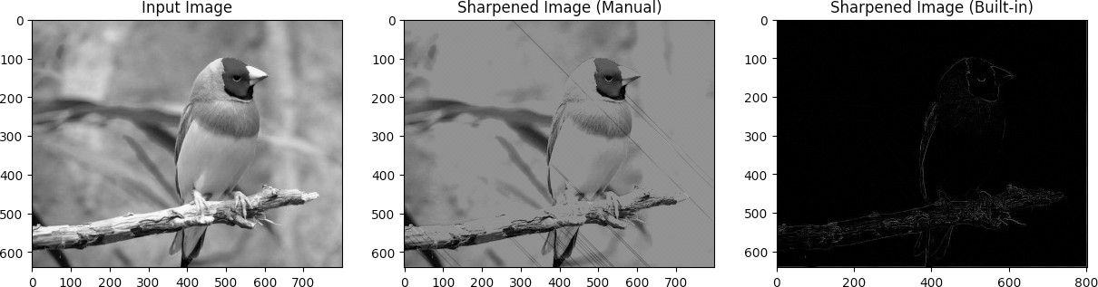

**Task-27:** Take an 8-bit grayscale image and apply sharpening operation by using composite laplacian filter (with and without built in image sharpening function). Show both input and output image side by side in a subplot with a title.

# Code:

import cv2

import numpy as np

import matplotlib.pyplot as plt # Load the input image

img = cv2.imread('photo.jpg', cv2.IMREAD_GRAYSCALE) # Define the composite Laplacian filter

filter = np.array([[0, -1, 0], [-1, 5, -1], [0, -1, 0]])

# Apply the composite Laplacian filter manually ans = img.copy()

ans = np.pad(ans, 1, 'constant', constant_values=0) for i in range(1, ans.shape[0]-1):

for j in range(1, ans.shape[1]-1):

ans[i, j] = np.clip(round(np.sum(ans[i-1:i+2, j- 1:j+2]*filter)), 0, 255)

ans = ans[1:ans.shape[0]-1, 1:ans.shape[1]-1]

# Apply the composite Laplacian filter using built-in function conv2 = cv2.filter2D(img, -1, filter)

# Display the input and output images side by side plt.figure(figsize=(15,10))

plt.subplot(1,3,1) plt.imshow(img, cmap='gray') plt.title('Input Image') plt.subplot(1,3,2) plt.imshow(ans, cmap='gray')

plt.title('Sharpened Image (Manual)') plt.subplot(1,3,3)

plt.imshow(conv2, cmap='gray') plt.title('Sharpened Image (Built-in)') plt.show()

# Input/Output:

**Task-28:** Take an 8-bit grayscale image and calculate the gradient of image as well as gradient orientation and gradient magnitude.

# Code:

import cv2

import numpy as np

import matplotlib.pyplot as plt

# read the image in grayscale format

img_gray = cv2.imread('photo.jpg', cv2.IMREAD_GRAYSCALE) # calculate the x and y gradients using Sobel operator sobelx = cv2.Sobel(img_gray, cv2.CV_64F, 1, 0, ksize=3) sobely = cv2.Sobel(img_gray, cv2.CV_64F, 0, 1, ksize=3) # calculate gradient magnitude and orientation

mag, angle = cv2.cartToPolar(sobelx, sobely, angleInDegrees=Tr ue)

plt.figure(figsize=(15,10)) plt.subplot(1,3,1) plt.imshow(img_gray, cmap='gray') plt.title('Original Image') plt.subplot(1,3,2) plt.imshow(mag, cmap='gray') plt.title('Gradient Magnitude') plt.subplot(1,3,3) plt.imshow(angle, cmap='gray') plt.title('Gradient Orientation') plt.show()

# Input/Output:

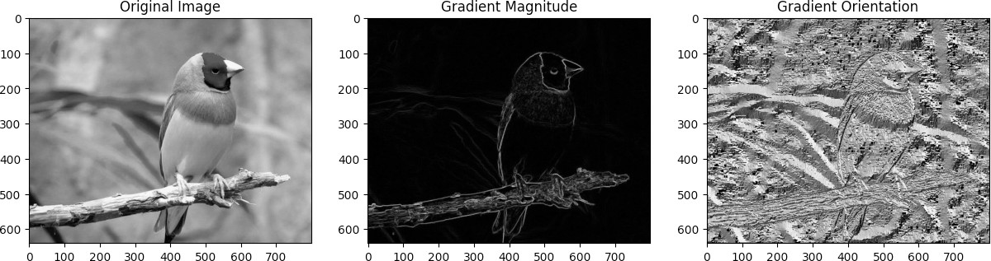

**Task-29:** Take an 8-bit grayscale image and apply edge detection by using roberts operator (with and without built in function). Show both input and output image side by side in a subplot with a title.

# Code:

import cv2

import numpy as np

import matplotlib.pyplot as plt # read the grayscale image

img = cv2.imread('photo.jpg', 0

# create the Roberts operator kernels roberts_x = np.array([[1, 0], [0, -1]])

roberts_y = np.array([[0, 1], [-1, 0]])

# apply the Roberts operator using convolution roberts_x_img = cv2.filter2D(img, -1, roberts_x) roberts_y_img = cv2.filter2D(img, -1, roberts_y)

# calculate the magnitude and orientation of the gradient gradient_magnitude = np.sqrt(np.square(roberts_x_img) + np.squ are(roberts_y_img))

gradient_orientation = np.arctan2(roberts_y_img, roberts_x_img

)

# apply the Roberts operator using built-in function roberts_img = cv2.Canny(img, 100, 200)

# plot the images side by side plt.figure(figsize=(10,10)) plt.subplot(2,2,1) plt.imshow(img, cmap='gray') plt.title('Original Image') plt.subplot(2,2,2)

plt.imshow(roberts_x_img, cmap='gray') plt.title('Roberts Operator (X)') plt.subplot(2,2,3) plt.imshow(roberts_y_img, cmap='gray') plt.title('Roberts Operator (Y)') plt.subplot(2,2,4) plt.imshow(roberts_img, cmap='gray') plt.title('Roberts Operator (Built-in)') plt.show()

# Input/Output:

**Task-30:** Take an 8-bit grayscale image and apply edge detection by using sobel operator (with and without built in function). Show both input and output image side by side in a subplot with a title.

# Code:

import cv2

import numpy as np

import matplotlib.pyplot as plt

# Read in the image in grayscale

img = cv2.imread('photo.jpg', cv2.IMREAD_GRAYSCALE) sobel = np.array([[-1,-2,-1],[0,0,0],[1,2,1]])

sobel_out = img.copy()

sobel_out = np.pad(sobel_out,((1,1),(1,1)),'constant') for i in range(sobel_out.shape[0]-2):

for j in range(sobel_out.shape[1]-2):

sobel_out[i,j] = np.sum(sobel*sobel_out[i:i+3,j:j+3]) sobel_out = sobel_out[1:-1,1:-1]

#using built in function

sobel_out2 = cv2.filter2D(img,-1,sobel)

plt.figure(figsize=(15,10)) plt.subplot(1,3,1) plt.imshow(img, cmap='gray') plt.title('Input Image') plt.subplot(1,3,2)

plt.imshow(sobel_out, cmap='gray') plt.title('Sobel Filter (Manual)') plt.subplot(1,3,3) plt.imshow(sobel_out2, cmap='gray') plt.title('Sobel Filter (Built-in)') plt.show()

# Input/Output:

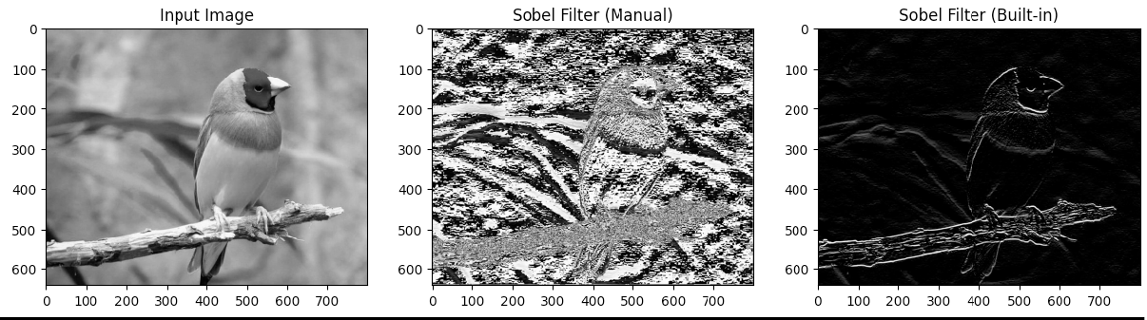

**Task-31:** Take an 8-bit grayscale image and apply edge detection by using prewitt operator (with and without built in function). Show both input and output image side by side in a subplot with a title.

# Code:

import cv2

import numpy as np

import matplotlib.pyplot as plt

# Read in the image in grayscale

img = cv2.imread('photo.jpg', cv2.IMREAD_GRAYSCALE) prewitt = np.array([[-1,-1,-1],[0,0,0],[1,1,1]])

prewitt_out = img.copy()

prewitt_out = np.pad(prewitt_out,((1,1),(1,1)),'constant') for i in range(prewitt_out.shape[0]-2):

for j in range(prewitt_out.shape[1]-2):

prewitt_out[i,j] = np.sum(prewitt*prewitt_out[i:i+3,j:

j+3])

prewitt_out = prewitt_out[1:-1,1:-1] #using built in function

prewitt_out2 = cv2.filter2D(img,-1,prewitt)

plt.figure(figsize=(15,10)) plt.subplot(1,3,1) plt.imshow(img, cmap='gray') plt.title('Input Image') plt.subplot(1,3,2)

plt.imshow(prewitt_out, cmap='gray') plt.title('Prewitt Filter (Manual)') plt.subplot(1,3,3) plt.imshow(prewitt_out2, cmap='gray') plt.title('Prewitt Filter (Built-in)') plt.show()

# Input/Output:

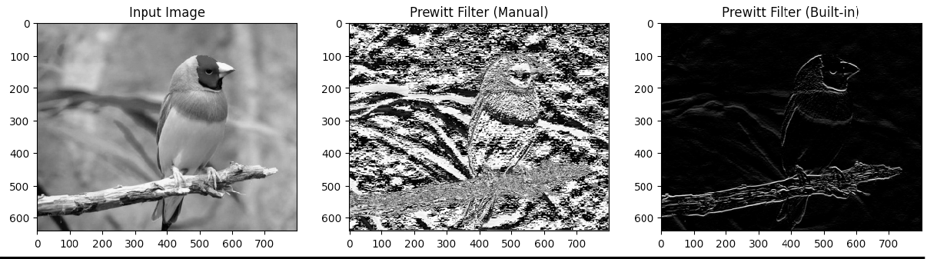

**Task-32:** Take an 8-bit grayscale image and apply sharpening operation by using unsharp masking and high boost filtering (with k = 1, 2, 3, 4). Show both input and output image side by side in a subplot with a title.

# Code:

import cv2

import numpy as np

import matplotlib.pyplot as plt # Load the grayscale image

img = cv2.imread('photo.jpg', cv2.IMREAD_GRAYSCALE) # Convert to floating-point format and normalize img = np.float32(img) / 255.0

# Apply unsharp masking

blur = cv2.GaussianBlur(img, (5, 5), 3)

sharpened = cv2.addWeighted(img, 2, blur, -1, 0) # Apply high boost filtering

k_values = [1, 2, 3, 4]

for i, k in enumerate(k_values):

# Create high pass filter mask

mask = cv2.Laplacian(img, cv2.CV_32F, ksize=3) # Add scaled mask to original image

filtered = cv2.add(img, k * mask)

# Convert back to 8-bit grayscale range filtered = np.uint8(filtered * 255.0)

# Display input and output images side by side plt.subplot(2, 4, i+1), plt.imshow(img, cmap='gray') plt.title('Input'), plt.xticks([]), plt.yticks([]) plt.subplot(2, 4, i+5), plt.imshow(filtered, cmap='gray') plt.title(f'k={k}'), plt.xticks([]), plt.yticks([])

plt.show()

# Input/Output:

**Task-33:** Using OpenCV, perform Thresholding, Global Thresholding, Adaptive Thresholding, Otsu Thresholding, Edge Detection (Sobel Edge Detection, Laplacian Edge Detection, Canny Edge Detector), and Hough Line Transformation. Show results in separate plots.

# Code:

import cv2

import numpy as np

import matplotlib.pyplot as plt img = cv2.imread('photo.jpg')

img_gray=cv2.cvtColor(img,cv2.COLOR_BGR2GRAY) # Thresholding

threshold_value=127 ret,thresh1=cv2.threshold(img_gray,threshold_value,255,cv2.THR ESH_BINARY)

#global thresholding ret1,th1=cv2.threshold(img_gray,127,255,cv2.THRESH_BINARY) #adaptive thresholding th2=cv2.adaptiveThreshold(img_gray,255,cv2.ADAPTIVE_THRESH_MEA N_C,cv2.THRESH_BINARY,11,2)

#Otsu's thresholding ret2,th2=cv2.threshold(img_gray,0,255,cv2.THRESH_BINARY+cv2.TH RESH_OTSU)

#sobel edge detection sobelx=cv2.Sobel(img_gray,cv2.CV_64F,1,0,ksize=5) sobely=cv2.Sobel(img_gray,cv2.CV_64F,0,1,ksize=5) #laplacian edge detection laplacian=cv2.Laplacian(img_gray,cv2.CV_64F) #Canny edge detection edges=cv2.Canny(img_gray,100,200)

#hougline transform minLineLength=100 maxLineGap=10

lines=cv2.HoughLinesP(edges,1,np.pi/180,100,minLineLength,maxL ineGap)

#plot all the images in single figure plt.figure(figsize=(20,20)) plt.subplot(331),plt.imshow(img_gray,cmap='gray') plt.title('Original Image'),plt.xticks([]),plt.yticks([]) plt.subplot(332),plt.imshow(thresh1,cmap='gray') plt.title('Thresholded Image'),plt.xticks([]),plt.yticks([]) plt.subplot(333),plt.imshow(th1,cmap='gray')

plt.title('Global Thresholding'),plt.xticks([]),plt.yticks([]) plt.subplot(334),plt.imshow(th2,cmap='gray') plt.title('Adaptive Mean Thresholding'),plt.xticks([]),plt.yti cks([])

plt.subplot(335),plt.imshow(th2,cmap='gray')

plt.title("Otsu's Thresholding"),plt.xticks([]),plt.yticks([]) plt.subplot(336),plt.imshow(sobelx,cmap='gray') plt.title('Sobel X'),plt.xticks([]),plt.yticks([])

plt.subplot(337),plt.imshow(sobely,cmap='gray') plt.title('Sobel Y'),plt.xticks([]),plt.yticks([]) plt.subplot(338),plt.imshow(laplacian,cmap='gray') plt.title('Laplacian'),plt.xticks([]),plt.yticks([]) plt.subplot(339),plt.imshow(edges,cmap='gray') plt.title('Canny Edge Detection'),plt.xticks([]),plt.yticks([]

)

plt.show()

#print huoghline transform for x1,y1,x2,y2 in lines[0]:

cv2.line(img,(x1,y1),(x2,y2),(0,255,0),2) plt.imshow(img,cmap='gray')

plt.show()

# Input/Output:

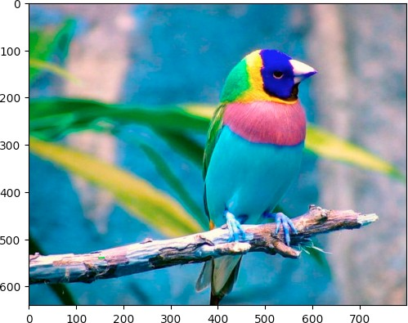

**Task-34:** Manually perform Thresholding on a gray scale image.

# Code:

from google.colab import drive drive.mount('/content/drive') import cv2

import numpy as np

import matplotlib.pyplot as plt img = cv2.imread('photo.jpg')

img_gray=cv2.cvtColor(img,cv2.COLOR_BGR2GRAY) #mannual thresholding

threshold_value=127

for i in range(img_gray.shape[0]):

for j in range(img_gray.shape[1]):

if img_gray[i,j]>threshold_value: img_gray[i,j]=255

else:

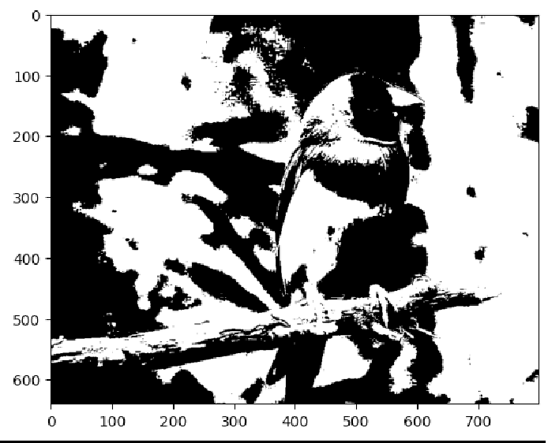img_gray[i,j]=0 plt.imshow(img_gray,cmap='gray') **Input/Output:**

**Task-35:** Manually perform Sobel Edge Detection with first-order derivative in the X-direction and the Y- direction. Show all the resultant figures in a single plot.

# Code:

import cv2

import numpy as np

import matplotlib.pyplot as plt img = cv2.imread('photo.jpg')

img_gray=cv2.cvtColor(img,cv2.COLOR_BGR2GRAY) # Get user input for kernel size

kernel_size = int(input("Enter kernel size (odd number): "))

# Check if kernel size is odd if kernel_size % 2 == 0:

kernel_size += 1

# Generate Sobel filter kernels

gx = np.zeros((kernel_size, kernel_size)) gy = np.zeros((kernel_size, kernel_size))

value = kernel_size // 2 center = value

#for gx kernel

for i in range(kernel_size):

for j in range(kernel_size):

if j == center and i != center: gx[i, j] = value*2

else:

gx[i, j] = value value -= 1

# for gy kernel

value = kernel_size // 2

for i in range(kernel_size):

for j in range(kernel_size):

if j == center and i != center: gy[j, i] = value*2

else:

gy[j, i] = value value -= 1

#apply sobel filter on image using gx and gy kernel manually img_sobelx = np.zeros(img_gray.shape)

img_sobely = np.zeros(img_gray.shape)

for i in range(img_gray.shape[0]-kernel_size):

for j in range(img_gray.shape[1]-kernel_size): img_sobelx[i, j] = np.sum(img_gray[i:i+kernel_size, j:

j+kernel_size] * gx)

img_sobely[i, j] = np.sum(img_gray[i:i+kernel_size, j: j+kernel_size] * gy)

#plot all the images in single figure plt.figure(figsize=(20,20)) plt.subplot(131),plt.imshow(img_gray,cmap='gray') plt.title('Original Image'),plt.xticks([]),plt.yticks([]) plt.subplot(132),plt.imshow(img_sobelx,cmap='gray') plt.title('Sobel X'),plt.xticks([]),plt.yticks([]) plt.subplot(133),plt.imshow(img_sobely,cmap='gray') plt.title('Sobel Y'),plt.xticks([]),plt.yticks([]) plt.show()

# Input/Output:

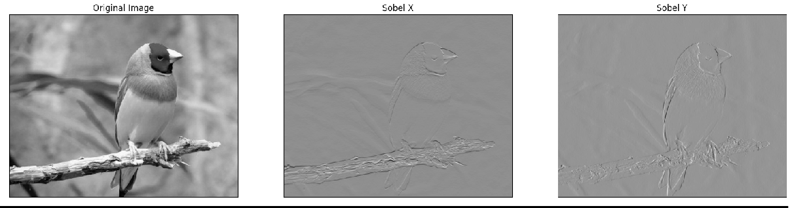Enter kernel size (odd number): 3