*Knowledge & Technology*

**Bangladesh Army University of Engineering & Technology (BAUET)**

**Qadirabad, Natore-6431**



**Course Code:** CSE-2218

**Course Title:** Advanced Programming Sessional

**Name of the Title:** E-Tailor

## Submitted by:

Md. Arik Rayhan ID: 20104033

|  |  |
| --- | --- |
| **Submitted to:** | |
| Md. Muktar Hossain | Sr. Lecturer, Dept. of CSE, BAUET |
| Md. Harun Or Rashid | Lecturer, Dept. of CSE, BAUET |

|  |  |  |
| --- | --- | --- |
| **List of Contents** | | |
| **Chapter** | **Title** | **Page No.** |
| **1** | **Introduction** | 1-2 |
|  | 1.1 Introduction | 1 |
|  | 1.2 Objectives | 1 |
|  | 1.3 Background | 2 |
|  | 1.4 Conclusion | 2 |
| **2** | **Literature Review** | 3 |
|  | 2.1 Introduction | 3 |
|  | 2.2 Analysis | 3 |
|  | 2.3 Conclusion | 3 |
| **3** | **Methodology** | 4-6 |
|  | 3.1 Introduction | 4 |
|  | 3.2 Algorithm  3.3 Flowchart  3.4 Use-case Diagram | 4  4  5 |
|  | 3.5 Conclusion | 6 |
| **4** | **Results and Discussions** | 7-17 |
|  | 4.1 Introduction | 7 |
|  | 4.2 Splash Screen  4.3 Login Page  4.4 Register Page  4.5 Home Page  4.6 Product Page  4.7 Order Page  4.8 Admin Page  4.9 Measurement Page | 8  9  10  11  12  13  14  15 |
|  | 4.10 Conclusion | 16 |
| **5** | **Conclusion** | 17-20 |
|  | 5.1 Introduction | 17 |
|  | 5.2 Future Scope/Work  5.3 Testing  5.4 Analysis | 17  17  18 |
|  | 5.5 Conclusion | 18 |
|  | **References** | 19 |

ii

|  |  |  |
| --- | --- | --- |
| **List of figures** | | |
| **Figure No.** | **Title** | **Page No.** |
| 3.1 | Flowchart of Proposed System | 5 |
| 3.2 | Use-case Diagram of Proposed System | 6 |
| 4.2 | Splash Screen | 8 |
| 4.3 | Login Page | 9 |
| 4.4 | Register Page | 10 |
| 4.5 | Home Page | 11 |
| 4.6 | Product Page | 12 |
| 4.7 | Order Page | 13 |
| 4.8 | Admin Page | 14 |
| 4.9 | Measurement Page | 15 |

iii

**CHAPTER 1**

**INTRODUCTION**

* 1. **INTRODUCTION**

Online tailoring management system is a system aimed to assist in management of tailoring activities within the industry. It will provide online services to customers such as measurement submission to their tailors, check whether their garments are finished and also help in proper keeping of records. This will ensure availability of right information, information safety, easy storage, access and retrieval. The study aims at building a computerized tailoring management system that would be more effective and efficient than the existing manual system

* 1. **OBJECTIVES**

The major aim of the E-tailor app is to enhance the quality of shopping. Meet the learning style or needs of people. Improve efficiency and effectiveness. Improve user accessibility and time flexibility to engage shoppers in the shopping process. The major objectives are-

• Automate the current manual tailoring system and maintain a searchable customer, product database, maintain data security and user rights.

• To enable customers to send their measurements to their tailors for their clothes to be made.

• To provide information about the cost, the fabric type, the urgency at which a customer wants the dress finished, the type of material to be used and quantity in terms of pairs needed.

• To compute the total cost depending on the selected fabric, type of material, quantity and duration and avails that information to the customer.

• To enable report generation: it is able to give a report of finished garments to the clients for collection and bookings made, administrator is able to view all the customers and their details, finished garments and all the bookings made.

• To create a data bank for easy access or retrieval of customer details, orders placed and the users who registered to the system.

* 1. **Background**

Tailoring has been known to be dominated by unlearned people. It has been seen as a profession for the drop outs in the Kenyan systems and elsewhere. Tailors use traditional manual systems to book in their clients. The clients have to travel to location of the tailor shop to get their measurement taken. These measurements are written on papers or books. This method poses a high threat in terms of security of their information i.e., can get lost, unauthorized people can easily access the information, data confidentiality and integrity not maintained.

1

No proper backups and the system are tedious. Online tailoring management system will solve all these problems and automate the tailor shops and enhance accessibility irrespective of geographical locations provided there is internet.

* 1. **CONCLUSION**

Online Tailoring management system will break the geographical barriers and bring the whole process into a quick and easy way to access tailors. It will automate the traditional tailoring system into a modern computerized system. This will enhance data retrieval, storage and security. It is also cost effective since it will cut down on travelling cost to get your measurements taken and also going to check if you clothe has been made and is ready for collection.

The clients can access their online tailors 24/7 and at any location provided they are connected to the internet. Due to the advancement in telecommunication e.g., undersea cabling, internet accessing speed is expected to double as the cost reduces. This will make this system more efficient to use and offer a competitive edge in the market.

2

**CHAPTER 2**

**Literature Review**

**2.1 INTRODUCTION**

Currently customers have to walk to the tailor shops to get their measurements taken for the tailoring of their garments. Their details are taken and kept on papers. Customers too need to move from their offices to go and check for the clothes whether there complete or not. This is time consuming and costly. Due to the manual systems in use, the whole process tends to be slow. Customers too have no prior information on cost of netting their garments.

**2.2 ANALYSIS**

The proposed online tailoring management system will eliminate all these manual interventions and increase the speed of the whole process. The system will allow customers to register online and successfully submit their measurements. The system has inbuilt validation system to validate the entered data. The customer can login to the system to check on the status of the clothes for collection. The system will show the already completed garments for clients to collect. The system also provides information about the cost of each garment the customer intends to get knit. This data will be stored in the database for further reference or audit.

**2.3 CONCLUSION**

Since there was a shift in teaching methods with the discarding of physical classes and acceptance of virtual online classes, educators needed little tweaks in their teaching style. E-learning apps have come a lot handy in their pursuit of learning the new methods of teaching.

3

**CHAPTER 3**

**METHODOLOGY**

**3.1 INTRODUCTION**

It shows how data will be collected from the users of the system. The data collection techniques to be used include: I will use this technique to collect information about how the current system operates and its processes. This involves systematically watching and recording the behaviors and characteristics of operations and processes. It gives more detailed and context related information and can adapt to events as they occur, however, the method may be time consuming. I will conduct an oral interview whereby I will interview business owners, suppliers and buyers to get a deeper insight of how the system is going to work. I prefer this method because it gives more information from various interviewees and offers greater flexibility as the opportunity to restructure questions is there, especially in case of unstructured interview. This is data I will collect from existing sources e.g., from the books, internet, journals and magazines that were collected by other researchers and analysis was done. It is from this data that I will then compare with the primary data and make a final decision and conclusion.

**3.2 PROPOSED ALGORITHM**

Here we discussed some steps of app working procedure-

* Step 1: At first user have to install our app.
* Step 2: Then users need to register and sign in our app

* Step 3: After sign in user need update his profile
* Step 4: Then the user can check cloths that are available
* Step 5: Then users can complete their order
* Step 6: The user can also change their profile information

4

**3.3 FLOW CHART**

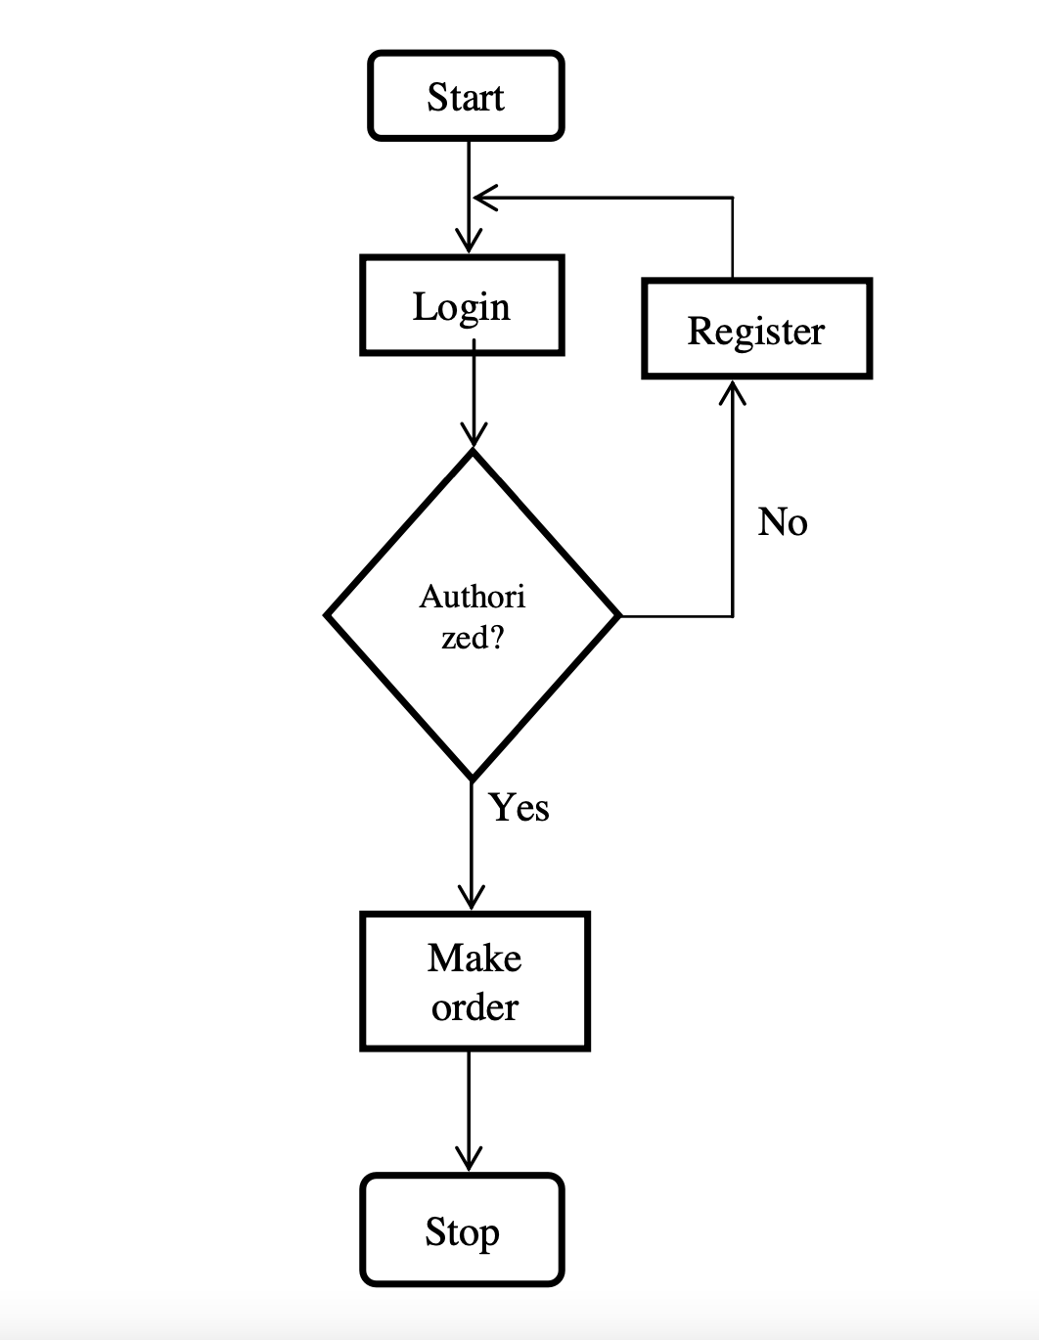

Figure 3.1: Flowchart of Proposed System

5

**3.4 USE-CASE DIAGRAM**

ADMIN

ADMIN

USER

USER

Figure 3.2: Use-case Diagram of Proposed System

**3.5 CONCLUSION**

Here in this section, we have discussed about the flowchart, algorithm and use-case Diagram of the application.

6

**CHAPTER 4**

**IMPLEMENTATION**

**4.1 INTRODUCTION**

In this section we will discuss about the result and discussion of the application, we will see how the pages in the application work and how they are designed. It is the processes of putting the proposed system in operation. Some of the Activities undertaken by the analyst are Training personnel who will use the system. There is also provision of user manual and help page for efficient use of the system. Next is to install Computer Equipment and internet to help them connect with their clients in the globe. This will facilitate the full functionality of this proposed system. Equipment should be acquired from recognized vendor. These include central processing unit (CPU), Ethernet cables, routers, output and input devices e.g., keyboard, mouse, monitor and all secondary storage devices.

7

**4.2 SPLASH SCREEN**

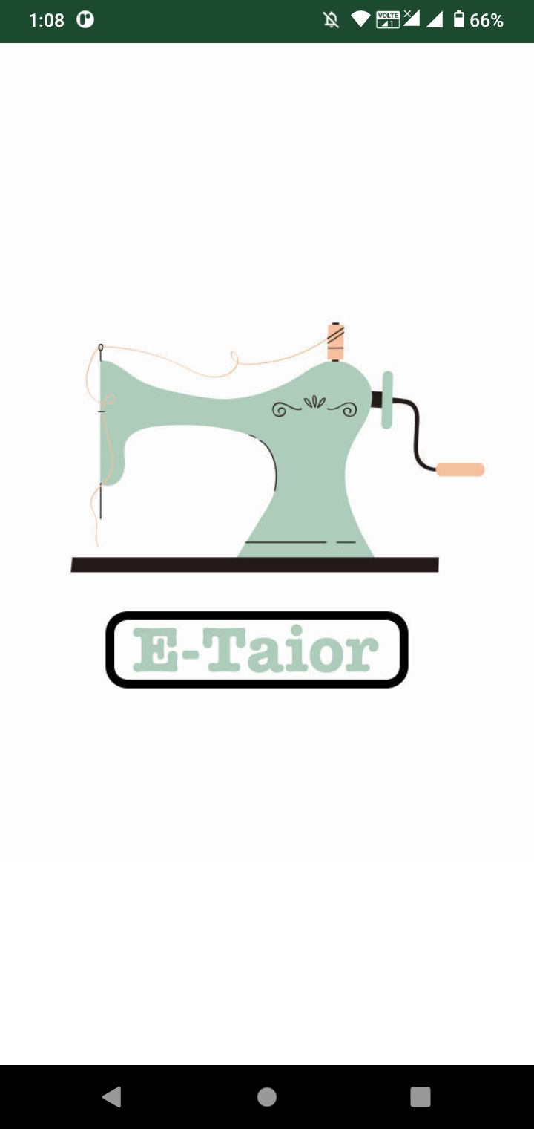

Figure 4.1: Splash Screen

8

**4.3 LOGIN PAGE**

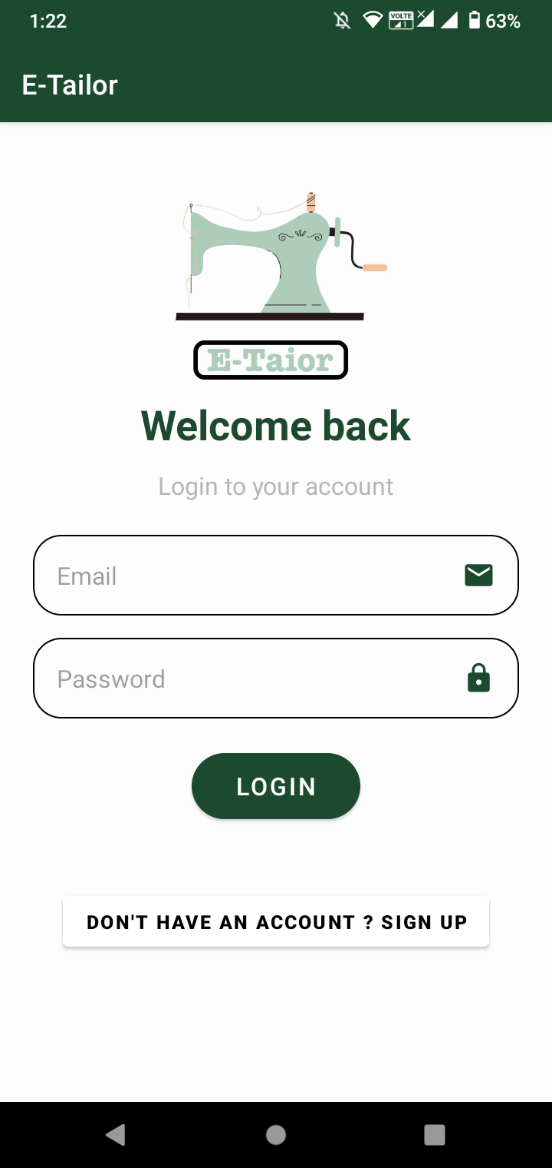

Figure 4.2: Login Page

9

**4.4 REGISTER PAGE**

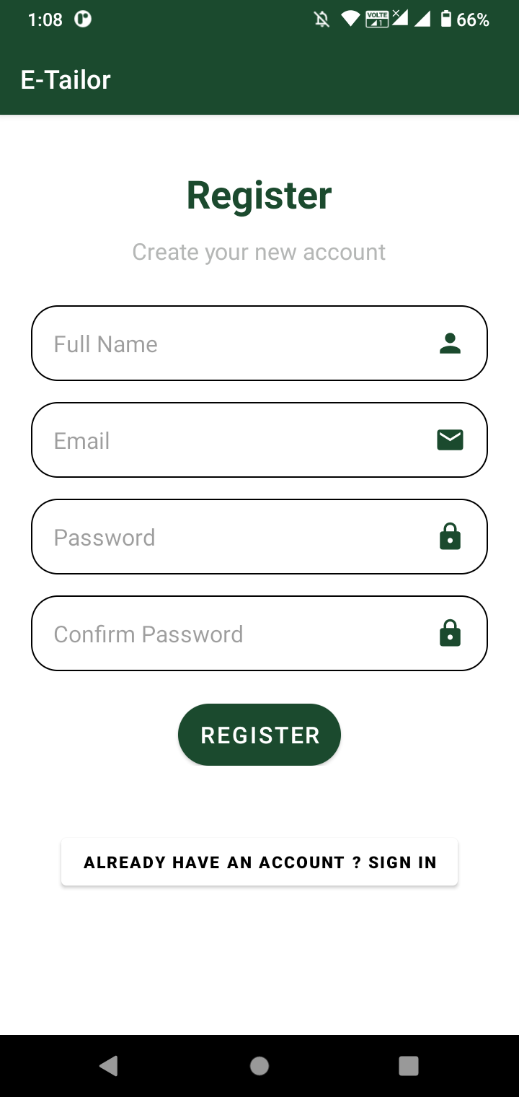

Figure 4.3: Register Page

10

**4.5 HOME PAGE**

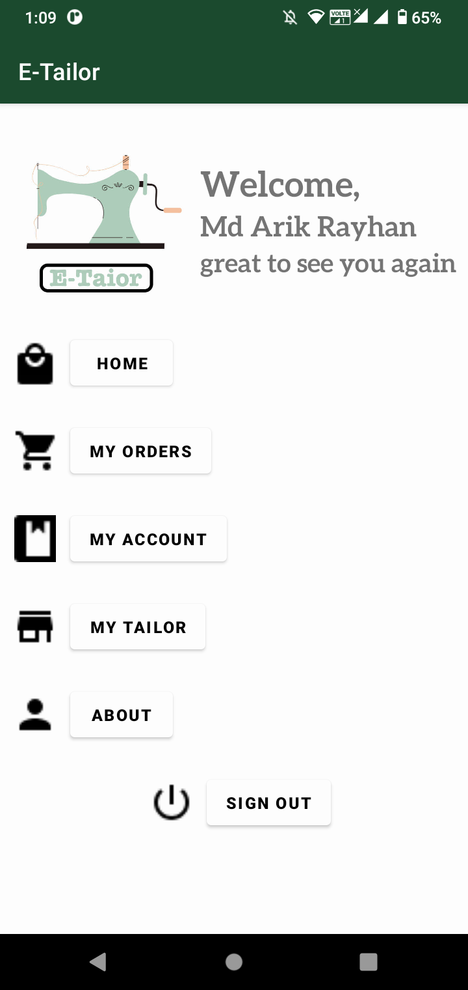

Figure 4.4: Home Page

11

**4.6 PRODUCT PAGE**

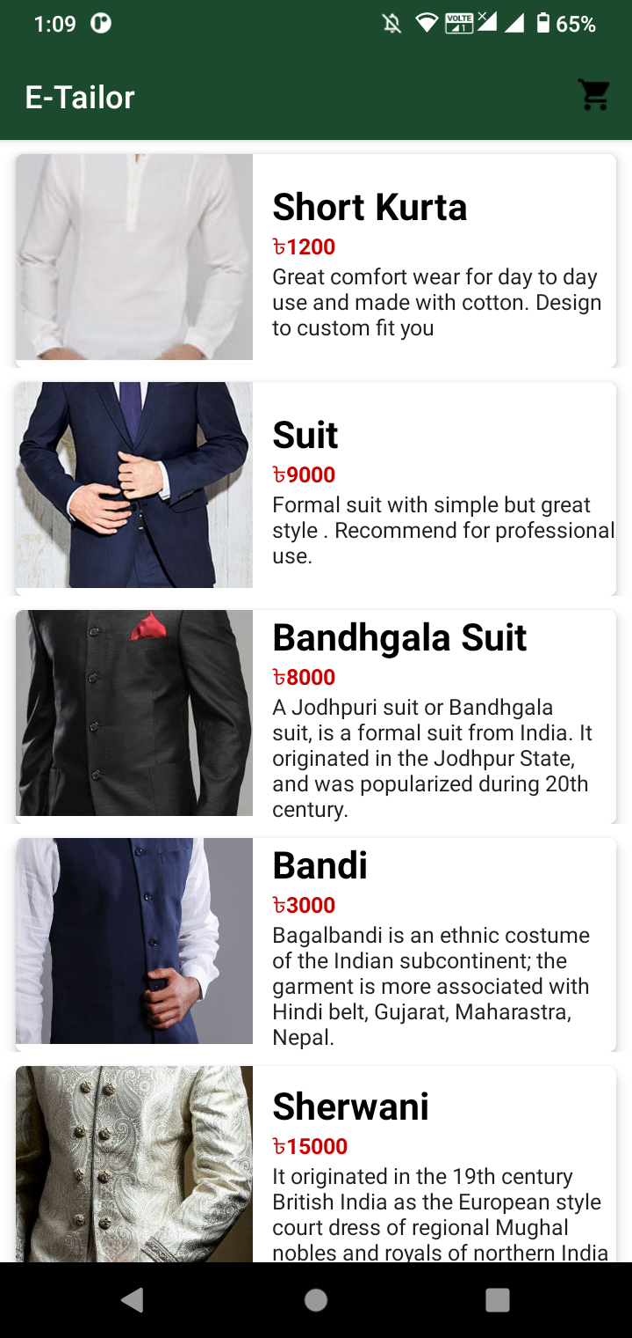

Figure 4.5: Product Page

12

**4.7 ORDER PAGE**

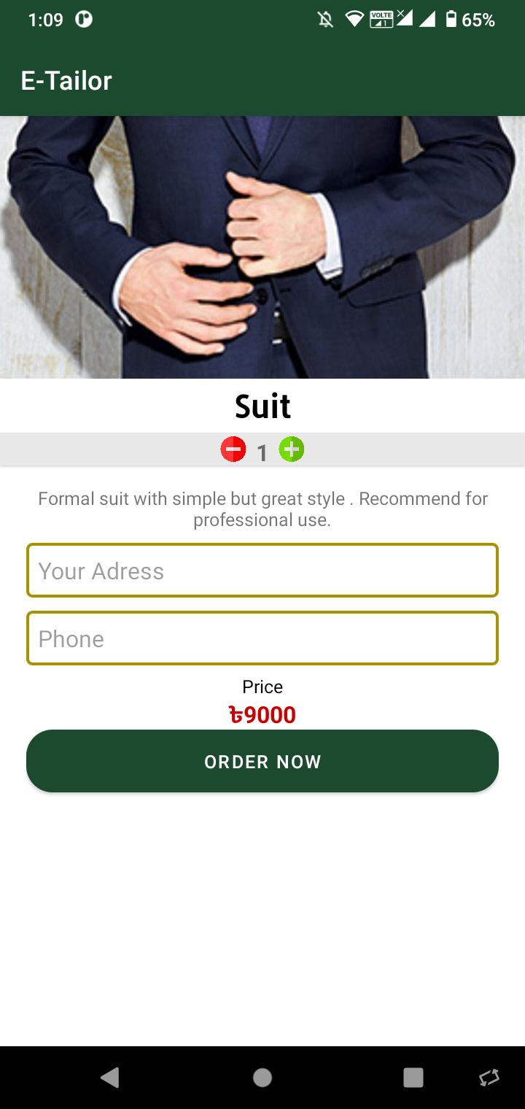

Figure 4.6: Order Page

13

**4.8 ADMIN PAGE**

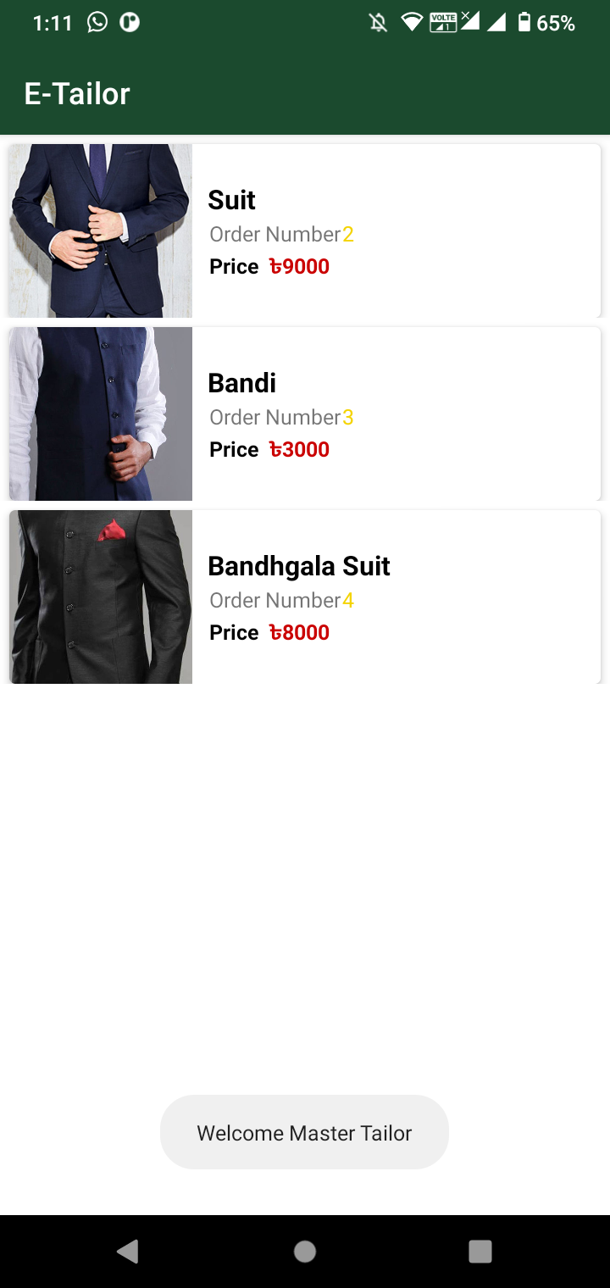

Figure 4.7: Admin Page

14

**4.9 MEASUREMENT PAGE**

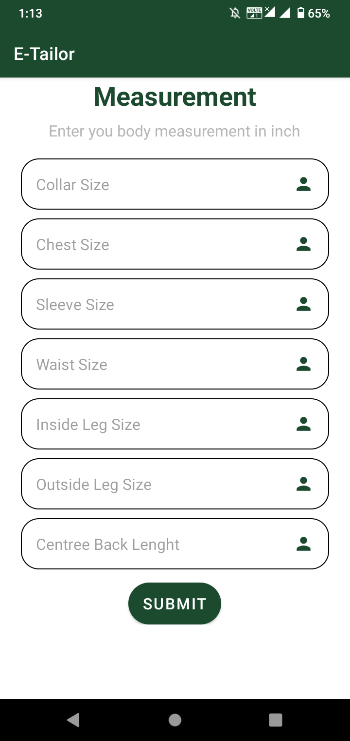

Figure 4.8: Measurement Page

15

**4.10 CONCLUSION**

Since there was a shift in shopping methods with the discarding of physical shops and acceptance of virtual online shops, sellers needed little tweaks in their business style. E-commerce apps have come a lot in handy in their pursuit of learning the new methods of teaching.

16

**CHAPTER 5**

**RESULT ANALYSIS**

**5.1 INTRODUCTION**

As discussed in the previous chapters the main problem addressed was dealing with online tailoring management. It is the above situation that drove us to techniques of developing this Online Tailoring Management System to enable users to handle details of their clothes efficiently and effectively. The project has implemented Most of the objectives stipulated in earlier chapters. The online tailoring management system offers a number of benefits to the user and can capture data, store, view, add and delete the records entered.

It also provides information to the customer about the fabrics to be used, quantity in terms of pairs, urgency and computes the total cost of knitting the garment.

**5.2 FUTURE WORK**

This app is currently in development phase. There is a lot of work to be done in the application.

Like we need to create a cross platform application. Also, we can in trigate functions like virtual reality and 3d scanning to get full body measurement of the customer.

**5.3 TESTING**

Testing is an integral part of the app development process. You can consistently run tests against your app to verify your app's correctness, functional behavior, and usability before you release it publicly. You can manually test your app by navigating through it.

Alpha testing is when a closed group takes a stab at your software. Beta testing is when a group of the general public uses an early version of your app. Both are useful in software development and serve different purposes. At first, we test our app among our team members. We create multiple accounts and test with different passwords.

Android app beta testing is a phase of the software development lifecycle where a group of external users (beta testers) test your application in real-world environments to discover errors and provide you with feedback. We apply beta testing to our classmates. This time also passed our beta test.

**5.4 ANALYSIS**

* Huge profit opportunities — taking into account the above-mentioned popularity of mobile e-commerce solutions.
* Making use of the latest technology advances — some apps for business purposes get to be popular because of incorporating modern tech. It’s a great place to introduce something revolutionary into everyday life.
* Ability to change and improve people’s lives — many startup owners dream about making an impact. Here’s an opportunity.

17

**5.5 CONCLUSION**

The core reason for the establishment of a tailoring management system is to enable the customers and administrators in a convenient, fair, and timely manner of interaction. Therefore, the IT used by whoever uses the system should support the core objective of the system if it is to remain relevant. A lot still needs to be done in the IT department in order to make available

technology effective. The Online Tailoring Management System will permit registration and delivery measurements to the tailor for the next process to follow. It also maintains clients’ information and generates various reports about the tailor shop. The main users of the project are clients and System Administrators.

It also enables customers to check the status of their garments i.e., if ready or not for collection. The system provides information about the cost, the fabric types the customer wants his/her dress knit from, the duration a customer wants the dress finished, the type of material to be used, quantity in terms of pairs needed, and most importantly, the system computes the total cost and avails that information to the customer.

However, online payment has not been achieved, but the customer is expected to pay either via mobile money transfer services like Bkash, Nagad, or cash when they come to pick up their clothes.

18

**REFERENCE**

[1] https://www.academia.edu/

[2] https://sqlite.org/

[3] https://developer.android.com/

[4] https://stackoverflow.com/

19