Experiment 1
User Interface Design
COMAPARSION OF UI DESIGN BETWEEN TWO FIGMA CREATION

Name: Mohamed Aseel S
Roll No: 240701319
Prototype link: https://www.figma.com/design/tL94vl3GULZfF4jjNFdDxB/Exp1?m=auto&t=igyD6aAAGxBQZZR0-1

Bad Website:
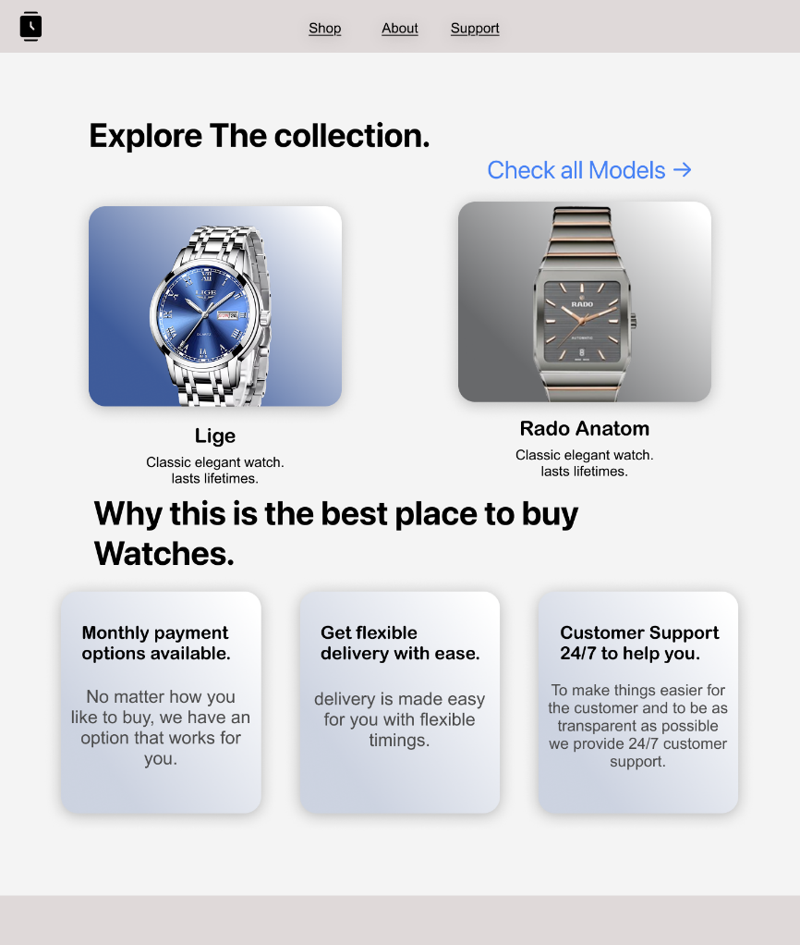

1. Design Style:
- Uses a very plain and minimal layout.
- Light background with soft cards, but lacks strong visual impact.
- Product cards look generic and similar to many basic e-commerce templates.
- Overall appearance feels simple but not premium.
2. Content:
- Displays a few watch models with short descriptions.
- Text content is minimal and does not strongly highlight brand value or luxury.
- Focuses mainly on functionality rather than storytelling.
3. Navigation:
- Simple top navigation with limited options (Shop, About, Support).
- Navigation is clear but does not stand out visually.
4. Purpose:
- Mainly focused on basic product listing and information.
- Suitable for small-scale shopping but lacks a strong brand identity.

Good website:
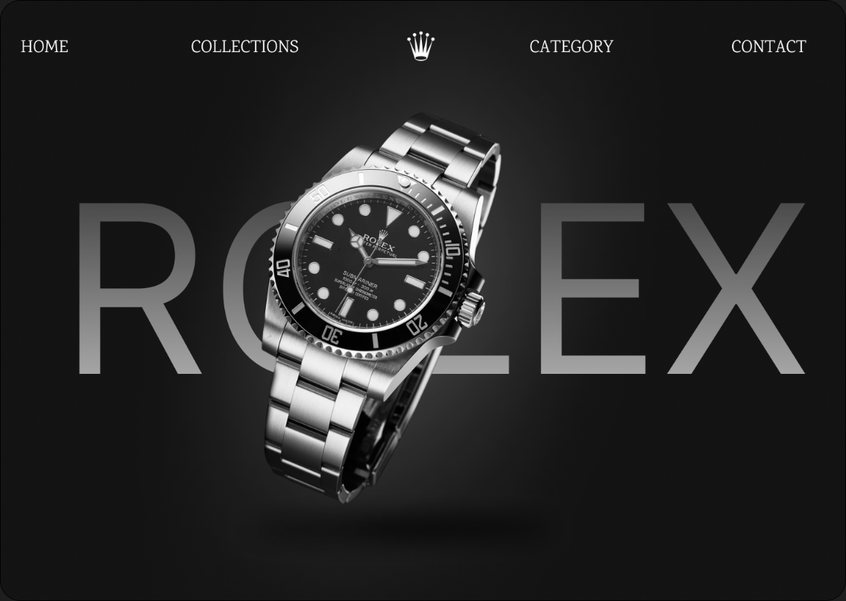
GOOD WEBSITE (Rolex – Dark Luxury Theme)
1. Design Style:
- Uses a dark, premium, and luxury-focused design.
- High-quality product image placed at the center creates strong visual appeal.
- Large typography and contrast enhance elegance and brand dominance.
- Overall design feels exclusive and high-end.
2. Content:
- Minimal text, but very impactful.
- Focuses on brand presence rather than heavy descriptions.
- The product itself becomes the main attraction.
3. Navigation:
- Well-spaced navigation options (Home, Collections, Category, Contact).
- Clean layout with icons and branding that enhance user experience.
- Navigation blends well with the theme without distraction.
4. Purpose:
- Designed to build brand identity and luxury perception.
- Targets premium customers and emphasizes exclusivity over quantity.+

Key Differences:
- Focus: The first website is product-centric, while the second is brand-centric.
- Design Aesthetics: The first is simple and functional; the second is bold, premium, and visually striking.
- User Experience: The first provides basic usability, while the second delivers an immersive luxury experience.
- Target Audience: The first targets general customers; the second targets high-end luxury buyers.

