Experiment -2
NAME: Mohamed Aseel S ROLL NO: 240701319
Design a UI where users recall visual elements (e.g., icons or text chunks). Evaluate the effect of chunking on user memory.
FRAME 1:
CHUNKING PHASE:

Analysis of the Memory Recall Task - Chunking Phase Screen
This screen represents the Chunking Phase of a Memory Recall Task, where users observe and memorize different icons within a limited time. Below is a breakdown of its key components:

1. Purpose of the Screen
- This is the visual memory encoding phase, where users view and group items mentally before recalling them.
- The term "Chunking Phase" suggests that the game applies the chunking principle, which helps users remember items by categorizing them into meaningful groups.

2. Key Elements and UI Components

⏳ Countdown Timer (Top Left - Red Circle: "00:05")
- Indicates that users have 5 seconds to observe and memorize the displayed items.
- The bright red color and bold text create urgency, ensuring users stay focused.

🟪 Progress Bar (Pink Bar Below Title)
- Shows the time remaining visually, reinforcing the sense of urgency.
- A partially filled bar suggests that some time has already passed.

🔲 Grid of Icons
- Various icons (such as a pig, burger, clock, police car, arrow, snowman, bee, laughing emoji, etc.) are displayed in a 5x4 grid format.
- These icons are visually distinct yet grouped by similarities, encouraging chunking strategies like:
  - Categorizing by theme (e.g., animals, food, transportation). o Grouping similar colors or backgrounds (e.g., pink, blue, or yellow tiles).
  - Associating repeated icons (e.g., multiple bees, burgers, police cars).

🐝 Bee Character Holding a Scroll (Top Right)
- Acts as a friendly mascot, enhancing engagement and giving a playful theme.
- The scroll may imply instructions or guidance in later stages.

3. How the Chunking Phase Works
- Users scan the grid and look for patterns or related items to create mental chunks.
- The countdown timer limits observation time, forcing quick memory strategies.
- Once time is up, users transition to the recall phase, where they must identify previously seen items.

4. Cognitive and UX Benefits of Chunking
- Enhances short-term memory by allowing users to recall groups of information instead of individual elements.
- Reduces cognitive overload by helping users organize data efficiently.
- Improves pattern recognition, making recall easier and more accurate.

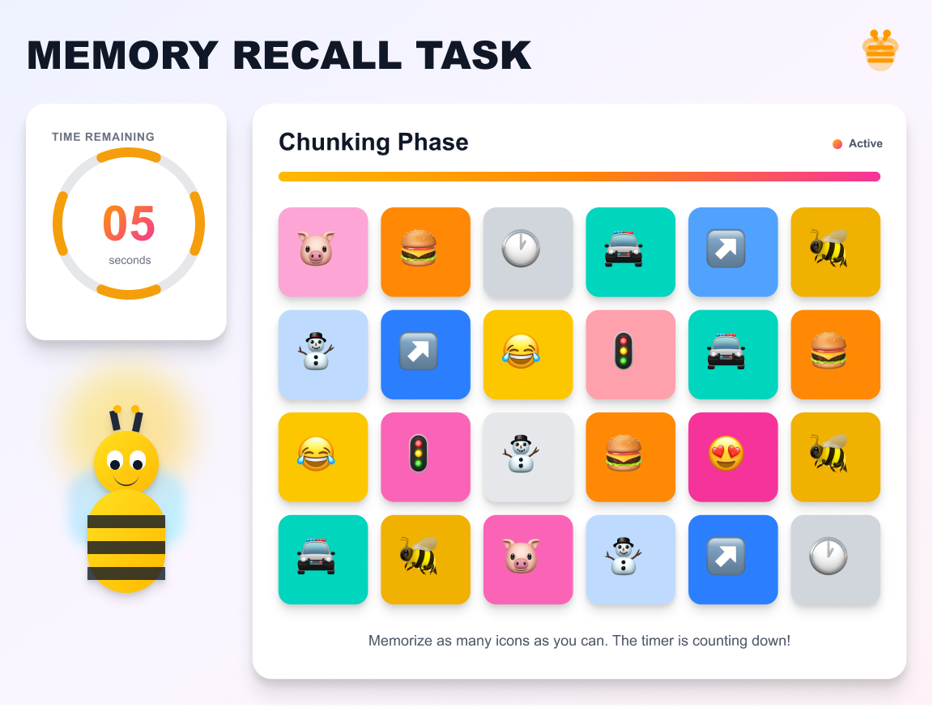
FRAME 2:
RECALL PHASE:

Analysis of the Memory Recall Task - Selection Phase
This screen represents the Selection Phase of a Memory Recall Task, where users recall and choose the items they remember from the previous Chunking Phase. Below is a breakdown of its components:

1. Purpose of the Screen
- This is the memory retrieval stage, where users select the items they remember seeing in the previous phase.
- The goal is to test the effectiveness of chunking and short-term memory retention.

2. Key Elements and UI Components

📝 Title & Instructions
- "MEMORY RECALL TASK" (Bold Header) – Reinforces the purpose of the task.
- "SELECT THE ITEMS YOU REMEMBER:" – Clear instruction guiding the user to choose remembered items.

🟪 Grid of Icon Choices
- A set of eight icons are presented as multiple-choice options.
- Some icons were previously displayed, while others are distractors (new icons added to confuse users).
- Users must identify which icons appeared in the Chunking Phase.
- Each icon has a radio button below it for selection.

🟪🐝 Animated Bee Character (Bottom Left)
- The bee character reinforces a playful, engaging theme.
- It may act as a mascot or guide throughout the memory task.

🟪 "SUBMIT" Button (Bottom Center)
• Once users have made their selections, they press "SUBMIT" to confirm their recall choices.

3. How the Selection Phase Works
- Users analyze the displayed icons and recall which ones they saw in the Chunking Phase.
- They select the remembered icons using the radio buttons below each option.
- Some icons are distractors, testing whether the user’s memory is accurate or if they mistakenly recall incorrect icons.
- Clicking "SUBMIT" finalizes their choices, leading to a results or feedback screen.

4. Cognitive and UX Benefits
- Tests memory accuracy by comparing user selections with previously displayed items.
- Incorporates distractors to evaluate how well users distinguish real vs. false memories.
- User-friendly interface with clear selection mechanics (radio buttons).
- Gamified elements (bee character, bright colors) make the task engaging.

-
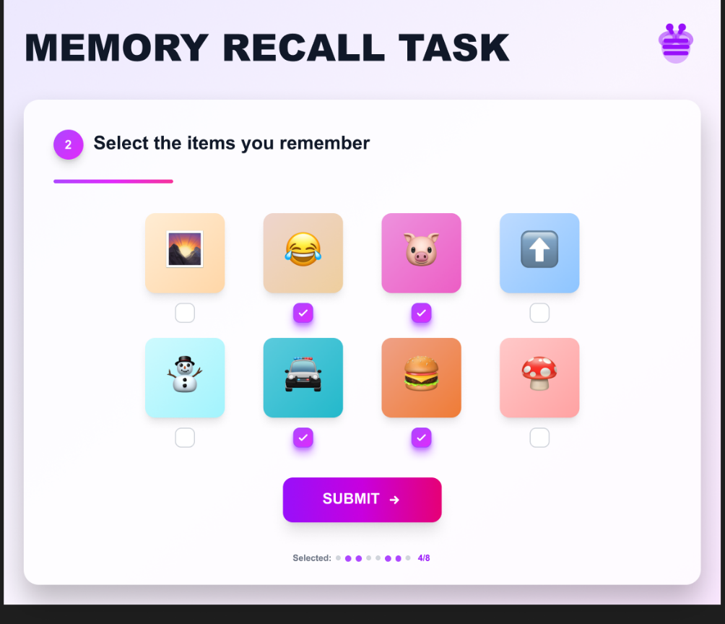
FRAME 3:
RESULT PAGE:

Analysis of the Memory Recall Task - Score & Feedback Screen
This screen represents the Score & Feedback Phase of the Memory Recall Task, where users receive their performance evaluation based on the selections made in the previous Recall Phase.

1. Purpose of the Screen
- Provides feedback on recall accuracy by showing the number of correct answers.
- Allows users to decide their next action (continue, restart, or exit).

2. Key Elements & UI Components

📝 Title & Score Display
- "MEMORY RECALL TASK" – Reinforces the game’s title.
- "YOUR RECALL SCORE!" – Indicates that the user’s performance is being displayed.
- A wooden scoreboard with the user’s score (4/5) in bold, showing correct answers out of total attempts.

🟪 Action Buttons (Right Side)
- "CONTINUE" – Proceeds to the next level or stage.
- "RESTART" – Allows the user to retake the memory recall test.
- "EXIT" – Ends the task and exits the game.

🐝 Animated Bee Character (Bottom Left)
- The bee character adds a playful, gamified element.
- Holds a blank sign, possibly for dynamic messages or additional instructions.

3. How This Phase Works
- The game evaluates the user’s selections from the Recall Phase.
- It calculates the accuracy score (4/5 in this case) and displays it on a wooden board.
- Users review their performance and choose their next action:
  - Continue if they want to proceed.
  - Restart if they want to improve their recall.
  - Exit if they want to stop playing.

4. Cognitive & UX Benefits
- Instant feedback helps users track their memory performance.
- Multiple options (Continue, Restart, Exit) give users control over their learning experience.
- Visual & gamified elements make the task engaging and less stressful.

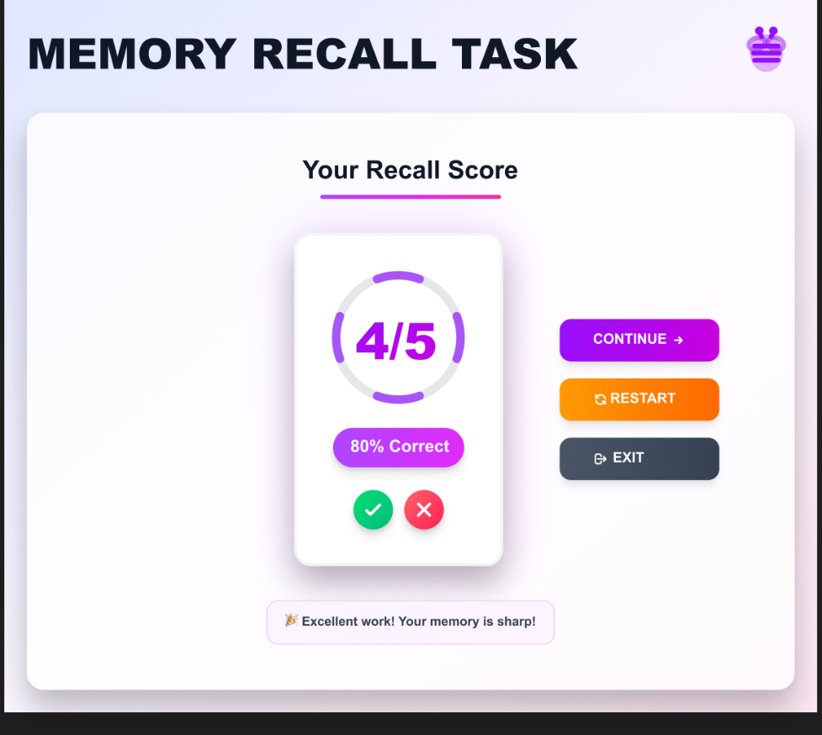
PROTOTYPE LINK:
https://www.figma.com/design/EIYTKGLX6uTmJ7mCnrwpzt/Untitled?node-id=1-2&t=21PwGOe07ap5mcT2-1

